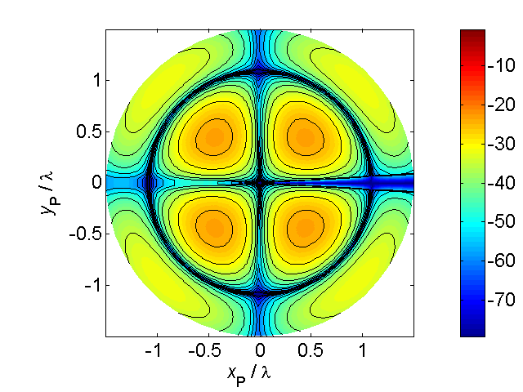

[**HSC PHYSICS ONLINE**](http://www.physics.usyd.edu.au/teach_res/hsp/sp/spHome.htm)

**POSITION**

**CHANGES IN POSITION**

**POSITION and CHANGES IN POSITION**

Motion implies change and it is change that makes life. The whole universe is a bewildering array of incessant motion. The topic **kinematics** gives as the necessary language to describe the motion of moving objects. We will begin our study of motion by considering only a single object which will be represented as a point particle and will be shown as a dot in a scientific annotated diagram.

To describe the motion of our point particle we need to specify the where it is located at specified times. We will start by describing the [2D] motion of a particle in a plane. To do this we must define a frame of reference (Cartesian coordinate system and Origin). To say that the particle is located at position (*x*, *y*) at time *t* defines an **event**.

Image yourself driving a tractor around a rectangular field. Let the tractor be represented by a point at the centre of the tractor and the frame of reference is given by a Cartesian coordinate system with the centre of the field taken as the Origin. At any instant *t*, the position of the tractor is given by its (x, y) coordinates. We can then make as series of measurements of the position of the tractor as a function of time. Each measurement of *t*, *x* and *y* defines an event. The measurements for three events are shown in figure (1).

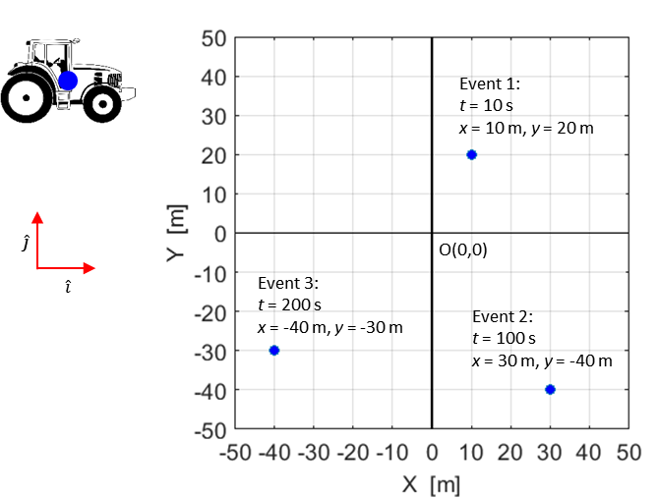

Fig. 1. Three events showing the location of the tractor.

Summary of the measurements for the three events shown in figure (1).

Event 1: time *t*1= 10 s position vector 

Event 2: time *t*2= 100 s position vector 

Event 1: time *t*3= 200 s position vector 

The position vectors represent the **displacement** of the particle w.r.t. the Origin (0, 0)

(N.B. the use of subscripts makes it easy to identify an event and using the concept of unit vectors makes it easier to give the position of the tractor).

The magnitude of the vector  is

1. 

The magnitudes of the displacements are



The direction of the position vector  is

1. 



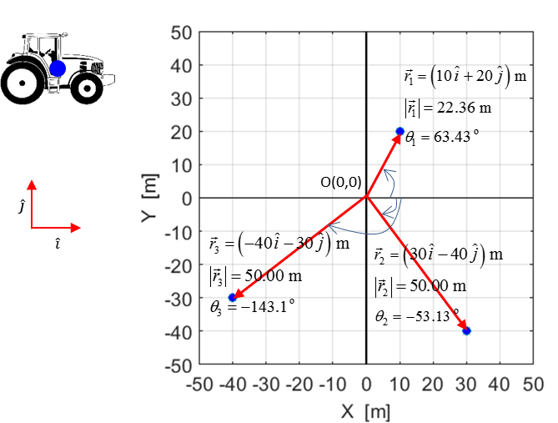

Fig. 2. The position vectors for the tractors for the three events.

An event occurs at an instant of time. The time between events is known as the **time interval** . ( is one symbol, the Greek letter delta means a change in or increment).

The time intervals for the motion of our tractor shown in figure (1) are:



(N.B. Again notice that the use of subscript makes it easy to identify the time intervals).

We can now calculate the change in the position that occurs in each time interval. The change in position vector is not necessarily equal to the total distance  travelled by the particle during that time interval:



We can now calculate the average velocity of the tractor in the time intervals between events. The average velocity  of a particle during the time interval  is defined as the ratio in the displacement (position vector) of the particle to the time interval which the change occurred

 vector quantity

The average velocities of our tractor are



Using equation (1) the magnitudes of the average velocities for our tractor are



Using equation (2), the direction of the velocity vectors for the tractor are

 see figure (3)

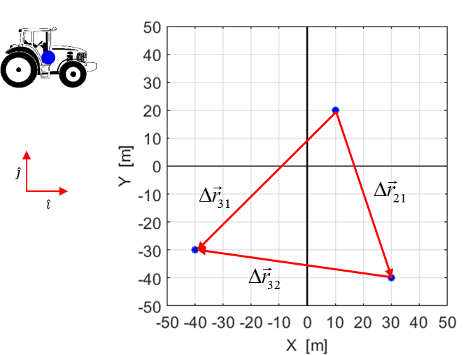

Fig.3. Vectors showing the relative displacements of the tractor. The direction of the average velocities between events are in the same direction as the displacement vectors.

**DISTANCE AND DISPLACEMENT**

We will now reconsider the concepts related to motion to reinforce your understanding of the concepts related to kinematics.

Consider the [2D] motion of two particles which start together at the Origin O and finish at the point P at the same time as shown in figure (4). One particle moves along the red trajectory labelled (1) whereas the second particle moves along the orange trajectory labelled (2).

The two events are:

Event 1: The particles starts at the Origin O

*t*1 =0 s *x*11 = 0 m *y*11 = 0 m

*t*1 =0 s *x*21 = 0 m *y*21 = 0 m

Event 2: The particles end at position P

*t*2 = 10 s *x*11 = 6 m *y*11 = 8 m

*t*2 = 10 s *x*21 = 6 m *y*21 = 8 m

N.B. the first subscript gives the object and the second subscript determines the event.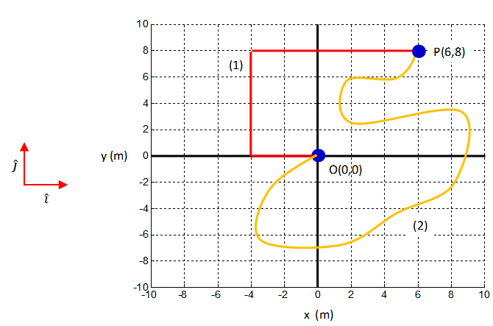

Fig. 4. The trajectories of the two particles staring at the Origin O and finishing at the point P.

The **distance** or **distance travelled** by particle 1 (trajectory #1) is 22.0 m and for particle 2 (trajectory #2) the distance travelled is much greater.

 distance is a scalar quantity

However, a much more useful quantity to describe the journeys is the **displacement** where you only consider the initial position O at time  and the final position P at time . The displacement by definition is the straight line distance between the initial and final positions and the direction of the final position with respect to the initial position.

Therefore, to specify the displacement one needs to state its **magnitude** (size) and **direction**. Such physical quantities are called **vectors**. You will come across many vector quantities such as velocity, acceleration, force, momentum, electric field and magnetic field.

Even though the two particles have travelled different distances their displacement is the same.

The displacement as vector can be represented graphically as an **arrow** whose length is proportional to the magnitude of the vector and points in the same direction as the vector quantity. The vector for the displacement for the journey from the origin O to the point P is shown in figure (5).

The magnitude of the displacement is given by Pythagoras’ theorem and the angle to give the direction is determined from the right angle as shown in figure (5). Therefore, the displacement  of two particles located at the point P with respect to the origin O is

 magnitude (positive scalar)

 direction given by angle w.r.t x-axis



Fig. 5. Displacement is a vector represented by an arrow whose length is proportional to the magnitude of the vector quantity. The direction in which the arrow points gives the direction of the vector quantity.

**Resolving a vector into its components**

A vector quantity can be **resolved** into **components** along each of the coordinate axes. The displacement shown in figure (5) can be resolved into an X component and its Y component .

N.B. you could use x and y for the symbols or use x and y as subscripts.

To find the components of a vector draw a box around the vector and then draw the two Cartesain components as shown in figure (6).

N.B. The two Cartesian components replace the original vector. Avoid the mistake of many students who add the two components to the original vector, thus counting it twice.



Fig. 6a. The displacement vector and its Cartesian components.



Fig. 6b. Resolving a vector into its *sx* and *sy* components.

From figure (6) we can conclude that



vector expressed in terms of its components and unit vectors



Pythagoras’ theorem – magnitude of the vector

 angle to give direction of vector

 Y component of the vector

 Y component of the vector

To find the components of each of the three vectors we are going to add, it is best to draw a diagram of each vector with a box around it. It is then an easy task to add the components for each vector as shown in figure (8).



Fig. 8. Each vector is shown separately with a box around it. It is them an easy task to determine the magnitude, direction and components of each vector.

Since all the x-components point in the same direction we can add them as numbers, and the same goes for the y-components. The resultant displacement is found as follows:

components of each vector are

=(6.0 - 0) m = 6.0 m

=(8.0 - 0) m = 8.0 m

=(-8.0 - 6) m = -14.0 m

=(6.0 - 8.0) m = -2.0 m

=(-2.0 –(-8.0)) m = 6.0 m

=(-8.0 – 6.0) m = -14.0 m

adding the components



From figure (7) it is obvious that the components of the resultant vector are , and these values are in agreement given by adding the components of each individual vector.

The magnitudes of the vector are (using equation (1))



The total distance travelled from O to P to Q to R is

(10.0 + 14.1 + 15.2) m = 39.3 m

whereas the magnitude of the displacement of the point R w.r.t. the origin 0 is 8.2 m. Distance travelled is a scalar quantity while displacement is a vector. Hence, must use different rules in adding scalars and vectors. Let us emphasize this again, the addition of vectors is a very special procedure clearly distinct from the addition of the scalar magnitude of the quantities.

The directions of the vector are found by using equation (2)

*Best way to avoid ambiguity for direction / angle is to use a diagram to show the orientation. When using the function atan(y/x) to find the angle ignore the sign of the numbers for x and y. The angles are given w.r.t. the x-axis*















* Given the components of a vector we can find its magnitude and an angle to give its direction.
* Given the magnitude of a vector and an angle w.r.t. a coordinate axis we can find its components.

For the displacement vector shown in figure (6)

 magnitude



direction given by angle w.r.t X axis

 X component

 Y component

**Addition of vectors**

Vectors do not add as simple numbers. We have to develop a set of rules for vector addition as vector addition is different from the addition of scalars.

Consider a particle that moves in straight line paths from the Origin O(0, 0) to the point P(6, 8) then to Q(-8, 6) and then to R(-2,-8). Figure (7) shows the positions of the particle at these three instants and the three position vectors  and figure (8) shows the relative position vectors  for the particle moving from O to P, P to Q and Q to R respectively.

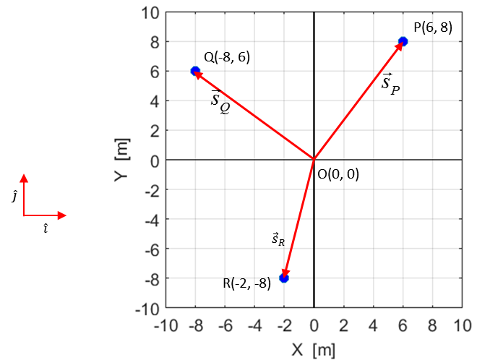

Fig. 7. The positions and displacement vectors for the movement of the particle from to P to Q and to R.

The vectors can be added graphically using a scaled diagram. The vectors are drawn head-to-tail after each other as in figure (8). The **resultant vector** then points from the starting position (the Origin O in this example) to the final position (the point R). The resultant vector corresponds to the displacement of the particle at the end of the journey from our Origin.

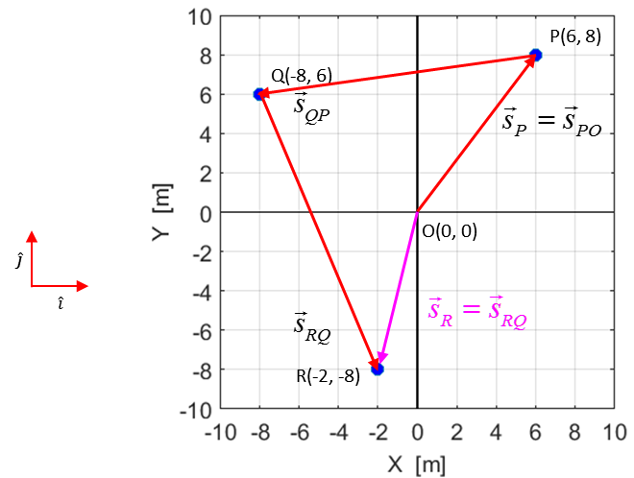

Fig. 8. The relative position vectors for the particle moving from O to P to Q to and the resultant vector .

The relative position vectors are



Rather than adding the vectors graphically, a better approach is find the resultant vector by **adding the components**. In this example, the final position of the particle at R can calculated by adding the three relative position vectors, hence, the resultant vector is



Which is correct as the coordinates of the point are (-2, -8).

**Components of a vector**