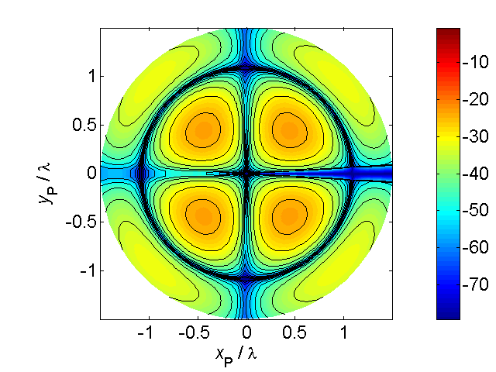

[**VISUAL PHYSICS ONLINE**](http://www.physics.usyd.edu.au/teach_res/hsp/sp/spHome.htm)

**KINEMATICS**

**[2D] MOTION IN A PLANE**

We will consider the two-dimension motion of objects moving in a plane with a **uniform acceleration**. This topic will be covered in greater depth in Module 5 Advanced Mechanics (Year 12).

Again, the first step is define a frame of reference

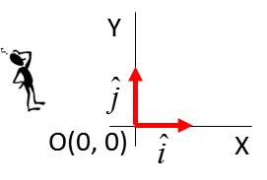 Observer

Origin O(0,0, 0) reference point

Cartesian coordinate axes (X, Y, Z)

Unit vectors 

Specify the units

The equations for the [2D] motion of an object moving in a plane are

acceleration 

velocity 

displacement 

These vectors equations are not very useful. It is much better to express the equation for [2D] motion in terms of the X and Y components of each vector. Remember a vector component is a scalar quantity.

When the object is moving with a **uniform (constant) acceleration**, the equations describing the motion for the time interval  between Event #1 (initial values) and Event #2 (final values) are

time 

acceleration 

velocity 



displacement









The angles  are both measured w.r.t. to the X axis



N.B. subscripts 1 and 2 denote the time for Event #1 and Event #2 and  or  identify the X or Y component. The equations above are not in a form that is shown in high school physics textbooks, but, the equations written with the double subscript give a better mathematical description of the motion.

We will consider the [2D] motion in a plane called **projectile motion**. When studying Physics, one key to becoming successful is being able to visualize a physical phenomenon. So, “make an effort” to visualize the flight of a thrown ball, a golf ball and a tennis ball.

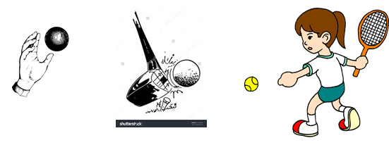

Now Physics is not about the real-world. A Physicist looks at a physical phenomenon and makes a set of **approximations** and **simplifications** to develop a mathematical model that can be used to make **predictions**. These predictions are then compared to the real-world measurements to test the validity of the mathematical model. The simple model is often expanded by adding complexities to given a better model of the real-world situation.

In developing our model of the flight of a ball, we need to make lots of approximations and simplifications. The ball is identified as our system (point particle) and is represented as a dot in a scientific diagram. We ignore the action of throwing or catching the ball and ignore any contacts with an obstacle e.g. our ball does not hit the ground. We are only interested in the **flight** of the ball.

Assume that the ball only moves in a vertical plane and ignore any friction effects or effects of the wind.

Motion parallel to the ground (horizontal motion) is directed along the X Cartesian axis and the motion perpendicular to the ground (vertical motion) is directed along the Y Cartesian axis.

The acceleration is assumed to be constant (does not change with time) such that



 is called the **acceleration due to gravity** and should be taken as a positive scalar quantity. The +Y direction is taken as vertically up and the direction of the acceleration of our system is vertically down, hence

.

Event #1 gives the initial values for the time, velocity and displacement of our system and Event # 2 gives the final values for time, velocity and displacement.

**Exercise**

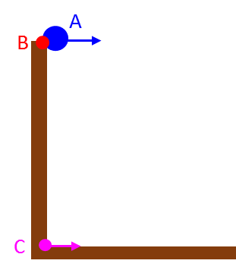Consider the projectile motion of three balls: **blue**, **red** and **magenta**.

System **A** 10 kg **blue** ball

System **B** 5 kg **red** ball

System **C** 1 kg **magenta** ball

**Event #1 ()**

The three balls are launched simultaneously as shown in the diagram and the initial values are displayed in the table.

|  |  |  |  |
| --- | --- | --- | --- |
|  | **A** | **B** | **C** |
| mass [kg] |  |  |  |
| time [s] |  |  |  |
| acceleration [m.s-2] |  |  |  |
| velocity [m.s-1] |  |  |  |
| displacement [m] |  |  |  |
| acceleration due to gravity [m.s-2] |  |  |  |

**Event #2** ()

The time interval for the motion of the balls is 3.0 s.

1. Visualize the motion of the three balls. On a single diagram, sketch for the trajectory for each ball.
2. What the final values for the acceleration, velocity and displacement after 3.0 s? Give the values for the components, magnitudes and directions.
3. For each ball, draw a series of graphs to show the variation with time in the 3.0 s interval for: the trajectories; acceleration components; velocity components and displacement components.

Only after you have completed Part (A), view an animation of the projectile motion of the three balls. How do your predictions agree with the trajectories displayed in the simulation?

[VIEW: simulation of the motion of the three balls](http://www.physics.usyd.edu.au/teach_res/hsp/sp/images/ag_2D_1.gif)

1. What can you conclude about the independence of the motions in the horizontal (X) and vertical (Y) directions?

**Go to the next page only after you have completed questions A to D**

**Carefully compare your results with the following answers and resolve and any discrepancies**

Figure (1) shows the trajectories of the three particles:

System **A** 10 kg **blue** ball

System **B** 5 kg **red** ball

System **C** 1 kg **magenta** ball

The solid curves show the paths for the three balls. The coloured dots show the positions of the balls at 0.30 s intervals.

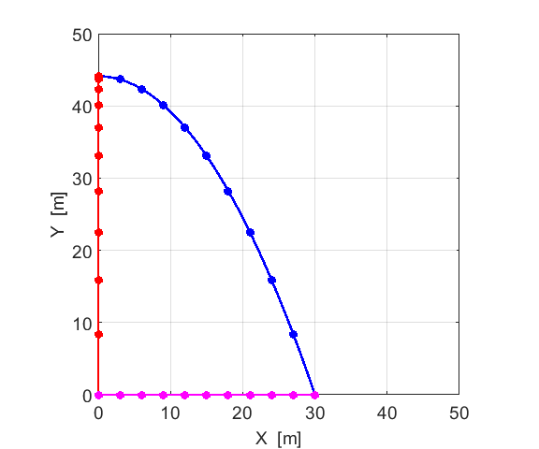

Fig. 1. The trajectories of the three balls.

The **blue (A)** and **red (B)** balls have identical vertical motions.

The **blue (A)** and **magenta (C)** balls have identical horizontal motions.

The horizontal motion and vertical motion are independent of each other.

The motion of a ball does **not** depend upon its mass.

Figure (2) show the variation in the components of the acceleration, velocity and displacements as functions of time. The colour of the line identifies the ball (**A blue**, **B red**, **C magenta**). If two or more of the results for the graph are the same, the colour is shown as **black**.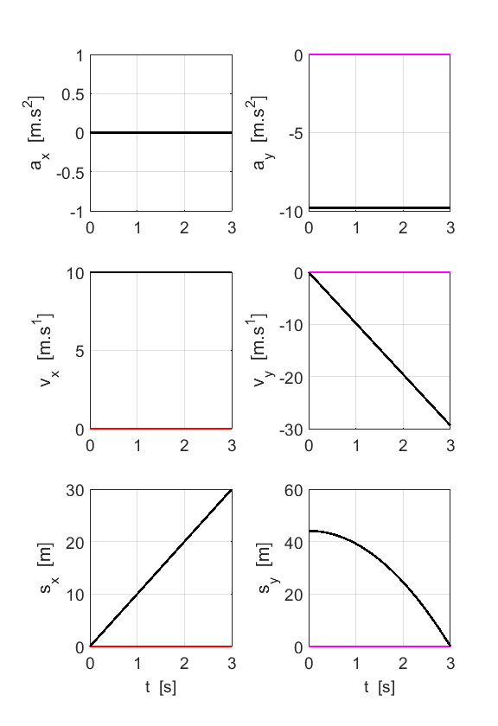

Fig. 2. Time evolution of the acceleration, velocity and displacement.

|  |  |  |
| --- | --- | --- |
| system **A** | system **B** | system **C** |
|  | | |
| **Event #1 (initial conditions)** | | |
|  |  |  |
|  |  |  |
| **Event #2 (final)** | | |
|  | | |
|  |  |  |
|  |  |  |
|  | | |
|  |  |  |
|  | | |
|  |  |  |
|  |  |  |
|  | | |
|  |  |  |

**EXERCISE**

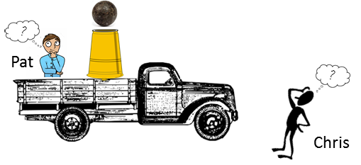A truck is travelling at 36 km.h-1 when a cannon on the back of the track fires a cannon ball vertically into the air. The cannon ball leaves the cannon at 72 km.h-1.

One person said that the cannon ball went straight up into the air while another person said that the cannon ball followed a parabolic path.

Surely, both people cannot be correct !!!

**What is you view on the motion of the cannon ball?**

Think about the physical situation carefully and visualize the motion of the ball. Setup a model so that you can make predictions about the ball’s motion.

Make a list of the physical quantities of interest that you can calculate. Remember there are two observers – Pat and Chris.

Make a list of the approximations and simplifications necessary to make your numerical predictions.

Calculate the numerical values of the quantities in your list.

Show a set of graphs illustrating the motion of the ball.

**Go to the next page only after you have completed all the above mentioned tasks**

**Carefully compare your results with the following answers and resolve and any discrepancies**

**Approximation and Simplifications**

Assume that the velocity of the truck is constant and travels on a level road. We are concerned only with the flight of the cannon ball and ignore the firing or landing of the cannon ball. Assume that the ball only travels in a vertical plane and ignore any frictional effects.

The acceleration is assumed to be constant (does not change with time) such that



The physical situation is complicated. We have two observers (Pat and Chris) and two systems (truck and the cannon ball).

Think about the situation by visualizing it. We can conclude that from Pat’s point of view the truck remains stationary and the ball goes up and down. Chris’ s point of view is that the truck moves with a constant velocity and the ball also goes up then falls.

To simplify the situation, we identity two systems and two frames of reference.

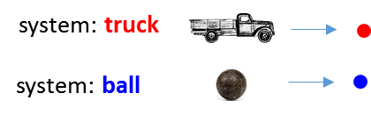

**Frame of reference**

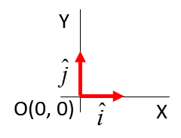Motion parallel to the ground (horizontal motion) is directed along the X Cartesian axis and the motion perpendicular to the ground (vertical motion) is directed along the Y Cartesian axis. At the instant that the cannon ball is fired, the Origin O(0, 0) is taken as the point at which the cannon ball leaves the barrel of the cannon. The Origin is always a stationary point in the frame of references of the two observers Pat and Chris.

**Event #1 ()** occurs at time zero when the cannon fires to give the initial values for acceleration, velocity and displacement of each system (truck and ball).

**Event #2 ()** occurs at some later time  to give the final values for acceleration, velocity and displacement of each system (truck and ball).

[VIEW ANIMATION OF THE TRUCK AND BALL](http://www.physics.usyd.edu.au/teach_res/hsp/sp/mod1/m1_plane_ag.htm)

**Pat’s frame of reference: Initial values**

|  |  |  |
| --- | --- | --- |
| **Event #1** | **Truck** | **Ball** |
| time [s] |  |  |
| acceleration [m.s-2] |  |  |
| velocity (X cpt) |  |  |
| velocity (Y cpt) |  |  |
| displacement [m] |  |  |
| acceleration due to gravity [m.s-2] |  |  |

Figure (3) shows the motion of the **truck** and the **cannon ball** from the frame of reference of **Pat**. In Pat’s frame of reference the truck does not move while the ball rises as it slows down and stops at its maximum height and falls with increasing speed.

Figure (4) show the variation in the components of the acceleration, velocity and displacements as functions of time for the **truck** and **cannon ball** system in Pat’s frame of reference. The colour of the line identifies the system (**Truck: red** and **Ball: blue**). If two of the results for the graph are the same, the colour is shown as **black**.

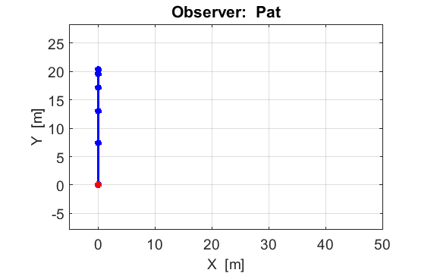

Fig. 3. The motion of the **truck** and **cannon ball** in Pat’s frame of reference. The dots give the positions of the systems at 0.41 s time intervals. From the spacing of the dots for the **ball**, we conclude that the ball slows down going up and gets faster in falling.

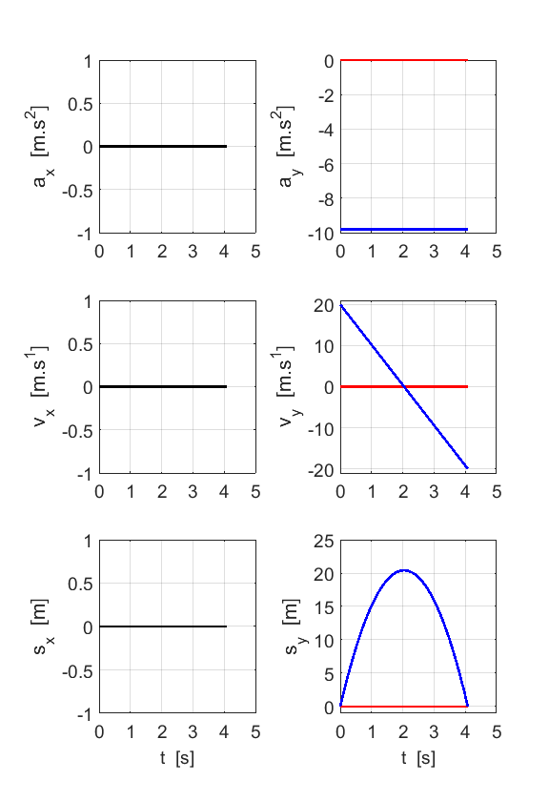

Fig. 4. Time evolution for the motion of the **truck** and **ball** in the frame of reference of Pat. Red lines for truck. Blue lines for ball. Black lines: tuck and ball have same values for the motion.

**Calculations in Pat’s frame of reference**

**Truck** The truck remains stationary



The truck does not move, therefore, the above values for the truck do not change.

**Cannon Ball**

The ball only moves in a vertical direction along the Y axis.

**Event # 1: () Initial values**



**Event #2 Ball reaches its maximum height**

max height 

time to reach maximum height 

maximum height  at max height ball stops

We know that 



We know that 



The ball reaches its maximum height of 20.4 m in 2.04 s.

**Event #3 Ball returns to the cannon**

time to return to cannon 

velocity of ball to return to cannon 

The motion is symmetrical, the time it takes for the ball to fall back into the cannon is twice the time it takes to teach its maximum height



and the velocity of the ball is



We also can calculate these quantities



The time of flight of the cannon ball is 4.08 s and the velocity at the end of the flight is 20 m.s-1 in a vertical downward direction.

**Chris’s frame of reference: Initial values**

|  |  |  |
| --- | --- | --- |
| **Event #1** | **Truck** | **Ball** |
| time [s] |  |  |
| acceleration [m.s-2] |  |  |
| velocity (X cpt) |  |  |
| velocity (Y cpt) |  |  |
| displacement [m] |  |  |
| acceleration due to gravity [m.s-2] |  |  |

Figure (5) shows the motion of the **truck** and the **cannon ball** from the frame of reference of **Chris**. In Chris’s frame of reference the truck moves at a constant velocity while the ball rises as it slows down and stops at its maximum height and falls with increasing speed.

Figure (6) show the variation in the components of the acceleration, velocity and displacements as functions of time for the **truck** and **cannon ball** system in Chris’s frame of reference. The colour of the line identifies the system (**Truck: red** and **Ball: blue**). If two of the results for the graph are the same, the colour is shown as **black**.

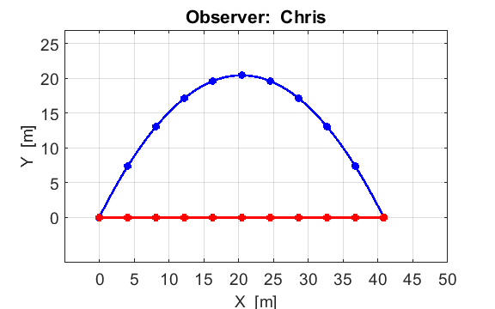

Fig. 5. The motion of the **truck** and **cannon ball** in Chris’s frame of reference. The dots give the positions of the systems at 0.41 s time intervals. From the spacing of the dots for the **ball**, we conclude that the ball slows down going up and gets faster in falling. The trajectory of the ball is a **parabola**. The spacing of the red dots are uniform, therefore, the speed of the truck is uniform (constant).

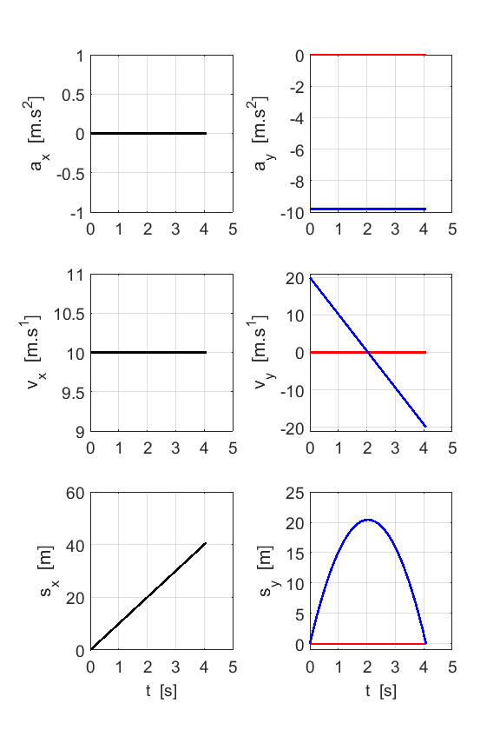

Fig. 6. Time evolution for the motion of the **truck** and **ball** in the frame of reference of Chris. Red lines for truck. Blue lines for ball. Black lines: tuck and ball have same values for the motion. For the **ball**, the  graph is a **straight line** with a slope equal , the shape of the  graph is a **parabola**.

**Calculations in Chris’s frame of reference**

**Cannon Ball**

**Event # 1: () Initial values**



**Event #2 Ball reaches its maximum height**

max height 

time to reach maximum height 

maximum height  at max height ball stops

We know that 



We know that 



The ball reaches its maximum height of 20.4 m in 2.04 s.

**Event #3 Ball returns to the cannon**

time to return to cannon 

velocity of ball to return to cannon 

The motion is symmetrical, the time it takes for the ball to fall back into the cannon is twice the time it takes to teach its maximum height



and the velocity of the ball is



We also can calculate these quantities



The final velocity of the ball is



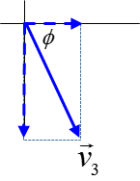

In the +X direction the **ball** moves with a constant velocity of 10 m.s-1. The X displacement of the ball during the flight is



**Truck**

The **truck** moves with a **constant velocity** which is the same as the ball. therefore, the ball is always vertically above the truck. At the end of the flight of the ball will land back into the mouth of the cannon.

Figure (3) and figure (6) shows the paths of the cannon ball relative to **Pat** and **Chris** as observers. Both agree the ball goes up and back down again.



Fig. 3. The trajectory of the **cannon ball** and **truck** from Pat’s frame of reference.



Fig. 6. The trajectory of the **cannon ball** and **truck** from Chris’s frame of reference

We can see from figure (3) and figure (6) that both Pat and Chris are correct in describing the trajectory of the ball. Pat see the ball rise and fall only in a vertical direction, however, Chris see a parabolic trajectory for the ball.

**Motion is a relative concept and depends upon the motion of an observer**

[VISUAL PHYSICS ONLINE](http://www.physics.usyd.edu.au/teach_res/hsp/sp/spHome.htm)

If you have any feedback, comments, suggestions or corrections please email:

Ian Cooper School of Physics University of Sydney

ian.cooper@sydney.edu.au