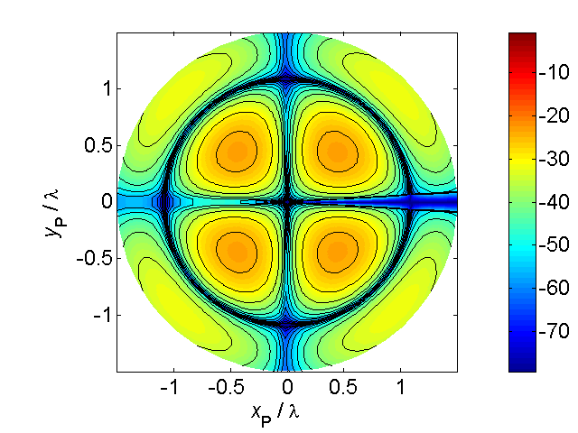

[**HSC PHYSICS ONLINE**](http://www.physics.usyd.edu.au/teach_res/hsp/sp/spHome.htm)

**THE LANGUAGE OF PHYSICS:**

**FRAMES OF REFERENCE**

In studying the motion of objects you need to use scientific terms carefully as the meaning of words used in Physics often have a different meaning to the way they are used in everyday speech.

The language you will learn can be used to describe the motion of galaxies, stars, planets, comets, satellites, rockets, golf balls, cars, microscopic objects, and so on. Principles, laws, theories and models will be given to help us understand the physical world surrounding us and to make predictions using mathematical models.

We will often develop simple models that are not necessarily good approximation to the real world but none the less can be quite useful. A physicist is a person who can take a complex situation and begin to understand its working by first creating a simple model which ignores many aspects of the real situation, but by doing this, they can start to develop an understanding of the situation. To improve your physics ability throughout this course it is essential that you learn how to visualise and simplify a physical situation. Often a starting point to answering an examination question is to draw a scientific but simple diagram of the physical situation. People who are good at physics do this automatically. Those that struggle with physics and think it is a “hard” subject do so because they can’t visualise and then draw an appropriate annotated diagram of the situation as part of their answer.

Our goal is to develop a set of models to describe, understand and predict the motion of objects. In developing our simplest models, an object or set of objects is identify as a **system**. By identifying the system of interest and focussing our attention on the system makes it easy to apply the appropriate physical principles. The system will be taken as point particle and draw as a dot • in scientific annotated diagram as shown in figure (1).

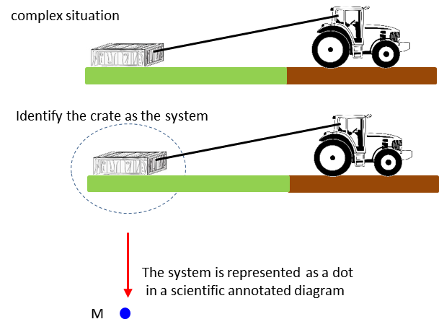

Fig. 1. An object or collection of objects is identified as a **system** and represented by a dot • in a scientific annotated diagram.

The mass of an object is given by the symbol or  and if there is more than one object, subscripts are used to identify each object. For example, or could be used to represent the mass of three cars. The mass of the three cars together is . The S.I. Unit for **mass** is the **kilogram** [kg]. Physical quantities like mass where a single number gives a measurement of the quantity and add together as simple numbers are called **scalar** quantities.

Any quantity that has a magnitude but no direction is called a **scalar** and examples include time, temperature, volume, density, energy and electric charge.

One of the driving forces on developing the ***scientific method***was the study of astronomy starting in the 17th century. This lead to a model in which our Universe is composed entirely of particles such as electrons, protons, and neutrons. If at some time one knew the position each particle and the forces between those particles, then you could know everything about the Universe as it would be theoretically possible to predict the future. This was the viewpoint of nearly all scientists until about 1927 when the ideas of ***classical physics*** (ideas dating until the beginning of the 20th century) were strongly held. At the beginning of the 20th century numerous phenomena could not be explained in terms of the ideas of classical physics and this has led to completely new and strange ideas in what we call ***modern physics***. Modern physics includes the theories of special relativity (e.g. different observes measure different time intervals of an event); general relativity (e.g. clocks run slower in stronger gravitational fields – the time synchronisation of mobile phones uses the principles of general relativity); and quantum theory (no clear distinction between what is a particle and wave; Heisenberg Uncertainly Principle, e.g. can’t know the position and momentum of a particle simultaneously).

**FRAMES OF REFERENCE**

Our starting point to understanding the Universe was that we had to know the position of each particle in space. Therefore, we need to set up a method of specifying the position of particles which is precise and unambiguous. We will consider a two-dimensional universe. The methods we will develop can easily be extended give the position of particles in our real three-dimensional world (in terms of modern physics, time and space are interwoven and a better model is to consider a four-dimensional world []).

Consider the problem of specifiying the position (location) of three cars as shown in figure (2).



Fig. 2. What is the position of the three cars?

To clearly specify the position of the cars we need to have a **frame of reference**.

The most useful frame of reference in three-dimensions is defined by three perpendicular lines and is referred to as a **Cartesian coordinate system** (figure 3).

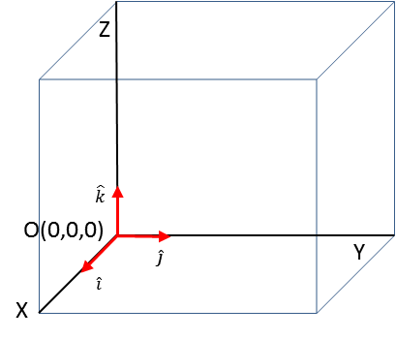

Fig. 3. Cartesian coordinate system with X, Y and Z axes each perpendicular to each other. The direction of the Z axis is given by the direction of the thumb of the right hand when the fingers of the right hand are rotated from the X axis to Y axis.

The **unit vectors** , ,  give the directions along the Cartesian coordinate axes and allows us to specify a vector and its Cartesian components in a convenient format.

 gives the direction that the X coordinate is increasing (say i-hat)

 gives the direction that the Y coordinate is increasing (j-hat)

 gives the direction that the X coordinate is increasing (k-hat)

*The concept of unit vectors is not usually used at the high school level but using the notation of unit vectors in the “long run” improves your ability to have a better understanding of physical principles.*

For the position of the cars problem we will use a [2D] Cartesian coordinate system using the X and Y axes. We take any point in space as an **Origin O**. Through the origin O, we construct two lines at right angles to specify the X and Y coordinate axes. These lines could be labelled [X axis Y axis] or [N S E W] or [horizontal vertical] as shown in figure (4).



Fig. 4. Frames of references: origin O and coordinate axes

Figure (5) gives the position of the cars in our frame of reference where the objects – the cars are replaced by dots.

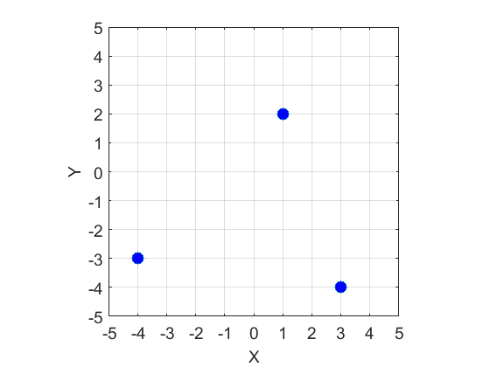

Fig. 5. The location of the cars in our Cartesian coordinate system with origin O(0,0).

The location of the cars with respect to the Origin O is uniquely given in terms of their X and Y coordinates. We can identify the three cars using the labels: R(red car), Y(yellow car) and G(grey car).

Location of the cars in our frame of reference (X coordinate, Y coordinate)

Red car R(1, 2)

Yellow car Y(3, -4)

Grey car R(-4, -3)

The best way to specify the location of the cars is in terms of the vector quantity called the **displacemen**t  which is specified by its X and Y coordinates  which corresponds to the X and Y **components** of the vector with respect to the Origin and the unit vectors and 



The subscript R, Y and G are used to identify each car, therefore, the displacement of each car can be expressed as

P, The location of each car is expressed a vector wdisplacement of each car can be expressed asThe **magnitude** of the displacement vector for one car  is the straight line distance between the Origin O and the location of the car is represented by the symbol(magnitude of the vector) and the location of the car and its direction is given by the angle  measured with respect to the X axis.

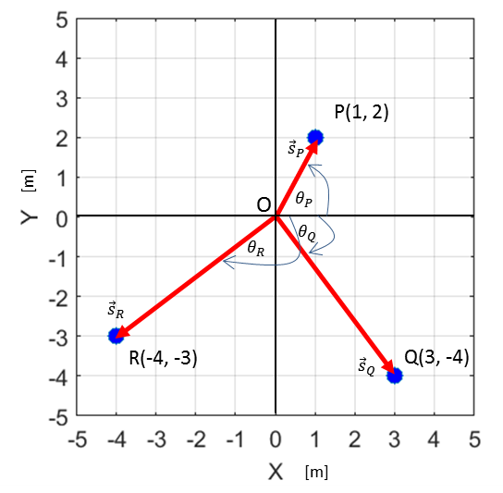

Fig. 6. The displacements of the car with respect to the origin O.

The distance *s* between the origin O(0,0) and a point at  is given by equation (1) and is called the **magnitude**

(1)  Pythagoras’ Theorem

The magnitude of a vector is always zero or a positive scalar quantity.

The direction of a point at (*s*,*s*) makes with the X axis is be given by the angle  (Greek letter theta) as expressed by equation (2)

(2) 

The components and displacement vectors of the three car using equations (1) and (2) are:



The displacement of the cars can be expressed in terms of the unit vectors and X and Y components of the vector



For car Q



All the calculations of the displacements were measured with respect to our observed located at the origin O(0, 0).

**RELATIVE POSITIONS**

We can also calculate **relative positions**. For example, what are the displacement of the cars with respect to an observed located at the position of car Q. The calculation of relative positions can be done using the concept of **vector subtraction**.

The vector components of the three cars are:



The position of car Q with respect to the observer at Q is given by the vector



where the first subscript is the object and the second subscript is the observed. Obviously the answer is correct, the displacement of the car at Q w.r.t the observer at Q is zero.

The position of car P with respect to the observer at Q as shown in figure (6) is given by the vector



where the first subscript is the object P and the second subscript Q is the observed at Q.

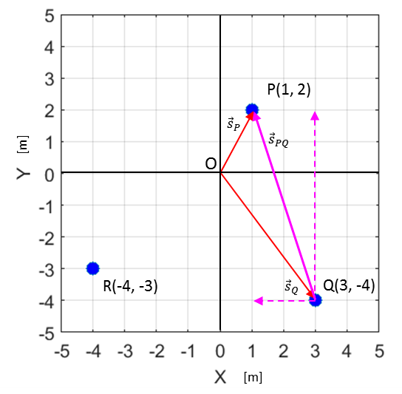

Fig. 6. The position of car P w.r.t. an observed located at Q.

The position of car R with respect to the observer at Q as shown in figure (7) is given by the vector



where the first subscript is the object R and the second subscript Q is the observed at Q.

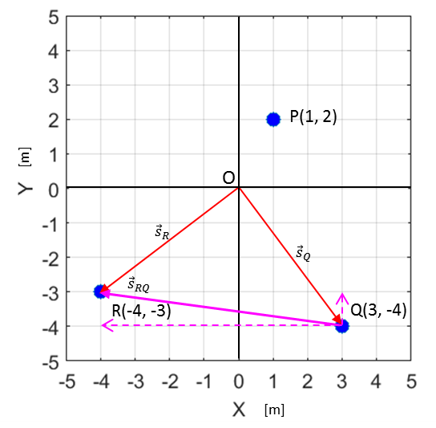

Fig. 7. The position of car R w.r.t. an observed located at Q.

**REVIEW**

In specifying a vector quantity, it is necessary to have defined a frame of reference (Cartesian coordinate system and origin - observer).

For [2D] vectors, the vector  has a magnitude *s* or and a direction  and components 



 **magnitude is a positive scalar quantity**





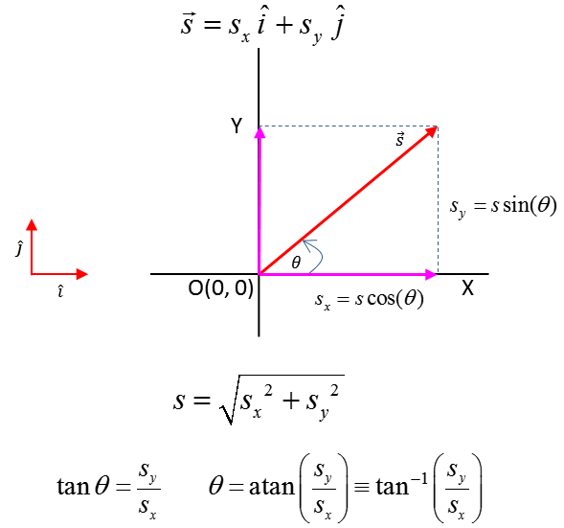

Fig. 8. Specifying a [2D] vector quantity.

* **A vector has a magnitude and direction. You can’t associate a positive or negative number to a vector. Only the components of a vector are zero or positive or negative numbers.**
* **Scalars are not vectors and vectors are not scalars.**
* **In answering most questions on kinematics and dynamics you should draw an annotated diagram of the physical situation. Your diagram should show objects as dots; the Cartesian coordinate system, the origin and observer; the values of given and implied physical quantities; a list unknown physical quantities physical; the units for all physical quantities; principles and equations.**