**[VISUAL PHYSICS ONLINE](http://www.physics.usyd.edu.au/teach_res/hsp/sp/spHome.htm)**

**DYNAMICS**

**CONSERVATION OF ENERGY**

**OSCILLATING MASS / SPRING SYSTEM**

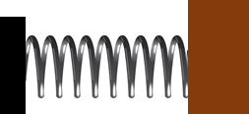Consider the mechanical System of a block (mass ) attached to spring (spring constant ) that can be set oscillating on a horizontal surface. We ignore any frictional or drag effects acting on the vibrations of the System.

How to approach the problem of studying the motion of the block attached to the spring by applying the concepts of work and energy:

* Visualize the physical situation
* Identify the System or Systems
* Define the frame of reference
* Identify the forces acting on the System
* [1D] problem – don’t need to use vector notation
* Calculate the work done on or by the System

Figure (1) shows an annotated diagram of the physical situation. The force exerted by the stretched or compressed spring on the block is. The **equilibrium position** is taken as the Origin O(0, 0) and the displacement in the X direction is  .

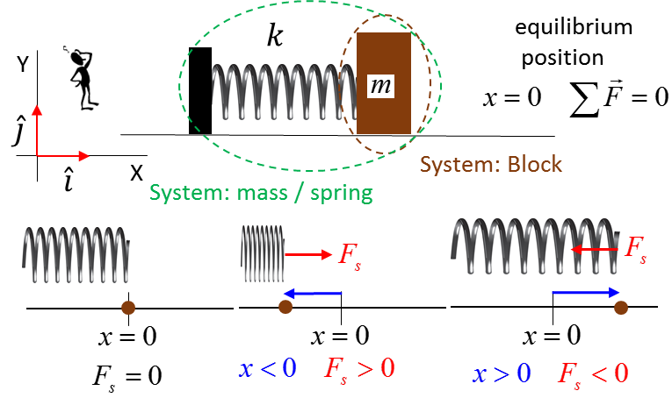

Fig. 1. Mass / Spring system.

For the block System the forces acting on it are: the gravitational force ; the normal force  and the spring force .The free body diagram for the forces acting on the block System and the variation of the spring force with displacement is shown in figure (2). All the forces acting on the block are called conservative force since no energy is lost the System to the surrounding environment. The area under the force vs displacement curve is equal to the work done .

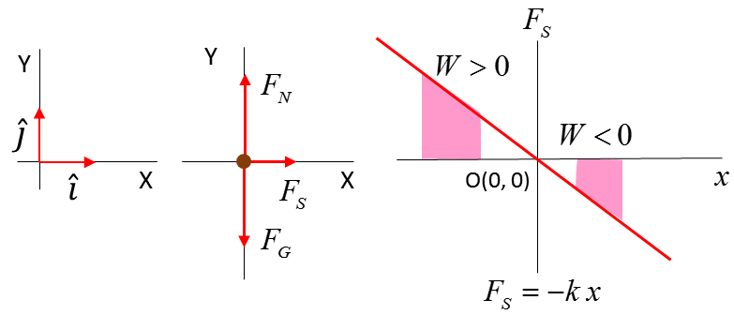

Fig. 2. Forces acting on block System.

For a spring, the force  and extension  of the spring is described by **Hooke’s Law**

(1) 

Consider two events for the oscillating motion of the block.

Event #1: time  velocity  displacement 

Event #2: time  velocity  displacement 

Zero work is done by the gravitational force and the normal force since the displacement is perpendicular to the force. Work is done only by the force exerted by the spring.

The work done by the spring on the mass in the time interval between events is

(2) 

The potential energy  of the spring / mass System where  when  s defined as

(3)  potential energy

The concept of **potential energy** is a **relative** concept and is measured from a **reference point** where . Potential energy is related to the idea of “stored energy”. A stretched or compressed spring certainty can do work and transfer energy. The potential energy refers to the System of spring and mass. The spring or mass do **not** possess potential energy.

Combining equation (2) and equation (3)

(4) 

**The work done is the negative of the change in potential energy when conservative forces (zero mechanical energy dissipated) acts on the System**

The work done changes the kinetic energy

(5) 

Comparing equation (4) and equation (5)

(6) 

(7) 

It is useful to define the term called total energy E

(8) ** total energy**

In the motion of the oscillating mass, the kinetic and potential energies are always changing with time but the total change in the kinetic and potential energies is zero. Therefore, the total energy is constant – we say that the total energy is a conserved quantity.

(9)  **conservation of energy**

Equation (9) reveals one of the most important foundation principles of Physics – **conservation of energy**. The potential energy and kinetic energy change with time, but there is zero change in the total energy of the spring / mass System .

[VIEW animation of oscillating spring / mass System](http://www.physics.usyd.edu.au/teach_res/mp/doc/mec_spring_energy.htm" \t "_blank)

**Symbols**

A variety of symbols are used for different forms of energy. You should be aware of this fact.

kinetic energy 

potential energy 

total energy 

The symbol used for the electric field strength is also *E.* You must consider the physical situation to make sure that *E* represents the electric field or the total energy. When doing topics on electromagnetism, it is less confusing to use *U* as the symbol for the potential energy.

[VISUAL PHYSICS ONLINE](http://www.physics.usyd.edu.au/teach_res/hsp/sp/spHome.htm)

If you have any feedback, comments, suggestions or corrections please email:

Ian Cooper School of Physics University of Sydney

ian.cooper@sydney.edu.au