**[VISUAL PHYSICS ONLINE](http://www.physics.usyd.edu.au/teach_res/hsp/sp/spHome.htm)**

**DYNAMICS**

**CONSERVATION OF ENERGY**

**GRAVITIONAL SYSTEM**



Consider the upward motion of a ball (mass ) thrown vertically into the air. We ignore the action of throwing and any frictional or drag effects acting the motion of the ball (conservative forces only act on the ball).

How to approach the problem of studying the motion of the ball by applying the concepts of work and energy:

* Visualize the physical situation
* Identify the System or Systems
* Define the frame of reference
* Identify the forces acting on the System
* [1D] problem – don’t need to use vector notation
* Calculate the work done on or by the System

Figure (1) shows an annotated diagram of the physical situation. The only force acting on the ball is the gravitational force. . The ground at  is taken as the Origin for the vertical displacement .

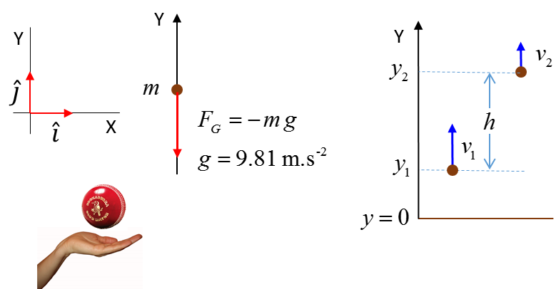

Fig. 1. The System is the ball.

Consider two events for the vertical upward motion of the ball:

Event #1: time  velocity  displacement 

Event #2: time  velocity  displacement 

The work done by the gravitational force on the System is

(1) 

The **gravitational potential energy**  of Earth / Ball System where  when  s defined as

(2)  potential energy

(3) 

**The work done is the negative of the change in potential energy since the gravitational force is a conservative force.**

The concept of **potential energy** is a **relative** concept and is measured from a **reference point** where . Potential energy is related to the idea of “**stored energy**”. The potential energy refers to the System of Earth / Ball - the ball does **not** possess potential energy. The value of the potential energy is not so important, it is the change in potential energy  that is important and its value is independent of the reference point where .

A falling brick can hurt your toes because of its stored energy as the gravitational potential energy is converted to kinetic energy.

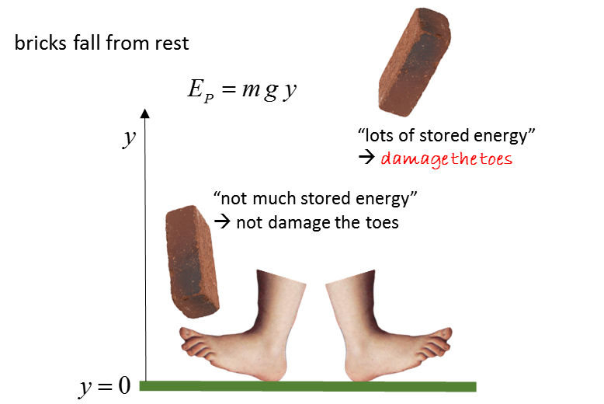

Combining equation (2) and equation (3)

The work done changes the kinetic energy

(4) 

Comparing equation (12) and equation (13)

(5) 

(6) 

The total energy is

(7) ** total energy**

As the ball rises it loses kinetic energy and gains potential energy, but, the loss in kinetic energy is equal to the gain in potential energy. When the ball falls, it gains kinetic energy and losses potential energy, but, the gain in kinetic energy is equal to the loss in potential energy. For the motion of the ball going up then down, the kinetic and potential energies are always changing with time but the total change in the kinetic and potential energies is zero. Therefore, the total energy is constant – we say that the total energy is a conserved quantity.

 **conservation of energy**

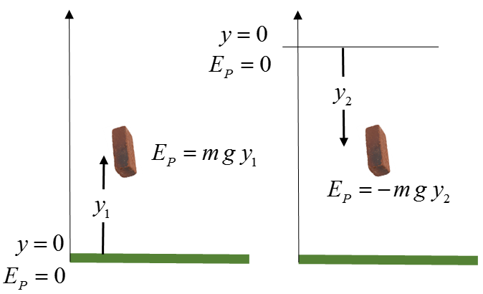

Fig. 2. Potential energy is a relative concept. It value depends upon the reference point where . The value of the potential energy is not important - it is the change in potential energy  that is most useful.

N.B. The symbol for potential energy in the Syllabus is . Both symbols  and  can be used.

**Example**

An 945 kg roller-coaster cart is released from rest at Point A. Assume there is no friction or air resistance between the points A and C.

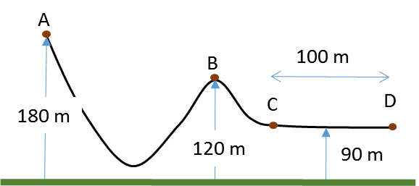

How fast is the roller-coaster cart moving at Point B?

What average force is required to bring the roller-coaster cart to a stop at point D if the brakes are applied at point C?

**Solution**

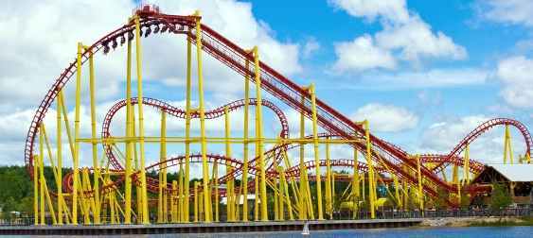How to approach the problem

Visualize the physical situation

Problem type: KE PE Energy conservation

Define a frame of reference.

List known & unknown physical quantities (symbols & units)

State physical principles

Annotated scientific diagram

For the motion of the cart on the roller-coaster track we can ignore any dissipative forces. Therefore, total energy of the System (cart + Earth) is a constant for the motion.

Total Energy = Kinetic energy + Potential energy = constant

 at all times

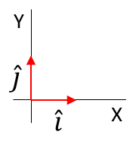Take the Origin to be at the ground level and all heights are measured w.r.t. the ground









Event #A (cart at A)



Event #B (cart at B)





Event #C (cart at C)





An applied force on the cart reduces its kinetic energy to zero by doing work on the cart.

Work = Change in kinetic energy



[VISUAL PHYSICS ONLINE](http://www.physics.usyd.edu.au/teach_res/hsp/sp/spHome.htm)

If you have any feedback, comments, suggestions or corrections please email:

Ian Cooper School of Physics University of Sydney

ian.cooper@sydney.edu.au