**[VISUAL PHYSICS ONLINE](http://www.physics.usyd.edu.au/teach_res/hsp/sp/spHome.htm)**

**DYNAMICS**

**CONSERVATION OF MOMENTUM**

**INELASTIC COLLISIONS**

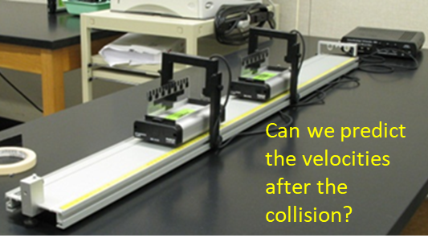

Collisions are occurring around us all the time. Collisions are an intrinsic occurrence of our physical world. Collisions are very complex processes, but through mathematical models of real-world situations that use the principles of conservation of energy and momentum, we can gain in insight into the behaviour of the particles involved in the collision and make numerical predictions.

**Thinking Exercise**

Study the images and identify the collisions taking place. Visualize at least another 10 examples of collisions.

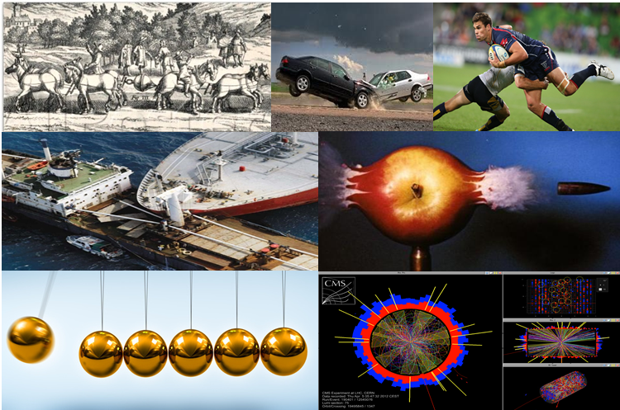

In any collision, energy is conserved, but we often can’t keep track of how the energy is distributed amongst the participants in the collision. One of the most guiding principles in Physics is the **Law of Conservation of Energy**.

We will construct simple models for collisions processes. Collisions are categorized to what happens to the kinetic energy of the System.

There are two possibilities:

(1) **ELASTIC COLLISION**: The final kinetic energy is equal to the initial kinetic 



(2) **INELASTIC COLLISION**: The final kinetic energy is less than the initial kinetic energy 



The lost kinetic energy may be transferred into sound, thermal energy, deformation, etc.

**Kinetic energy is not conserved, but, the momentum of the system is conserved**



A **completely inelastic collision** occurs when the objects **stick together** after the collision and a **maximum** amount of kinetic energy is lost.

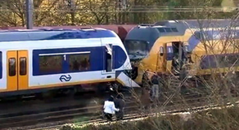 When two trains collision all the original kinetic energy is dissipated in a completely inelastic collision, but, momentum is conserved.

**Example**

A 95.7 kg footballer running at 3.75 m.s-1 collides head-on with a 125 kg player running at 5.22 m.s-1. After the tackle, the two footballers stick together. What is the velocity after the collision and determine the kinetic energy lost?

**Solution**

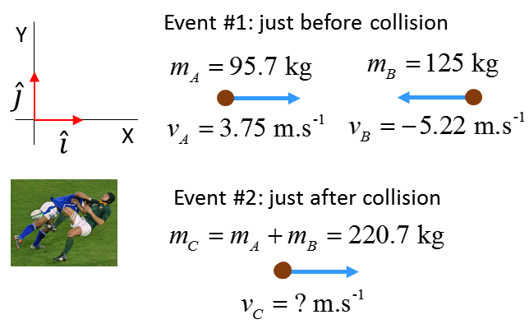

Momentum 

Conservation of momentum



All the collision, both players move in the -X direction.

Kinetic Energy



About 92% of the original kinetic energy is converted to other types of energy, (mainly thermal energy).

**Example**

[2D] Collisions: Analysing a traffic accident

A car (mass 1200 kg) travels at a speed of 21 m.s-1 approaches an intersection. Another car (1500 kg) is heading to the same intersection at 18 m.s-1. The two cars collide at the intersection and stick together. Calculate the velocity of the wreaked cars just after the collision.

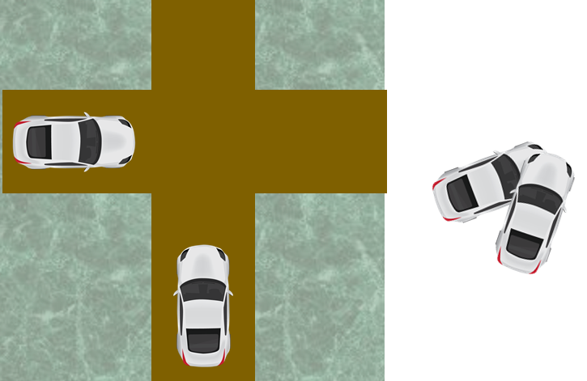

**Solution**

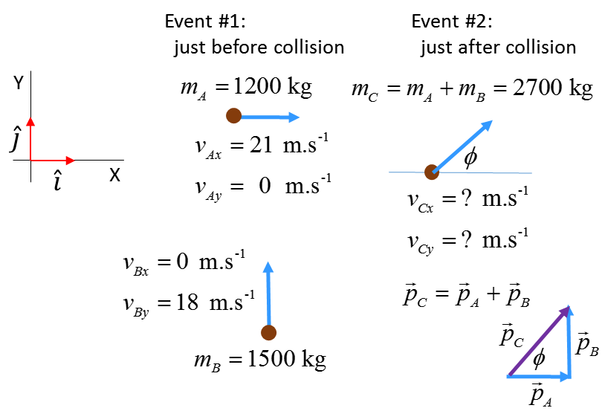

Initial momentum (Event #1)



Final momentum (Event #2)





Momentum is conserved in the collision

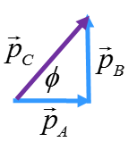 

Putting the numbers into a calculator or EXCEL



N.B. It is easier to answer this question using the unit vectors  then alternative methods.

N.B. In a real-world traffic accident, the police will measure the length of skid marks at the crash site and using basic physics to

determine the initial velocities of the cars. This evidence is used in court to identify the driver at fault.

[VISUAL PHYSICS ONLINE](http://www.physics.usyd.edu.au/teach_res/hsp/sp/spHome.htm)

If you have any feedback, comments, suggestions or corrections please email:

Ian Cooper School of Physics University of Sydney

ian.cooper@sydney.edu.au