**[VISUAL PHYSICS ONLINE](http://www.physics.usyd.edu.au/teach_res/hsp/sp/spHome.htm)**

**DYNAMICS**

**CONSERVATION OF MOMENTUM AND ENEGY**

**ELASTIC COLLISIONS**

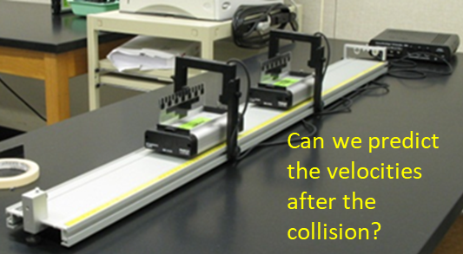

In an elastic collision both momentum and kinetic energy are conserved.

Initial values just before collision (Event #1)

Final values just after collision (Event #2)

Total momentum 

Total kinetic energy 

All collisions are inelastic in the real-world. However, for some collisions where objects bounce off each other with little deformation like billiard balls, we can approximate the collision as elastic.

**Example billiard ball collisions in [1D] and [2D]**

A stationary billiard ball is struck head-on by another billiard ball. Predict the motion of the two billiard balls after the collision.

1. Two billiard balls travelling at the same speed and in opposite directions collide head-on. Predict the motion of the two billiard balls after the collision.
2. A stationary billiard ball is stuck a glancing blow by another billiard ball. Show that the two billiard balls move at right angles to each other after the collision

**Solution**

(1)

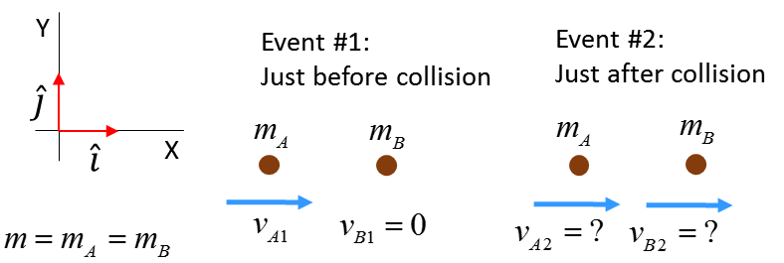

Initial momentum and kinetic energy (Event #1: just before collision)





Final momentum and kinetic energy (Event #2: just after collision)



Assume an elastic collision 

Conservation of momentum and kinetic energy

(1) 

(2) 

Solve the two equations for the two unknowns  and .

Squaring equation (1) and comparing it with equation (2)

(3) 



After the collision, the incident ball comes to rest, while the target ball moves off with the speed of the incident ball before the collision.

(2)

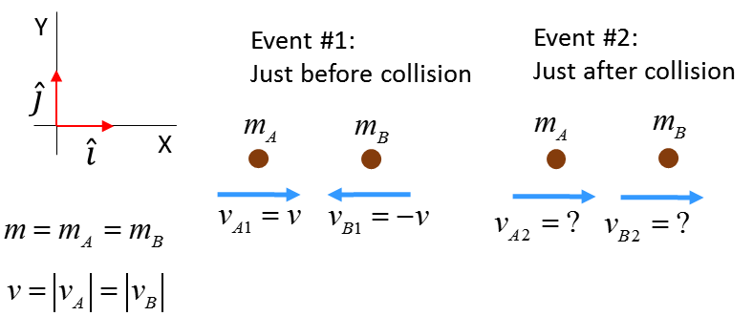

Initial momentum and kinetic energy (Event #1: just before collision)





Final momentum and kinetic energy (Event #2: just after collision)



Assume an elastic collision 

Conservation of momentum and kinetic energy

(1) 

(2) 

Solve the two equations for the two unknowns  and .



After the collision, the balls bounce off each other the at the speeds before the collision but now move in opposite direction.

(3)

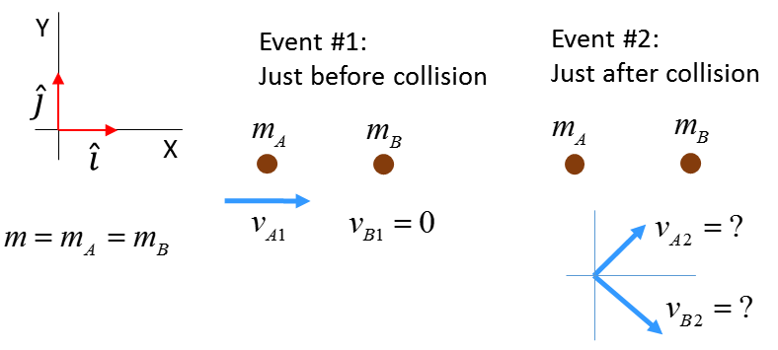

Elastic collision; kinetic energy is conserved



Geometrically the equation  is a statement of Pythagoras’s Theorem

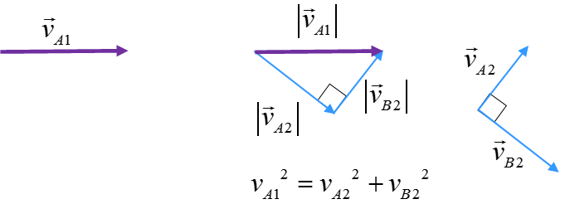

After the collision, the two balls move at **right angles** to each other.

**Thinking Exercise**

A basketball is dropped and bounces off the ground.

Is momentum conserved?

Is energy conserve?

Compare the forces acting on the ball if it bounces or sticks to the ground.

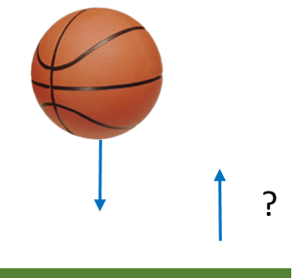

**Answer**

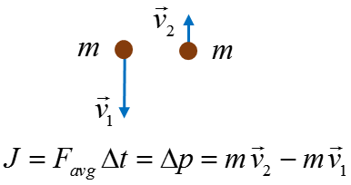**System: Basketball**

Momentum is **not** conserved since a force acts upon the ball to change its momentum during the time it is in contact with the ground

**System: Basketball and Earth**

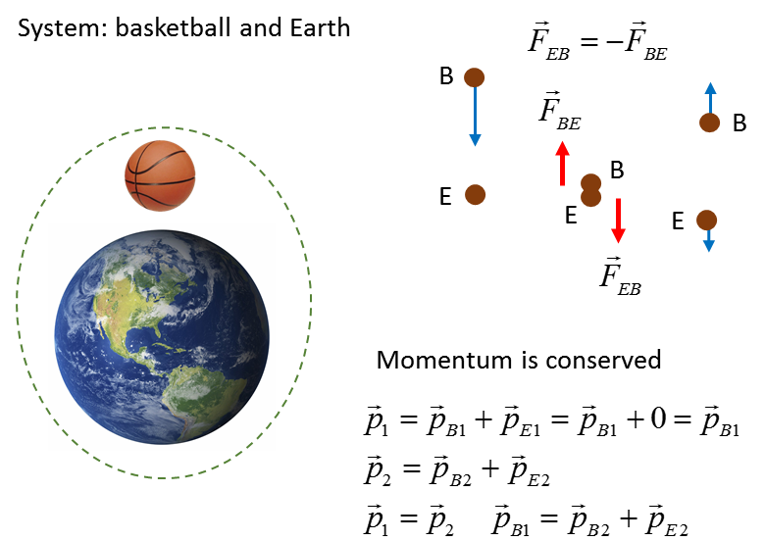

**Momentum is conserved**: after the collision, the Basketball and the Earth move away from each other in opposite directions.

 Earth does not move much

**Energy**

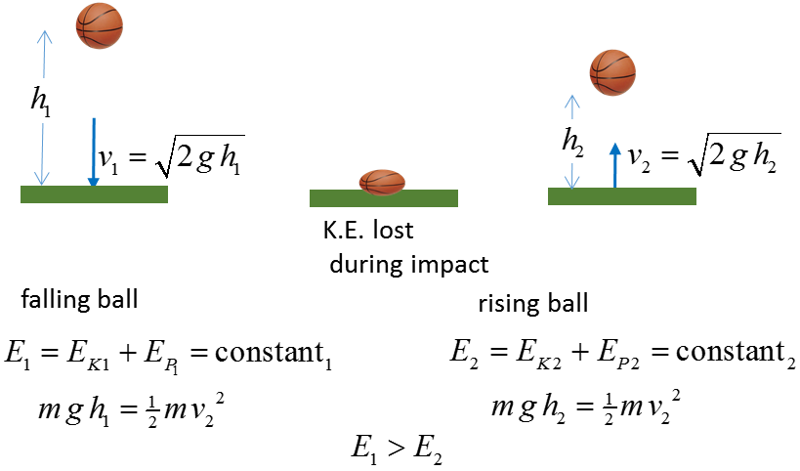

We can assume mechanical energy (K.E. and P.E.) are conserved when the basketball is in flight. Mechanical energy is dissipated in the impact with the ground so the ball does not bounce as high.

**Force**

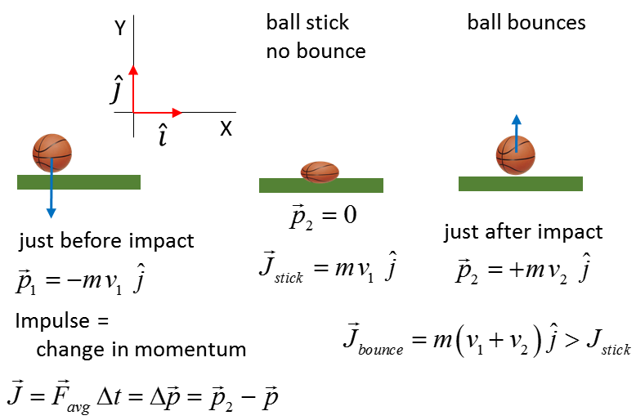

A **greater force** is exerted by the ground on the ball when it **bounces** compared to no bounce.

**Web resources**

<http://www.animations.physics.unsw.edu.au/jw/momentum.html>

<http://www.ccpo.odu.edu/~klinck/Reprints/PDF/knightPhysEd75.pdf>

<https://www.youtube.com/watch?v=yUpiV2I_IRI>

<https://www.khanacademy.org/science/physics/linear-momentum/elastic-and-inelastic-collisions/v/elastic-and-inelastic-collisions>

[VISUAL PHYSICS ONLINE](http://www.physics.usyd.edu.au/teach_res/hsp/sp/spHome.htm)

If you have any feedback, comments, suggestions or corrections please email:

Ian Cooper School of Physics University of Sydney

ian.cooper@sydney.edu.au