**[VISUAL PHYSICS ONLINE](http://www.physics.usyd.edu.au/teach_res/hsp/sp/spHome.htm)**

**DYNAMICS**

**CONSERVATION OF MOMENTUM**

**EXPLOSIONS**

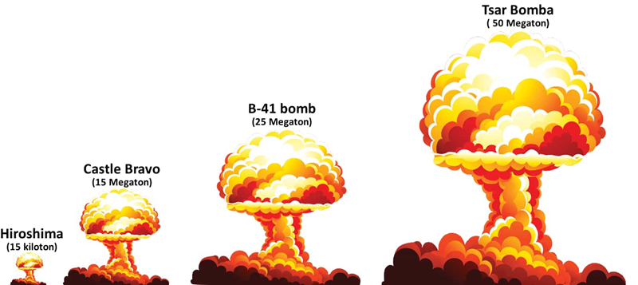

|  |
| --- |
| **Exercise**  [View images of conservation of momentum](https://www.google.com.au/search?q=images+conservation+of+momentum&tbm=isch&tbo=u&source=univ&sa=X&ved=0ahUKEwj47NO6r4vXAhXFJpQKHStAA80QsAQILw&biw=1920&bih=1069)  What story do the images tell? Select 5 good images. State why you think they are good. |

In an explosion, chemical energy (potential energy stored in the bonds of the atoms) is transformed into the kinetic energy of the fragments. It would be impossible task to analyse an explosion using Newton’s Laws. However, using models and the principles of conservation of momentum, many of the details of the explosion can be extracted and numerical values predicted for the fragments after the explosion.

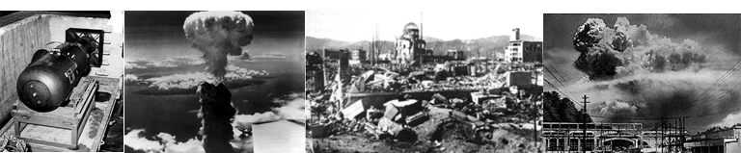

Fig. 1. The atomic bomb explosion over Nagasaki.

Consider the explosion of a bomb into two fragments identified as A and B. The System is the bomb and after the explosion the two fragments A and B. The initial momentum of the System before the explosion is zero. Momentum must be conserved, so the final momentum of the two fragments must be zero. Therefore, the fragments must move in opposite directions with equal magnitudes for their momentum.

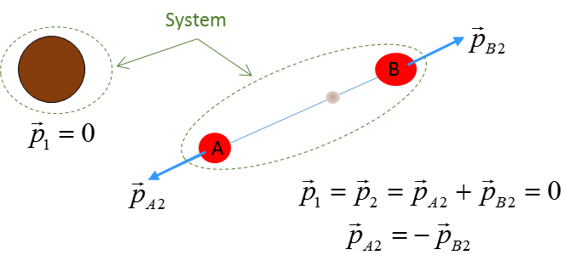

Fig. 2. An explosion of a bomb into two fragments A and B.

**Example**

A 3.65x103 kg cannon fires a cannonball of mass 28.5 kg. The cannon **recoils** with a velocity of 5.25 m.s-1 backwards. Calculate:

1. The velocity of the cannonball
2. The muzzle speed of the cannon ball
3. The kinetic energy of the cannon and cannon ball

**Solution**

* How to approach the problem
* Visualize the physical situation
* Problem type: Momentum Energy Conservation
* Identify the canon and cannonball as the System(s)
* Define a frame of reference.
* [1D] problem – can treat quantities as scalars
* List known & unknown physical quantities (symbols & units)
* State physical principles
* Annotated scientific diagram

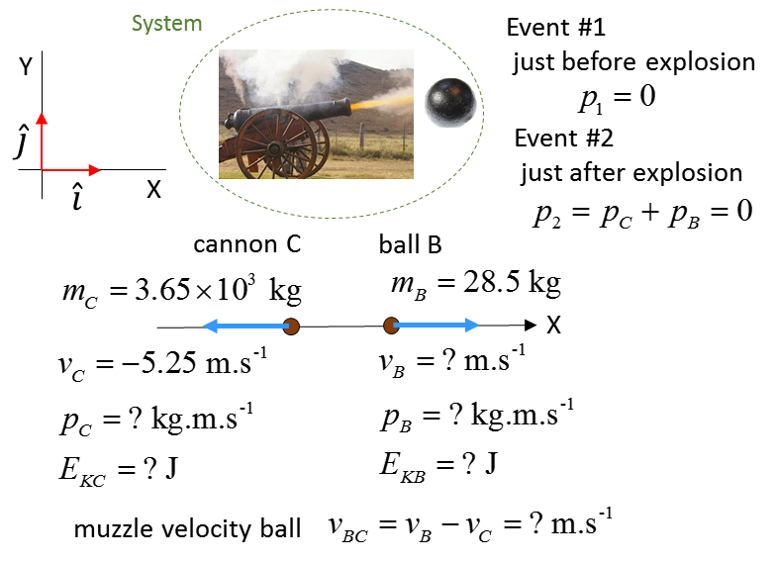

Momentum 

Momentum is conserved

Event #1: just before cannon fires 

Event #2: just after cannon fires 



The velocity of the ball is positive, indicating the ball is fired in the forward direction.

Kinetic Energy 



The kinetic energy of the cannon and ball comes from the stored potential energy in the gun powder chemicals.

The muzzle speed of the cannonball is the speed at which the ball leaves the cannon w.r.t to the cannon.



**Example**

An expensive plate falls on to the ground and shatters into three pieces of equal mass. Two of the pieces fly off at right angles to each other with equal speeds . Find the velocity of the third piece. Assume the floor is smooth and the pieces of the plate slide without any frictional effects.

**Solution**

* How to approach the problem
* Visualize the physical situation
* Problem type: Momentum Conservation
* Identify the three pieces as A B C
* Define a frame of reference.
* [2D] problem – X and Y components
* List known & unknown physical quantities (symbols & units)
* State physical principles
* Annotated scientific diagram

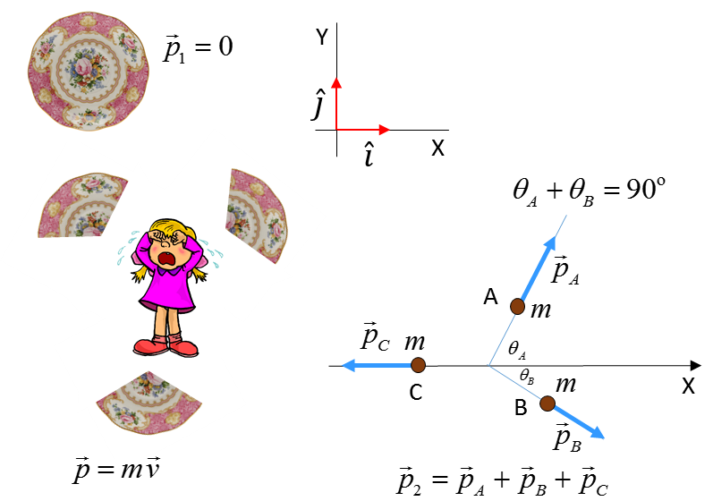

In the collision with the floor the plate shatters into three pieces each of mass . Consider the floor as the XY plane.

Event #1: Just before shattering 

Event #2: Just after shattering into three pieces A, B and C



Momentum is conserved 







all pieces have the same mass  cancels



Velocity components



The third piece moves in the **-**X direction with a speed of .

**Thinking exercise**

Relate each image to the principle of the conservation of linear momentum.

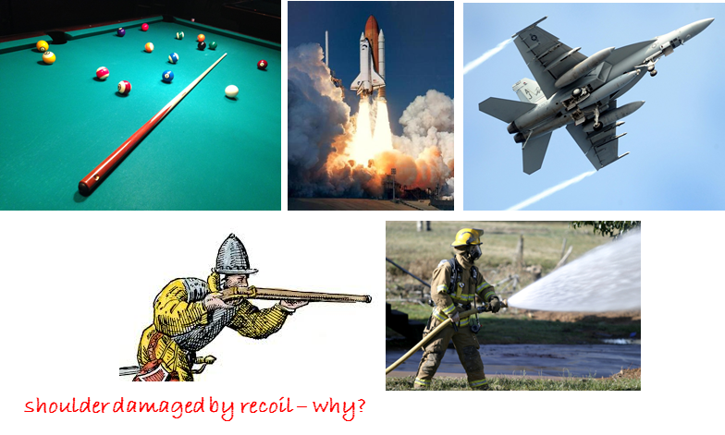

[VISUAL PHYSICS ONLINE](http://www.physics.usyd.edu.au/teach_res/hsp/sp/spHome.htm)

If you have any feedback, comments, suggestions or corrections please email:

Ian Cooper School of Physics University of Sydney

ian.cooper@sydney.edu.au