[**VISUAL PHYSICS ONLINE**](http://www.physics.usyd.edu.au/teach_res/hsp/sp/spHome.htm)

**DYNAMICS**

**ENERGY** 

**WORK** 

**POWER** 

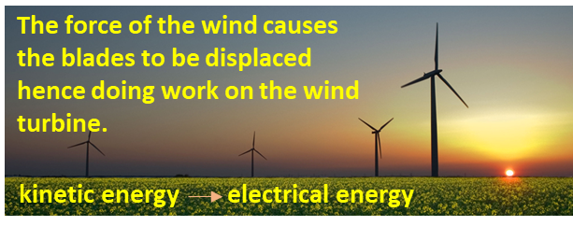

**ENERGY [ joule J ]**

**Energy** is one of the most important concept in Physics. We often refer to kinetic energy, potential energy, gravitational potential energy, stored energy, work, thermal energy, internal energy, heat, heat energy, mechanical energy. sound energy, etc. We know what energy is and we can calculate energy, but, it is **not** possible to give a precise definition of the term energy.

***Warning*** – many of the words used in Physics for example, energy and heat have different meaning to the everyday use of such words.

**WORK *W* and KINETIC ENERGY *EK***

When a force acts on an object through a given displacement, energy can be transferred to the object. This transfer of energy is defined as work. The **work done** *W b*y a **single** force acting on an object is

1.  scalar [ joule J ]

* You will not have to use this formal definition of work, rather you will remember and use a simplified version.
* Work is a **scalar** quantity. When work is done on an object  and when work is done by the object .
* The angle  is the angle between the two vectors for force and displacement.

If the force and displacement vectors are **parallel** to each other



If the force and displacement vectors are **perpendicular** to each other



* If both the **angle** and **force** are constants



If the direction of the force and displacement are parallel



* Work is the area under the force vs displacement graph.
* If a number of forces act on the object during the displacement them the **net work** is simply the sum of the work done by each force



**Summary**

Most general definition of work

(1) 

If the force and angle are constants

(2) 

The force is constant and its direction is parallel to the displacement

(3) 

The net work is the sum of the work done by each force

(4) 

Again, consider the action of hitting a tennis ball (mass ) as shown in figure (1). The racket exerts a constant force on the ball over the distance interval . We assume that the motion is one-dimensional along the X axis. Therefore, we don’t need to consider the vector nature of the force and displacement. We can determine the work done on the tennis ball by the force applied to the racket during the impact. The constant force  produces a constant acceleration  of the ball which changes its velocity from  to  within the displacement .

Newton’s 2nd law 

constant  

work 

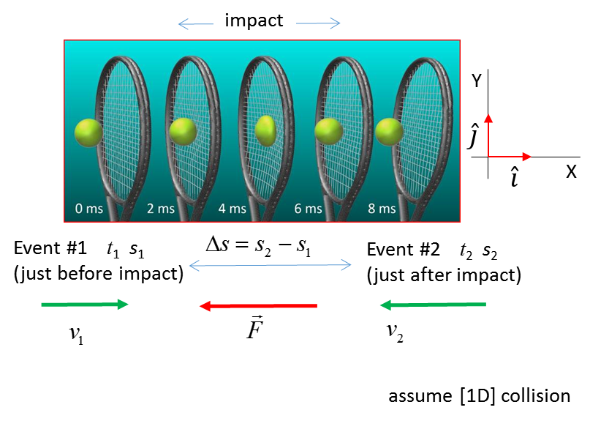

Fig. 1. Work is done on the tennis ball by the racket.

The quantity  is called the **kinetic energy**. It is the energy of a moving object.

(5)  scalar  [ J ]

The symbol is the best to use for the kinetic energy. Other symbols commonly used include 

**Work – Energy Theorem**

Net Work Done = Change in Kinetic Energy

(6) 

The work done by a variable force for [1D] motion is equal to the area under the force vs displacement curve. The area under the  rectangle is equal the area under the actual force curve (figure 2).

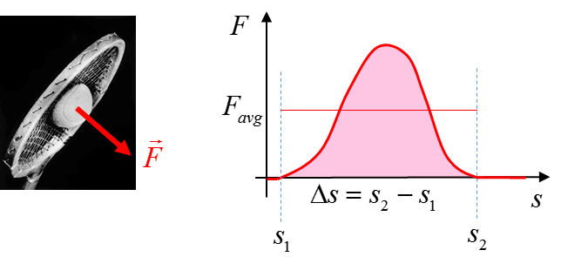

Fig. 2. Work done by a variable force.



**POWER**  [watt W]

Power is a measure of how quickly energy is transformed. The power associated with the work done is defined as

(7)  scalar [ watt 1 W = 1 J.s-1 ]

In terms of average quantities, equation (7) can be expressed as

(8) 

where the work is done in the time interval .

For the case in which the force is constant



(9) 

The power is proportional to both the force and the velocity.

**Once again, the Syllabus documentation contains nonsense statements (see page 36)**

**work is expressed as** 

**power is expressed as **

**You cannot multiple two vectors. The scalar (dot) product must be used.**

|  |
| --- |
| **Example**  To pass a truck safely, a car () needs to accelerate from 60 km.h-1 to 80 km.h-1 in less than 3.00 s.  Assuming a constant acceleration, calculate the following for the car in the 3.00 s time interval for the car to overtake safely:  Acceleration of the car  Displacement of the car  Applied force acting on car  Change in kinetic energy of the car  Work done on the car  Average power supplied by the engine  Maximum power supplied by engine  Change in momentum of the car  Impulse given to the car by the engine  Repeat the calculations for the average power when the car accelerates from 80 km.h-1 to 100 km.h-1 in 3.00 s.    **Solution**  How to approach the problem  Visualize the physical situation  Problem type: Energy – Work - Power  Identify the car as the System C  Define a frame of reference.  [1D] problem – can treat quantities as scalars  List known & unknown physical quantities (symbols &  units)  State physical principles  Annotated scientific diagram  Visualize the physical situation        Constant Acceleration    Displacement    Force Newton’s 2nd Law    Change in K.E.    Work done    Work done = Change in K.E.  Average power        Maximum power    Change in Momentum      Impulse      Impulse = change in momentum  Acceleration from 80 km.h-1 to 100 km.h-1    Acceleration from 80 km.h-1 to 100 km.h-1      Acceleration from 60 km.h-1 to 80 km.h-1    As the car gets faster, greater power needs to be supplied by the engine to keep the acceleration constant. |

**CAR ACCIDENTS**

Many young people are killed on our roads each year in car accidents that could have been avoided by driving more slowly. To understand the physics of car accidents and how car manufactures incorporate safety features in their designs it is important to appreciate the concepts of **impulse** and **work**. A common fatal accident is when a car hits a tree or pole. A car of mass  has a velocity  before the collision and is brought to rest () in a stopping time  and stopping distance  by the force of the pole acting on the car. This stopping force  depends on the initial momentum or initial kinetic energy of the car.

impulse to stop the car 

work done to stop the car 

* The greater the momentum of the car, the greater the impulse required to stop the car.
* The greater the kinetic energy of the car, the greater the amount of work required to stop the car.

You are more likely to avoid a fatal accident by driving slower.

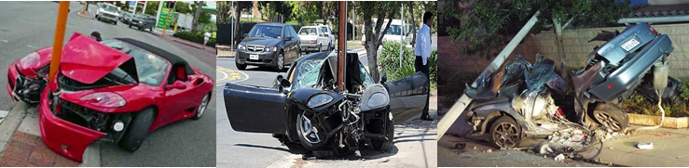

The **stopping force** is **inversely proportional** to the **stopping time** and **stopping distance**.

If the stopping time and stopping distance are very small as in the case when you smash into a pole the stopping force will be enormous. Figure (3) shows the force vs time and force vs distance for a car of mass 1500 kg initially travelling at 50 km.h-1 and 100 km.h-1 and being brought to rest by an impact with a pole. The ratio of the velocities is *u*2/*u*1 = 2 but the ratio of stopping distances is *F*2/*F*1 = 22 = 4. This is why the front end of modern cars are designed to have a large **crumple zone** to reduce the impact force in a collision. For a stopping distance of 0.20 m, the stopping force for the car travelling at 100 km.h-1 is enormous ~3×106 N (~200 x weight of car). If the stopping distance was 1.0 m, the force is reduced by a factor of 5.



Fig. 3a. Stopping force vs stopping time for a car being brought to rest by an impact with a pole.



Fig. 3b. Stopping force vs stopping distance for a car being brought to rest by an impact with a pole.

People by law are required to wear seats belts and for cars to achieve a 5 Star safety rating they must have a number of air bags. Seat belts and air bags are designed to increase the stopping time and stopping distance to reduce the force at impact during a collision since

impulse to stop the car *J* = *F* Δ*t* = *F* Δ*t* = constant

work to stop the car *W* = *F* Δs = *F* Δs = constant

As an example, consider the head a person (*m* = 5 kg) hitting their head on the steering wheel with the area of contact being 10 mm × 10 mm (10-4m2). The initial velocity at impact is 36 km.h-1 (10 m.s-1) and the stopping distance is 10 mm (0.01 m). The compression strength of bone is 1.7×108N.m-2.

stopping force 

force to smash bone 

Therefore, in this accident, bones in the skull would certainly be smashed and serious head injuries would occur and most likely death would result. This is the reason cars now are built with collapsible steering columns.

**WEB search** – use the internet to search for videos of motor bike riders coming off their bikes at high speed.



In watching motor bike racers, it is amazing that a rider comes off their bike at 300 km.h-1 and they walk away after the accident? Why?

**In an accident, the important thing is not how fast you are travelling but how quickly you stop**

**PHYSICS AND SPORT**

Most sports involve objects colliding during the play - golf, tennis, football, hockey, etc. When objects interact during a short period of time, they may experience very large forces. Evidence of these forces is the distortion in shape of an object at the moment of impact, for example, the distortion of the golf and tennis balls. In the 1970’s, the best golfers in the world hit the ball about 250 m.

Today, golfers can hit the ball more than 320 m. *Why?* Manufactures of tennis rackets and golf clubs have applied physical principles and properties of new materials to greatly enhance the momentum imparted to a ball upon impact by the racket or club. From extensive video analysis of sprinters manufactures of shoes now custom make the soles and spikes of top-class runners.

RUNNING.WPG**WEB search** – use the internet to search design parameters of running shoes and 3D manufacturing.

Why can you damage your feet running barefoot on concrete but not grass?

What are the features of good running shoes?

[VISUAL PHYSICS ONLINE](http://www.physics.usyd.edu.au/teach_res/hsp/sp/spHome.htm)

If you have any feedback, comments, suggestions or corrections please email:

Ian Cooper School of Physics University of Sydney

ian.cooper@sydney.edu.au