[**VISUAL PHYSICS ONLINE**](http://www.physics.usyd.edu.au/teach_res/hsp/sp/spHome.htm)

**DYNAMICS**

**CONSERVATION OF ENERGY AND MOMENTUM**

**COLLISIONS / EXPLOSIONS**

**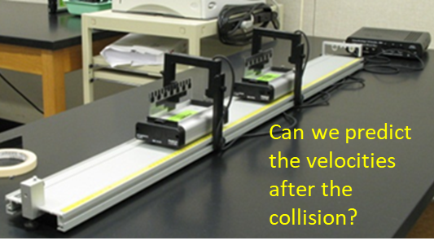**

|  |
| --- |
| **Exercise**  [View images of conservation of momentum](https://www.google.com.au/search?q=images+conservation+of+momentum&tbm=isch&tbo=u&source=univ&sa=X&ved=0ahUKEwj47NO6r4vXAhXFJpQKHStAA80QsAQILw&biw=1920&bih=1069)  What story do the images tell? Select 5 good images. State why you think they are good. |

**OSCILLATION SPRING AND MASS SYSTEM**

Consider the mechanical System of a block (mass ) attached to spring (spring constant ) that can be set oscillating on a horizontal surface. We ignore any frictional or drag effects acting on the vibrations of the System.



How to approach the problem of studying the motion of the block attached to the spring by applying the concepts of work and energy:

* Visualize the physical situation
* Identify the System or Systems
* Define the frame of reference
* Identify the forces acting on the System
* [1D] problem – don’t need to use vector notation
* Calculate the work done on or by the System

Figure (1) shows an annotated diagram of the physical situation. The force exerted by the stretched or compressed spring on the block is. The **equilibrium position** is taken as the Origin O(0, 0) and the displacement in the X direction is  .

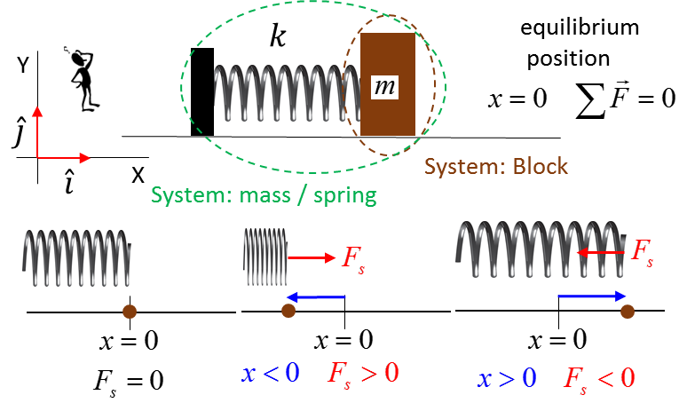

Fig. 1. Mass / Spring system.

For the block System the forces acting on it are: the gravitational force ; the normal force  and the spring force .The free body diagram for the forces acting on the block System and the variation of the spring force with displacement is shown in figure (2). All the forces acting on the block are called conservative force since no energy is lost the System to the surrounding environment. The area under the force vs displacement curve is equal to the work done .

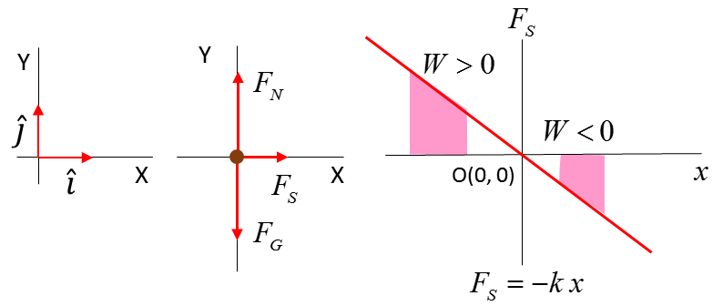

Fig. 2. Forces acting on block System.

For a spring, the force  and extension  of the spring is described by **Hooke’s Law**

(1) 

Consider two events for the oscillating motion of the block.

Event #1: time  velocity  displacement 

Event #2: time  velocity  displacement 

Zero work is done by the gravitational force and the normal force since the displacement is perpendicular to the force. Work is done only by the force exerted by the spring.

The work done by the spring on the mass in the time interval between events is

(2) 

The potential energy  of the spring / mass System where  when  s defined as

(3)  potential energy

The concept of **potential energy** is a **relative** concept and is measured from a **reference point** where . Potential energy is related to the idea of “stored energy”. A stretched or compressed spring certainty can do work and transfer energy. The potential energy refers to the System of spring and mass. The spring or mass do **not** possess potential energy.

Combining equation (2) and equation (3)

(4) 

**The work done is the negative of the change in potential energy when conservative forces (zero mechanical energy dissipated) acts on the System**

The work done changes the kinetic energy

(5) 

Comparing equation (4) and equation (5)

(6) 

(7) 

It is useful to define the term called total energy E

(8) ** total energy**

In the motion of the oscillating mass, the kinetic and potential energies are always changing with time but the total change in the kinetic and potential energies is zero. Therefore, the total energy is constant – we say that the total energy is a conserved quantity.

(9)  **conservation of energy**

Equation (9) reveals one of the most important foundation principles of Physics – **conservation of energy**. The potential energy and kinetic energy change with time, but there is zero change in the total energy of the spring / mass System .

[VIEW animation of oscillating spring / mass System](http://www.physics.usyd.edu.au/teach_res/mp/doc/mec_spring_energy.htm" \t "_blank)

**GRAVTATIONAL FORCE / KINETIC ENERGY / POTENTIAL ENERGY**

Consider the upward motion of a ball (mass ) thrown vertically into the air. We ignore the action of throwing and any frictional or drag effects acting the motion of the ball (conservative forces only act on the ball).

How to approach the problem of studying the motion of the ball by applying the concepts of work and energy:

* Visualize the physical situation
* Identify the System or Systems
* Define the frame of reference
* Identify the forces acting on the System
* [1D] problem – don’t need to use vector notation
* Calculate the work done on or by the System

Figure (1) shows an annotated diagram of the physical situation. The only force acting on the ball is the gravitational force. . The ground at  is taken as the Origin for the vertical displacement .

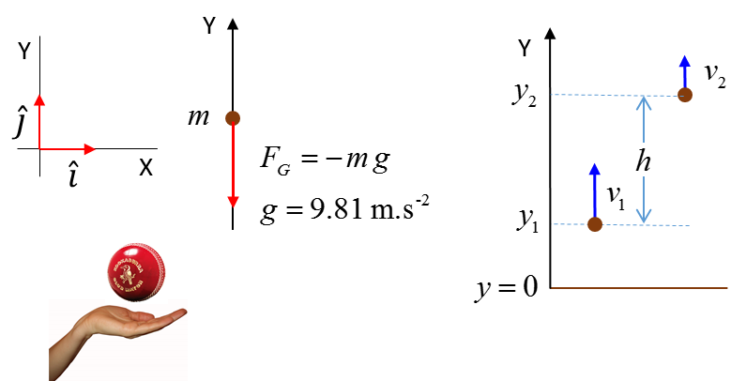

Fig. 1. The System is the ball.

Consider two events for the vertical upward motion of the ball:

Event #1: time  velocity  displacement 

Event #2: time  velocity  displacement 

The work done by the gravitational force on the System is

(10A) 

The **gravitational potential energy**  of Earth / Ball System where  when  s defined as

(11)  potential energy

(12) 

**The work done is the negative of the change in potential energy since the gravitational force is a conservative force.**

The concept of **potential energy** is a **relative** concept and is measured from a **reference point** where . Potential energy is related to the idea of “**stored energy**”. The potential energy refers to the System of Earth / Ball - the ball does **not** possess potential energy. The value of the potential energy is not so important, it is the change in potential energy  that is important and its value is independent of the reference point where .

A falling brick can hurt your toes because of its stored energy as the gravitational potential energy is converted to kinetic energy.

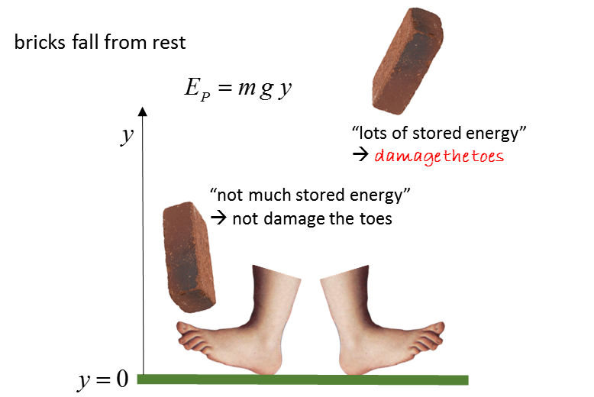

Combining equation (10) and equation (11)

The work done changes the kinetic energy

(13) 

Comparing equation (12) and equation (13)

(14) 

(15) 

The total energy is

(16) ** total energy**

As the ball rises it loses kinetic energy and gains potential energy, but, the loss in kinetic energy is equal to the gain in potential energy. When the ball falls, it gains kinetic energy and losses potential energy, but, the gain in kinetic energy is equal to the loss in potential energy. For the motion of the ball going up then down, the kinetic and potential energies are always changing with time but the total change in the kinetic and potential energies is zero. Therefore, the total energy is constant – we say that the total energy is a conserved quantity.

 **conservation of energy**

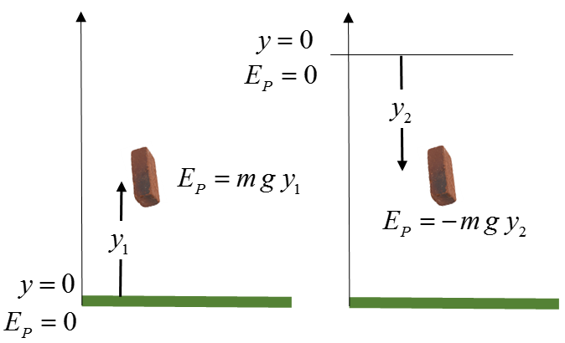

Fig. 2. Potential energy is a relative concept. It value depends upon the reference point where . The value of the potential energy is not important - it is the change in potential energy  that is most useful.

N.B. The symbol for potential energy in the Syllabus is . Both symbols  and  can be used.

**Example**

An 945 kg roller-coaster cart is released from rest at Point A. Assume there is no friction or air resistance between the points A and C.

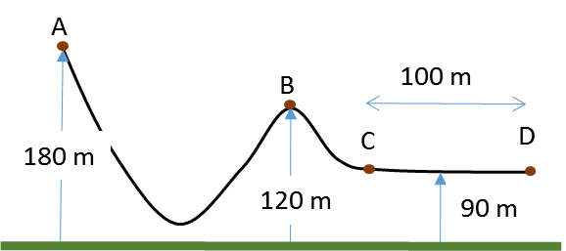

How fast is the roller-coaster cart moving at Point B?

What average force is required to bring the roller-coaster cart to a stop at point D if the brakes are applied at point C?

**Solution**

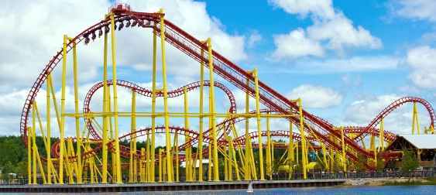How to approach the problem

Visualize the physical situation

Problem type: KE PE Energy conservation

Define a frame of reference.

List known & unknown physical quantities (symbols & units)

State physical principles

Annotated scientific diagram

For the motion of the cart on the roller-coaster track we can ignore any dissipative forces. Therefore, total energy of the System (cart + Earth) is a constant for the motion.

Total Energy = Kinetic energy + Potential energy = constant

 at all times

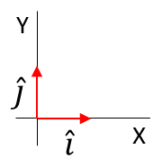Take the Origin to be at the ground level and all heights are measured w.r.t. the ground









Event #A (cart at A)



Event #B (cart at B)





Event #C (cart at C)





An applied force on the cart reduces its kinetic energy to zero by doing work on the cart.

Work = Change in kinetic energy



**EXPLOSIONS**

In an explosion, chemical energy (potential energy stored in the bonds of the atoms) is transformed into the kinetic energy of the fragments. It would be impossible task to analyse an explosion using Newton’s Laws. However, using models and the principles of conservation of momentum, many of the details of the explosion can be extracted and numerical values predicted for the fragments after the explosion.

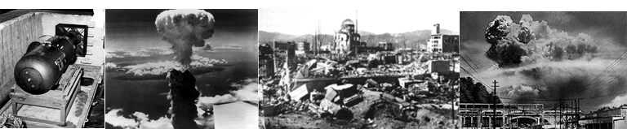

Fig. 3. The atomic bomb explosion over Nagasaki.

Consider the explosion of a bomb into two fragments identified as A and B. The System is the bomb and after the explosion the two fragments A and B. The initial momentum of the System before the explosion is zero. Momentum must be conserved, so the final momentum of the two fragments must be zero. Therefore, the fragments must move in opposite directions with equal magnitudes for their momentum.

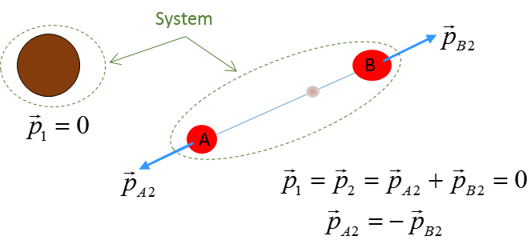

Fig. 4. An explosion of a bomb into two fragments A and B.

**Example**

A 3.65x103 kg cannon fires a cannonball of mass 28.5 kg. The cannon **recoils** with a velocity of 5.25 m.s-1 backwards. Calculate:

1. The velocity of the cannonball
2. The muzzle speed of the cannon ball
3. The kinetic energy of the cannon and cannon ball

**Solution**

* How to approach the problem
* Visualize the physical situation
* Problem type: Momentum Energy Conservation
* Identify the canon and cannonball as the System(s)
* Define a frame of reference.
* [1D] problem – can treat quantities as scalars
* List known & unknown physical quantities (symbols & units)
* State physical principles
* Annotated scientific diagram

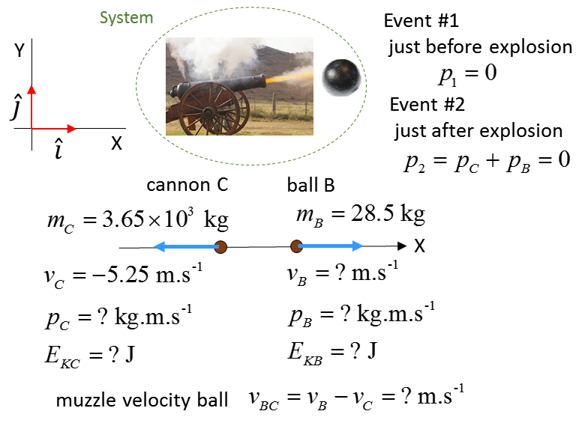

Momentum 

Momentum is conserved

Event #1: just before cannon fires 

Event #2: just after cannon fires 



The velocity of the ball is positive, indicating the ball is fired in the forward direction.

Kinetic Energy 



The kinetic energy of the cannon and ball comes from the stored potential energy in the gun powder chemicals.

The muzzle speed of the cannonball is the speed at which the ball leaves the cannon w.r.t to the cannon.



**Example**

An expensive plate falls on to the ground and shatters into three pieces of equal mass. Two of the pieces fly off at right angles to each other with equal speeds . Find the velocity of the third piece. Assume the floor is smooth and the pieces of the plate slide without any frictional effects.

**Solution**

* How to approach the problem
* Visualize the physical situation
* Problem type: Momentum Conservation
* Identify the three pieces as A B C
* Define a frame of reference.
* [2D] problem – X and Y components
* List known & unknown physical quantities (symbols & units)
* State physical principles
* Annotated scientific diagram

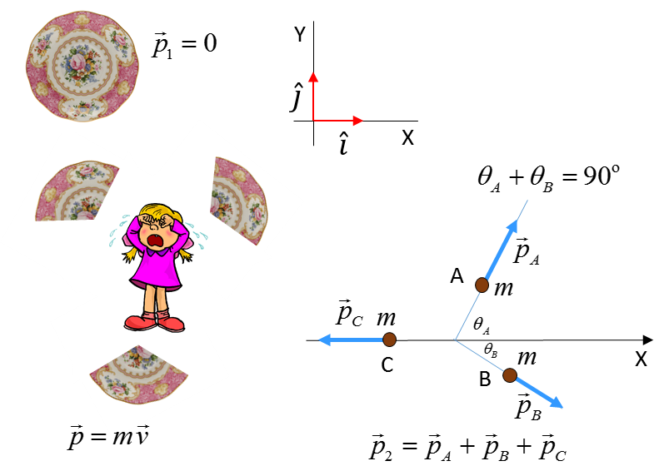

In the collision with the floor the plate shatters into three pieces each of mass . Consider the floor as the XY plane.

Event #1: Just before shattering 

Event #2: Just after shattering into three pieces A, B and C



Momentum is conserved 







all pieces have the same mass  cancels



Velocity components



The third piece moves in the **-**X direction with a speed of .

**Thinking exercise**

Relate each image to the principle of the conservation of linear momentum.

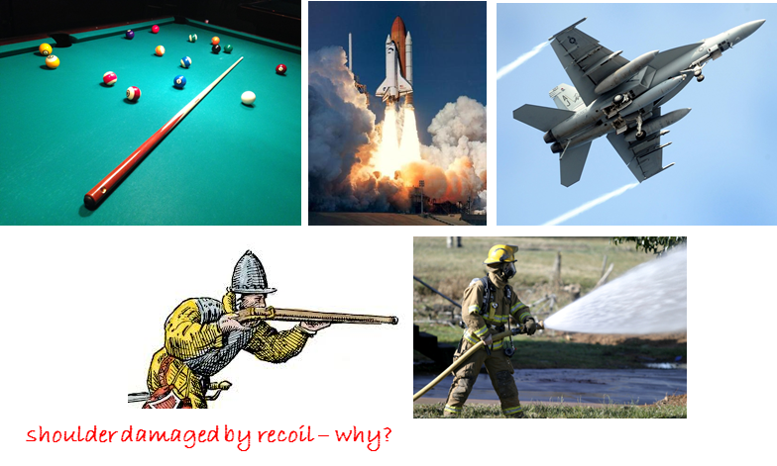

**INELASTIC COLLISIONS**

Collisions are occurring around us all the time. Collisions are an intrinsic occurrence of our physical world. Collisions are very complex processes, but through mathematical models of real-world situations that use the principles of conservation of energy and momentum, we can gain in insight into the behaviour of the particles involved in the collision and make numerical predictions.

**Thinking Exercise**

Study the images and identify the collisions taking place. Visualize at least another 10 examples of collisions.

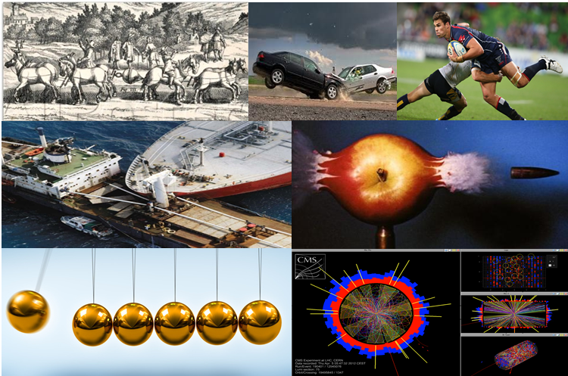

In any collision, energy is conserved, but we often can’t keep track of how the energy is distributed amongst the participants in the collision. One of the most guiding principles in Physics is the **Law of Conservation of Energy**.

We will construct simple models for collisions processes. Collisions are categorized to what happens to the kinetic energy of the System.

There are two possibilities:

(1) **ELASTIC COLLISION**: The final kinetic energy is equal to the initial kinetic 



(2) **INELASTIC COLLISION**: The final kinetic energy is less than the initial kinetic energy 



The lost kinetic energy may be transferred into sound, thermal energy, deformation, etc.

**Kinetic energy is not conserved, but, the momentum of the system is conserved**



A **completely inelastic collision** occurs when the objects **stick together** after the collision and a **maximum** amount of kinetic energy is lost.

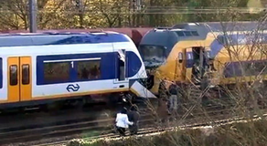 When two trains collision all the original kinetic energy is dissipated in a completely inelastic collision, but, momentum is conserved.

**Example**

A 95.7 kg footballer running at 3.75 m.s-1 collides head-on with a 125 kg player running at 5.22 m.s-1. After the tackle, the two footballers stick together. What is the velocity after the collision and determine the kinetic energy lost?

**Solution**

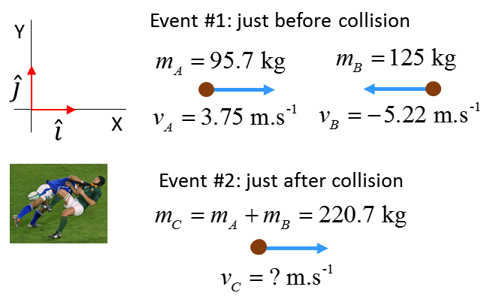

Momentum 

Conservation of momentum



All the collision, both players move in the -X direction.

Kinetic Energy



About 92% of the original kinetic energy is converted to other types of energy, (mainly thermal energy).

**Example**

[2D] Collisions: Analysing a traffic accident

A car (mass 1200 kg) travels at a speed of 21 m.s-1 approaches an intersection. Another car (1500 kg) is heading to the same intersection at 18 m.s-1. The two cars collide at the intersection and stick together. Calculate the velocity of the wreaked cars just after the collision.

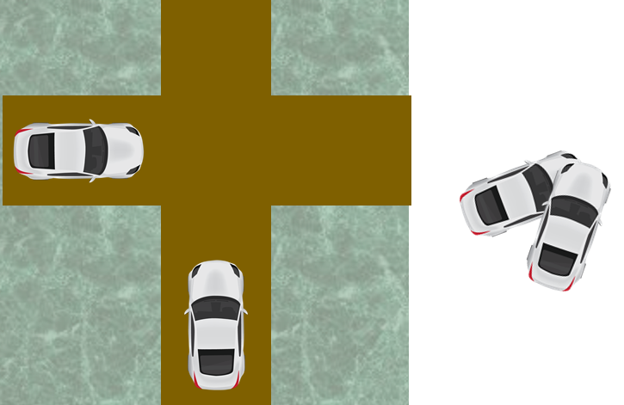

**Solution**

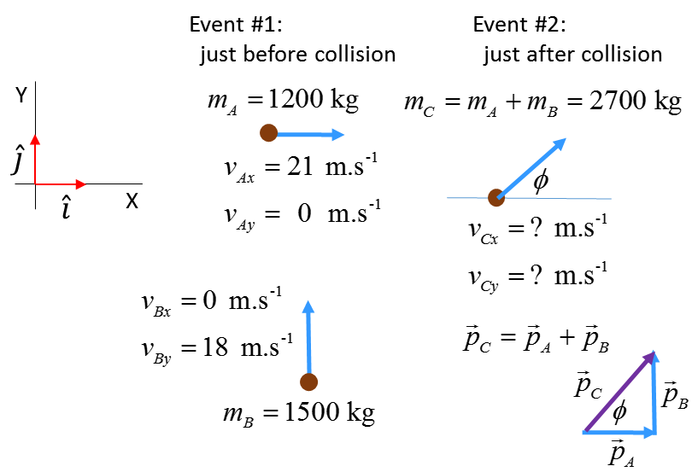

Initial momentum (Event #1)



Final momentum (Event #2)





Momentum is conserved in the collision

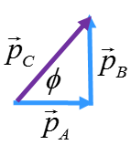 

Putting the numbers into a calculator or EXCEL



N.B. It is easier to answer this question using the unit vectors  then alternative methods.

N.B. In a real-world traffic accident, the police will measure the length of skid marks at the crash site and using basic physics to

determine the initial velocities of the cars. This evidence is used in court to identify the driver ay fault.

**ELASTIC COLLISIONS**

In an elastic collision both momentum and kinetic energy are conserved.

Initial values just before collision (Event #1)

Final values just after collision (Event #2)

Total momentum 

Total kinetic energy 

All collisions are inelastic in the real-world. However, for some collisions where objects bounce off each other with little deformation like billiard balls, we can approximate the collision as elastic.

**Example billiard ball collisions in [1D] and [2D]**

A stationary billiard ball is struck head-on by another billiard ball. Predict the motion of the two billiard balls after the collision.

1. Two billiard balls travelling at the same speed and in opposite directions collide head-on. Predict the motion of the two billiard balls after the collision.
2. A stationary billiard ball is stuck a glancing blow by another billiard ball. Show that the two billiard balls move at right angles to each other after the collision

**Solution**

(1)

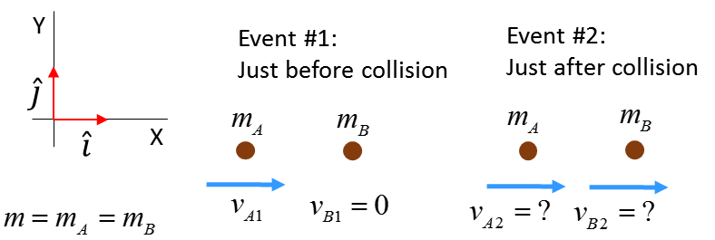

Initial momentum and kinetic energy (Event #1: just before collision)





Final momentum and kinetic energy (Event #2: just after collision)



Assume an elastic collision 

Conservation of momentum and kinetic energy

(1) 

(2) 

Solve the two equations for the two unknowns  and .

Squaring equation (1) and comparing it with equation (2)

(3) 



After the collision, the incident ball comes to rest, while the target ball moves off with the speed of the incident ball before the collision.

(2)

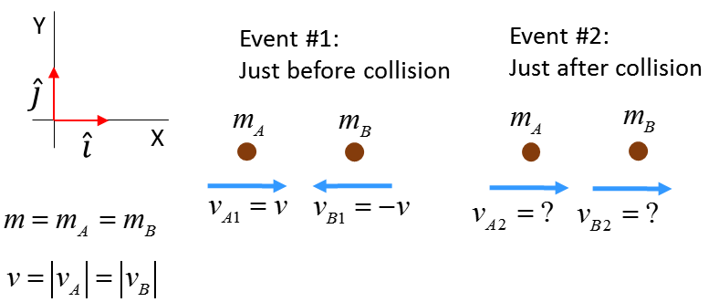

Initial momentum and kinetic energy (Event #1: just before collision)





Final momentum and kinetic energy (Event #2: just after collision)



Assume an elastic collision 

Conservation of momentum and kinetic energy

(1) 

(2) 

Solve the two equations for the two unknowns  and .



After the collision, the balls bounce off each other the at the speeds before the collision but now move in opposite direction.

(3)

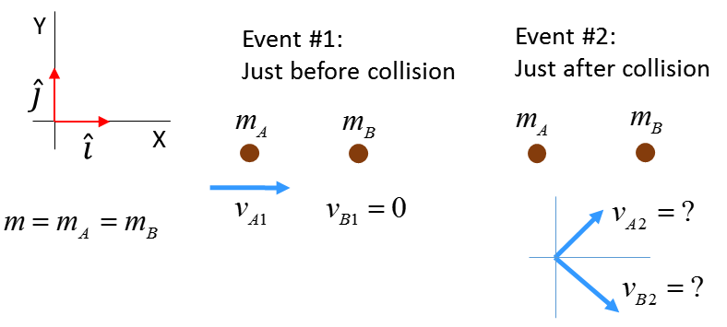

Elastic collision; kinetic energy is conserved



Geometrically the equation  is a statement of Pythagoras’s Theorem

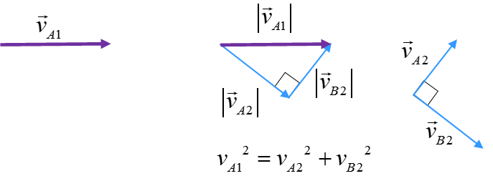

After the collision, the two balls move at **right angles** to each other.

**Thinking Exercise**

A basketball is dropped and bounces off the ground.

Is momentum conserved?

Is energy conserve?

Compare the forces acting on the ball if it bounces or sticks to the ground.

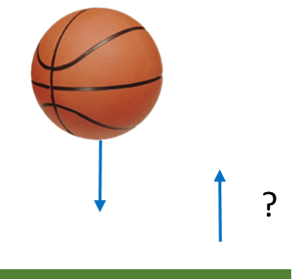

**Answer**

**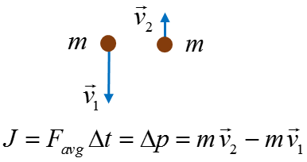System: Basketball**

Momentum is **not** conserved since a force acts upon the ball to change its momentum during the time it is in contact with the ground

**System: Basketball and Earth**

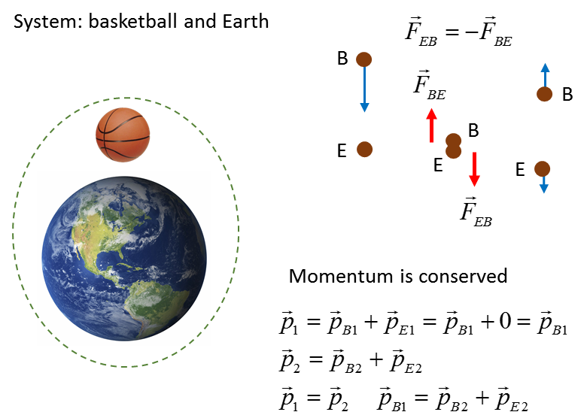

**Momentum is conserved**: after the collision, the Basketball and the Earth move away from each other in opposite directions.

 Earth does not move much

**Energy**

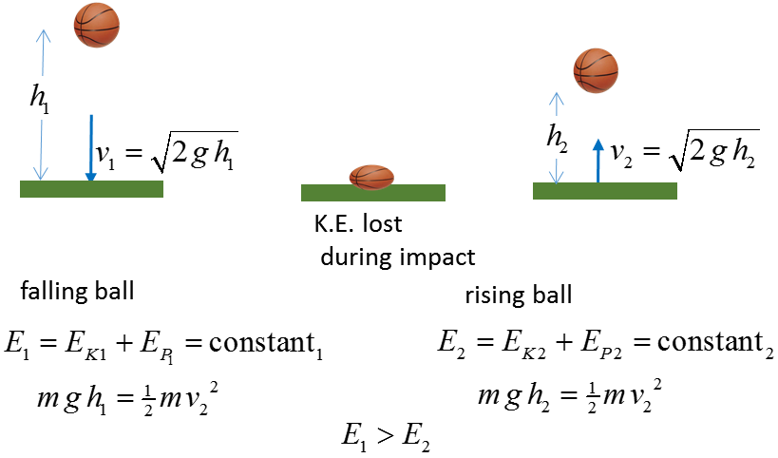

We can assume mechanical energy (K.E. and P.E.) are conserved when the basketball is in flight. Mechanical energy is dissipated in the impact with the ground so the ball does not bounce as high.

**Force**

**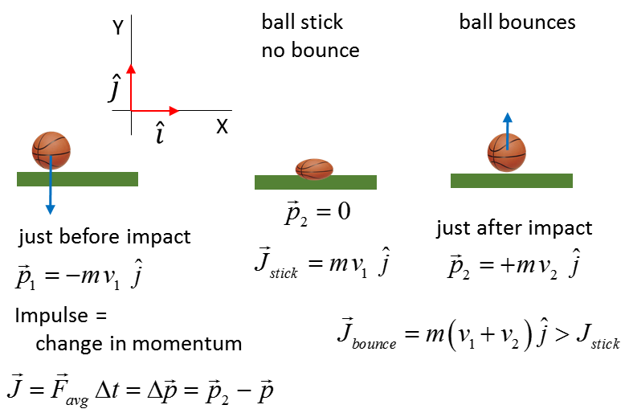**

A **greater force** is exerted by the ground on the ball when it **bounces** compared to no bounce.

**Web resources**

<http://www.animations.physics.unsw.edu.au/jw/momentum.html>

<http://www.ccpo.odu.edu/~klinck/Reprints/PDF/knightPhysEd75.pdf>

<https://www.youtube.com/watch?v=yUpiV2I_IRI>

<https://www.khanacademy.org/science/physics/linear-momentum/elastic-and-inelastic-collisions/v/elastic-and-inelastic-collisions>

[VISUAL PHYSICS ONLINE](http://www.physics.usyd.edu.au/teach_res/hsp/sp/spHome.htm)

If you have any feedback, comments, suggestions or corrections please email:

Ian Cooper School of Physics University of Sydney

ian.cooper@sydney.edu.au