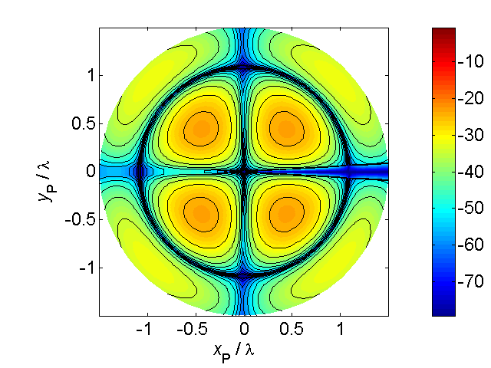

[**HSC PHYSICS ONLINE**](http://www.physics.usyd.edu.au/teach_res/hsp/sp/spHome.htm)

**DYNAMICS**

**TYPES OF FORCES**

**Electrostatic force** (force mediated by a field - long range: action at a distance) – the attractive or repulsion between two stationary charged objects.



**Gravitational force** (force mediated by a field - long range: action at a distance) – attraction between two objects because of their mass.

**Weight** (force mediated by a field - long range: action at a distance) – the gravitational force acting on an object due to its attraction to the Earth. Near the Earth’s surface the weight of an object is

(4)  weight of an object near Earth’s surface

where *m* is the mass of the object and *g* is the local acceleration due to gravity at the Earth’s surface.

Beware: there are other definitions of weight.

**Contact forces** occur when two objects are in direct contact with each other. Three examples of contact forces are: normal force, friction and tension.



**Normal force** – the force acting on an object in contact with a surface which acts in a direction at **right angles** to the surface (perpendicular).

**Friction force** – the force acting on the object which acts in a direction parallel to the surface. A simple model for friction *Ff* is that it is proportional to the normal force *FN* and the constant of proportionality is called the **coefficient of friction** *μ*. The maximum frictional force is

(5)  only valid for a simplified model of friction.



There are two coefficients of friction known as the **static coefficient** of friction (no movement between surfaces in contact) and the **kinetic coefficient** of friction (relative movement between the surfaces) where  . Usually the difference between the values for  and  is only small.

In many texts, it is stated that friction opposes the motion of all objects and eventually slows them down. But this type of statement is very misleading. How can we walk across the room, how can cars move? It is because of friction. In walking, you push against the floor and the frictional force of the floor on you is responsible for the forward movement. The drive wheels of a car turn because of the engine. The driven wheels exert a force on the road, and the road exerts a forward force on the car because of friction between the types and road. In icy conditions the driven wheels spin so that that there is very little friction between the tyres and the road and the car can’t be driven safely. When the foot is taken off the accelerator peddle, a car will slow down because of friction.

Consider the example of a person pushing a box across the floor. Take the box as the System. The forces acting on the box are: its weight  ; the normal force  of the floor on the box, the frictional force  acting on the box as it slides across the floor and the applied force  exerted by the person on the box.

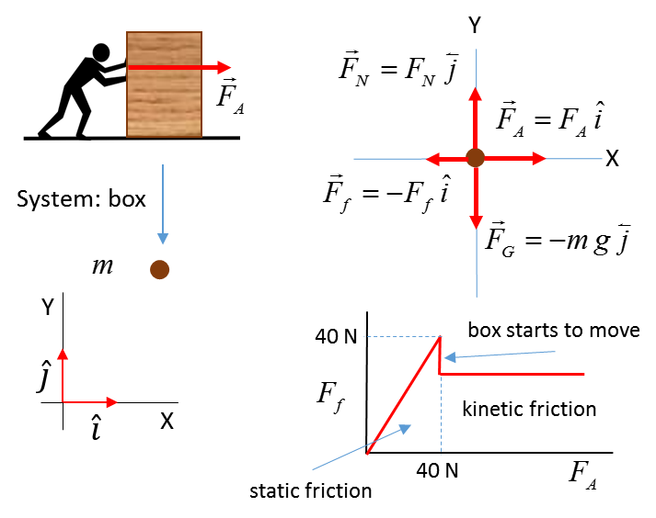

Initially the box is at rest. As the applied force increases in magnitude as the person pushes with more effort, the static frictional force increases linearly to just match the applied force until the applied force reaches the maximum value of the static frictional force



If the applied force increases further, the box will start to move and the value of the frictional force decreases to a roughly constant value characteristic of the coefficient of kinetic friction



The mass of the box is 10.0 kg and the coefficients of static and kinetic friction are



Calculate the fictional force acting on the box and the box’s acceleration for the following magnitudes of the applied force

(use )



Newton’s 2nd Law 

The net force acting on the System (box)



The acceleration of the System is zero in the Y direction



The maximum frictional force is



If



If 

|  |  |  |  |  |  |  |  |
| --- | --- | --- | --- | --- | --- | --- | --- |
|  | 0 | 10 | 20 | 39 | 41 | 50 | 60 |
|  | 0 | 10 | 20 | 39 | 36 | 36 | 36 |
| [m.s-2] | 0 | 0 | 0 | 0 | 0.5 | 1.4 | 2.4 |

**Tension** – the force acting along a stretched rope which is connected to an object.



**Springs** – a common instrument for measuring force magnitudes is the spring balance. When an object is connected to a spring it will experience a force when the spring is compressed or extended. A simple model for a spring is that the force *Fs* exerted on the object is proportional to the compression or extension *x* of the string from its natural length. This force is known as the **elastic restoring force**. The constant of proportionality is the **spring constant** *k*. This relationship is known as **Hooke’s Law**

(6)  Hooke’s law – elastic springs



**Example 1**

We will consider the forces acting on a stationary book on a floor and the reaction forces. The book is at rest, therefore, from Newton’s 1st Law the sum of all the forces acting on the book must be zero. The book pushes down on the floor due to its weight *FFB* and the floor deflects slightly pushing back on the book *FBF*. The book is attracted towards the centre of the Earth with a force *FBE* and the Earth is pulled by the book with a force *FEB*.



Fig. 5. Forces involved in a book resting on a floor.

**Example 2**

You need to study all the steps in this example for a box on an inclined surface as shown in figure (6). Assume that frictional force is given by .

N.B. the procedure

Choose the X axis parallel to the include and the Y axis at right angle to the incline as shown in figure 6.

The object is represented as a dot.

Show all the forces which act only on the box.

Resolve all these forces into components parallel and at right angles to the incline.

Apply Newton’s 2nd Law to the forces acting along each coordinate axis to find the acceleration up the incline *a*x. The box only moves along the surface therefore, *a*y = 0.

The diagram showing the forces are often referred to as **free-body diagram**. To gain the most from this very important example, work through it many times after you have completed this Module on Forces and Newton’s law.



Fig. 6. Forces acting on a box accelerating up the inclined surface due to the weight of the object at the end of the rope of the pulley system. Newton’s 2nd Law can be used to find the unknown acceleration of the box up the incline.

**Example 3 EQUILIBRIUM**

A flower pot which has a mass of 5.55 kg is suspended by two ropes – one attached horizontally to a wall and the other rope sloping upward at an angle of 40o to the roof. Calculate the tension in both ropes.

**Solution**

**How to approach the problem Identify Setup Execute Evaluate**

* Visualize the situation – write down all the given and unknown information.
* Draw a free-body diagram – forces.
* Draw a free-body diagram – x and y components for the forces.
* Forces can be added using the head-to-tail method but it is best to solve the problem using x and y components.
* Object at rest: apply Newton’s 1st law to the x and y components.
* Solve for the unknown quantities.



Applying Newton’s 1st law to the x and y components for the forces:







**Example 4**

You are driving a car along a straight road when suddenly a car pulls out of a driveway of 50.0 m in front of you. You immediately apply the brakes to stop the car. What is the maximum velocity of your car so that the collision could be avoided? Consider two cases: (1) the road is dry and (2) the road is wet.

mass of car *m* = 1500 kg

coefficient of friction  rubber on dry concrete

 rubber on wet concrete

**Solution**

**How to approach the problem Identify Setup Execute Evaluate**

* Visualize the situation – write down all the given and unknown information. Draw a diagram of the physical situation showing the inertial frame of reference.
* Type of problem – forces and uniform acceleration.
* Draw a free-body diagram showing all the forces acting on the car.
* Use Newton’s 2nd law to find normal force and frictional force and acceleration.
* Car slows down due to constant frictional force 🡪 acceleration of car is uniform 🡪 use equations of uniform acceleration to find initial velocity of car.
* Solve for the unknown quantities.



From Newton’s 2nd Law the acceleration of the car is



Constant acceleration



Maximum initial velocity to avoid collision

dry conditions μ=0.800 *u* = +28.0 m.s-1

*u* = +(28.0)(3.6) km.h-1 = +101 km.h-1

wet conditions μ=0.300 *u* = +17.2 m.s-1

*u* = +(17.2)(3.6) km.h-1 = +61.9 km.h-1

When you are driving, whether an event occurs that could lead to a fatal accident is very dependent upon the road conditions. In this example, to stop and avoid the collision, there is a difference of 40 km.h-1 in the initial velocities. Many occupants inside a car have been killed or severely injured because the driver did not slow down in poor road holding conditions. Also, in this example we ignored any reaction time of the driver. If the reaction time of the driver was just 1 s, then a car travelling at 100 km.h-1 (28 m.s-1) would travel 28 m before breaking.

**Predict Observe Explain**

Image that you are standing on a set of bathroom scales in an elevator (lift). **Predict** how the scale reading changes when the elevator accelerates upwards, downwards and travels with a constant velocity. Write down your predictions and justify them. **Observe**: Work through Example 5. **Explain** any discrepancies between the answers given in Example 5 and your prediction.

**Example 5**

A 60 kg person stands on a bathroom scale while riding an elevator. What is the reading on the scale in the following cases:

1. The elevator is at rest.
2. The elevator is going up at 2.0 m.s-1.
3. The elevator is going up at 4.0 m.s-1.
4. The elevator is going down at 2.0 m.s-1.
5. The elevator starts from rest and goes up reaching a speed of 2.0 m.s-1 in 1.8 s.
6. The elevator is moving up and accelerates from 2.0 m.s-1 to 4.0 m.s-1 in 1.8 s.
7. The elevator starts from rest and goes down reaching a speed of 2.0 m.s-1 in 1.8 s.
8. The elevator is moving down and accelerates from 2.0 m.s-1 to 4.0 m.s-1 in 1.8 s.
9. The elevator is moving up and slows from 4.0 m.s-1 to 2.0 m.s-1 in 1.8 s.
10. The elevator is moving down and slows from 4.0 m.s-1 to 2.0 m.s-1 in 1.8 s.

**Solution**

**How to approach the problem**

**Identify Setup Execute Evaluate**

* Visualize the situation – write down all the given and unknown information. Draw a diagram of the physical situation showing the inertial frame of reference.
* Type of problem – forces and Newton’s laws.
* Draw a free-body diagram showing all the forces acting on the person.
* Use Newton’s 2nd law to give the relationship between the forces acting on the person and the acceleration of the person.
* Determine the acceleration of the person in each case.
* Solve for the unknown quantities.



The person exerts a force on the bathroom scales and the bathroom scales exerts a force on the person. This is an action / reaction pair. But, we are only interested in the forces acting on the person which are the weight and the normal force due to the scale on the person.

The scale reading *FN* is found from Newton’s 2nd law:



acceleration due to gravity *g* = 9.8 m.s-2 (scalar quantity in this example)

acceleration of person *a* > 0 if direction up and *a* < 0 if acceleration down

The weight of the person is *FG* = *mg* = (60)(9.81) N =588.6 N

We can assume when the velocity changes the acceleration *a* is constant and equal to the average acceleration



In cases (1), (2), (3) and (4) there is no change in the velocity, hence



Therefore, the scale reading is *F*N = 588.6 N or 60 kg.

For cases (5), (6) and (10) 

case (5) 

case (6) 

case (10) 

The acceleration is



The scale reading is

 or 67 kg

This scale reading is often called the person’s **apparent weight**.

The person feels the floor pushing up harder than when the elevator is stationary or moving with a constant velocity.

For cases (7), (8) and (9) 

case (7) 

case (8) 

case (9) 

The acceleration is



The scale reading is

 or 53 kg

The person feels their weight has decreased.

In the extreme case when the cable breaks and the elevator and the person are in free-fall and the downward acceleration is *a* = -*g*. In this case the normal force of the scales on the person is *FN* = *m*(*g* - *g*) = 0 N. The person seems to be weightless. This is the same as an astronaut orbiting the Earth in a spacecraft where they experience **apparent weightlessness**. The astronaut and spacecraft are in free-fall and there are zero normal forces acting on the person. The astronaut still has weight because of the gravitational force acting on them.

The acceleration does not depend upon the direction of the velocity. What is important is the change in the velocity.

A good way to understand this concept is to draw the appropriate motion maps



**VELOCITY DEPENDENT FORCES**

The force of **friction** acting on the object sliding along a surface is nearly independent of the speed of the object. However, other types of resistance to motion are velocity dependent. The resistance force of an object moving through a fluid is called the **drag force** .

**Viscous drag**  **low speeds**

For a small object moving at low speeds through a fluid such as dust particles, to a good approximation, the resistive force is proportional to the velocity  of the object

 viscous drag

**-** sign since force and velocity are in opposite directions

For the vertical motion of an object through a fluid, the forces acting on the object are the gravitational force  (weight) and the resistive force . In our frame of reference, we will take down as the positive direction. The equation of motion of the object is determined from Newton’s Second Law.



where *a* is the acceleration of the object at any instance.

The initial conditions are 

When , the velocity is constant  where  is the **terminal velocity**



 **terminal velocity**

The motion of a 2.0 kg object through a viscous fluid

*m* = 2.00 kg

*β* = 5.00 kg.s-1

*g* = 9.80 m.s-2

*vT* = 3.92 m.s-1

Initial values for velocity *v*0[m.s-1]

**blue: 10 red: *vT* magenta: 2 cyan: 0**



When you consider the viscous drag acting upon falling objects, heavier objects do fall faster than lighter objects.

**Drag at high speeds** 

For objects moving at high speeds, such as, aeroplanes, cricket balls, cars or bikes, the resistance force to a good approximation is proportional to the square of the velocity



For the vertical motion of an object through a fluid, the forces acting on the object are the gravitational force  (weight) and the resistive force . In our frame of reference, down is the positive direction. The equation of motion of the object is determined from Newton’s Second Law.



where *a* is the acceleration of the object at any instance.

The initial conditions are



When , the velocity is constant  where  is the **terminal velocity**





**Example** Small rock dropped from rest:

*m* = 0.010 kg α = 1.00×10-4 kg.m-1

*v*0 = 0 m.s-1 ⇒ *vT* = 31.3 m.s-1

|  |  |
| --- | --- |
|  |  |
|  |  |

[VIEW](http://www.physics.usyd.edu.au/teach_res/mp/doc/mec_friction_2.pdf)

Interest only article on the motion of falling objects with resistance

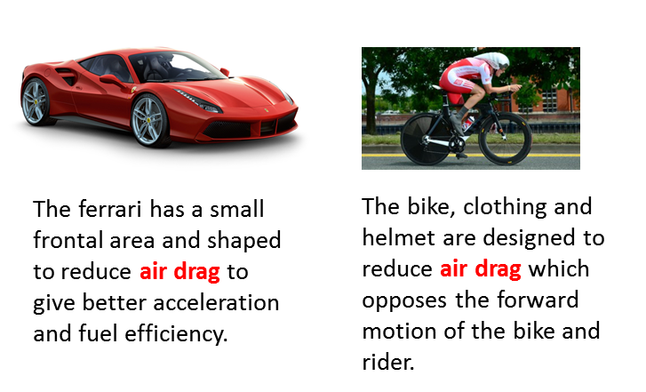

**ROLLING RESISTANCE**

**Rolling resistance** (**rolling friction** or **rolling drag**) is the force resisting the rolling motion when a body such as a ball, tire, or wheel on a surface. It is mainly caused by non-elastic effects where some of the kinetic energy is dissipated as the object rolls along the surface.

In analogy with sliding friction, rolling resistance force  is often expressed as a coefficient times the normal force .



The coefficient of rolling resistance is generally much smaller than the coefficient of sliding friction .

**Why does a rolling sphere slow down?**

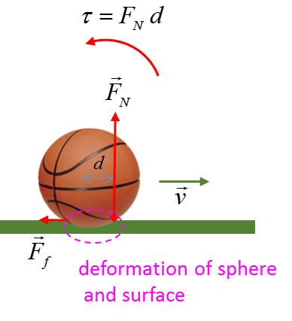

Because of the deformations of sphere and surface in the contact region, the normal force  does not pass through the centre of mass of the sphere and the normal force acts over an area and not appoint as in an idealized case. A **torque**  is produced by the normal force  which **slows** down the sphere and then stops it.