[**VISUAL PHYSICS ONLINE**](http://www.physics.usyd.edu.au/teach_res/hsp/sp/spHome.htm)

**DYNAMICS**

**TYPES OF FORCES**

**VELOCITY DEPENDENT FORCES**

**ROLLING RESISTANCE**

**VELOCITY DEPENDENT FORCES**

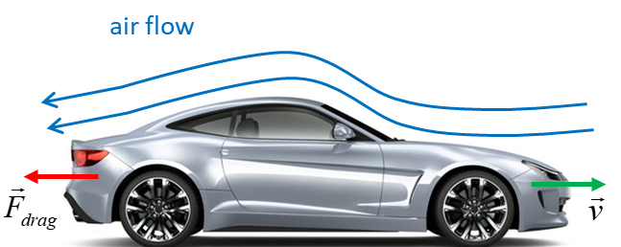

The force of **friction** acting on the object sliding along a surface is nearly independent of the speed of the object. However, other types of resistance to motion are velocity dependent. The resistance force of an object moving through a fluid is called the **drag force** .

**Viscous drag**  **low speeds**

For a small object moving at low speeds through a fluid such as dust particles, to a good approximation, the resistive force is proportional to the velocity  of the object

 viscous drag

**-** sign since force and velocity are in opposite directions

For the vertical motion of an object through a fluid, the forces acting on the object are the gravitational force  (weight) and the resistive force . In our frame of reference, we will take down as the positive direction. The equation of motion of the object is determined from Newton’s Second Law.



where *a* is the acceleration of the object at any instance.

The initial conditions are 

When , the velocity is constant  where  is the **terminal velocity**



 **terminal velocity**

The motion of a 2.0 kg object through a viscous fluid

*m* = 2.00 kg

*β* = 5.00 kg.s-1

*g* = 9.80 m.s-2

*vT* = 3.92 m.s-1

Initial values for velocity *v*0[m.s-1]

**blue: 10 red: *vT* magenta: 2 cyan: 0**



When you consider the viscous drag acting upon falling objects, heavier objects do fall faster than lighter objects.

**Drag at high speeds** 

For objects moving at high speeds, such as, aeroplanes, cricket balls, cars or bikes, the resistance force to a good approximation is proportional to the square of the velocity



For the vertical motion of an object through a fluid, the forces acting on the object are the gravitational force  (weight) and the resistive force . In our frame of reference, down is the positive direction. The equation of motion of the object is determined from Newton’s Second Law.



where *a* is the acceleration of the object at any instance.

The initial conditions are



When , the velocity is constant  where  is the **terminal velocity**





**Example** Small rock dropped from rest:

*m* = 0.010 kg α = 1.00×10-4 kg.m-1

*v*0 = 0 m.s-1 ⇒ *vT* = 31.3 m.s-1

|  |  |
| --- | --- |
|  |  |
|  |  |

[VIEW](http://www.physics.usyd.edu.au/teach_res/mp/doc/mec_friction_2.pdf)

Interest only article on the motion of falling objects with resistance

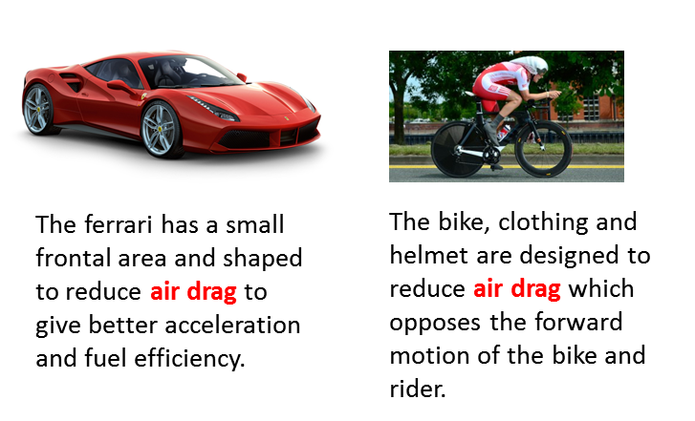

**ROLLING RESISTANCE**

**Rolling resistance** (**rolling friction** or **rolling drag**) is the force resisting the rolling motion when a body such as a ball, tire, or wheel on a surface. It is mainly caused by non-elastic effects where some of the kinetic energy is dissipated as the object rolls along the surface.

In analogy with sliding friction, rolling resistance force  is often expressed as a coefficient times the normal force .



The coefficient of rolling resistance is generally much smaller than the coefficient of sliding friction .

**Why does a rolling sphere slow down?**

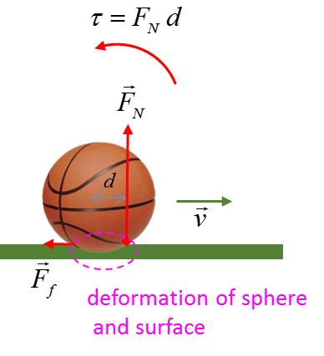

Because of the deformations of sphere and surface in the contact region, the normal force  does not pass through the centre of mass of the sphere and the normal force acts over an area and not a point as in an idealized case. A **torque**  is produced by the normal force  which **slows** down the sphere and then stops it.

[VISUAL PHYSICS ONLINE](http://www.physics.usyd.edu.au/teach_res/hsp/sp/spHome.htm)

If you have any feedback, comments, suggestions or corrections please email:

Ian Cooper School of Physics University of Sydney

ian.cooper@sydney.edu.au