[**VISUAL PHYSICS ONLINE**](http://www.physics.usyd.edu.au/teach_res/hsp/sp/spHome.htm)

**DYNAMICS**

**EQUILIBRIUM**

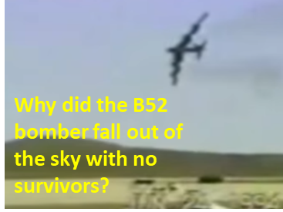

[YouTube: 1994 Fairchild Air Force Base B-52 Plane Crash](https://www.youtube.com/watch?v=182AepOJjMs)

**WARNING!!!** This video contains actual crash footage. Viewer discretion is advised.

**Conditions for Equilibrium**

An object is in equilibrium if:

* The resultant force acting on the object is zero.



* The sum of the torques (moments) acting on an object must be zero.



|  |
| --- |
| **Example**  A flower pot which has a mass of 5.55 kg is suspended by two ropes – one attached horizontally to a wall and the other rope sloping upward at an angle of 40o to the roof. Calculate the tension in both ropes.  **Solution**  [How to approach the problem](http://www.physics.usyd.edu.au/teach_res/hsp/sp/mod0/spProblemSolving.pdf)**:**  **Identify Setup Execute Evaluate**   * Visualize the situation – write down all the given and unknown information. * Draw a free-body diagram – forces. * Draw a free-body diagram – x and y components for the forces. * Forces can be added using the head-to-tail method but it is best to solve the problem using x and y components. * Object at rest: apply Newton’s 1st law to the x and y components. * Solve for the unknown quantities.     Applying Newton’s 1st law to the x and y components for the forces: |

**How can an aircraft fly at a constant velocity?**

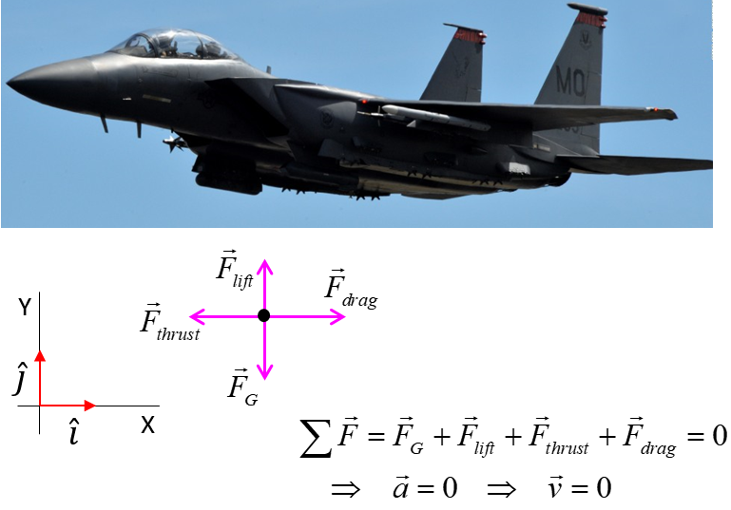

[VISUAL PHYSICS ONLINE](http://www.physics.usyd.edu.au/teach_res/hsp/sp/spHome.htm)

If you have any feedback, comments, suggestions or corrections please email:

Ian Cooper School of Physics University of Sydney

ian.cooper@sydney.edu.au