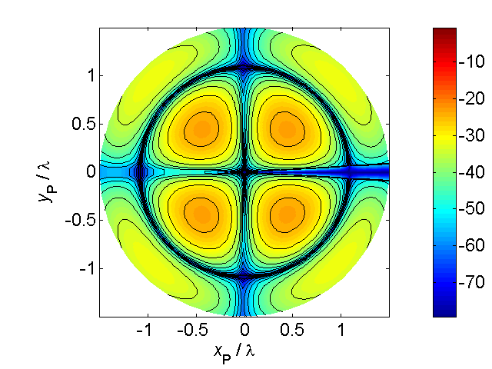

[**HSC PHYSICS ONLINE**](http://www.physics.usyd.edu.au/teach_res/hsp/sp/spHome.htm)

**DYNAMICS**

To change the velocity of an object a non-zero net force must upon it

**IMPULSE AND MOMENTUM**

If a car travelling along a road brakes, then the wheels stop turning. The car’s tyres exert a forward force on the road and the road exerts a backward force on the car which slows and finally stops the car. If a car and a large truck where travelling at the same speed than it is obvious that a much larger force is necessary to stop the truck in a certain time than it does to stop the car. A larger force is required to stop a car travelling at 100 km.h-1 in 2 seconds compared to stopping the car in 2 s when it was travelling at 30 km.h-1 (see figure (1)).

In a given time interval:

* The larger the mass of a moving object the greater the force required to stop it.
* The larger the velocity of a moving object the greater the force required to stop.



Fig. 1. The force to stop a vehicle depends on its momentum.

We can better understand the concept of force and change in velocity using Newton’s 2nd Law. We need to setup a simple model in which the motion is confined to one dimension so that we don’t have to use any vector notation. The object is represented as a point particle with a mass . Initially the particle has a velocity . The average force  acts on the particle for a time interval  so that the final velocity of the particle is . Therefore, during this time interval  the average acceleration  of the particle is



Newton’s 2nd Law can now be expressed as

  is a constant

From this we can obtain the result

1. 

The quantity  is called the **impulse** of the force and the quantity  is called the **momentum** of the object.

(2)  **impulse** vector [N.s]

(3)   **momentum** vector [N.s or kg.m.s-1 ]

**The impulse of a force is equal to the change in momentum which the force produces.**

Hence, the greater the momentum of a moving object, the greater the force needed to stop it in a given time interval . Also, if we wish to accelerate an object to a velocity  in a time interval  the force needed is determined by the momentum we wish to achieve.

**The rate of change of momentum of an object is equal to the resultant (net) force acting on an object.**

So, Newton’s Second Law can be expressed as

(4)  **Newton’s Second Law**

**WORK AND KINETIC ENERGY**

We can now consider stopping a car within a certain distance by the action of a force. We can conclude that in a given displacement (stopping distance):

* The larger the mass of a moving object the greater the force required to stop it.
* The larger the velocity of a moving object the greater the force required to stop it.

We start with Newton’s 2nd Law and an equation describing the motion of an object with constant acceleration.

Consider the [1D] motion of an object of mass  which has an initial velocity . A constant force  acts on the object through a displacement  to give the object a final velocity of .



(5) 

 is called the **work** done by the force on the object

(6)   **work** scalar [joule J]

 is called the **kinetic energy** of the object

(7)  **K.E.**  scalar  [J]

The work done by a force on an object is equal to the change in kinetic energy  which the force produces.

(6) 

**CAR ACCIDENTS**

Many young people are killed on our roads each year in car accidents that could have been avoided by driving more slowly. To understand the physics of car accidents and how car manufactures incorporate safety features in their designs it is important to appreciate the concepts of **impulse** and **work**. A common fatal accident is when a car hits a tree or pole as shown in figure (2). A car of mass  has a velocity  before the collision and is brought to rest () in a stopping time  and stopping distance  by the force of the pole acting on the car. This stopping force  depends on the initial momentum or initial kinetic energy of the car.

impulse to stop the car 

work done to stop the car 

* The greater the momentum of the car, the greater the impulse required to stop the car.
* The greater the kinetic energy of the car, the greater the amount of work required to stop the car.

You are much more likely to avoid a fatal accident by driving slower.

The **stopping force** is **inversely proportional** to the **stopping time** and **stopping distance**. If the stopping time and stopping distance are very small as in the case when you smash into a pole or tree the stopping force will be enormous. Figure (3) shows the force vs time and force vs distance for a car of mass 1500 kg initially travelling at 50 km.h-1 and 100 km.h-1 and being brought to rest by an impact with a pole. The ratio of the velocities is *u*2/*u*1 = 2 but the ratio of stopping distances is *F*2/*F*1 = 22 = 4. This is why the front end of modern cars are designed to have a large **crumple zone** to reduce the impact force in a collision. For a stopping distance of 0.20 m, the stopping force for the car travelling at 100 km.h-1 is enormous ~3×106 N (~200 x weight of car). If the stopping distance was 1.0 m, the force is reduced by a factor of 5.



Fig. 3a. Stopping force vs stopping time for a car being brought to rest by an impact with a pole.



Fig. 3b. Stopping force vs stopping distance for a car being brought to rest by an impact with a pole.

People by law are required to wear seats belts and for cars to achieve a 5 star safety rating they must have a number of air bags. Seat belts and air bags are designed to increase the stopping time and stopping distance to reduce the force at impact during a collision since

impulse to stop the car *J* = *F* Δ*t* = *F* Δ*t* = constant

work to stop the car *W* = *F* Δ*t* = *F* Δ*t* = constant

As an example, consider the head a person (*m* = 5 kg) hitting their head on the steering wheel with the area of contact being 10 mm × 10 mm (10-4m2). The initial velocity at impact is 36 km.h-1 (10 m.s-1) and the stopping distance is 10 mm (0.01 m). The compression strength of bone is 1.7×108N.m-2.

stopping force 

force to smash bone 

Therefore, in this accident, bones in the skull would certainly be smashed and serious head injuries would occur and most likely death would result. This is the reason cars now are built with collapsible steering columns.

**WEB search** – use the internet to search for videos of motor bike riders coming off their high speed bikes.



In watching motor bike racers, it is amazing that a rider comes off their bike at 300 km.h-1 and they walk away after the accident? Why?

**In an accident, the important thing is not how fast you are travelling but how quickly you stop.**

**PHYSICS AND SPORT**

Most sports involve objects colliding during the play - golf, tennis, football, hockey, etc. When objects interact during a short period of time, they may experience very large forces. Evidence of these forces is the distortion in shape of an object at the moment of impact, for example, the distortion of the golf and tennis balls. In the 1970’s, the best golfers in the world hit the ball about 250 m. Today, golfers can hit the ball more than 320 m. *Why?* Manufactures of tennis rackets and golf clubs have applied physical principles and properties of new materials to greatly enhance the momentum imparted to a ball upon impact by the racket or club. From extensive video analysis of sprinters manufactures of shoes now custom make the soles and spikes of top-class runners.

RUNNING.WPG**WEB search** – use the internet to search design parameters of running shoes and 3D manufacturing.

Why can you damages your feet running barefoot on concrete but not grass?

What are the features of good running shoes?