[**VISUAL PHYSICS ONLINE**](http://www.physics.usyd.edu.au/teach_res/hsp/sp/spHome.htm)

**DYNAMICS**

**TYPES OF FORCES**

**FRICTION**

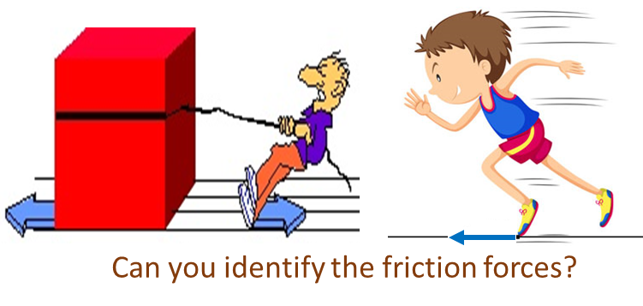

**Friction force:** the force acting on the object which acts in a direction parallel to the surface. A simple model for friction *Ff* is that it is proportional to the normal force *FN* and the constant of proportionality is called the **coefficient of friction** *μ*. The maximum frictional force is

(1) 

only valid for a simplified model of friction.



There are two coefficients of friction known as the **static coefficient** of friction (no movement between surfaces in contact) and the **kinetic coefficient** of friction (relative movement between the surfaces) where  . Usually the difference between the values for  and  is only small.

In many texts, it is stated that friction opposes the motion of all objects and eventually slows them down. But this type of statement is very misleading. How can we walk across the room, how can cars move? It is because of friction. In walking, you push against the floor and the frictional force of the floor on you is responsible for the forward movement.

The drive wheels of a car turn because of the engine. The driven wheels exert a force on the road, and the road exerts a forward force on the car because of friction between the types and road. In icy conditions, the driven wheels spin so that that there is very little friction between the tyres and the road and the car can’t be driven safely. When the foot is taken off the accelerator peddle, a car will slow down because of friction.

Consider the example of a person pushing a box across the floor. Take the box as the System. The forces acting on the box are: its weight  ; the normal force  of the floor on the box, the frictional force  acting on the box as it slides across the floor and the applied force  exerted by the person on the box.

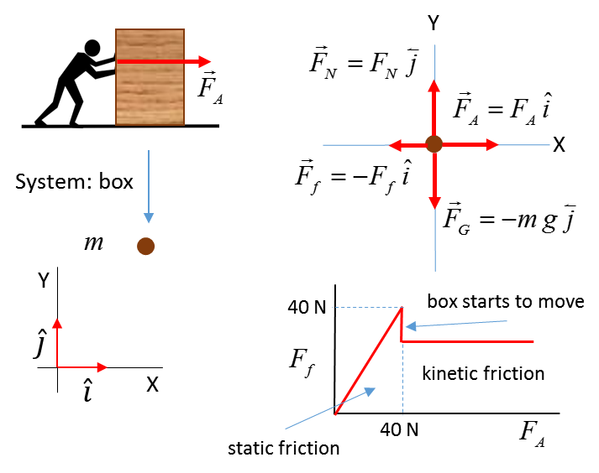

Initially the box is at rest. As the applied force increases in magnitude as the person pushes with more effort, the static frictional force increases linearly to just match the applied force until the applied force reaches the maximum value of the static frictional force



If the applied force increases further, the box will start to move and the value of the frictional force decreases to a roughly constant value characteristic of the coefficient of kinetic friction



The mass of the box is 10.0 kg and the coefficients of static and kinetic friction are



Calculate the fictional force acting on the box and the box’s acceleration for the following magnitudes of the applied force

(use )



Newton’s 2nd Law 

The net force acting on the System (box)



The acceleration of the System is zero in the Y direction



The maximum frictional force is



If



If 

|  |  |  |  |  |  |  |  |
| --- | --- | --- | --- | --- | --- | --- | --- |
|  | 0 | 10 | 20 | 39 | 41 | 50 | 60 |
|  | 0 | 10 | 20 | 39 | 36 | 36 | 36 |
| [m.s-2] | 0 | 0 | 0 | 0 | 0.5 | 1.4 | 2.4 |

|  |
| --- |
| **Example 1**  You need to study all the steps in this example for a box on an inclined surface as shown in the figure below. Assume that frictional force is given by .  N.B. the procedure  Choose the X axis parallel to the incline and the Y axis at right angle to the incline as shown in the figure.  The object is represented as a dot.  Show all the forces which act only on the box.  Resolve all these forces into components parallel and at right angles to the incline.  Apply Newton’s 2nd Law to the forces acting along each coordinate axis to find the acceleration up the incline *a*x. The box only moves along the surface therefore, *a*y = 0.  The diagram showing the forces are often referred to as **free-body diagram**. To gain the most from this very important example, work through it many times after you have completed this Module on Forces and Newton’s law.  Figure (below) caption.  Forces acting on a box accelerating up the inclined surface due to the weight of the object at the end of the rope of the pulley system. Newton’s 2nd Law can be used to find the unknown acceleration of the box up the incline. |

|  |
| --- |
| **Example 2**  You are driving a car along a straight road when suddenly a car pulls out of a driveway of 50.0 m in front of you. You immediately apply the brakes to stop the car. What is the maximum velocity of your car so that the collision could be avoided? Consider two cases: (1) the road is dry and (2) the road is wet.  mass of car *m* = 1500 kg  coefficient of friction  rubber on dry concrete  rubber on wet concrete  **Solution**  **How to approach the**  Visualize the situation – write down all the given and unknown information. Draw a diagram of the physical situation showing the inertial frame of reference.   * Type of problem – forces and uniform acceleration. * Draw a free-body diagram showing all the forces acting on the car. * Use Newton’s 2nd law to find normal force and frictional force and acceleration. * Car slows down due to constant frictional force 🡪 acceleration of car is uniform 🡪 use equations of uniform acceleration to find initial velocity of car. * Solve for the unknown quantities.     From Newton’s 2nd Law the acceleration of the car is    Constant acceleration    Maximum initial velocity to avoid collision  dry conditions μ = 0.800 *u* = +28.0 m.s-1  *u* = +(28.0)(3.6) km.h-1 = +101 km.h-1  wet conditions μ = 0.300 *u* = +17.2 m.s-1  *u* = +(17.2)(3.6) km.h-1 = +61.9 km.h-1  When you are driving, whether an event occurs that could lead to a fatal accident is very dependent upon the road conditions. In this example, to stop and avoid the collision, there is a difference of 40 km.h-1 in the initial velocities. Many occupants inside a car have been killed or severely injured because the driver did not slow down in poor road holding conditions. Also, in this example we ignored any reaction time of the driver. If the reaction time of the driver was just 1 s, then a car travelling at 100 km.h-1 (28 m.s-1) would travel 28 m before breaking. |

[VISUAL PHYSICS ONLINE](http://www.physics.usyd.edu.au/teach_res/hsp/sp/spHome.htm)

If you have any feedback, comments, suggestions or corrections please email:

Ian Cooper School of Physics University of Sydney

ian.cooper@sydney.edu.au