[**VISUAL PHYSICS ONLINE**](http://www.physics.usyd.edu.au/teach_res/hsp/sp/spHome.htm)

**DYNAMICS**

**LINEAR MOMENTUM** 

**IMPULSE** 

**CONSERVATION OF MOMENTUM** 

**MOMENTUM**

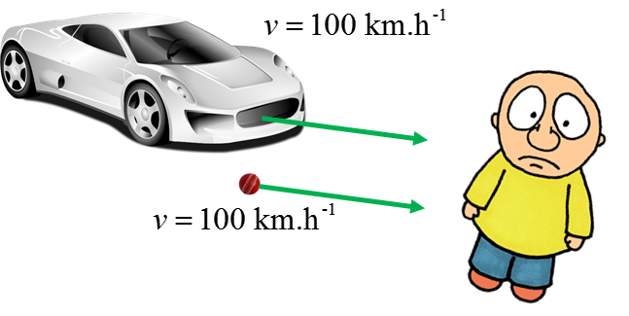

Fig. 1. There is a **BIG** difference in the results of being hit by a car travelling at 100 km.h-1 to being hit by a cricket ball also travelling at 100 km.h-1.

The description of events like the impacts illustrated in figure 1 are made more precise by defining a quantity called the **linear momentum** . The momentum  depends upon both the mass  and velocity  of the object and is defined by equation (1)

(1)  vector [ kg.m-1 or N.s ]

A more general form of **Newton’s Second Law** which holds even if the mass changes can be expressed in terms of momentum

(2A)  **Newton’s 2nd Law**

or the rate of change of momentum  depends upon the resultant (net) force  acting on the object

(2B)  **Newton’s 2nd Law**

If the mass  of the object is constant, then,

 **Newton’s 2nd Law** ( = constant)

**The rate of change of momentum of an object is equal to the resultant (net) force acting on an object**

**IMPULSE**

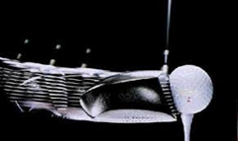

We can gain a better insight into Newton’s Second Law by defining the quantity known as **impulse** .

The impulse  of the net force  acting on an object during the time interval  is defined as

(3)   **impulse** vector [kg.m-1 or N.s]

The value of the integral gives the area under the force against time graph as shown in figure (3).

You give a tennis ball a wack with the racket as shown in figure (2). The ball flies off for a winner.

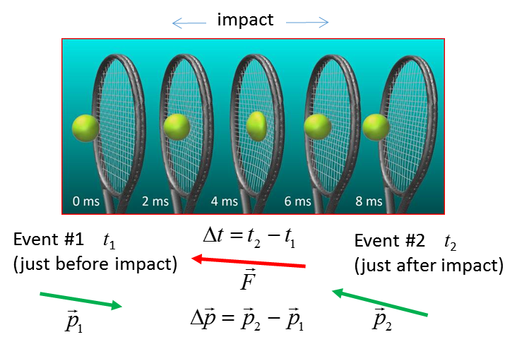

Fig. 2. An impulse acting on the tennis ball changes its momentum.

In the language of Physics, the racket delivers an impulse  to the tennis ball, changing its momentum . During the brief time interval  that the ball and racket are in contact, the net force  acting on the ball from the racket rises rapidly to a large value and then falls again to zero.

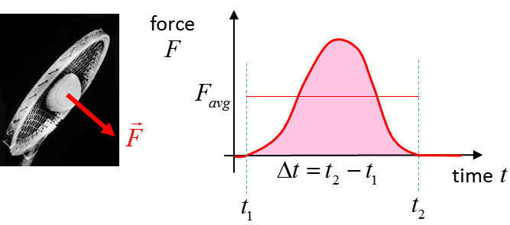

Fig. 3. The impulse  acting is equal to the area under  graph. The area under the  rectangle is equal the area under the actual force curve.

The change in the momentum of the ball depends not only on the force exerted on it but also the duration of the contact. The change in momentum  can be calculated from Newtons’ 2nd Law (equation 2A) and the definition of impulse (equation 3)

(4)  **impulse produces a change in momentum**

For the example of hitting the tennis ball shown in figure (2), the change in momentum is

(5) 

The impulse is a vector and points in the same direction as the change in momentum vector or the direction of the average force. Equations (4) & (5) describe the **Momentum – Impulse Theorem**.

|  |
| --- |
| **Example**  A car (1200 kg) and truck (7200 kg) are speeding along the highway travelling at 100 km.h-1. The car and truck brake so that they both stop in the same time interval of 8.0 s. Compare the forces acting on the car and truck during the stopping time.    **Solution**  *How can the car and truck stop by applying the brakes?* The tyres exert a forward force on the road and the road exerts a backward force on the tyres that slows and finally stops the vehicles.  How to approach the problem  Visualize the physical situation  Problem type: Momentum - Impulse  Identify the car as System C and the truck as System T  Define a frame of reference.  [1D] problem – can treat quantities as scalars  List known & unknown physical quantities  (symbols & units)  State physical principles  Annotated scientific diagram    Momentum – Impulse Theorem  Impulse = Change in momentum      System C (car)    System T (truck)    The force required to stop the truck compare to the car is 6 times greater.  Image result for image allure of the seasAllura of the Seas: length 362 m and mass 225 282 000 kg. To change the velocity of this big ship takes a long time – *why?* |

**CONSERVATION OF LINEAR MOMENTUM**

One of the most fundamental principles in all of Physics is the principle of **conservation of linear momentum**. It is of fundamental importance in Physics and has significant practical importance and simplifies many calculations. Recall, Newton’s Second Law applied to a System

(2A)  **Newton’s 2nd Law**

If the resultant (net) force acting on the System from outside the system (external forces) is zero



then, the change in momentum is also zero



or 

Since the momentum does not change when the resultant external force acting on the System is **zero**, we say that, **momentum is conserved**.

[VIEW](http://www.physics.usyd.edu.au/teach_res/hsp/u5/u5_ag_monentum.htm) Questions & animation of the [1D] collision of two particles

|  |
| --- |
| **Example**  Two canoes collide in a river and come to rest against each other. A person in one of the canoes pushes on the other canoe with a force of 56 N to separate the canoes.  The mass of a canoe and occupants is 150 kg and the other canoe and occupants has a mass of 350 kg. The length of each canoe is 4.55 m.  Calculate numerical values for ALL relevant physical quantities for 1.2 s of pushing to separate the canoes and state clearly the associated physical principles.  This example illustrates the important fact that  **Conservation of Linear Momentum is a consequence of Newton’s Third Law of Motion**  **Solution**  How to approach the problem  Visualize the physical situation  Try to answer the question by ”thinking” first  Problem type: Newton’s 2nd Law - Momentum – Impulse  Identify the Systems  Define a frame of reference.  [1D] problem – can treat quantities as scalars  List known & unknown physical quantities (symbols &  units)  State physical principles  Ignore any frictional forces  Annotated scientific diagram  The two canoes are identified as System A and System B.  Forces always act in pairs. Canoe A pushes on canoe B () then then B must also push on A (). This pair of forces have equal magnitude and must opposite direction according to Newton’s 3rd Law.    Apply Newton’s 2nd Law to both Systems to find their accelerations        The force and hence acceleration are assumed to be constant.  Apply  to find the velocity after 1.2 s.      Apply  to find the momentum of each System      Conservation of momentum  Take the two canoes together as System C.  Event #1 (initial values *t* = 0 s)  Event #2 (final values *t*= 1.2 s)    Momentum is conserved.  Alternate solution - use the definitions of momentum and impulse to show that momentum is conserved |

[VISUAL PHYSICS ONLINE](http://www.physics.usyd.edu.au/teach_res/hsp/sp/spHome.htm)

If you have any feedback, comments, suggestions or corrections please email:

Ian Cooper School of Physics University of Sydney

ian.cooper@sydney.edu.au