[**VISUAL PHYSICS ONLINE**](http://www.physics.usyd.edu.au/teach_res/hsp/sp/spHome.htm)

**FORCES & NEWTON’S LAWS OF MOTION**

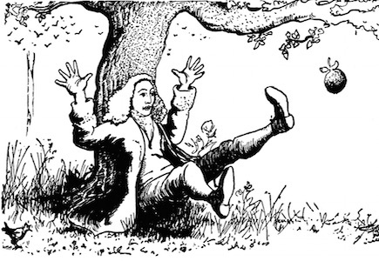

The study of what causes changes in the motion of an object is known as **dynamics**. The central concept of dynamics is the physical quantity **force**. The term **force** can’t be defined or explained in a simple sentence. You will learn what a force is and the ideas associated with forces, however, you just will not be able to state what a force is in a clear brief statement. Sometimes force is said to be a pull or push, but a force is more than just a push or pull. **Forces acts in pairs** – it is not possible to have a single force acting. The interaction between objects is often described in terms of forces. For example: (1) two objects will attract each other because of the gravitational force between them and (2) two electrons will repel each other because electrons are negatively charged.

The principles of dynamics are described by **Newton’s Laws of Motion**. The **three** laws are very simple to state, but extremely difficult to interpret and apply. This is because of your experience in walking, throwing, pulling and pushing has given you “mental” models of how things work based upon common sense. But, the way the world works is not necessarily based upon logic, intuition or common sense. After careful observation and measurement, physicists have developed scientific principles which often are at odds to our “mental models” based upon our experience of the physical world. Newton’s Laws are not the product of mathematical derivations, but rather they have been synthesized from a multitude of experimental data about how objects move. These laws are truly fundamental because they can’t be deduced from other principles.

**PROPERTIES OF FORCES**

* A force is a push or pull.
* A force is an interaction between object.
* Forces can be attractive or repulsive.
* **Forces act in pairs**.
* An interaction between two objects gives rise to a pair of forces of equal magnitude and act in opposite directions which act on separate objects (Newton’s 3rd law).
* A force is a **vector** quantity with magnitude and direction.
* Multiple forces can be replaced by a single force using vector addition to give the **resultant** or **net** force acting on an object.
* A force can be resolved into two **components** at right angles to each other. The components of a vector are scalar quantities.
* If the **resultant** (**net**) force on an object is zero, the object will remain stationary or move with a constant velocity (Newton’s 1st law: ).
* If the resultant (net) **force** on an object is **non-zero**, the object will experience an **acceleration** in the direction of the force (Newton’s 2nd law: ).
* The S.I. Unit for force is the newton [N] 1 N = 1 kg.m.s-2

**Force as vector**

vector [2D] 

X component 

Y component 

magnitude 

direction



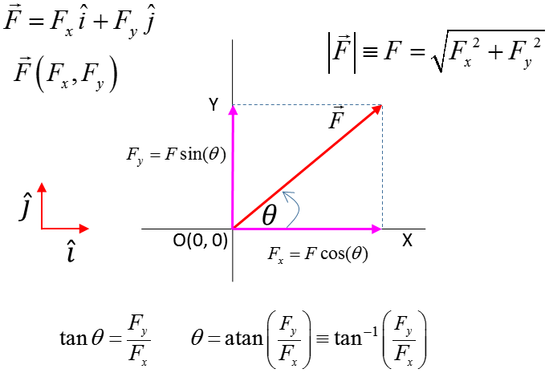

**NEWTON’S LAWS OF MOTION**

In studying motion, the first step was defining a frame of reference. The fame of reference chosen is one in which its acceleration is zero. This is called an **inertial frame of reference**. You are an observer in a car and the car represents your frame of reference.

If you have your eyes closed, then you can’t feel how fast you’re travelling. This is an inertial frame of reference. You feel the effects of acceleration, if the car suddenly speeds up you feel pushed backwards, if the car brakes abruptly you will be thrown for forward and if the car turns sharply then you appear to be thrown sideways.

When the car accelerates, it is a **non-inertial frame of reference**.

The Earth although it is orbiting the Sun and rotating about its axis, these effects are small and so we can take the Earth’s surface to be an inertial frame of reference. For our study of motion, we always take an inertial frame of reference.

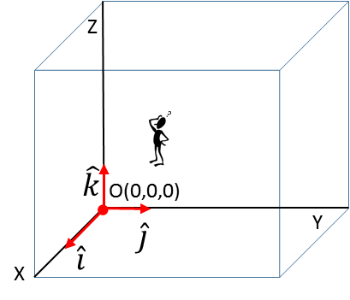**Inertial Frame of Reference**

Observer (stationary)

Origin O(0,0, 0)

Cartesian coordinate axes

Unit vectors 

**Newton’s 1st Law of Motion**

In an inertial frame of reference, if the resultant (net) force acting upon an object is zero, then the object will be at rest or moving with a constant velocity.

This law implies that the natural state of motion of an object is that it has zero acceleration (), therefore, the object is at rest () or moving in a straight line with a constant speed ().

The tendency for an object to remain at rest or keep moving is called **inertia**.

When the resultant (net) **force** acting on a particle is zero, the object is in **equilibrium**

(1)



Figure (1) helps us understand Newton’s 1st Law. You are standing in a tram travelling at a constant velocity when the tram suddenly brakes. You feel that someone has pushed you in the back and you topple forward. But, you do not experience a force. By Newton’s 1st Law, your upper part of the body will continue to move forward while your legs attached to the floor slow down with the tram. Again, you are standing in a stationary tram. The tram starts moving forward. Your feet move forward with the tram but your upper part of the body tends to remain at rest according to Newton’s 1st Law.



Fig. 1. Riding an accelerating tram.

Many injuries suffered in car accidents can be explain by Newton’s 1st Law. When a car is moving forward and then suddenly slows down in a collision, the people in the car will tend to keep moving forward with a constant velocity until they are brought to rest by smashing into the steering wheel or the windscreen. The faster the car is travelling before a collision, the greater the speed before impact which brings the occupants to rest and the more substantial are the injuries incurred. In many such collisions occupants often suffer massive internal injuries. Your internal organs must obey Newton’s 1st Law – they continue moving forward damaging the diaphragm and the organs themselves which results in excessive internal bleeding. Many young drivers have died from internal injuries in car accidents – you should always remember Newton’s 1st Law – the faster you are going before an accident the more likely you are to die – slowing down does save lives. Seat belts, collapsible steering wheels and air bags are used to limit the injuries in accidents caused by inertia.

Similarly, a car moving off suddenly from rest can cause a person’s upper parts of their body namely the head to remain stationary whilst the lower parts of the body seated and in contact with the car floor move forward. Serve neck injuries are very common in rear end collisions when the neck muscles are severely stretched. The stretched muscles act a like a spring and the head is whipped back to catch-up with the rest of the body. This is often referred to whip-lash injuries of the neck and back. Head restraints on car seats are used to carry the head forward to prevent this type of injury to the neck.



Fig.2. Seat belts, air bags and head restraints can reduce injuries in a collision.

Sir Isaac Newton (1642-1727) was by many standards the most important person in the development of modern science. Newton, who was born the same year that Galileo Galilei (1564-1642) died. He built on Galileo's ideas to demonstrate that the laws of motion in the heavens and the laws of motion on the Earth were one and the same. The work of Galileo and Newton would banish the notions of Aristotle that had stood for 2000 years. Galileo’s ideas challenged the views of the Church on the Aristotelian conception of the Earth centred Universe. He got him into trouble with the Inquisition and was forced to recant publicly his Copernican views. In the later years of his life he was under house arrest. His story is one of many that highlighted the conflict between the scientific approach and "science" based on unquestioned authority. Even today, there still are many forces in modern society (religious, cultural, political, etc) that are against the scientific approach of open enquiry.

Perhaps Galileo's greatest contribution to physics was his formulation of the concept of inertia: an object in a state of motion possesses an “inertia” that causes it to remain in that state of motion unless a resultant force acts on it. Most objects in a state of motion do **not** remain in that state of motion. For example, a block of wood pushed across a table quickly comes to rest when we stop pushing. Thus, Aristotle held the view that objects in motion did not remain in motion unless a force acted constantly on them. Galileo, by virtue of a series of experiments (many with objects sliding down inclined planes), realized that the analysis of Aristotle was incorrect because it failed to account properly for a hidden force: the frictional force between the surface and the object. As we push the block of wood across the table, there are two opposing forces that act: the force associated with the push, and a force that is associated with the friction and that acts in the opposite direction. Galileo deduced that as the frictional forces are decreased (for example, by placing oil on the table) the object would move further and further before stopping. From this he abstracted a basic form of the law of inertia: if the frictional forces could be reduced to exactly zero a moving object would continue moving at a constant speed in a straight line unless a new force acts on it at some later time. Figure (3) illustrates the difference between the Aristotle view motion and the views of Galileo and Newton.



Fig.3. Aristotle view of motion compared to the view of

Galileo and Newton.

**Web search**

1. View several movie clips on Newton’s 1st Law of motion.
2. Find at least eight examples of physical situations that can be explained by Newton’s 1st law, e.g. spin dryer, sauce bottle, …

John Ogborn (Difficulties in Dynamics, Physics at Secondary School: Physics and Applications Vol II, Proceedings for the Conference 1983. Institute of Physics, Slovak Academy of Sciences.) has summarised peoples difficulties with Newton's Laws of Motion:

* the first law is unbelievable
* the second law is incomprehensible
* the third is merely religious incantation

Learning or teaching Physics is not a simple task. A Koyre (Journal of Historical Ideas, 4,400,p.405, 1943) has made an appropriate comment:

"*What the founders of modern science, among them Galileo, had to do, was not to criticise and combat faulty theories, but to replace them by better ones. They had to do something quite different. They had to destroy one world and replace it by another. They had to reshape and reform its concepts, to evolve a new approach to being, a new concept of knowledge, a new concept of science - and even to replace a pretty natural approach, that of common sense, by another which is not natural at all*."

**Newton’s 2nd Law of Motion**

In an inertial frame of reference, the resultant (net) force acting upon an object produces an acceleration of the object in the direction of the force. The acceleration  is proportional to the resultant force  and inversely proportional to the mass of the object.

(2)  Newton’s 2nd Law

Equation (2) tells us:

* The greater the resultant (net) force acting on an object the greater its acceleration.
* The greater the mass of the object the smaller its acceleration.
* A definition of the concept of force. If the object of mass *m* has an acceleration *a* then the force acting on it is defined as the product of its mass and acceleration. The product  is **not** a force but gives a number equal to the magnitude of the force.

**Newton’s 3rd Law of Motion**

In an inertial frame of reference, if an object A exerts a force  on object B then object B exerts a force  on object A which is equal in magnitude but opposite in direction

(3)  Newton’s 3rd law

Newton’s 3rd Law is illustrated by the example of the repulsion between like charges and the attraction between opposite charges as shown in figure (4). Whenever a force acts on an object there must be simultaneously be an equal in magnitude and opposite direction force acting on some other object. **Forces always act in pairs**. This pair of forces act on different objects.

**Action and reactions are equal and opposite and act on different objects**



Fig. (4) Newton’s 3rd Law – repulsion and attraction between charges.

**Discuss how Newton’s 3rd Law explains the following examples:**

* The rotation of a lawn sprinkler.
* A boat being propeller through water.
* The recoil of a firing gun.
* The operation of a rocket and jet engine.
* Walking.
* Driving a car.
* Forces between Sun, Moon and Earth give rise to the tides of the oceans.
* A plane flying through the air.

The following list are common statements of Newton's Third Law found in Physics textbooks, all of which are misleading.

* + Every action has an equal opposite reaction.
  + To every force there is an equal and opposite force.
  + Action and reaction are equal and opposite.

**Why are these three statements misleading?**

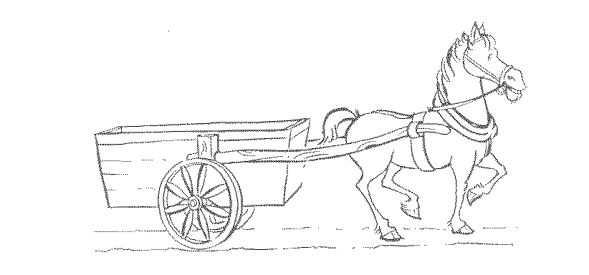

**The donkey and cart problem**

### If the above statements of Newton's Third Law are true, how can the donkey pull the cart?

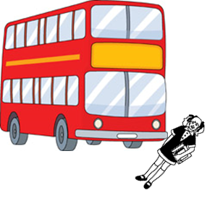**Hit by a bus problem**

You have just been hit by a speeding bus.

What force does the bus exert on you?

What force do you exert on the bus?

### Head-On problem

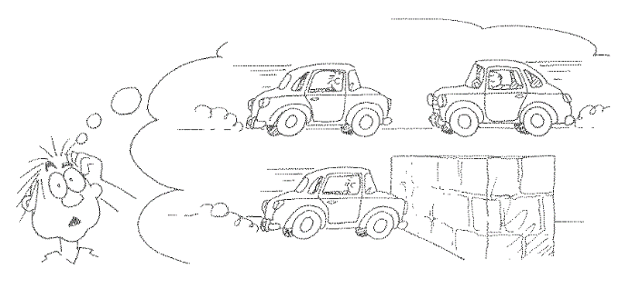Consider the consequences of driving a car into a head-on collision with an identical car travelling toward you at the same speed, as opposed to colliding at the same speed into a massive concrete wall. Which of these two situations would result in the greatest impact force? (Lewis Epstein & Paul Hewitt, *Thinking Physics*)

# *Newton's laws of motion: weight*

If you review many introductory Physics textbooks you will find two conflicting definitions of weight.

What are these two definitions?

Use these two definitions to answer the following questions.

* How can you explain the "weightlessness" of astronauts orbiting the earth?
* What is the weight of a high jumper when standing on the ground and in flight?
* You are in a lift and the cable snaps. What is your weight?
* A mass is suspended from a spring balance? What is the force on the spring balance? Will the balance read different values at different latitudes?



# *How can we walk across the room?*

# 

# *How can an automobile move forward or stop?*

[VISUAL PHYSICS ONLINE](http://www.physics.usyd.edu.au/teach_res/hsp/sp/spHome.htm)

If you have any feedback, comments, suggestions or corrections please email:

Ian Cooper School of Physics University of Sydney

ian.cooper@sydney.edu.au