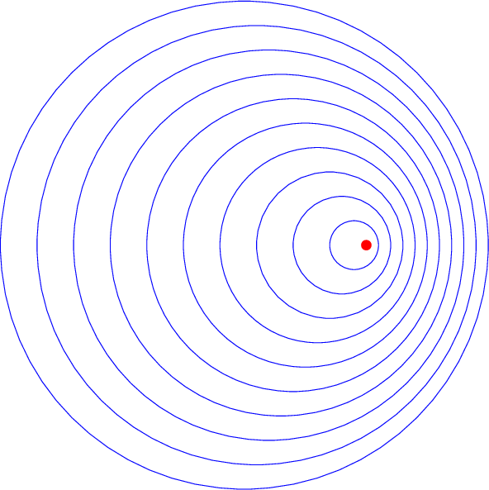

[**VISUAL PHYSICS ONLINE**](http://www.physics.usyd.edu.au/teach_res/hsp/sp/spHome.htm)

**Module 3.1 WAVES**

**DOPPLER EFFECT FOR SOUND**

**DOPPLER EFFECT - motion related frequency changes**

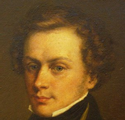Christian Doppler was an Austrian mathematician who lived between 1803-1853. Doppler was the son of a stonemason, who went on to become a celebrated academic and scientist. After young Christian completed school, he studied astronomy and mathematics in Salzburg and Vienna, and at the age of 38 went on to work at the Prague Polytechnic in Czechoslovakia. On 17 March 1853, at the age of only 49, Christian Doppler died from a respiratory disease in Venice (which was then still a part of the vast, wealthy Austrian Empire) and he’s still interred there, on the Venetian island cemetery of San Michele, where one can visit his tomb.

He is known for the principle he proposed in concerning the coloured light of double stars in 1842. This principle is now known as the Doppler Effect. He also hypothesized that the pitch of a sound would change if the source of the sound was moving. Doppler's hypothesis was tested by Buys Ballot in 1845. He used two sets of trumpeters: one set stationary at a train station and one set moving on an open train car. Both sets of musicians had perfect pitch and held the same note. As the train passed the station, it was obvious that the frequency of the two notes didn't match, even though the musicians were playing the same note. This provided evidence to support Doppler's hypothesis. Later, a scientist named Fizeau generalized Doppler's work by applying his theory not only to sound but also to light. The Doppler Effect is the change in frequency (wavelength) of a wave detected by an observer due to the relative motion between the observer and the source of the sound. It applies to all sorts of waves, including sound waves and light waves.

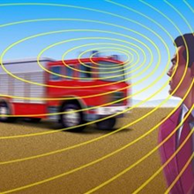A common example of the Doppler Effect is the change in pitch observed as a fire engine passes an observer. When the fire engine is approaching, the pitch sounds higher than the actual emitted frequency. When the fire engine passes by, the frequency sounds the same as the actual emitted frequency and when the fire engine is moving away, the pitch is observed to be lower than the actual emitted frequency.

When the source of the waves is moving towards the observer, each successive wave crest is emitted from a position closer to the observer than the previous wave. Therefore, each wave takes slightly less time to reach the observer than the previous wave - the distance between successive wave fronts is reduced (wavelength decreased), so the waves bunch together. Hence, the time between the arrival of successive wave crests at the observer is reduced, causing an increase in the frequency. Conversely, if the source of waves is moving away from the observer, each wave is emitted from a position farther from the observer than the previous wave - the distance between successive wave fronts is then increased (wavelength increased), so the waves "spread out". Therefore, the arrival time between successive waves is increased, reducing the frequency.

For waves that propagate in a medium, such as sound, the velocity of the observer and of the source are relative to the medium in which the waves are transmitted. The total Doppler Effect may therefore result from motion of the source, motion of the observer, or motion of the medium. Each of these effects is analysed separately. For waves which do not require a medium such as light, only the relative velocity between the observer and the source needs to be considered.

The Doppler Effect for sound is described by the equation

 **sound only**



 observed (detected) frequency

 observer’s speed relative to the medium

 frequency of oscillations of the source signal

 velocity of source relative to the medium

 speed of sound in the medium

The upper signs apply for the relative approach of the source and observer. The lower signs, for relative recession. Note: the symbol *v* represents the magnitude of the velocity only. Remember that the magnitude of a vector is always a positive quantity. The  signs are not used to indicate a direction. The choice of sign is based upon whether the resulting motion would increase or decrease the observed frequency. Hence, the signs to use can be determined by the information displayed in Table 1 and by understanding the images of the Doppler Effect in figure (1).

|  |  |  |
| --- | --- | --- |
| Table 1. Doppler Effect | | |
| **source *v*s** | **observer *v*o** | **observed frequency *f*o** |
| stationary | stationary | = *f*o |
| stationary | receding | < *f*o |
| stationary | approaching | > *f*o |
| receding | stationary | < *f*o |
| approaching | stationary | > *f*o |
| receding | receding | < *f*o |
| approaching | approaching | > *f*o |
| approaching | receding | ? |
| receding | approaching | ? |

There are many important applications on the Doppler Effect and a few examples include:

police microwave speed units

measuring the speed of a tennis ball

measuring the speed of blood flowing through an artery

monitoring the heart-beat of a developing fetus

burglar alarms

sonar: ships & submarines to detect submerged objects

detecting distance planets

observing the motion of oscillating stars

Do a web search to find out more about Doppler Effect and its applications.

[View Animations](http://www.physics.usyd.edu.au/teach_res/hsp/sp/mod31/m31_doppler_ag.htm)

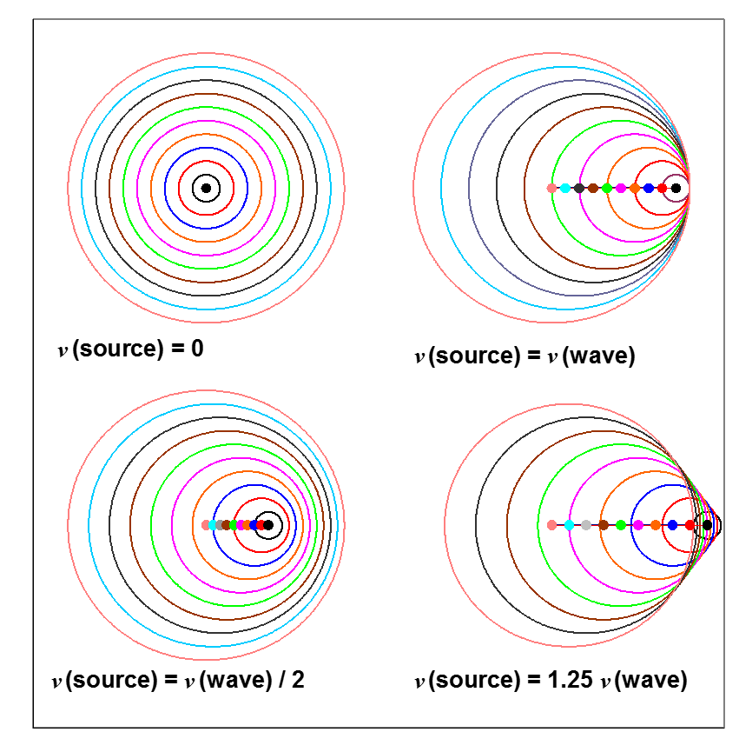

Fig. 1. Schematic diagrams of the Doppler Effect for a moving source. In front of the moving source the wavefronts bunch together, hence the wavelength is smaller and the frequency increased. Behind the moving source, the wavefronts spread out, hence the wavelength is larger and the frequency decreased. When the speed of the source is equal or greater than the wave speed, the wavefronts merge producing a large disturbance (superposition principle) and a bow wave [2D] or shock wave [3D] is generated.

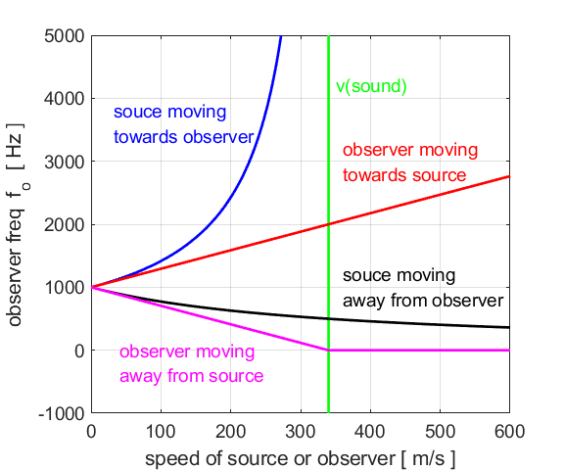

Fig. 2. Doppler shifted frequency versus speed for a 1000 Hz source. **Green curve**: speed of sound is 340 m.s-1. **Blue curve**: source moving towards a stationary observer - the frequency grows without limit as the speed of the source approaches the speed of sound, if the source moves faster than the speed of sound it produces not a pure tone but a shock wave. **CBlack curve**: source moving away from a stationary observer – frequency decreases with increasing speed of recession. **Red curve**: observer moving towards a stationary source – approximately a linear increase in frequency with speed. **Magenta curve**: observer moving away from stationary source – approximately a linear decrease in frequency with speed of recession.

**BOW and SHOCK WAVES**

Interesting effects occur when the speed of a source is as great or greater than the speed of the wave . The waves pile up in front of the source as shown in figure 1.

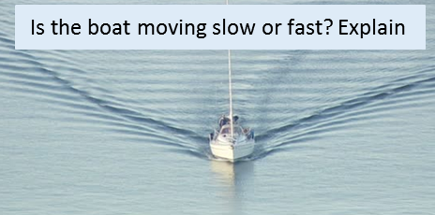A boat travelling through the water (speed of boat is larger than the speed of the water wave) generates a two-dimensional bow wave where the waves overlap at the edges producing a V shaped wave front.

A supersonic aircraft generates a three-dimensional shock wave. The shock wave is generated by overlapping spheres that form a cone shaped wavefront.

We don’t heat a sonic boom from slower than sound aircraft as the sound waves reaching us are perceived as one continuous tone. However, when a plane travels faster than the speed of sound, the wavefronts coalesce and the observer hears a single burst of sound because of the high / low pressures that are generated in the sound wave. The shock wave is actually made up of two cones: a high-pressure cone with the its apex at the front tip of the plane and the low-pressure cone with its apex at the tail.

A common misconception is that sonic booms are produced when aircraft fly through the sound barrier (speed of plane becomes greater than the speed of sound). This is not the case. A sonic boom is swept continuously behind and below the plane.

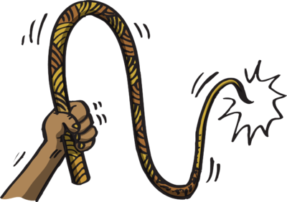When a whip is cracked, the cracking sound is a sonic boom produced by the tip of the whip travelling faster than the speed of sound.

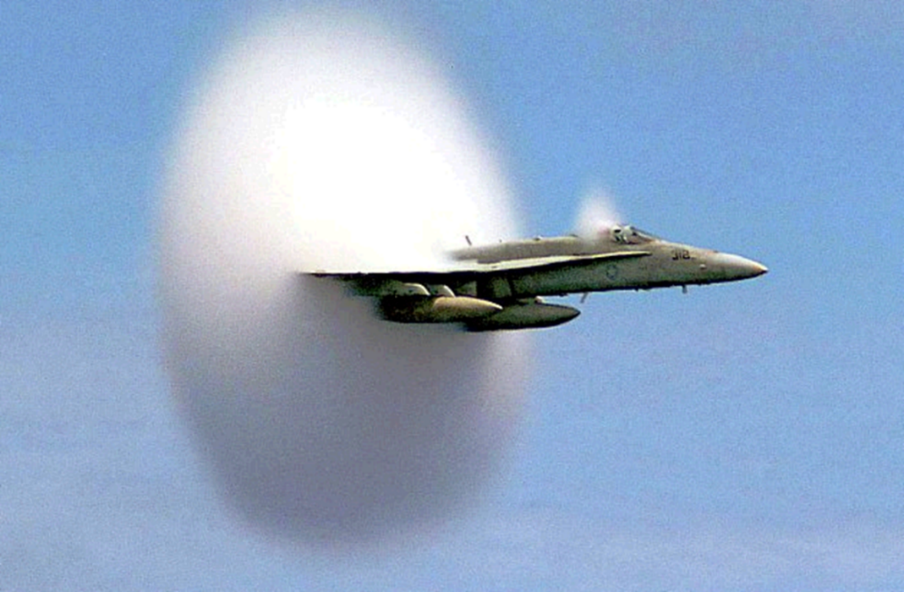

An aircraft producing a cloud of water vapour that condenses out of the rapidly expanding air in the rarefied region behind a wall of compressed air.

|  |
| --- |
| **Example**  A train whistle is blown by the driver who hears the sound at 650 Hz. If the train is heading towards a station at 20.0 m.s-1, what will the whistle sound like to a waiting commuter? Take the speed of sound to be 340 m.s-1.  **Solution**  *fs* = 650 Hz *vs* = 20 m.s-1 *vo* = 0 m.s-1 *v* = 340 m.s-1  *fo* = ? Hz (must be higher since train approaches observer). |

|  |
| --- |
| **Example**  An ambulance travels down a straight section of highway at a speed of 100 km.h-1, its siren emitting sound at a frequency of 400 Hz. What frequency is heard by a passenger in a car travelling on the same highway at a speed of 80 km.h-1 Consider all possibilities.  Speed of sound in air is 345 m.s-1.  **Solution**  The first steps are to visualise the problem.  Consider all the possible relative motions of the ambulance and car, then draw an annotated scientific diagram        Case 1      Case 2      Case 3      Case 4 |

|  |
| --- |
| **Example**  A train travelling at 25 m.s-1 sounds its horn at a frequency of 800.0 Hz as it approaches a tunnel in a cliff.   1. What is the frequency observed for a person standing near the entrance of the tunnel? 2. The sound from the horn reflects off the cliff back to the train driver. What does the train driver hear?   Speed of sound in air is 345 m.s-1.  **Solution**  The first steps are to visualise the problem and draw an annotated scientific diagram  Doppler Effect  (a)        (b)      The train driver would the beat pattern from the superposition of the original sound at 800 Hz and the reflected sound at 933 Hz.  Beat frequency |

|  |
| --- |
| **Example**  An ultrasonic wave at 8.000×104 Hz is emitted into a vein where the speed of sound is about 1.5 km.s-1. The wave reflects off the red blood cells moving towards the stationary receiver. If the frequency of the returning signal is 8.002×104 Hz, what is the speed of the blood flow?  What would be the beat frequency detected and the beat period? Draw a diagram showing the beat pattern and indicate the beat period.  **Solution**  *fs* = 8.000×104 Hz *fo* = 8.002×104 Hz *v* = 1.5×103 m.s-1  *vb* = ? m.s-1  Need to consider two Doppler shifts in frequency – blood cells act as observer and than as source.  Red blood cells (observer) moving toward source  Red blood cells (source) moving toward observer    *fbeat* = |*f*2-*f*1| = (8.002 - 8.000)×104 Hz = 20 Hz  *Tbeat* = 1/*fbeat* = 0.05 s |

|  |
| --- |
| **Problem**  The speed of blood in the aorta is normally about 0.3000 m.s-1. What beat frequency would you expect if 4.000 MHz ultrasound waves were directed along the blood flow and reflected from the end of red blood cells? Assume that the sound waves travel through the blood with a velocity of 1540 m.s-1. Solution   Doppler Effect  Beats  Blood is moving away from source ⇒ observer moving away from source ⇒ *f*o < *f*s    Wave reflected off red blood cells ⇒ source moving away from observer ⇒ *f*o < *f*s    Beat frequency = | 4.00 – 3.998442| ×106 Hz = 1558 Hz  *In this type of calculation you must keep extra significant figures.* |

[VISUAL PHYSICS ONLINE](http://www.physics.usyd.edu.au/teach_res/hsp/sp/spHome.htm)

If you have any feedback, comments, suggestions or corrections please email:

Ian Cooper School of Physics University of Sydney

ian.cooper@sydney.edu.au