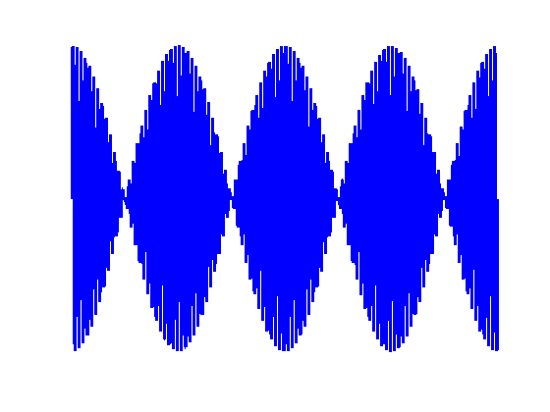

[**VISUAL PHYSICS ONLINE**](http://www.physics.usyd.edu.au/teach_res/hsp/sp/spHome.htm)

**WAVES**

**BEATS:**

**INTERFERENCE IN TIME**

Beats is an example of the interference of two waves in the time domain. Loud-soft-loud modulations of intensity are produced when waves of slightly different frequencies are superimposed.

Consider two sound sources producing audible sinusoidal waves at slightly different frequencies  and .

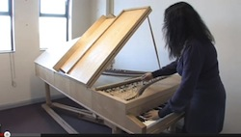

How can a piano tuner use beats in tuning a piano? What will the person hear?

If the two waves at first are in phase they will interfere constructively and a large amplitude resultant wave occurs which will give a loud sound.

As time passes, the two waves become progressively out of phase until they interfere destructively and the sound will be very quiet. The waves then gradually become in phase again and the pattern repeats itself.

Figure (1) shows a resultant waveform with rapid fluctuations but with an envelope that various slowly.

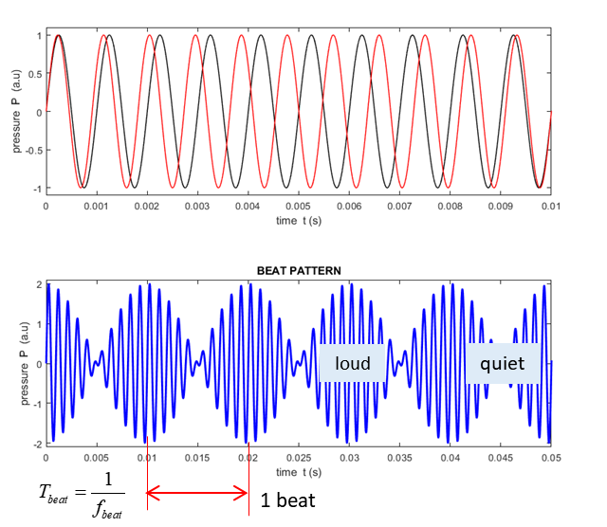

Fig. 1. Beat pattern. Two waves with different frequency create a beat because of interference between them. The beat frequency is the difference of the two frequencies. Estimate *f*1, *f*2 and *fbeat.*

The frequency  of the rapid fluctuations is the average frequency of  and 



The frequency  of the slowly varying envelope is given by half the absolute value of the difference in the frequencies  and 



Since the envelope has two extreme values in a cycle, we hear a loud sound twice in one cycle since the ear is sensitive to the square of the wave amplitude. This is called the beat frequency 

 beat frequency

|  |
| --- |
| **Example 1**  **Rapid oscillations**    **Beats**    loud pulsation will be heard every 0.10 s |
| **Example 2**  **Rapid oscillations**    **Beats**    loud pulsation will be heard every 0.050 s    **Example 3**  **Rapid oscillations**    **Beats**    loud pulsation will be heard every 0.050 s |
| **Exercise**  From the graphs shown in exercises 2, 3 and 4 verify the numerical results given in the three Examples. | | |

Beats can occur with any kind of wave and the best example is with sound waves. A piano tuner listens for beats produced from a standard frequency and the string to be tuned. The string is tuned when the two strings have the same frequency and the beats disappear.

The detection of relative motion by dolphins is explained using the **Doppler Effect** and **beats**. The dolphin sends out a signal and detects any echoes. If there is zero relative motion, then the two signals have the same frequency and no beats are detected. If there is relative motion, then one or both of the signals will have a change in frequency due to the Doppler Effect and so the two frequencies will be slightly different and beats will be detected.

The same principle is used by the polices radar units to catch you speeding.

Bats emit a 'chirp', and listen to the echoes. From these echoes bats can build a rich picture of the world about them just as dolphins can detect relative motion.

You hear dolphins call, but you can't hear bats. Why not? Humans can only hear sound up to about 16 kHz. Bats emit sounds at typically 2 or 3 times higher pitch than we can hear. Sounds above human hearing are usually called **ultrasonic**.   
Whales and elephants can make sounds below what we can hear, about 16 Hz and these are called **infrasonic**.

Plucking two guitar strings of slightly different frequencies will produce beats. The members of an orchestra can tune up by listening for beats between their instruments and that of a standard tone, usually A above middle C at 440 Hz produced by a piano or an oboe. Two piano strings differing in frequency by about 3 Hz sounds out of tune.

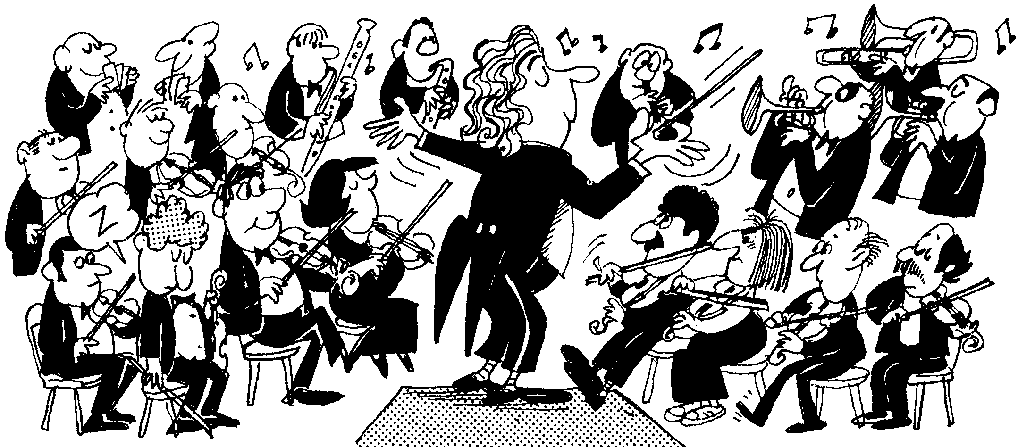

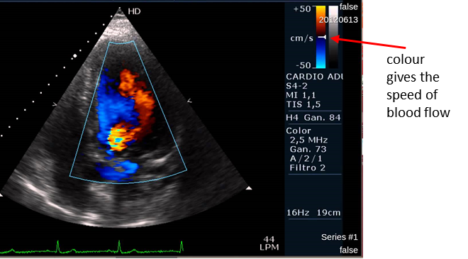The phenomena of Doppler Effects and Beats is used in the images of the blood flow through the heart are captured using ultrasound.

**Web search: Cardiovascular and Doppler ultrasound.**

The engines of multiengine propeller planes have to be synchronised so that the propeller sound does not produce annoying beats which would be heard as a loud throbbing sound.

|  |
| --- |
| **Example**  A tuning fork produces a steady note at 440 Hz tone. When this tuning fork is struck, and held near a vibrating guitar string, 20 beats are counted in 5.0 seconds. What are the possible frequencies produced by the guitar string?  **Solution**  Tuning fork  Guitar  Beat frequency    Guitar  or |

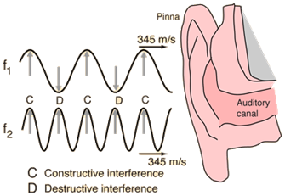Beats between two sounds can be heard up to about **7 Hz**. For beat frequency greater than about 7 Hz, we no longer hear individual beats and the sensation merges into one of consonance or dissonance depending on the ratio of the two frequencies.

In music, **consonance** and **dissonance** are categorizations of simultaneous or successive sounds. Consonance is associated with sweetness, pleasantness, and acceptability. Dissonance is associated with harshness, unpleasantness, or unacceptability.

[EXCEL SIMULATION: Download the MS EXCEL spreadsheet BEATS.XLS](http://www.physics.usyd.edu.au/teach_res/excel/)

[VISUAL PHYSICS ONLINE](http://www.physics.usyd.edu.au/teach_res/hsp/sp/spHome.htm)

If you have any feedback, comments, suggestions or corrections please email:

Ian Cooper School of Physics University of Sydney

ian.cooper@sydney.edu.au