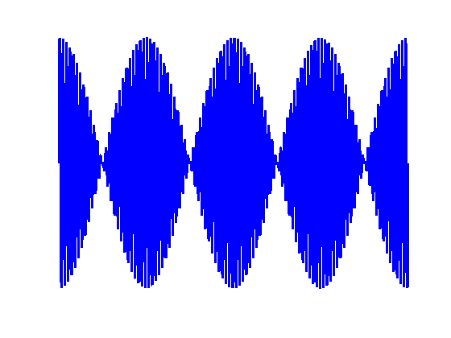

[**HSC PHYSICS ONLINE**](http://www.physics.usyd.edu.au/teach_res/hsp/sp/spHome.htm)

**WAVES**

**VIBRATIONS (OSCILLATUIONS)**

Anything that moves back and forth, to or fro, side to side, in out out, or up or down is said to be vibrating or oscillating.

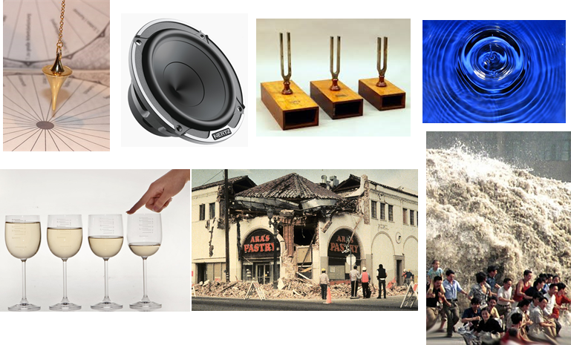

Fig. 1. Identify all the vibrations in the pictures.

A vibration is a periodic “wiggle” in time.

A wave is a periodic “wiggle” in both space and time.

The source of all ways is something that is vibrating.

Light and sound are both vibrations that propagate through space as a wave, but are two very different types of waves.

Sound is a mechanical wavethat propagates through space as the vibrations of a material medium - solid, liquid or gas. Sound can’t travel though a vacuum - a medium must be present for the vibrations to exist.

Light is the vibrations of electric and magnetic fields. It is self-propagating and no medium is required, hence, it can travel through

a vacuum.



A wave is a mechanism for the transfer of energy from one place to another without any material being transferred. Vibrations act a source of waves that travel outward from the source. It is the disturbance that propagates and not the medium.

|  |
| --- |
| **Example**  An ultrasonic wave at 8.000×104 Hz is emitted into a vein where the speed of sound is about 1.5 km.s-1. The wave reflects off the red blood cells moving towards the stationary receiver. If the frequency of the returning signal is 8.002×104 Hz, what is the speed of the blood flow?  What would be the beat frequency detected and the beat period? Draw a diagram showing the beat pattern and indicate the beat period.  **Solution**  *fs* = 8.000×104 Hz *fo* = 8.002×104 Hz *v* = 1.5×103 m.s-1  *vb* = ? m.s-1  Need to consider two Doppler shifts in frequency – blood cells act as observer and than as source.  Red blood cells (observer) moving toward source  Red blood cells (source) moving toward observer    *fbeat* = |*f*2-*f*1| = (8.002 - 8.000)×104 Hz = 20 Hz  *Tbeat* = 1/*fbeat* = 0.05 s |

|  |
| --- |
| **Problem**  The speed of blood in the aorta is normally about 0.3000 m.s-1. What beat frequency would you expect if 4.000 MHz ultrasound waves were directed along the blood flow and reflected from the end of red blood cells? Assume that the sound waves travel through the blood with a velocity of 1540 m.s-1. Solution   Doppler Effect  Beats  Blood is moving away from source ⇒ observer moving away from source ⇒ *f*o < *f*s    Wave reflected off red blood cells ⇒ source moving away from observer ⇒ *f*o < *f*s    Beat frequency = | 4.00 – 3.998442| ×106 Hz = 1558 Hz  *In this type of calculation you must keep extra significant figures.* |