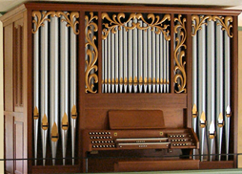

[**HSC PHYSICS ONLINE**](http://www.physics.usyd.edu.au/teach_res/hsp/sp/spHome.htm)

**WAVES MODULE 3.1**

**PRACTICAL ACTIVITY**

**TRAVELLING WAVES**

**GRAPHICAL ANALYSIS WORKSHOP**

This practical activity is best done with a team of three people. There should be a reflection period at the end, where teams present a short summary of their findings to the whole class. It best to use graph paper to draw your graphs. Measurements from figures 1 and 2 can be made by printing the figures, or making the measurements from the screen.

1. Draw a diagram of a sinusoidal transverse wave at one instant of time which as an amplitude of 10 mm and a wavelength of 20 mm. Draw another diagram of the wavefunction at a time of half a period later. Label the crests and troughs in both diagrams. Show three cycles of the wavefunction *s* as a function of position *x*.
2. Draw the complex wave due to the superposition of the three waves for x = 0 to 60 mm:

amplitude = 20 mm, wavelength = 20 mm

amplitude = 30 mm, wavelength = 60 mm

amplitude = 10 mm, wavelength = 30 mm

1. Draw a diagram for a longitudinal wave given by the displacements given in the Table. All measurements are w.r.t. the Origin. Mark the equilibrium positions on your diagram. Show (1) the actual displacement of the particles and (2) the displacement by a sine curve. Mark the positions of the compressions and rarefactions. What is the amplitude and wavelength of the longitudinal wave? What is the displacement of the particles at the centre of a compression or a rarefaction?

|  |  |  |
| --- | --- | --- |
| particle | equilibrium positions  (mm) | particle positions  (mm) |
| 0 | 0 | 0 |
| 1 | 10 | 17 |
| 2 | 20 | 27 |
| 3 | 30 | 30 |
| 4 | 40 | 33 |
| 5 | 50 | 43 |
| 6 | 60 | 60 |
| 7 | 70 | 77 |
| 8 | 80 | 87 |
| 9 | 90 | 90 |
| 10 | 100 | 93 |
| 11 | 110 | 103 |
| 12 | 120 | 120 |

1. Carefully inspect the transverse wave shown in figure 1 at times *t* = 0, *T*/8, 2*T*/8, . . . , *T*.

* Which way is the wave propagating? Why?
* Label each graph with the time steps

*t* = 0, *T*/8, 2*T*/8, . . . , *T*

* Label a crest with “C” on each graph to show the propagation of the wave.
* Using a mm scale, estimate the amplitude and wavelength of the wave.
* How far does the labelled crest move in one period?
* If the period of the wave is *T* = 15 ms (milliseconds), estimate the frequency and speed of the wave.
* Describe the motion of the marked dot shown in the diagram.
* Write an equation for the motion of this point.

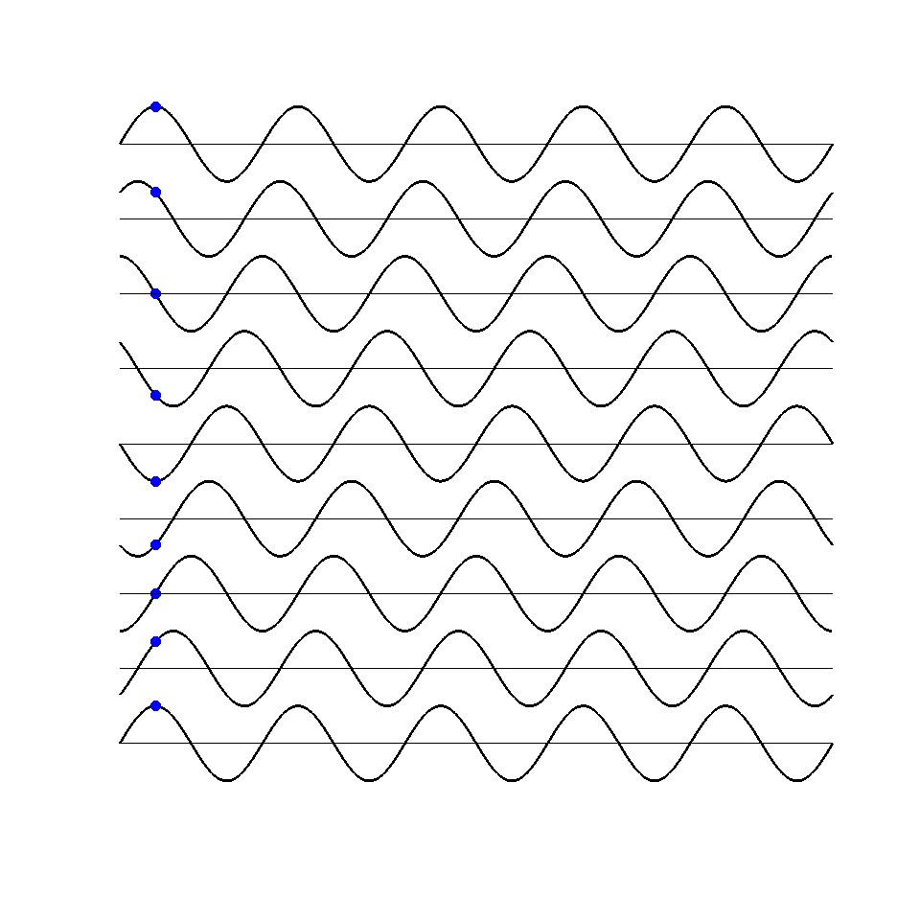

Fig. 1. A propagating transverse wave shown at different time steps.

1. A propagating longitudinal wave is shown in figure 2 at time steps *t* = 0, *T*/8, 2*T*/8, . . . , *T*

* Which way is the wave propagating? Why?
* Label each graph with the time steps

*t* = 0, *T*/8, 2*T*/8, . . . , *T*

* Label a crest (compression) with “C” on each graph to show the propagation of the wave.
* Using a mm scale, estimate the amplitude and wavelength of the wave.
* How far does the labelled crest move in one period?
* If the period of the wave is *T* = 5.0 ms, estimate the frequency and speed of the wave.
* Describe the motion of the marked dot shown in the diagram.

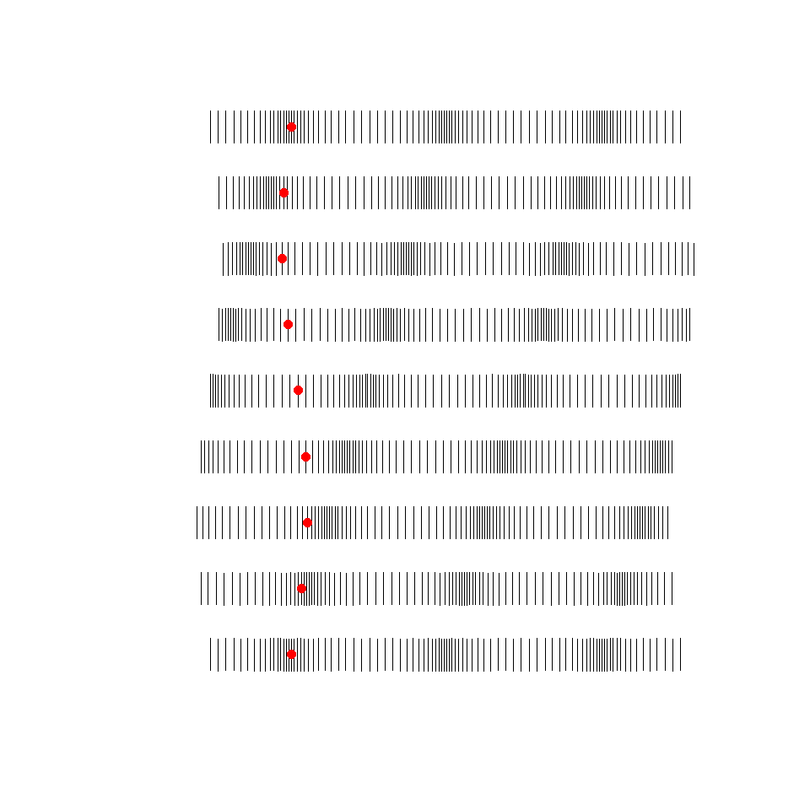

Fig. 2. Progressive longitudinal wave shown at *T*/8 time steps.

1. A travelling wave is described by the equation



where *x* and *y* are measured in millimetres and *t* in seconds.

Calculate the following physical quantities:

wave number (propagation constant)

wavelength

angular frequency

frequency

period

wave speed

amplitude

What is the direction of propagation of the wave?

1. The piston of a car engine has a mass of 1.25 kg and executes SHM with a frequency of 50 Hz and has an amplitude of 50 mm.

Find the maximum velocity, maximum acceleration and maximum force on the piston.

Only look at the solutions to the questions after you have completed your answers. Getting the right answer is not important - what is important is the learning process that will help you maximize your marks in the final HSC exam.

After you have completed your attempts at the questions, compare your answers with the solutions and account for any discrepancies.

Redo any questions that you had difficulty with a few days later.

**SOLUTION GUIDELINES**

**Answer 1**

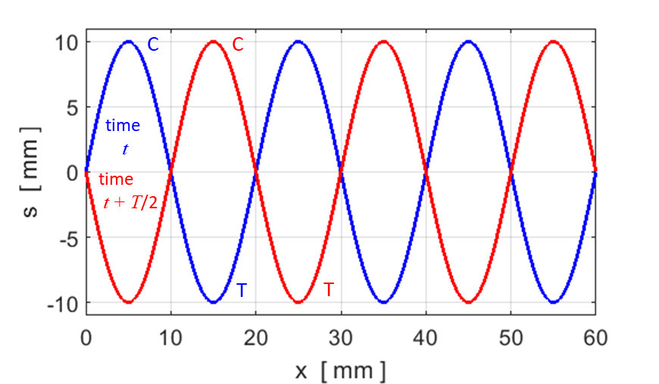

**Answer 2**

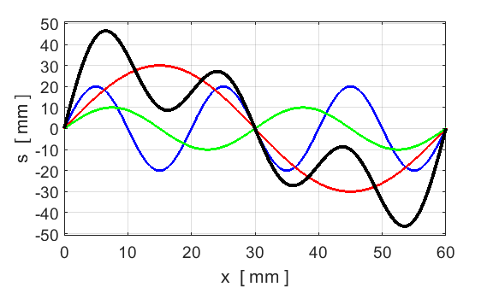

**Answer 3**

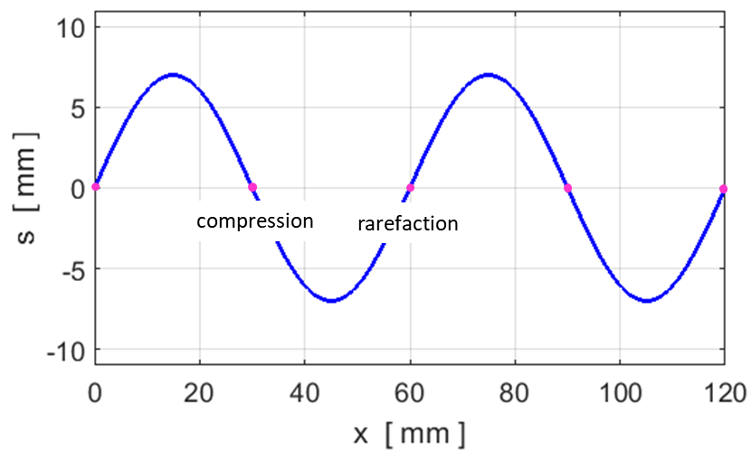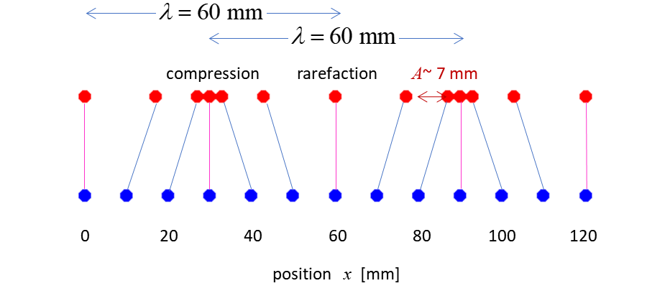

Note, the particles at the centre of a compression or rarefaction are located at their equilibrium positions.

**Answer 4**

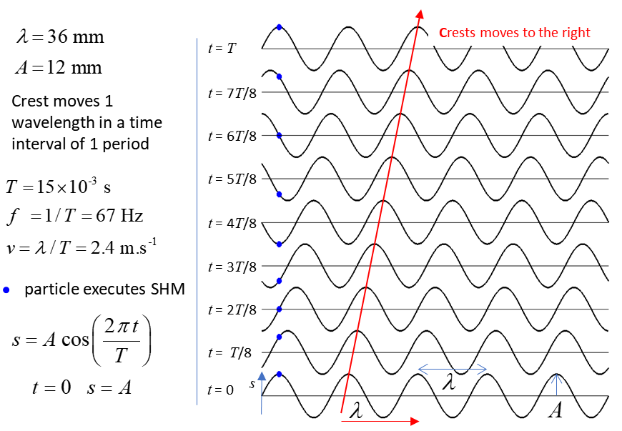

**Answer 5**

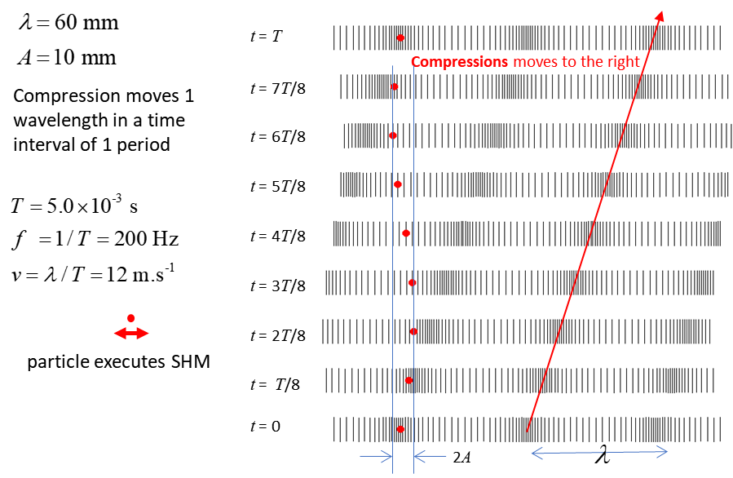

**Answer 6**

[View Notes](http://www.physics.usyd.edu.au/teach_res/hsp/sp/mod31/m31_wavesA.htm)



**Answer 7**

[View Notes](http://www.physics.usyd.edu.au/teach_res/hsp/sp/mod31/m31_wavesA.htm)

