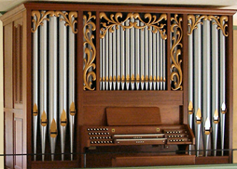

[**HSC PHYSICS ONLINE**](http://www.physics.usyd.edu.au/teach_res/hsp/sp/spHome.htm)

**WAVES MODULE 3.1**

**PRACTICAL ACTIVITY**

**STANDING WAVES IN AIR COLUMNS**

**VIDEO ANALYSIS WORKSHOP**

This practical activity is best done with a team of three people. There should be a reflection period at the end, where teams present a short summary of their findings to the whole class. You may need to stop and replay parts of the video. The video can be watched in class using your tablet computer or your mobile phone.

[VIEW VIDEO](http://www.physics.usyd.edu.au/teach_res/hsp/sp/images/tubeOC.mp4)

Carefully watch the video ***Sound Resonance Tube*** given by Dr Stephen Bosi and then answer the following questions.

1. Draw a diagram of the perspex tube and indicate the boundary conditions for the pressure fluctuations.
2. Explain the meanings of the terms and how they relate to the video: pressure fluctuations, frequency, wavelength, speed, amplitude, standing waves, nodes, antinodes, driving force, natural frequencies of vibration, resonance.
3. What is the mathematical relationship between speed , frequency  and wavelength ?
4. What is the relationship between normal mode number , the length of the tube , the wavelength ?
5. What is the distance between any pair of adjacent nodes? How is a node found in the video?
6. Look carefully at the positions of the pressure nodes along the length of the tube in Experiment 1. Draw a diagram of the standing wave pattern for the pressure fluctuations. How many ¼ wavelengths fit into the length of the tube? What is the mode number  for this normal mode of vibration?
7. What were the frequency  and wavelength measurements made by Stephen in Experiment 1?
8. Calculate the speed  of sound in air and the length of the tube .
9. Calculate the frequency  of the fundamental mode of vibration.
10. What harmonic is excited in Experiment 1?
11. What are the frequency and wavelength measurements in Experiment 2.
12. What is the harmonic excited in Experiment 2?
13. Calculate the speed of sound in air from the results of Experiment 2.
14. How do the values for the speed of sound in air from Experiment 1 and Experiment 2 compare?
15. Comment on the **validity**, **reliability**, **accuracy** and **precision** of the results from the experiments.

The length of the tube can be estimated by placing a piece of paper on the screen and marking the two ends of the tube and two marks for one wavelength in Experiment 1. We know that one wavelength is 555 mm, hence you can calculate the length of the tube in millimetres. Use this length to recalculate the speed of sound. So, is the experimental method **valid**?

Estimate the diameter *D* of the tube by adding two extra marks on your piece of paper. The pressure node at the open end of the tube is occurs outside the tube and so the effective length *Leff* of the tube is longer



The term  is called the **end correction**.

Recalculate the speed of sound using *Leff*. Is this model valid?

**Accuracy** – how accurate are the measurements for the position of the nodes by considering the physical size of the microphone? Hence, what is the accuracy of the speed of sound measurement?

**Precision** – Stephen only quoted the average wavelength. We can do better than this. Add marking to your piece of paper to measure the wavelength twice, and from these measurements, estimate the variation in the speed of sound.

1. Estimate the temperature of the room and its uncertainty from your results.
2. List and discuss the shortcomings you found in this video clip.

**Review answers only after you have completed all the questions**

**Solution Guidelines**

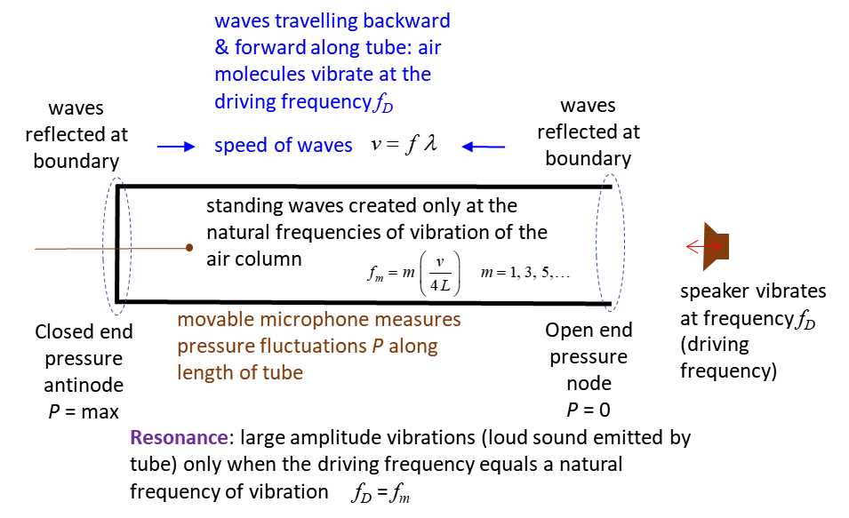

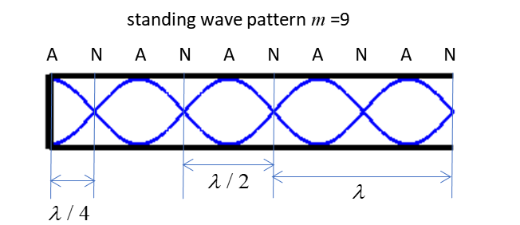

Expt. 1. Standing wave pattern for the 9th harmonic.

From the standing wave pattern, the natural frequency of the air column excited by the loudspeaker corresponds to the normal modes . The wavelength can be measured by measuring the distance between pressure nodes.

Steve’s measurements 

Speed  of sound in air 

The length  of the tube is



The fundamental frequency  is



**Experiment 2**

The driving frequency was 885 Hz.

Estimation of the normal mode number from

 13th harmonic

Steve’s measurements 



From the results of Experiments 1 and 2, the best estimate of the speed of sound in air is



which agrees very well with the stated speed of sound which was quoted as 345.5 m.s-1.

**Validity:** are the results of the experiment valid?

The model of a narrow, long air column predicts that the allowed modes of vibration are given by



For experiment 1



But we can estimate the physical length of the tube from the given measurement of the wavelength and from the screen measurements of the wavelength and tube length

screen measurements 

but, we know that



Therefore, the physical length of the tube is



The wavelength for the 9th harmonic is



and the speed of sound is



which is very different from our previous estimate



So, you can conclude that our model is not valid.

A better model for our Open-Closed tube is that at the open end the pressure node is located a distance outside the end of the open end, where



Using the screen measurements, the diameter *D* of the tube is



and



so, the effective length of the tube is



The velocity using this length is



Considering the end correction, we can conclude that our experimental method of determining the speed of sound in air is valid.

**Accuracy**

The microphone is used to locate the nodes and the separation between nodes is used to estimate the wavelength. However, the microphone disturbs the pressure distribution in the tube and the microphone because of its physical size can’t measure the position at a point. So, our measuring instrument imposes an uncertainty on our measurement and this error is related to the accuracy of the results. It is difficult to know what this error is, so, we must make a scientific judgment about its value. An appropriate estimate for the error is 2 mm. This corresponds to a 0.5% accuracy error in the measurement of the wavelength

100 X (2/555) = 0.3604 error = 2 mm wavelength = 555 mm

Just taking the numbers for the frequency and wavelength from Experiment 1, the speed of sound is



But, this is not a sensible answer (can’t use all those decimal places), we only can measure the speed to 

Therefore, our best estimate of the speed of sound considering the **accuracy** of our measuring instrument is



**Precision**

The precision of the results relates to the variation in the repeated measurement of the same quantity. Using the results of measurements 1 and 2, our best estimate of the speed of sound was

 precision

where  is the uncertainty in the measurement due to the precision.

Stephen only quoted an average wavelength. But, if you made your measurements off the screen for the distance between adjacent nodes in Experiment 1, the uncertainly in the measurement of the velocity is about 1%

 precision

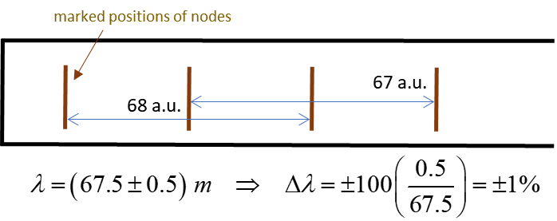

The results of the experiment are **reliable**. Repeating the experiment many times or using the different tubes, the results of the measurement would be reproducible.

**Air temperature **

 Air temperature  [K]



**Short Comings**

* The wavelength was given in centimetres. The Australian Government standard for the S.I. System of Units, states that the metre is the base unit and millimetres should be used and not centimetres.
* Only the wavelengths were given and their uncertainties were not.
* No discussion about, resonance, natural frequencies of vibration, driving force, fundamental frequency, normal modes of vibration.
* Did not show that the node at the open end of the tube occurs outside the open end.
* Did no show the variation in pressure fluctuation along the entire length of the tube, therefore, did not show the boundary conditions for the pressure. This could have been done by simply moving the microphone slowly along the length of the tube.
* Did not show the pressure variation along the tube when the driving (speaker) frequency did not match one of the natural frequencies of vibration.
* Did not show that at resonance the sound from the tube is louder than when the tube is excited at a frequency close to a natural frequency of vibration.