[**VISUAL PHYSICS ONLINE**](http://www.physics.usyd.edu.au/teach_res/hsp/sp/spHome.htm)

**THERMODYNAMICS**

**THERMAL ENERGY**

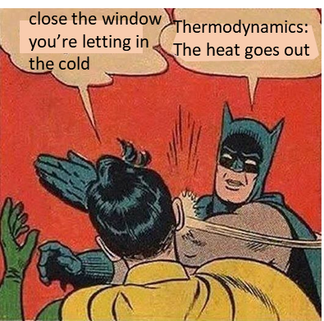

**INTERNAL ENERGY**

A thermodynamic System is composed of molecules in a solid state and/or a liquid and/or a gas state. The molecules always have some **random** or **chaotic motion**. Therefore, the System has a kinetic energy due to this random and chaotic motion. The kinetic energy is classified as **translational kinetic energy** (movement of molecules from one place to another), **rotational kinetic energy** (rotation of molecules about the XYZ axes) and **vibrational kinetic energy** (periodic vibrations of the molecules).

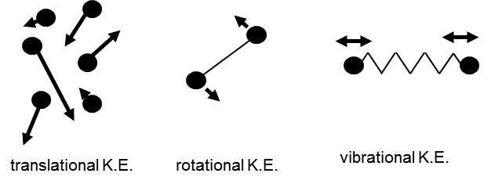

There are attractive and repulsive forces acting between molecules often giving rise to molecular bonds. Therefore, the System has **potential energy** due to these interactions.

The total sum of all the kinetic energies of the molecules together with the potential energies of the System is called the **internal energy**  of the System. It is a state variable and its value can change with time in response to the exchange of energy between the System and the surrounding environment through the processes of **work** and **heat** .

Often **internal energy** is also called **thermal energy**. However, sometimes, thermal energy has a much broader interpretation. Even physicist can’t agree on the language to be used in thermal physics. The best approach is to consider the internal energy as the sum of the kinetic energies and potential energies for the System and use thermal energy as a broader term that is closely related to internal energy.

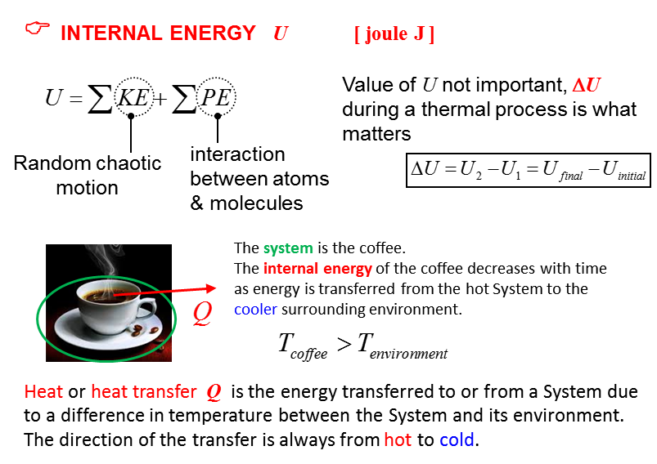

The internal energy of an isolated system is constant. Internal energy is **not** a form of energy but a way of describing the fact that the energy in atoms is both stored as potential and kinetic energy. It does **not** include kinetic energy of the object as a whole or any external potential energy due to actions of external forces or relativistic energy .

**But what do we mean by heat, work and temperature?**

**Temperature T [K kelvin]**

Macroscopic view:

**The temperature of a System is the degree of hotness or coldness of the System as measured on a temperature scale using a thermometer.**

Microscopic view:

**Temperature of a system is a measure of the random chaotic translational kinetic energy of the particles of the System.**

**Heat *Q*  [J joule]**

**Heat transfer can be considered both the amount of energy transferred as well as the process itself as a result of a temperature difference.**

**Heat** refers to the amount of energy exchanged between Systems due to their difference in temperature. Heat is not a property of a System (heat is not a state variable and not a function of time). It is often better to use **heat transfer** rather than the single word heat.

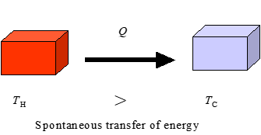

At one time it was though – erroneously – that an object contained a certain amount of “heat fluid” that could flow from one place to another. This idea was overturned by the observations of Benjamin Thompson (Count Rumford). He observed that as long as mechanical work was done to turn drill bits in the boring of cannons, they continued to produce unlimited quantities. Heat could not be contained in the metal cannons, but was continually produced by the turning drill bit.

**Work W [J joule]**

When a force causes a displacement, we say that work is done on or by the System. The energy transferred to or from a System by work may cause a change in temperature of the System.

**Example:** When a gas is compressed in a cylinder, the energy of the gas may result in an increase in the temperature of the gas.

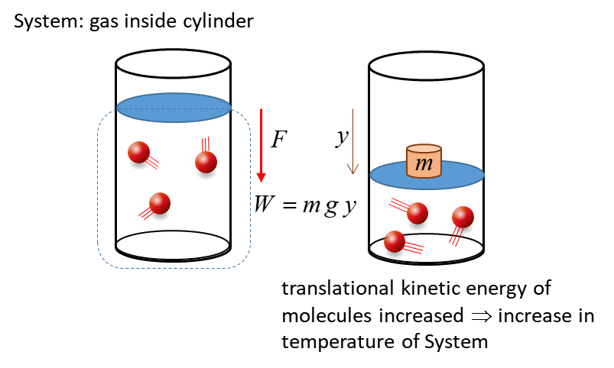

**Example:** if you rub your hands together, you do work. The energy associated with that work is not lost; instead, it produces an increase in the random, chaotic motion of the translational motions of the skin molecules which means that the temperature of the skin will increase. In the process of rubbing your hands, we can account for all the energies and we find that **energy is conserved**. No observation has been made in a situation in which energy is not conserved.

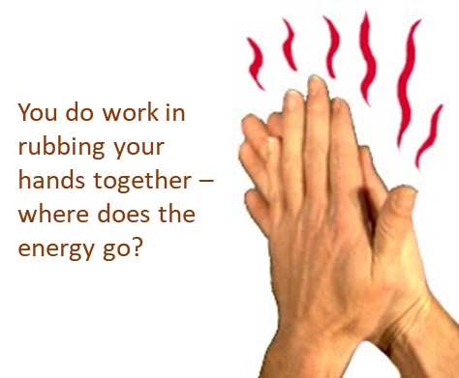

**FIRST LAW OF THERMODYNAMICS**

The **First Law of Thermodynamics** is a statement of **energy conservation** that specifically includes heat transfer (heat) and work.

If heat  is transferred to a System, the internal energy  increases. If this System does work  on the surrounding environment, this energy must come from the internal energy of that System.

The **First law of Thermodynamics** (a law of conservation of energy) is

 **First Law of thermodynamics**

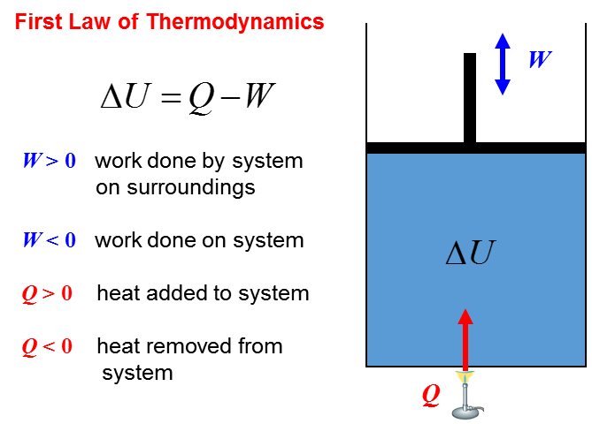

|  |
| --- |
| **Example**  Running along the beach on the weekend, you do 4.8x105 J of work and give off 3.7x105 J of heat. (a) What is the change in your internal energy? (b) When walking, you give off 1.5x105 J of heat and your internal energy decreases by 2.3x105 J. How much work have you done whilst walking?  **Solution**  The person is the System  Apply the First Law of Thermodynamics  Draw an animated scientific diagram    (a)  (b) |

The internal energy  is a very different quantity to heat  and work . Heat  is the amount of energy exchanged because of a temperature difference between Systems when in thermal contact or a System and its surrounding environment. Work  indicates a transfer of energy by the action of a force through a distance. The internal energy  is a state variable that depends on time and upon the state of the System and not how it was brought to that state.

|  |
| --- |
| **Example**  Consider a hot cup of coffee sitting on a table as the System. Using this System as an illustration, give a scientific interpretation of the terms: temperature, heat, work, internal energy, thermal equilibrium.  **Solution** |

**CONSERVATION OF ENERGY INVOLVING FRICTION**

Consider a block that is given an initial velocity  on a horizontal surface. The block comes to a stop due to the frictional force acting on it (coefficient of kinetic friction ). Let the System be the (block + surface). The external net force acting on the System is zero, therefore, we have an isolated System.

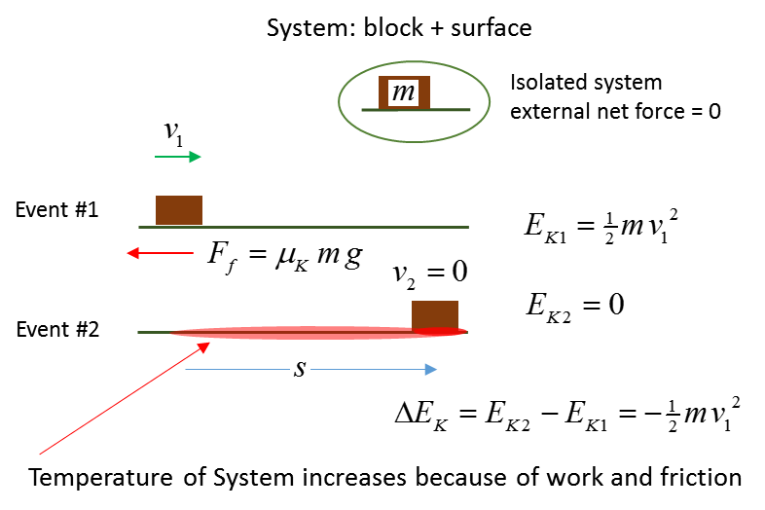

Since we have an isolated System there is zero transfer of energy into or out of the System. Since energy cannot be created or destroyed,

where did the decrease in energy (kinetic) of the System go?

The decrease in energy (kinetic) of the System shows up as an increase in the internal energy of the (block + surface) System and the temperature of the system will increase.



The temperature of the System increases without any heat input. The temperature rise comes from friction and work.

A very good example of an increase in temperature of an object without heating is when a cricket ball is struck by a bat. During the impact of bat and ball, kinetic energy is lost and the internal energy of both bat and ball increase, therefore, the temperature at the impact points of bat and ball increases. This is shown clearly in the thermal imaging of the impact of bat and ball. The image in cricketing terms is called “**hot spot**”. All objects because of their temperature, emit electromagnetic radiation (mainly infrared), the hotter the surface the more radiation is emitted at shorter wavelengths.

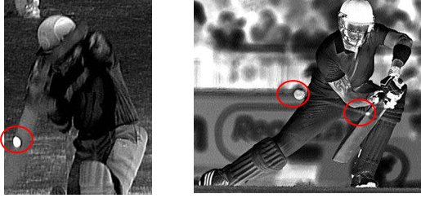

**METHODS OF HEAT TRANSFER**

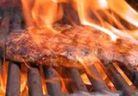

Heat can be exchanged in a variety of ways. The Sun, for example, warms us from across 149.6 million km by a process known as **radiation**. As sunlight is absorbed by the ground its temperature increases, the air near the ground gets warmer and begins to rise, producing a further exchange of energy by **convection**. As you walk across the hot ground in bare feet, you feel a warming effect as heat enters your body by **conduction**. In the following units, we look further into the processes of

**radiation convection conduction**

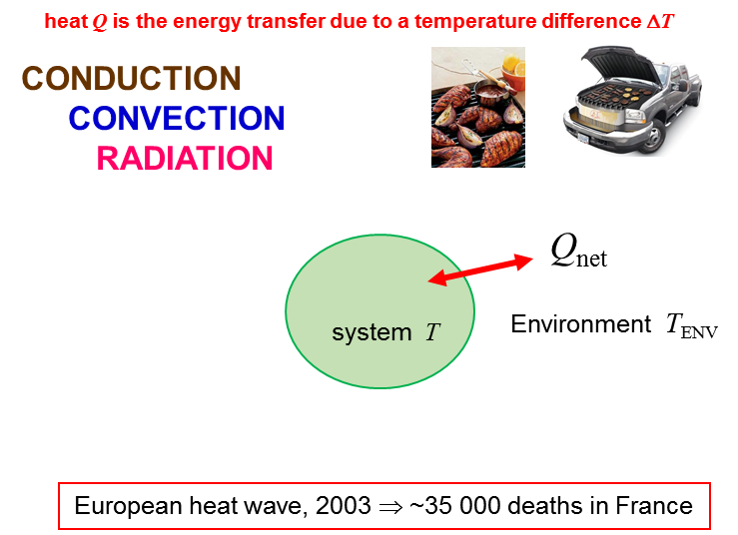

**Thinking Questions**

How are the methods of heat transfer related to the live sheep trade?

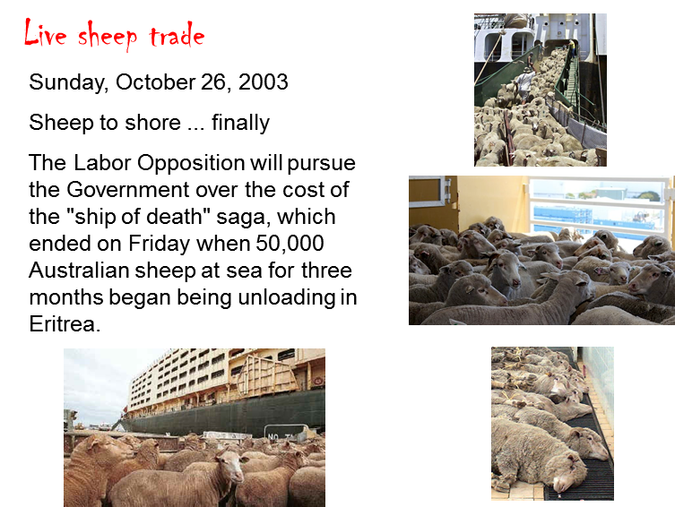

Identify all the methods of heat transfer from the two images

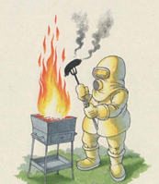

[VISUAL PHYSICS ONLINE](http://www.physics.usyd.edu.au/teach_res/hsp/sp/spHome.htm)

If you have any feedback, comments, suggestions or corrections please email:

Ian Cooper School of Physics University of Sydney

ian.cooper@sydney.edu.au