[**VISUAL PHYSICS ONLINE**](http://www.physics.usyd.edu.au/teach_res/hsp/sp/spHome.htm)

**THERMODYNAMICS**

**SECOND LAW OF THERMODYNAMICS ENTROPY**

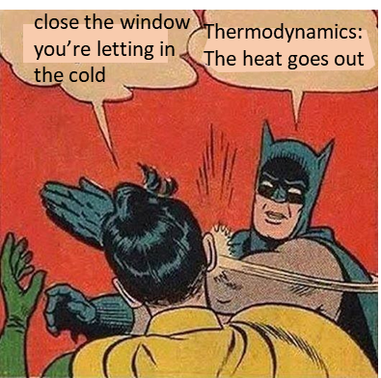

The **Second Law of Thermodynamics** is one of the fundamental laws which describes the workings of our universe. Not like other laws of physics, it can be stated in many different ways. In a sense, the Second Law implies a definite “directionality” to the behaviour of nature – it gives the “arrow of time”

One statement for the Second Law relating to heat:

When Systems of different temperature are brought into thermal contact, the spontaneous flow of energy that results is always from the higher temperature System to the lower temperature System. Spontaneous energy exchange never proceeds in the reverse direction.

Another statement of the Second law relating to entropy.

The total entropy of the Universe increases whenever a real process occurs. Hence, the total entropy of the Universe continually increases.

The concept of **entropy** is as fundamental to physics as energy or temperature. However, it is an abstract concept and is related to the amount of disorder of a System.

**ENTROPY S [ J.K-1 ]**

The **entropy**  of a System is related to the amount of disorder in a system. The entropy is a state variable and the change in the value of the entropy is important and not the actual value of the entropy.

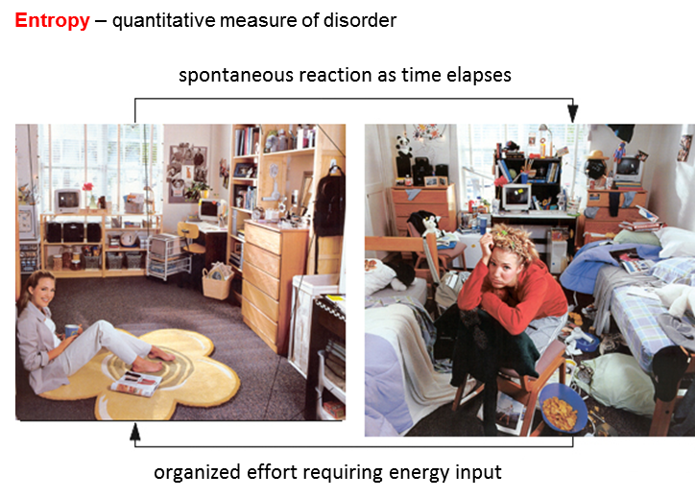

**Entropy in the Universe / Second Law of Thermodynamics**



The total entropy of the Universe stays the same whenever a reversible process occurs.



The total entropy of the Universe increases whenever an irreversible process occurs.



All real processes are irreversible. Hence, the total entropy of the Universe continually increases. In terms of entropy therefore, the Universe moves only in one direction – towards ever increasing entropy. The Second law of Thermodynamics gives the “arrow of time” ever-present in nature.

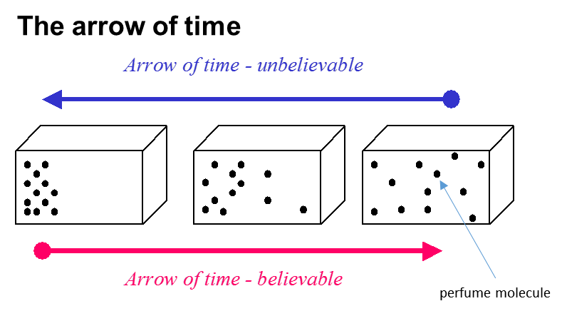

You open a perfume bottle – the perfume gradually spreads throughout the room – it is very unlikely due to the random movement of the perfume molecules that they would all accumulate back into the bottle. When the perfume molecules are in the bottle, it is an ordered arrangement. The molecules move in such a way to increase their disorder and hence increase the entropy.

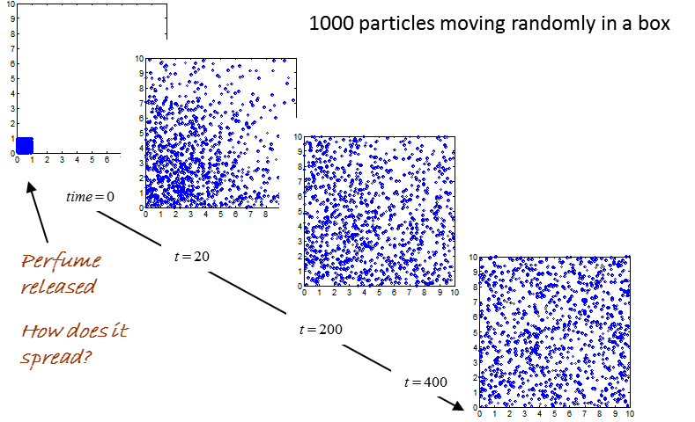

[VIEW ANIMATION](http://www.physics.usyd.edu.au/teach_res/mp/doc/tp_equilibrium.htm)

Entropy and disorder relate to **probability**. Each individual arrangement of the perfume molecules has exactly the same probability of occurring, but there are only a few ways you can arrange for the molecules to be in the bottle and a much greater number of ways to arrange the molecules to fill the room. So, the time evolution for the location of the molecules will be from a situation of lesser to greater probability.

This leads to a natural order in which events will evolve in nature.

**Entropy increases, energy becomes less available, and the universe becomes more random or more “run down”.**

There are no phenomena whereby a System will spontaneously leave a state of equilibrium. All natural processes proceed in such a way that the probability of the state increases – law of increasing entropy – it is one of the most important laws of nature – the Second Law of Thermodynamics

***Why does a block of ice melt?***

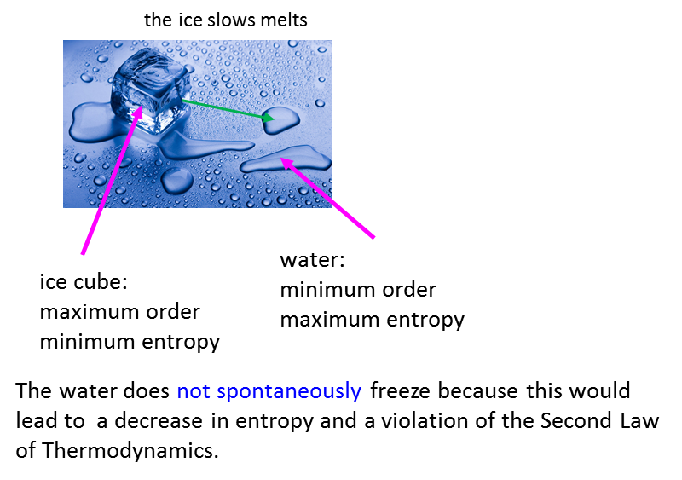

**So why does the energy spontaneously transfer from a hot System to a cold System?**

It is just like the perfume bottle, there are more ways to arrange the gas molecules in a larger volume than a smaller volume. When the two Systems at different temperature are bought into are in thermal contact, the temperature of the two systems will evolve to equilibrium when the two Systems have the same temperature. This occurs because there are more ways in which the kinetic energy can be distributed between all the molecules of the two Systems rather than fewer particles having greater kinetic energies in one of the Systems.

We have two bricks, one hotter than the other. The molecules in the hot brick have more kinetic energy on average than the average kinetic energy of the molecules in the cold brick. This means that the System of the two brick is rather ordered - the hot brick has the high kinetic energy molecules and the cold brick has the low kinetic energy molecules.

The bricks are bought into thermal contact and energy is transferred from the hot brick to cold brick (heat ) until we have thermal equilibrium where the two bricks have the same temperature.

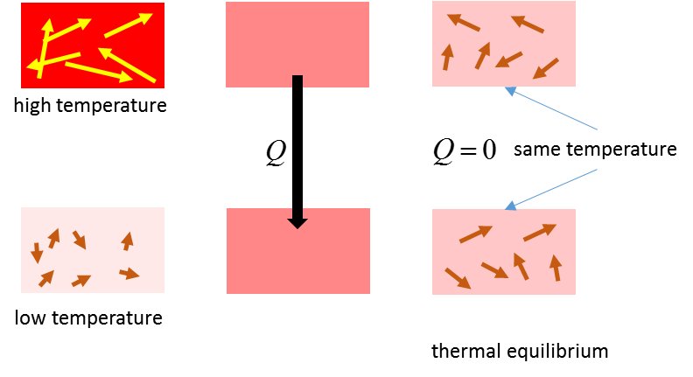

During the heat transfer, the entropy of the universe increases as the ordered pattern for the distribution of the kinetic energies of the molecules becomes more random and disordered. If heat was transferred from the cold brick to the hot brick, the distribution of the kinetic energies would become more ordered and this is a contradiction of the Second Law of Thermodynamics.

**Heath Death of the Universe**

The disorder of the Universe continually increases and as it does, the amount of energy available for useful work decreases. So, one possible fate is the death of the Universe as heat from hot to cold leads to all objects in the Universe being at the same temperature, so no energy is available to do work and no physical processes can occur.

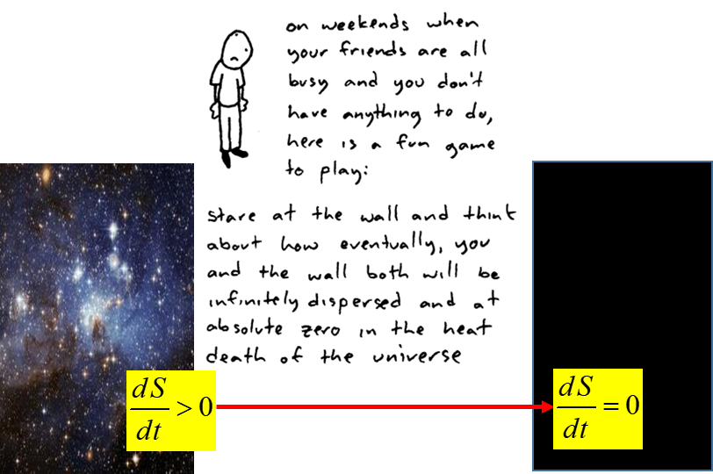

**Car Engines**

A car engine efficiency is always less than 100% because of the Second Law of Thermodynamics. It is impossible to convert all the heat energy from burning the petrol into useful work in moving the car.

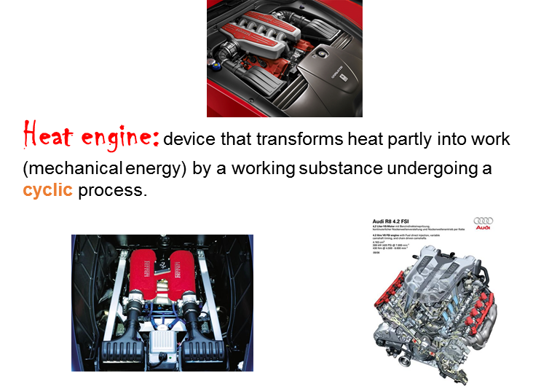

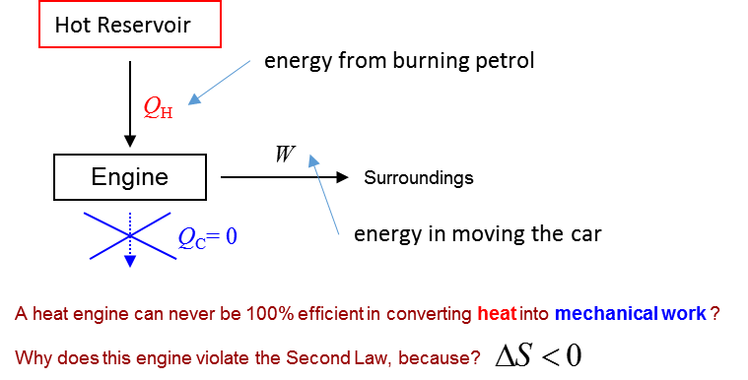

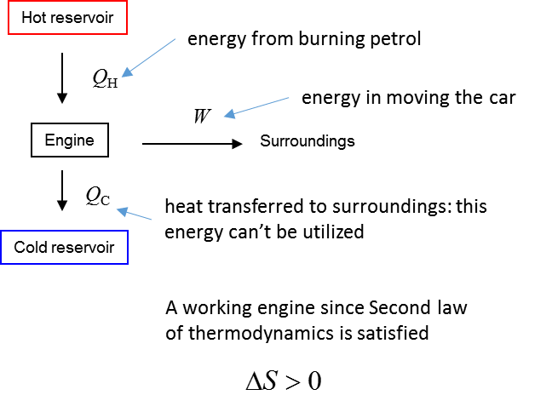

**Macroscopic view of entropy**

An approximate value for the change entropy  of a System at a temperature when energy  is transferred due to a temperature difference is given by



|  |
| --- |
| **Example**  System A at a temperature of 600 K transfers 1200 J of heat to System B which is at a temperature of 300 K. Find the change in entropy of the “universe”.  **Solution**    The entropy of System A decreases    The entropy of System B increases    The change in entropy of the universe is    The spontaneous transfer of energy must be from the hot System to the System at a lower temperature, otherwise, it would be a violation of the Second Law of Thermodynamics . |

[VISUAL PHYSICS ONLINE](http://www.physics.usyd.edu.au/teach_res/hsp/sp/spHome.htm)

If you have any feedback, comments, suggestions or corrections please email:

Ian Cooper School of Physics University of Sydney

ian.cooper@sydney.edu.au