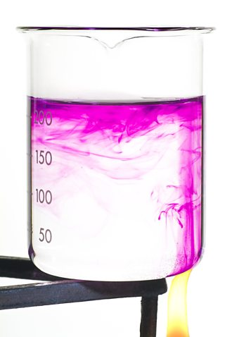[**VISUAL PHYSICS ONLINE**](http://www.physics.usyd.edu.au/teach_res/hsp/sp/spHome.htm)

**THERMODYNAMICS**

**WHAT HAPPENS WHEN SOMETHING IS HEATED ?**

**SPECIFIC HEAT**

A cup of water in a kettle quickly boils but when the kettle is full, we know that it takes much longer to boil. In both cases the rate of energy transfer to the water was the same. So, somehow the **mass** of an object is related to the temperature it will reach in a certain time. Put a metal saucepan with some water in it on to a cooktop. The metal quickly becomes hot but not the water. The **rise in temperature**  also depends on the substance being heated. The rise in temperature of a material is characterised by its **specific heat** . Many books use the term *specific heat capacity* (specific heat is the terminology that you should use).

Consider warming a material of mass  and specific heat  to raise its temperature by  without any change in phase (state). The required energy transferred  to the material is simply given by equation (1A)

(1A)  no change in phase

The rise in temperature  of the material is given by equation (1B)

(1B)  no change in phase

The specific heat is given by equation (1C)

(1C)  [ J.kg-1.K-1 ]

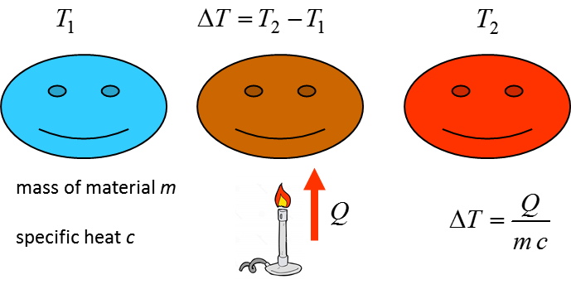

**Specific heats at constant pressure**

|  |  |
| --- | --- |
| **Material** | **[ J.kg-1.K-1 ]** |
| water (liquid 15 oC) | 4186 |
| water (ice -5 oC) | 2100 |
| water (steam 100 oC) | 2010 |
| human body (average) | 3470 |
| alcohol (ether) | 2400 |
| wood | 1700 |
| marble CacO3 | 860 |
| glass | 840 |
| aluminium | 900 |
| iron | 450 |
| copper | 390 |

**Implication of Specific Heat**

**Water has one of the highest values for its specific heat of any common substances.**

**It takes a lot more energy to raise the temperature of water than most other substances, and a lot more energy is released when the temperature of water falls.**

Water can store tremendous of energy because of its high specific heat. It acts as a source or sink of energy in the oceans and atmosphere. Without the presence of water, temperature variations between day and night would be much greater. This is why the daily temperature fluctuations are much smaller near the coast than inland.

Why are western European countries much warmer than the north-eastern region of Canada? Why do islands not have the extreme temperature variations as in the interior of continents?

Since water can store large amounts of energy because its high value of specific heat, it takes a long time to cool and therefore it is a good substance to use in a hot water bottle. As the temperature of the water in the bottle drops a lot of energy is given out.

Since the human body has a large specific heat, it requires a large amount of energy given out by metabolic processes to cause a rise in body temperature.

Water because of its high value of its specific heat is a very useful cooling agent in the cooling system of a car engine. **Explain why!**

|  |
| --- |
| **Example**  If 2000 J are absorbed by copper plate, aluminium plate, glass plate and water, each of mass 250 g, which would be "hottest"?  *c*Cu = 390 J.kg-1.K-1 *c*Al = 910 J.kg-1.K-1  *c*glass = 390 J.kg-1.K-1 *c*water = 4190 J.kg-1.K-1  **Solution**  *Q* = 2000 J  *m*Cu = *m*Al = *m*glass = *m*water = *m* = 250 g = 0.250 kg    copper  Δ*T* = 2000 / {(0.250)(390)} °C = 21 °C  aluminium  Δ*T* = 2000 / {(0.250)(910)} °C = 8.8 °C  glass  Δ*T* = 2000 / {(0.250)(840)} °C = 10 °C  water  Δ*T* = 2000 / {(0.250)(4190)} °C = 1.9 °C  Notice the small change in the temperature of the water.  Why is a copper saucepan better than an aluminium one? |

|  |
| --- |
| **Example**  For a 70 kg person (specific heat capacity 3500 J.kg-1.K-1), how much extra released energy would be required to raise the temperature from 37 °C to 40 °C?  **Solution**  *m* = 70 kg *c* = 3500 J.kg-1.K-1 Δ*T* = (40 – 37) °C = 3 °C    *Specific heat* *Q* = *m c* Δ*T*  *Q* = *m c* Δ*T* = (70)(3500)(3) = 7.45×105 J = 0.74 MJ    A fever represents a large amount of extra energy released. The metabolic rate depends on the temperature of the body. The rate of chemical reactions is very sensitive to temperature and even a small increase in the body's core temperature can increase the metabolic rate quite significantly.  If there is an increase of about 1 °C then the metabolic rate can increase by as much as 10%. Therefore, an increase in core temperature of 3% can produce a 30% increase in metabolic rate.  If the body's temperature drops by 3 °C the metabolic rate and oxygen consumption decrease by about 30%. This is why animals hibernating have a low body temperature. During heart operations, the person's temperature maybe lowered. |

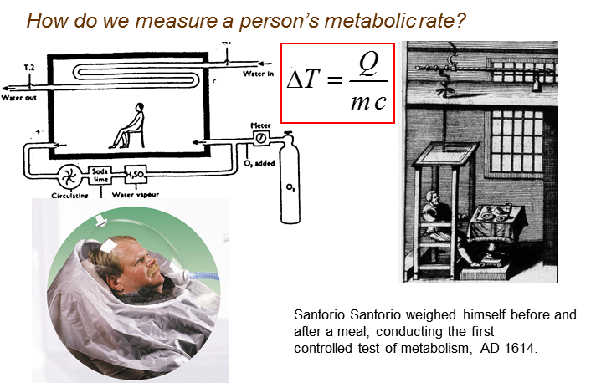

|  |
| --- |
| **Activity**  Manufacturers claim that microwaves give out a certain amount of power, usually around 700 or 800 W. By placing a litre of water in the microwave and heating it for a certain time, by measuring the temperature of the water before and after heating we can work out whether the manufacturer's claim is true.    Power = (Energy Transferred)/(time interval)  1 litre of water has a mass of 1 kilogram  specific heat of water is *c* = 4190 J.kg-1.K-1. |

[VISUAL PHYSICS ONLINE](http://www.physics.usyd.edu.au/teach_res/hsp/sp/spHome.htm)

If you have any feedback, comments, suggestions or corrections please email:

Ian Cooper School of Physics University of Sydney

ian.cooper@sydney.edu.au