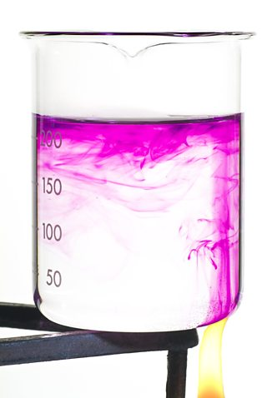[**VISUAL PHYSICS ONLINE**](http://www.physics.usyd.edu.au/teach_res/hsp/sp/spHome.htm)

**THERMODYNAMICS**

**WHAT HAPPENS WHEN SOMETHING IS HEATED ?**

**LATENT HEAT**

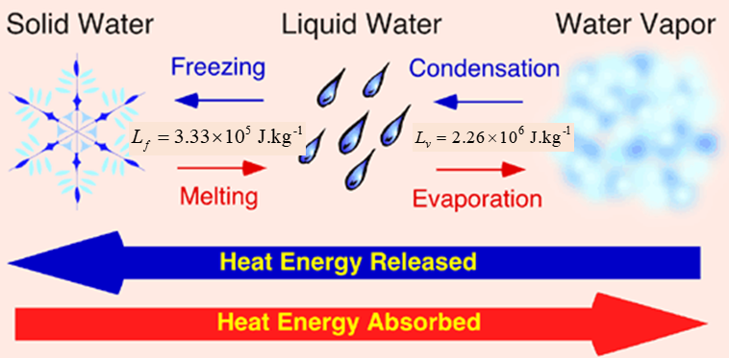

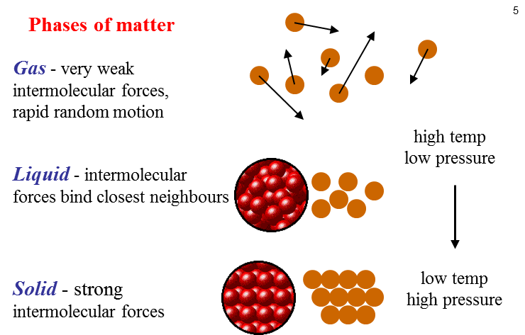

**HEATS OF FUSION AND VAPORISATION**

From the equation containing the specific heat, it seems that we can keep on transferring heat to an object and raising the temperature indefinitely. In fact, the equation seems to suggest that if we put in an infinite amount of heat we well get an infinite increase in temperature. However, instinctively we know that this is not totally true since at 100 ºC water starts to boil and stays at this temperature until it changes to a gas. So, the equation doesn't fully account for changes of state, which are also known as ***phase changes***.

In general, the temperature stays constant during any phase change.

**Melting point**: temperature at which a solid turns into a liquid or vice versa.

**Boiling point**: temperature at which a liquid turns into a gas (or vapour) or vice versa.

These points can be changed by adding impurities to the water / ice or changing the external pressure. Put a piece of string on an ice cube, which is straight out of the fridge. Sprinkle some salt on the string/ice cube. Wait a few seconds, you will then be able to lift the ice cube by the string. The string seems to have become glued to the cube. The explanation is this: The salt lowers the freezing temperature of ice. So, the melted ice soaks into the string. The salt now becomes less concentrated as it diffuses out of the region of the string so the freezing temperature is raised again. Since the rest of the ice cube is still at a temperature below freezing, the water will re-freeze including that which has soaked into the string - the string will essentially be frozen to the cube. An almost similar thing happens when you try and lick an ice tray. The tray is say at -15 ºC so it freezes the moister on your tongue.

**Why is energy needed to melt or vaporise a substance?**

At the melting point, the latent heat of fusion does not increase the translational kinetic energy of the molecules of the solid and hence the temperature does not increase. But, instead the energy is used to overcome the potential energy associated with the forces between the molecules, that is, work is done against the attractive force to weaken the bonds between the molecules such that they can now roll over one another in the liquid phase. Similarly, energy is required for molecules held close together in the liquid phase to escape into the gas phase. Generally, much more energy is required for the transition from a liquid to a gas and then the energy required for the transition of a solid to a liquid, hence, latent heats of vaporisation are generally much higher than latent heats of fusion.

Energy is acquired or released when a material changes phase. For example, energy is required to melt ice and vaporise water. However, energy is given out if water vapour condenses or water freezes. The heat acquired or released is called the **latent heat** (**heat of transformation**).

The energy transfer  involved in a change of phase depends upon the value of the latent heat  and the total mass  of the material, that is

(2)  constant temperature

 is a constant for a material at a given temperature and is called the latent heat of fusion (for melting) or latent heat of vaporisation (for boiling).

**Latent heat** **of fusion** is the energy required to melt 1 kg of a solid.

*water*  at 0 oC

**Latent heat** **of vaporisation** is the energy required to evaporate 1 kg of a liquid.

*water*   at 100 oC

**Water has large values for its latent heats compared to other common materials.**

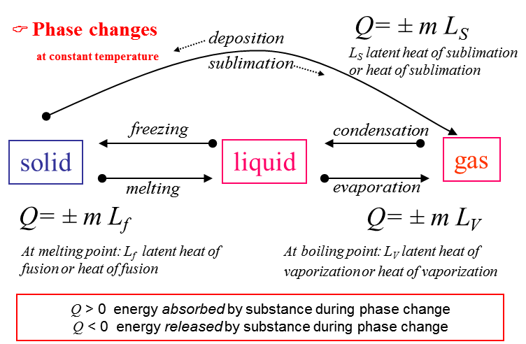

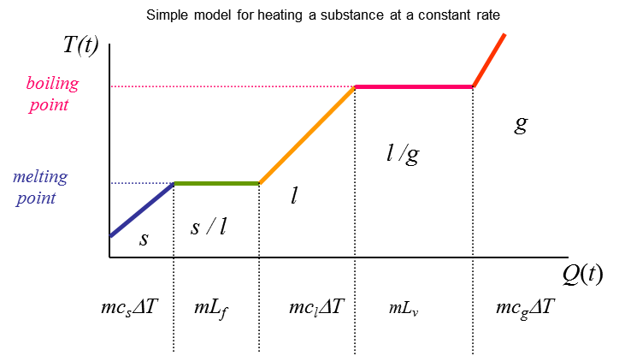

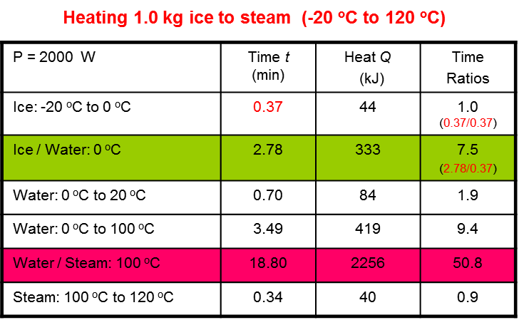

N.B. The large amount of energy required to vaporise the water.

**Evaporation**

The latent heat to change a liquid to a gas is not only required at the boiling point. Water can change from a liquid to a gas even at room temperature in a process called **evaporatio**n.

An open pan of liquid water will eventually disappear as it becomes water vapour. The change of phase from liquid to a gas that occurs at the surface is called evaporation.

The temperature of liquid water is related to the average translational kinetic energy of the molecules. The water molecules have a wide range of energies and move in random directions bumping into each other all the time. At one moment, a molecule could be moving very rapidly and a little later moving slowly. Some molecule at the surface gain sufficient energy to escape the surface by gaining kinetic energy from collisions with molecules below the surface and become molecules of vapour. Thus, the average kinetic energy of the liquid water molecules is decreased due to the escape of only the most energetic molecules, therefore, the temperature of the liquid water must decrease.

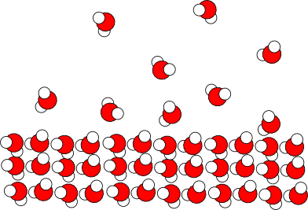

When water evaporates, it cools since energy is required (latent heat of vaporisation) comes from the water itself. So, its internal energy and therefore its temperature must drop.

water 100 oC 

water 20 oC 

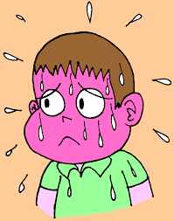The human body is like a car engine in that fuel is burnt to release energy, and therefore a cooling system is needed. The skin is our body’s cooling system. When we get hot, the brain sends messages so that the blood vessels dilate, increasing blood flow to the skin and increasing the temperature of the surface of our bodies. Therefore, the rate of energy lost from the skin to the surroundings via conduction, convection and radiation is increased. Also, perspiration occurs at a greater rate. Water on the surface of the skin evaporates into the air, lowering our temperature.

**Implications of latent heat**

1. As a liquid evaporates it extracts energy from its surroundings and hence the surroundings are cooled. The cooling by perspiring, which removes heat from the skin surface by vaporising the perspiration. Thus, on humid days we feel less comfortable because less energy is removed from the body by the processes of perspiration and evaporation.

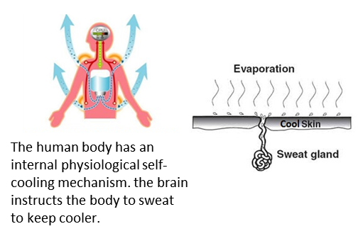

1. Evaporation rates increase with temperature, volatility of substance, area and lower humidity. You feel uncomfortable on hot humid days because perspiration on the skin surface does not evaporate and the body can't cool itself effectively.
2. When ether is placed on the skin it evaporates so quickly that the skin feels frozen. Ethyl chloride when sprayed on the skin evaporates so rapidly the skin is "frozen" and local surgery can be performed.
3. Evaporative air conditions cool the air by passing it over a moist surface where energy heat is absorbed from it by water evaporating from the surface.

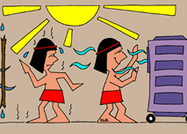

1. The circulation of air from a fan pushes water molecules away from the skin more rapidly helping evaporation and hence cooling.

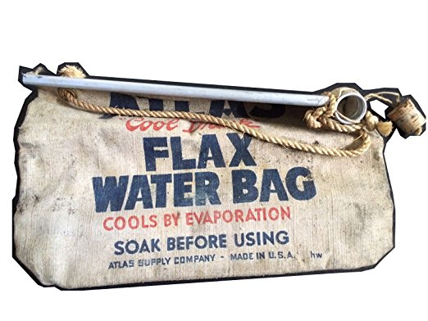

1. A canteen water bag soaked in water will keep the water cool because of evaporation.
2. When a gas condenses energy is released into the surroundings. Steam heating systems are used in buildings. A boiler produces steam and energy is given out as the steam condenses in radiators located in rooms of the building.
3. Scalding by steam produces severe burns due to the large heat of vaporisation of water released when the steam condenses on the skin. Therefore, a steam burn is much more damaging to the skin than a burn from boiling water. The steam releases considerable energy when it condenses to a liquid and wets the skin.
4. **Why does a dog pant?**

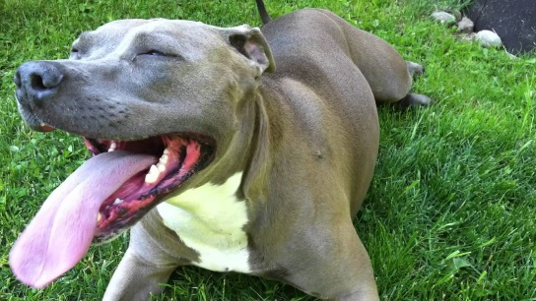

**Humidity**

As water evaporates it adds water to the air. The presence of water vapour in the air is referred to as **humidity**. When air contains a large amount of water vapour (moisture), the humidity is said to be high. When air contains little moisture, the humidity is said to be low or dry. The air can only hold a certain amount of moisture at a particular temperature. The air is said to be saturated when it contains a maximum amount of moisture. Hence, the more humidity the more difficult it is for water to evaporate and add more moisture to the air. The humidity is usually expressed as a percentage. For example, if the air holds half the maximum amount of water vapour that can hold, the relative humidity is said to be 50%. A room can be well heated but without good ventilation and air conditioning it can make the air dry. This causes rapid evaporation from the mucous membranes of the breathing passages, causing irritation and makes infection more likely.

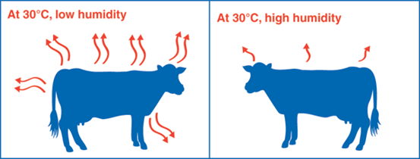

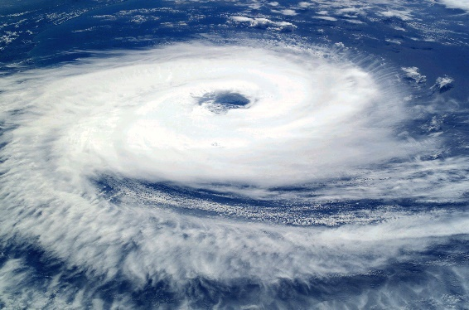

The condensation of water vapour in the air (gas to a liquid) releases energy into the atmosphere. This is the source of energy in a cyclone.

**What is cooking all about?**

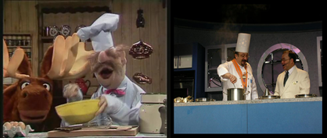

Specific heat of Aluminium is 900 J.kg-1.K-1, Copper 390 J.kg-1.K-1 , Iron 450 J.kg-1.K-1. This means that less thermal energy is required to warm a copper cooking pan than a steel or aluminium or iron one of equal mass. If you recall that copper is a much better thermal conductor than either aluminium or iron. So, it is much more energy efficient to buy an all copper pan - take note of this the next time you are shopping for cookware.



**How pressure cookers work?**

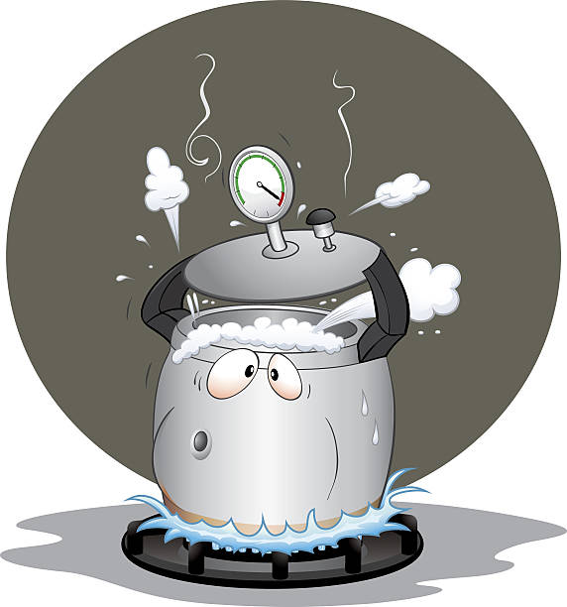These are essentially cooking pots with an air tight lid. As water is heated and turns to vapour, the pressure builds up because the vapour cannot escape. Water usually boils and turns to steam (vapour) at 100 ºC at a pressure of 1 atmosphere (i.e 101 kPa). By increasing the pressure, the water can be warmed to higher temperatures before it changes to a vapour. This means that anything being cooked inside the pot will experience higher temperatures and therefore the cooking time will be less. But will it taste as good?

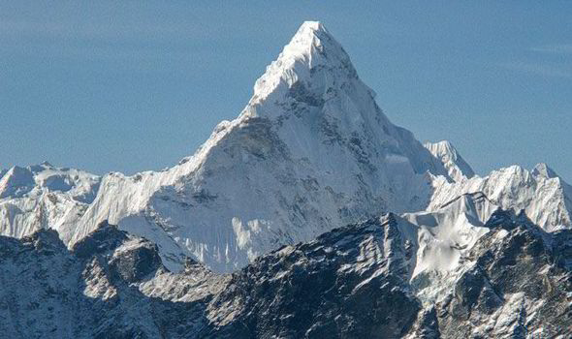**Tea on Mount Everest**

The air pressure on top of Mount Everest is about half an atmosphere (i.e 50 kPa). Water will boil (and turn to vapour) at about 70 ºC. Unfortunately, this water temperature makes a very poor cup of tea!

|  |
| --- |
| **Example**  A styrofoam picnic chest has dimensions 0.5 x 0.3 x 0.35 m with walls 0.02 m thick.   1. If the temperature difference across the walls is 35 ºC, at what rate will the heat conducted into the chest? 2. How many kilograms of ice do you need to put in the chest to keep the beer at 0 ºC for 5 hours? Assume the beer was initially cooled to 0 ºC.     The thermal conductivity of Styrofoam *ksty* = 0.010 W.m-1.K-1  Latent heat of fusion of ice Lf = 333 kJ.kg-1    **Solution**  (1) We are told there is a temperature difference across the walls of the chest. The rate of heat transfer only depends on this temperature difference    where *A* is the surface area of the box,d*T* is the temperature difference across the walls, d*x* is the wall thickness.  The box has six sides, we must now calculate the total area  *A* = (2)(0.5)(0.3) + (2)(0.3)(0.35) + (2)(0.35)(0.5) = 0.86 m2  d*T* = 35 ºC.  thickness, d*x =* 0.02 m  Substitute these into the rate of heat transfer equation above  *Q* = (0.01)(0.86)(35) / 0.02 = **15.1 W**  So, the rate of heat transfer across the walls of the chest is 15.1 W.    (2) In other words, the question is saying, "what is the least amount of ice that would melt after 5 hours". From part (a) we know that 15.1 J of energy can enter the chest in 1 second. So, we must work out how much energy enters in 5 hours. Then calculate how much ice this can melt.  Note that 5 hours = 5 x 3600 seconds = 1.8×104 s.  So total energy in 5 hours = (1.8×104)(15.1) J = 2.718×105 J  The energy *Q* required to melt ice is given by the latent heat of fusion equation  *Q* = *m L*  where *m* is the mass of the ice that will melt. We can now calculate this mass by rearranging the above equation and substituting  *m* = *Q* / *L* = 2.718×105 / 3.33×105 = 0.82 kg |

|  |
| --- |
| **Example (Calorimetry)**  How many 20 g ice cubes, whose initial temperature is -10 ºC, must be added to 1.0 L of hot tea, whose initial temperature is 90 ºC, in order that the final temperature of the mixture be 10 ºC? Assume all the ice melts in the final mixture and the specific heat of tea is the same as that of water.  Latent heat of fusion of ice *Lv* = 3.33x105 J. kg-1  Specific heat of water *c*water *= 4190* J. kg-1 K-1  Specific heat of ice *cice* = 2100 J. kg-1 K-1  Assume that the tea has the same properties as water.  Note that 1 L of water has a mass of 1 kg.  **Solution**  Let *m*ice be the mass of ice *m*ice = ?  *m*tea be the mass of tea = mass of water with the same volume  *m*tea = 1kg.  Use conservation of energy. The energy required to melt the ice, then heat it to 10 ºC, must come from the tea.  The following are the three stages the ice must go through to reach the final temperature of 10 ºC:  (i) ice heats up from -10 ºC to 0 ºC  (ii) ice melts at 0 ºC  (iii) melted ice heats up from 0 ºC to 10 ºC  (iv) energy for stages (i), (ii), and (iii) must come from tea.    Energy required for (i) + (ii) + (iii) = Energy lost by tea  The expressions for the different stages are given by  (i) *m*ice *cice*  Δ*T(i)* = *m*ice (2100)(10) = 2.10x104 *m*ice  (ii) *m*ice *Lv* = 3.33x105 *m*ice  (iii) *m*ice *cwater* Δ*T(iii)* = *m*ice (4190)(10) = 4.19x104 *m*ice  (iv) *m*tea *cwater* Δ*Ttea*= (1)(4190)(90) = 3.352x105 J    Using the conservation of energy equation above we have  2.10x104 *m*ice + 3.33x105 *m*ice  + 4.19x104 *m*ice = 3.352x105  Now solving for *m*ice we get *m*ice = 0.847 kg = 847 g of ice are needed.  Divide this by the mass of one ice cube (20 g) to find out how many cubes are needed.  Number of ice cubes = (847 / 20) = 43 |

|  |
| --- |
| **Example (Calorimetry)**  How much ice at –10.0 °C must be added to 4.00 kg of water at 20.0 °C to cause the resulting mixture to reach thermal equilibrium at 5.0 °C. Assume no energy transfer to the surrounding environment, so that energy transfer occurs only between the water and ice.  **Solution**  *m*ice = ? kg *m*water = 4.00 kg    temperature rise for ice to melt Δ*T*ice1 = 0 – (–10) °C = 10 °C  temperature rise of melted ice Δ*T*ice2 = (5 – 0) °C = 5 °C  temperature fall for water Δ*T* = (20 – 5) °C = 15 °C  *N.B. all temperature changes are positive*  *c*ice = 2000 J.kg-1.K-1 *c*water = 4190 J.kg-1.K-1  *L*f = 3.33×105 J.kg-1  *Conservation of energy* Energy lost by water = Energy gained by ice  *Specific heat capacity* *Q* = *m c* Δ*T*  *Phase change Q = m L*    energy lost water (fall in temperature) = energy gained by ice (rise in temp ice + melting + rise in temp water)  *m*water *c*water Δ*T*water = *mice c*iceΔ*T*ice1 +  *m*ice *L*f + *mice c*waterΔ*T*ice2      In such problems, you need to be careful to include all changes in temperature and changes in phase. |

|  |  |  |  |
| --- | --- | --- | --- |
| **Example**  The energy released when water condenses during a thunderstorm can be very large. Calculate the energy released into the atmosphere for a typical small storm.    **Solution**  Assume 10 mm of rain falls over a circular area of radius 1 km  *h =* 10 mm = 10-2 m *r* = 1 km = 103 m  volume of water *V* = π *r*2 *h* = π (106)(10-2) = 3×104 m3  mass of water *m* = ? kg density of water ρ = 103 kg.m-3  *m* = *ρ V* = (103)(3×104) = 3×107 kg  *latents heats – change of phase*  *Q* = *mL*  *L*v = 2.26×106 J.kg-1  *Q* = *m L*V *=* (3×107)(2.26×106) = 7×1013 J  The energy released into the atmosphere by condensation for a small thunder storm is more than 10 times greater then the energy released by one of the atomic bombs dropped on Japan in WW2.    This calculation gives an indication of the enormous energy transformations that occur in atmospheric processes.   |  |  |  | | --- | --- | --- | |  |  |  | |

[VISUAL PHYSICS ONLINE](http://www.physics.usyd.edu.au/teach_res/hsp/sp/spHome.htm)

If you have any feedback, comments, suggestions or corrections please email:

Ian Cooper School of Physics University of Sydney

ian.cooper@sydney.edu.au