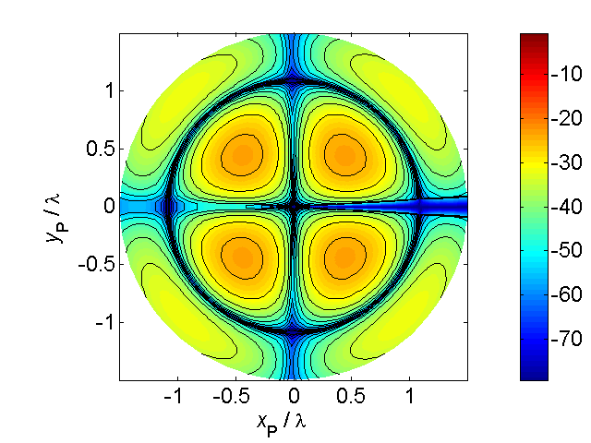

[**VISUAL PHYSICS ONLINE**](http://www.physics.usyd.edu.au/teach_res/hsp/sp/spHome.htm)

**THERMODYNAMICS**

**TEMPERATURE**

**What do we mean by the term TEMPERATURE ?**

Temperature is a concept with which you are very familiar, it’s the sense impression that allows you to differentiate between **hot** and **cold**. Temperature is not a term that can be defined precisely and scientifically.

**The temperature of a System is the degree of hotness or coldness of the System as measured on a temperature scale using a thermometer.**

The scale is based upon a **thermometric property** of matter that varies with temperature in a way that is reproducible (pressure, volume, electrical resistance, emitted EM radiation, emf - electromotive force). The thermometric property relates to the type of **thermometer** used to measure the temperature.

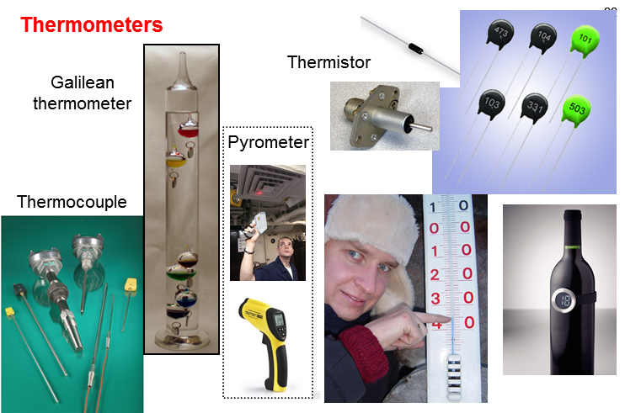

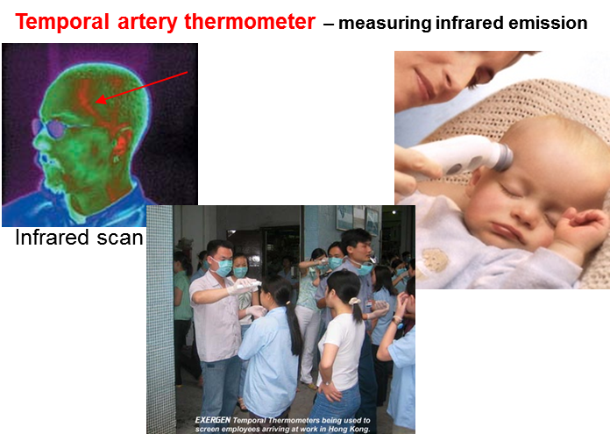

The most common temperature scale used is the **Celsius Temperature Scale** and was formally based upon the melting and boiling points of water at atmospheric pressure

0 oC melting point (mixture of ice and water)

100 oC boiling point (mixture of water and steam)

The S.I. unit for temperature is the **Kelvin Temperature Scale**

a change in 1 °C = 1 K Kelvin K





The lowest temperature on the Kelvin scale is 0 K and is referred to as **absolute zero**. Absolute zero is theoretically the lowest possible temperature of a System. At absolute zero, the internal energy of a System is at its absolute minimum value but it still is greater than zero. In practice, the temperature of a System is always greater than 0 K.

In calculations involving a temperature difference , you can use either the Celsius Scale or the Kelvin Scale. However, using an equation with temperature  you must use the Kelvin Temperature Scale.

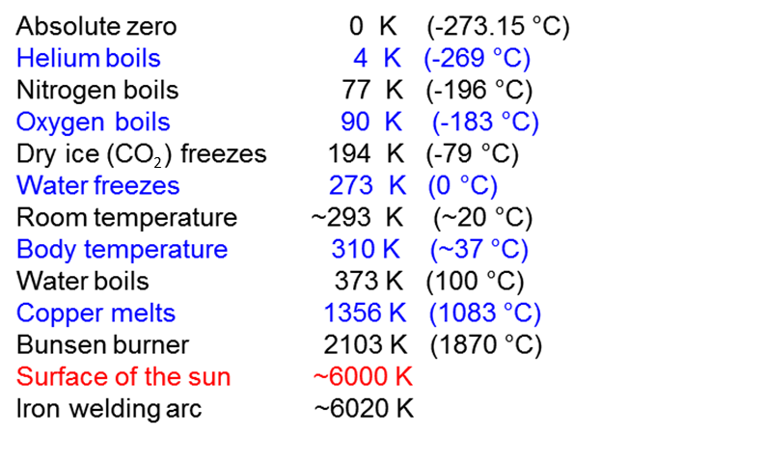

The temperature of a System determines the System’s tendency to transfer energy.

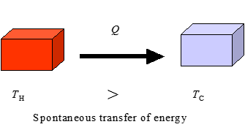

**Heat transfer will of itself always flow from a region of higher to lower temperature**

**Heat**  refers to the amount of energy transferred due to a temperature difference. Heat is a happening not a substance (heat is not contained in something). The term heat should only be used in relationship to the transfer of energy. You should **not** use the phrase *heat is a form of energy*. **Heat is not a form of energy** but the energy transferred due to a temperature difference. Heat is not a function of time. You can only specify the amount of energy that has been exchanged between Systems or between a System and its surroundings.

temperature of System 

temperature of surrounding environment 

energy is lost from the System to its surroundings  internal energy  of System decreases

 energy is gained from the System’s surroundings  internal energy  of System increases

Two Systems are in **thermal equilibrium** if and only if they are at the same temperature. An **isolated System** is one with no interaction with its surroundings (insulating walls). Two isolated systems brought into thermal contact and allowed to exchange heat with each other (but not with their surroundings) will, after a “long time” be in thermal equilibrium.



**Zeroth Law of Thermodynamics**

If a can of coke and a bottle of milk each have the same temperature as the inside of your refrigerator, then the coke and milk have the same temperature as well. This trivial observation is called the **Zeroth Law of Thermodynamics**.

**If Systems A and B each are in thermal equilibrium with a third System C, then A and B are in thermal equilibrium with each other.**

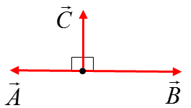This law seems trivial, but it is not so obvious if you consider the following example. If vectors  and  are each perpendicular to a vector , this fact does **not** necessarily mean that  is perpendicular to .

**Microscopic view of Temperature**

At the microscopic (atomic) level, the temperature of a System depends upon the internal energy  of the System



If energy is added to a System through the processes of **heat** and/or **work** then the internal energy of the System  will increase:

* If the average translational kinetic energy  of the System increases, then the temperature  of the System will also increase.

* If the average translational kinetic energy of the System does not increase, but potential energy  increases, then a change in phase (state) may occur.

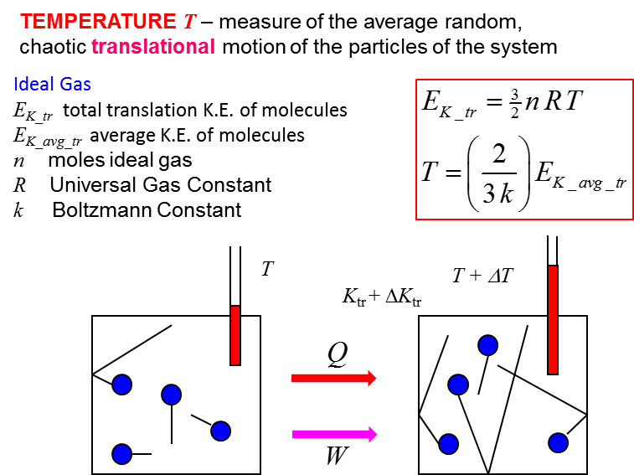

For an ideal monoatomic gas, the temperature  is directly proportional to the average translational kinetic energy  of the molecules of the gas.

Thus, on a microscopic level, the **temperature of a gas is a direct measure of the average translational kinetic energy**. A higher temperature corresponds to higher molecular speeds. At absolute zero, , all molecular motion ceases in our classical theory, but using more advanced theories, quantum effects prevent this from happening – molecule can never have zero energy.

[VISUAL PHYSICS ONLINE](http://www.physics.usyd.edu.au/teach_res/hsp/sp/spHome.htm)

If you have any feedback, comments, suggestions or corrections please email:

Ian Cooper School of Physics University of Sydney

ian.cooper@sydney.edu.au