[**VISUAL PHYSICS ONLINE**](http://www.physics.usyd.edu.au/teach_res/hsp/sp/spHome.htm)

**THERMODYNAMICS**

**METHODS OF HEAT TRANSFER**

**CONDUCTION**

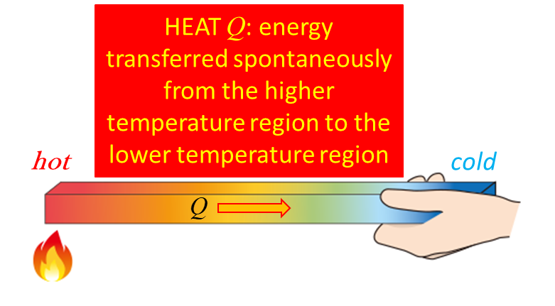

**Conduction** is heat transfer by means of molecular agitation within a material without any motion of the material as a whole.

If one end of a metal rod is at a higher temperature, then energy will be transferred down the rod toward the colder end because the higher speed particles will collide with the slower ones with a net transfer of energy to the slower ones.

Some materials are called **conductors** since they conduct heat very well, whereas other materials are called **insulators**.

For conduction between two plane surfaces (e.g. heat loss through the wall of a house) the steady-state rate of heat transfer  is



Rate of heat transfer  [ W J.s-1 ]

Thermal conductivity  [ W.m-1.K-1 ]

constant (uniform material)

Cross-sectional area  [ m2 ]

Temperature gradient  [ K.m-1 or oC.m-1 ]

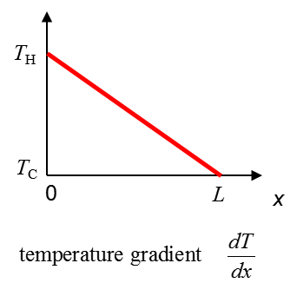

The negative sign (-) indicates the direction of energy transfer is from the higher temperature region to the lower temperature region.

An alternative equation for the heat transfer is



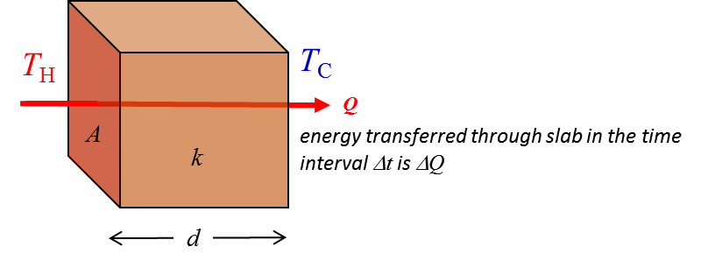

The **thermal conductivity**  is a property of the material.

* Diamond has a very high  value: perfect heat sink, e.g. for high power laser diodes
* Humans has a low value: our core temp relatively constant (37 oC)
* Air has a very low value: air is a good insulator (home insulation; woollen clothing; windows double glazing)
* **Metals** – good conductors: **electrons** transfer energy from hot to cold

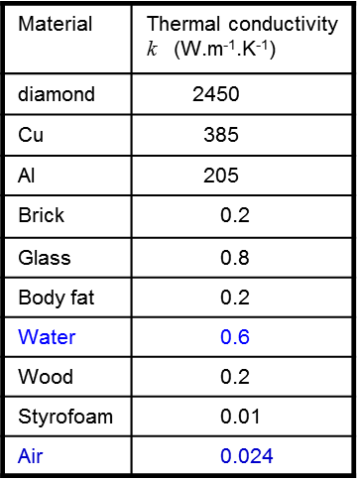

Identify the conductors and insulators from the data displayed in the Table.

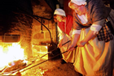

Image yourself holding an iron poker in a fire. After a short time, the poker feels very hot. Why?

The metal is a good conductor of thermal energy due to the temperature difference between the fire and your hand. The atoms of the poker in the fire gain internal energy from the fire and jiggle about more rapidly. These atoms vibrate neighbouring causing them to also jiggle more rapidly and this is one way for energy to be conducted along the length of the rod. The increased jiggling of the atoms increases the average translational energy of the molecules and this is shown by the increasing temperature at the end of the poker in your hand. More importantly for metals, the energy transferred is mainly due to the motion of the **free electrons** within the metal. The free electrons are those electrons which are not tightly bound to an individual atom (outer most electrons) and are free to move within the metal transferring energy to other electrons and colliding with atoms causing them to jiggle more rapidly. This is the reason metals are good conductors of thermal energy and electricity.

For good insulators, the electrons are firmly attached to individual atoms and can’t contribute to the conduction of thermal energy. Most liquids and gases are poor conductors, especially air. Materials such as fibreglass are poor conductors because they have many small air pockets. Snow is a poor conductor because the air trapped within the snow flakes. A blanket of snow keeps the ground warm in winter. Animals find shelter by burrowing into the snow. The snow doesn’t provide warmth for the animal – it simply slows down the rate of thermal energy loss by conduction.

**What story could you add to this picture?**

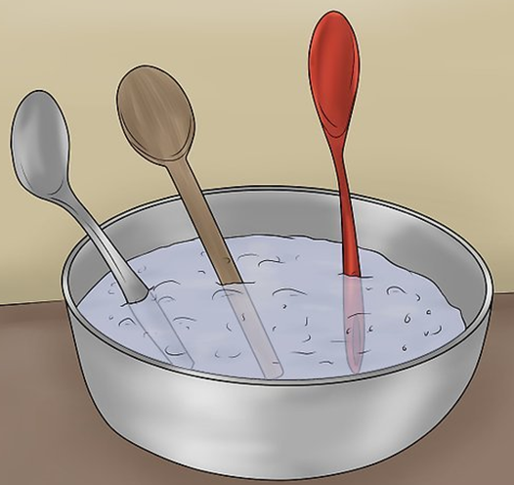

|  |
| --- |
| **Example**  Suppose a person could live for 120 min unclothed in air at 8 oC.  How long could they live in water at 8 oC?  Thermal conductivities  *k*air = 0.024 W.m-1.K-1 *k*water = 0.6 W.m-1.K-1  **Solution**  We set up a simple model in which we only consider the heat transferred from the person by conduction.    The person dies when the energy loss is  whether the person is in the air or water. The only variables are the different thermal conductivities of the air and water and the time intervals for the energy lost to cause death.  The rate of heat transfer by conduction is    We want to estimate the time interval    We can now find the maximum time interval  that the person can survive in the water where    Although our numbers may not be accurate, our conclusion is **valid** – a person can only survive for a very short period in cold water. |

|  |
| --- |
| **Example** An igloo is a hemispherical enclosure built of ice. Elmo’s igloo has an inner radius of 2.55 mm and the thickness of the ice is 0.30 m. This thickness can be considered small compared to the radius. Heat leaks out of the igloo at a rate determined by the thermal conductivity of ice, *kice* = 1.67 W.m-1.K-1.  At what rate must thermal energy be generated inside the igloo to maintain a steady air temperature inside the igloo at 6.5 oC when the outside temperature is -40 oC?  Ignore all thermal energy losses by conduction through the ground, or any heat transfer by radiation or convection or leaks.  **Solution**  Visualize the problem  Type of problem: thermal conductivity  Physical principles and equations  Known and Unknown values  Scientific annotated diagram    The rate of energy production must be equal to the rate of loss of thermal energy by conduction through the hemispherical ice wall.  Rate of energy transfer by conduction    Because the thickness of the ice is much smaller than either the inside or outside radius, it does not matter which radius is used – taking the average radius |

|  |
| --- |
| **Example**  An aluminium pot contains water that is kept steadily boiling (100 ºC). The bottom surface of the pot, which is 12 mm thick and 1.5x104 mm2 in area, is maintained at a temperature of 102 °C by an electric heating unit. Find the rate at which heat is transferred through the bottom surface. Compare this with a copper based pot.  The thermal conductivities for aluminium and copper are  *k*Al = 235 W.m-1.K-1 and *k*Cu = 401 W.m-1.K-1  **Solution**    Copper based pots are better than aluminium based pots for cooking because copper is a better thermal conductor than aluminium. |

|  |
| --- |
| ***Thinking Questions***  (1)  Hold a lighted match in on hand and a nail in the other so that the nail is in the flame. Which are you going to drop first, the match or the nail? Explain. You should try it.    (2)    (3)  You get up early on a cold winter morning and walk barefoot across the bedroom carpet into the tiled bathroom. We know from the principle of thermal equilibrium that the carpet and tiles can be assumed to be at the same temperature. Explain why your feet feel cold on the tiles compared to the carpet.    (4)  Two cylinders of the same length and diameter are joined together. One cylinder is wooden and the other is copper. A piece of paper is wrapped and centred around the junction of the two cylinders. A Bunsen burner heats the paper at the junction until a distinctive burn mark is visible.  There are three possible results.  (A) The burn mark is centred over the junction.  (B) The centre of the burn mark is on the side of the wooden cylinder.  (C) The centre of the burn mark is on the side of the copper cylinder.    What is the correct answer: A, B or C. Explain your reasoning?  (5)  Two rods are used to conduct heat from a region of 100 oC to a region of 0 oC. The rods can be placed in series or in parallel. For the two arrangements, compare the heat transferred from hot to cold. |

**Syllabus comment**

The equation for thermal conductivity in the Syllabus is expressed as



No respectable Physics textbook would express the equation for thermal conduction as in the Syllabus. A more acceptable formula is



However, you must be careful in interpreting this equation. The term for the time interval  is



 is the amount of energy transferred from hot to cold in the time interval . However, . The heat transferred is not a function of time.  and  are meaningless, cannot measure at a time .

[VISUAL PHYSICS ONLINE](http://www.physics.usyd.edu.au/teach_res/hsp/sp/spHome.htm)

If you have any feedback, comments, suggestions or corrections please email:

Ian Cooper School of Physics University of Sydney

ian.cooper@sydney.edu.au