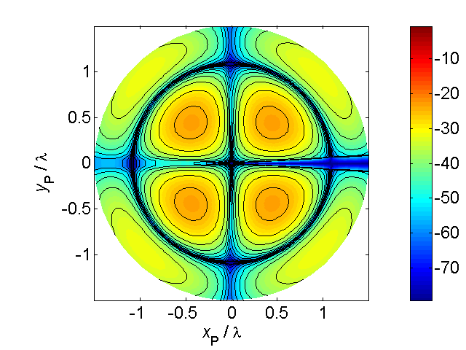

[**HSC PHYSICS ONLINE**](http://www.physics.usyd.edu.au/teach_res/hsp/sp/spHome.htm)

**WORKSHOP**

**GLOBAL WARMING and the**

**GRENHOUSE EFFECT**

This topic and the issue of climate change is one of the most hotly debated topics by scientists, communities and governments.

*transmission of short wavelength radiation but*

*absorption & radiation of infrared radiation*

This Workshop is best done as a group of three working together.

On an A3 sheet of paper (two A$ sheets joined together) complete a **summary** that includes

* a list of the key scientific words

* a list of physical quantities

* concept map

* annotated diagrams

* causes

* diagrams to improve your understanding of the mathematical model

(no atmosphere)

**What is the greenhouse effect, and is it affecting our climate?**

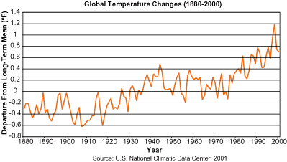

The greenhouse effect is unquestionably real, and is essential for life on Earth. It is the result of absorption of energy by certain gases in the atmosphere (called greenhouse gases) and radiation by these gases in all directions. Water vapor is the most important greenhouse gas, followed by carbon dioxide and other trace gases. Without a natural greenhouse effect, the temperature of the Earth would be about -18°C instead of its present 14°C. However, the concern is not with the fact that we have a greenhouse effect, but it is with the question regarding whether human activities are leading to an enhancement of the greenhouse effect.

Because of the absorption by the atmosphere of the infrared radiated by the warm surface of the Earth, it does not escape freely into space. This causes a warming of the troposphere. The warm air in the troposphere radiates in all directions and some of the energy is absorbed by the ground and keeping it warmer than it would otherwise. As long as the amount of water vapour and carbon dioxide in the air stays the same, and as long as the amount of energy arriving from the Sun is constant, an equilibrium is established. Both the ground and atmosphere are warmed by the greenhouse effect. However, human activities are upsetting this natural balance by increasing the amount of carbon dioxide in the atmosphere. This enhances the greenhouse effect. Other gases are also being released into the atmosphere that absorb infrared radiation but more importantly some of those gases are absorbing in the atmospheric window from 7 to 13 μm, where radiation used to escape freely.

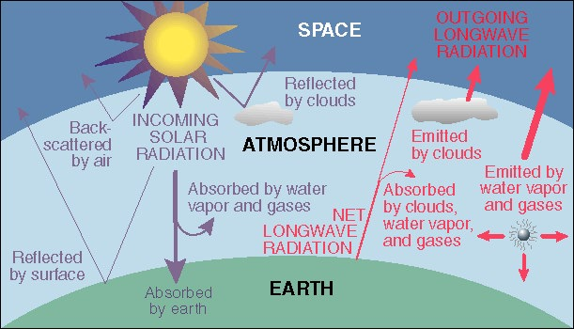

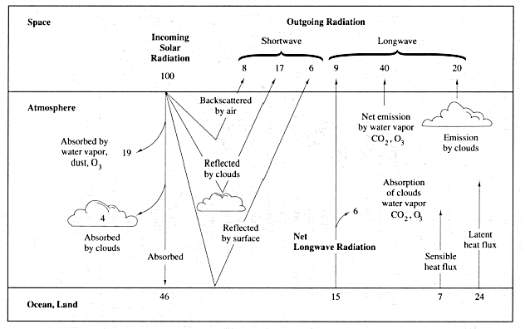

## The main components in this diagram are the following:

## Short wavelength (optical wavelengths) radiation from the Sun reaches the top of the atmosphere.

## Clouds reflect 17% back into space. If the Earth gets more cloudy, as some climate models predict, more radiation will be reflected back and less will reach the surface.

## 8% is scattered backwards by air molecules.

## 6% is actually directly reflected off the surface back into space

## So the total reflectivity of the Earth is 31%. This is technically known as an *Albedo*. Note that during Ice Ages, the Albedo of the Earth increases as more of its surface is reflective. This, of course, exacerbates the problem.

## What Happens to the 69% of the incoming radiation that doesn't get reflected back:

## 19% gets absorbed directly by dust, ozone and water vapour in the upper atmosphere. This region is called the stratosphere and it’s heated by this absorbed radiation. Loss of stratospheric ozone is causing the stratosphere to cool with time, which, of course, greatly confuses the issue of global warming.

## 4% gets absorbed by clouds located in the troposphere. This is the lower part of the Earth's atmosphere where weather happens.

## The remaining 46% of the sunlight that is incident on top of the Earth's atmosphere reaches the surface.

Since the Earth wants to stay in thermal equilibrium, it must also radiate this energy. The Earth has an equilibrium temperature of about 300 K. At this temperature, the wavelength of the emitted radiation is in the infrared.

What happens to the outgoing infrared radiation transferred from the Earth's surface? If it all went directly back into space, the Earth would be a significantly colder place than it is.

* 15% is directly radiated back by the cloud-free land surface and 6% of that is absorbed by the atmosphere and 9% goes directly back into space.
* 60% is radiated back into space by the net emission of the atmosphere and the clouds. The total radiated back into space is 69% meaning that 31% is temporarily stored as energy and emitted back later.
* Of this 31%, 24% is used to facilitate evaporation. This heat is later released through condensation. This process is called latent heat.
* 7% is stored by the Earth's crust and then radiated at later times through a complicated heat exchange network of convection and conduction. At a few meters below the surface of the Earth, the temperature is nearly constant over most of the year because of this low heat flux.

So clearly, if human activities increase the ability for the Earth's atmosphere to absorb IR radiation, this produces a net warming of the atmosphere over time. This is the ***Enhanced Greenhouse Effect***.

**Using mathematical models**

We can estimate the Earth’s surface temperature by setting up a simple model and then applying appropriate physical principles.

Assume the Earth of radius *R* , intercepts the short wavelength radiation from the Sun over an area π*R*². Let *I*o represent the intensity (radiant energy flux density) intercepted by the Earth (solar constant *I*o = 1360 W.m-2). The albedo of the whole Earth α, determines the amount of radiant energy reflected back into outer space (assume α = 0.3). Then, amount of energy absorbed by the Earth’s surface every second is

*P*abs = *A I* = (1 - α) π *R*2 *I*o

Assume the Earth and its atmosphere correspond to a blackbody. Therefore, the energy radiated every second by the Earth at a temperature *T*E is

*P*rad = (4 π *R*2) σ *T*E4

where 4π*R*2 is the surface area of the globe. (σ = 5.67x10-8 W.m-2.K-4)

It is known that the Earth’s surface temperature has remained relatively constant over many centuries. Therefore, we must have an energy balance, energy in must equal energy out

*P*abs = *P*rad

(1 - α) π *R*2 Io =  (4 π *R*2) σ *T*E4

*T*E = {(1 - α) *I*o / 4σ}0.25

*T*E = 255 K = -18 °C

This temperature is similar to the surface temperature of the Moon that does not have an atmosphere. The mean surface temperature of the Earth is about 15 °C. Our simple model did not consider the existence of the atmosphere with gases that absorb and emit long wavelength radiation. The difference of > 30 °C represents the atmospheric **natural** **greenhouse effect** on the surface temperature. The long wavelength radiation is "trapped" near the ground, the lowest part of the atmosphere is the hottest and the temperature decreases with increasing altitude until the stratosphere is reached. The temperature does not continue to fall in the stratosphere because of the absorption of ultraviolet radiation. The greenhouse effect explains why it is cooler on high mountains than at sea level, even though the mountain-top is closer to the Sun.

### 

### Are greenhouse gases increasing?

Human activity has been increasing the concentration of greenhouse gases in the atmosphere (mostly carbon dioxide from combustion of coal, oil, and gas; plus a few other trace gases). There is no scientific debate on this point. Pre-industrial levels of carbon dioxide (prior to the start of the Industrial Revolution) were about 280 parts per million by volume (ppmv), and current levels are about 370 ppmv. According to the IPCC "business as usual" scenario of carbon dioxide increase (IS92a) in the 21st century, we would expect to see a doubling of carbon dioxide over pre-industrial levels around the year 2065.

Some Major Greenhouse Gases

1. Carbon Dioxide (CO2)
2. Methane (CH4)
3. Nitrous Oxide (N2O)
4. Chlorofluorocarbons (CFCs)

Carbon Dioxide (CO2)

The global carbon dioxide budget is complex and involves transfer of CO2 between the atmosphere, the oceans, and the biosphere. Through the photosynthetic process, the land removes about 1014 kg of carbon in the form of CO2 per year. However, about the same quantity of carbon in the form of CO2 is added to the atmosphere each year by vegetation and soil respiration and decay. The world's oceans release about 1014 kg carbon in the form of CO2 into the atmosphere per year and in turn absorb about 1.04×1014 kg carbon each year. Most of the oceanic carbon is in the form of sedimentary carbonates. Burning of fossil fuels adds about 5×1012 kg carbon and biomass burning and deforestation add about another 2×1012 kg carbon to the atmosphere in the form of CO2 annually. By summing all of the fluxes of CO2 into and out of the atmosphere, we can find that about 3×1012 kg carbon in the form of CO2 is building up in the atmosphere each year. The average concentration of CO2 was about 290 ppmv in pre-industrial times; now (1990) it is about 350 ppmv and increasing steadily at a rate of about 0.3-0.4 %/yr. Since CO2 is chemically inert, it is not destroyed by photochemical or chemical processes in the atmosphere; either it is lost by transfer into the ocean or biosphere or it builds up in the atmosphere.

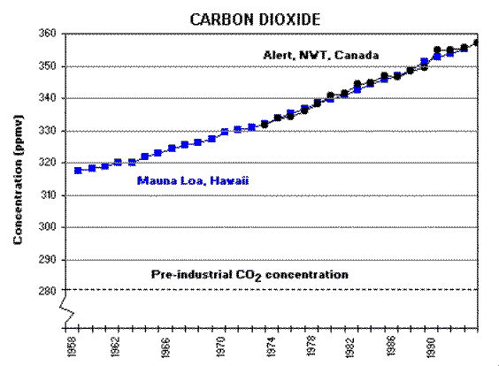

Methane (CH4)

Methane can be destroyed in the atmosphere via reaction with the hydroxyl radical (OH):

CH4 + OH- --> CH3 + H2O

The OH- radical destroys about 5×1011 kg of CH4 each year. The mean atmospheric life time of CH4 is about 8 years. Methane is produced in anaerobic environments by the action of methanogenic bacteria and by biomass burning. The major anaerobic environments that produce CH4 include wetlands (150 +/- 50) ×109 kg/yr, rice paddies (100 +/- 50) ×109 kg/yr, and enteric fermentation in the digestive system of cattle, sheep, etc. (100-150) ×109 kg/yr. Biomass burning may supply (10-100) ×109 kg CH4 /yr. 

Nitrous Oxide (N2O)

Nitrous oxide is chemically inert in the troposphere. However, N2O is destroyed in the stratosphere via photolysis by solar radiation, which is responsible for about 90% of its destruction, and by reaction with excited atomic oxygen, O(1D), which is responsible for about 10% of its destruction:

N2O + *hν* --> N2 + O(1D), < 341 nm

N2O + O(1D) --> N­2 + O2

N2O + O(1D) --> 2NO

These photochemical and chemical processes destroy about (10.5 +/- 3) ×109 kg/yr. The mean lifetime of N2O in the atmosphere is about 150 years. Nitrous oxide is building up in the atmosphere at a rate of about (3 +/- 0.5) ×109 kg N/yr. The global destruction rate of N2O is about (10 +/- 3) ×109 kg N/yr. Hence, the global sources of N2O should be about (13.5 +/- 3.5) ×109 kg N/yr. At present, there is a problem in identifying the sources of N2O of this total magnitude.

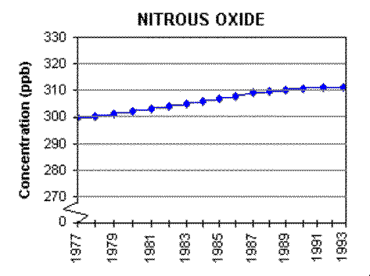

Chlorofluorocarbons (CFC-11 and CFC-12)

CFC-11 and CFC-12 are chemically inert in the troposphere and diffuse up to the stratosphere, where they are destroyed by photolysis by solar radiation and by reaction with excited atomic oxygen.

### Is the climate warming?

Global surface temperatures have increased about 0.6°C (plus or minus 0.2°C) since the late-19th century, and about (0.2 to 0.3°C) over the past 25 years (the period with the most credible data). The warming has not been globally uniform. Some areas (including parts of the southeastern U.S.) have cooled. The recent warmth has been greatest over N. America and Eurasia between 40 and 70°N. Warming, assisted by the record El Niño of 1997-1998, has continued right up to the present.

Linear trends can vary greatly depending on the period over which they are computed. Temperature trends in the lower troposphere (between about 1000 and 6000 m) from 1979 to the present, the period for which Satellite Microwave Sounding Unit data exist, are small and may be unrepresentative of longer term trends and trends closer to the surface. Furthermore, there are small unresolved differences between radiosonde and satellite observations of tropospheric temperatures, though both data sources show slight warming trends. If one calculates trends beginning with the commencement of radiosonde data in the 1950s, there is a slight greater warming in the record due to increases in the 1970s. There are statistical and physical reasons (e.g., short record lengths, the transient differential effects of volcanic activity and El Nino, and boundary layer effects) for expecting differences between recent trends in surface and lower tropospheric temperatures, but the exact causes for the differences are still under investigation (see National Research Council report "Reconciling Observations of Global Temperature Change").

An enhanced greenhouse effect is expected to cause cooling in higher parts of the atmosphere because the increased "blanketing" effect in the lower atmosphere holds in more heat. Cooling of the lower stratosphere (about 30-35,000ft.) since 1979 is shown by both satellite Microwave Sounding Unit and radiosonde data, but is larger in the radiosonde data. There has been a general, but not global, tendency toward reduced diurnal temperature range (the difference between high and low daily temperatures) over about 50% of the global land mass since the middle of the 20th century. Cloud cover has increased in many of the areas with reduced diurnal temperature range. Relatively cool surface and tropospheric temperatures, and a relatively warmer lower stratosphere, were observed in 1992 and 1993, following the 1991 eruption of Mt. Pinatubo. The warming reappeared in 1994. A dramatic global warming, at least partly associated with the record El Niño, took place in 1998. This warming episode is reflected from the surface to the top of the troposphere.

Indirect indicators of warming such as borehole temperatures, snow cover, and glacier recession data, are in substantial agreement with the more direct indicators of recent warmth. Arctic sea ice has decreased since 1973, when satellite measurements began but Antarctic sea ice may have increased slightly.

The world's oceans have complicated reactions or feedbacks on the enhanced greenhouse effect. On one hand, they can provide sources for the increased water vapor as the Earth becomes warming. On the other hand, the thermal holding capacity of the oceans would delay and effectively reduce the observed global warming. In addition, oceans play an important role in the global greenhouse gas budgets. For example, according to some estimates, the recent anthropogenic increase in atmospheric CO2 may be responsible for a large part of the recent global warming. The ocean biota, primarily phytoplankton, are believed to remove at least half of the anthropogenic carbon dioxide added to the atmosphere. Hence, the ocean sink of carbon dioxide is called the "biological CO2 pump". However, further knowledge about the flux of carbon between ocean and atmosphere is needed to accurately predict the consequences of the build-up of carbon dioxide.

Vegetation changes caused by a climate change would affect the hydrologic cycle and surface albedo. The biggest adverse impact of a CO2-induced climate change would be caused by changing precipitation patterns that would lead to overall lower rainfall amounts, or droughts during the growing season with increased frequency or severity. The biomass productivity is linearly related to the amount of water transpired over the course of a growing season. The high correlation has been found between the NDVI, an index of biomass productivity, and the precipitation during the growth season. Furthermore, high temperature appears to be detrimental to seed growth because it shortens the time period for this stage of growth in many plants. However, the rise of atmospheric CO2 concentration should cause increase in photosynthesis, growth and productivity of the Earth's vegetation. Thus, the direct effects of rising CO2 and expected climate change should have a less adverse impact on vegetation than climate change alone.

Clouds are simultaneously strong downward infrared radiators and shortwave solar radiation reflectors. However, how clouds are likely to change with increased greenhouse warming is essentially unknown. Global warming will lead to an increase in the amount of water vapour in the atmosphere and because water vapour is a powerful greenhouse gas, this will lead to an increase in the warming. However, some scientists propose that tropical storm clouds would reach higher in the atmosphere under warmer conditions. Then the clouds would produce more rain thus adding less water vapour to the middle troposphere. The resulting drier middle troposphere will produce a negative feedback to the global warming.

### Generally, increased temperature would tend to melt ice and result in increased absorption of solar energy by the ocean, a positive feedback. However, a decrease in sea ice would also lead to larger heat fluxes from the ocean to the atmosphere, a negative feedback. Thus, the interaction among the atmosphere, the ocean, sea ice, and the sensitivity of sea ice to climate change need to be observed and quantified.

### Can the observed changes be explained by natural variability, including changes in solar output?

Some changes, particularly part of the pre-1960 temperature record, show some relationship with solar output, but the more recent warm era is not well correlated. The exact magnitude of purely natural global mean temperature variance is not known precisely, but model experiments excluding solar variation indicate that it is likely less than the variability observed during this century.

#### Attenuation of solar radiation

Nearly 30 % of this incoming solar energy is immediately reflected back into space by the atmosphere, by clouds and by the Earth's surface, leaving about 70 % to heat the Earth’s surface and atmosphere. The fraction of the incoming radiation reflected by a surface is called its ***albed****o*. Climatologists need to known the albedo of the Earth for climate prediction (Earth’s albedo maybe about α = 0.3). Some gases in the atmosphere are virtually transparent to radiation at certain wavelengths while they maybe good absorbers at other wavelengths. Most of the atmosphere is transparent to visible (400 nm < λ < 750 nm) and the long radio wavelengths (we get radio transmission over long distances by the reflection of radio waves off the ionosphere). The atmosphere is opaque in the UV (λ < 400 nm) mainly due to the absorption by the ozone O3 molecule and far infrared (λ > 1 mm). In the near infrared there are many absorption bands due to the presence of water vapour (as distinct from clouds) and carbon dioxide. The most important being water vapour. Also, there are particles suspended in the air like dust, carbon particles, smoke, salt particles, etc that may cause more extinction in the infrared region than molecular absorption. The energy absorbed by the Earth's surface is radiated back to the atmosphere because the Earth is at a steady temperature. Most of this emitted radiation is infrared (the surface temperature of the Earth is much lower than that of the Sun). This radiated energy is absorbed by the water vapour, carbon dioxide (troposphere) and ozone (stratosphere), with the rest escaping into outer space. If the atmosphere did not retain energy, then the temperature of the Earth's surface would drop to the point where most life would be impossible.

The Earth is in a steady state situation. However, if the above energy balance is upset, (eg an increase in the greenhouse effect by human activity) then the temperature of the Earth would have to rise to establish a new energy balance. The Earth’s atmosphere is not completely transparent to solar radiation. As the radiant energy passes through the atmosphere some is **absorbed**, some **scattered** and some **reflected** back to space. As a result, the ***intensity*** of the solar radiation reaching the Earth’s surface is much lower than at much higher altitudes.

About 17% of the incoming radiation is absorbed in the atmosphere. The main atmospheric gases absorbing solar energy are water vapour (H20), carbon dioxide (CO2), ozone (O3), oxygen (O2), nitrogen (N2) and their oxides (N2O, NO2), and methane (CH4).

The absorption and emission of radiation in gases occurs at specific wavelengths according to their atomic and molecular structure. The isolated gaseous atoms and molecules of the atmosphere can only absorb and emit energy at certain discrete energies. The energies involved in the transitions are quantised. Thus, the interaction of an atom or molecule with electromagnetic radiation, such as light, can only take place at well-defined frequencies that are characteristic of that molecule and of the corresponding pair of energy values between which the transition is taking place.

*hf* = *E*2 - *E*1

where *E*2 and *E*1 are the energies of an energetically higher and lower state respectively, *f* is the frequency of radiation, and *h* is Planck’s constant (*h* = 6.626x10-34 J.s). In other words, the radiant energy has to be in **resonance** with the energy gap in order to make the molecule "jump." If a molecule changes from a state of lower energy to one of higher energy, it needs to absorb the necessary energy quanta (photons) hf out of the radiation. If the molecule changes its energy from a higher to a lower state, the energy difference is liberated, also in the form of photons. The frequency of absorption and emission of photons has the same value.

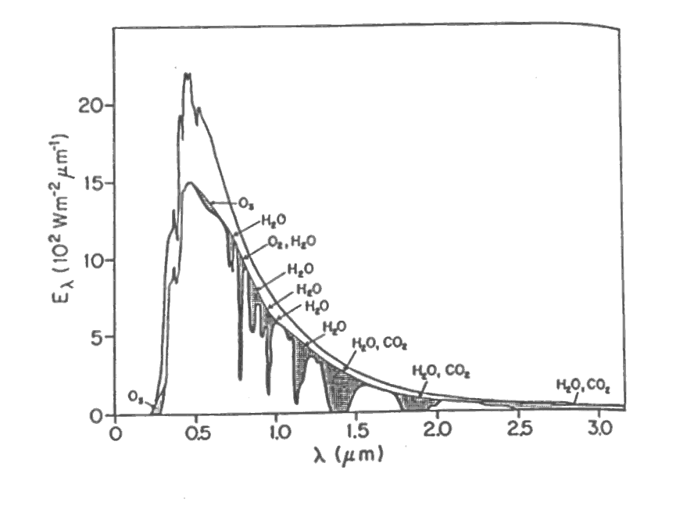

Fig. 6 Spectral distribution of solar irradiation at the top of the atmosphere and at sea level. The shaded area represents absorption by various atmospheric gases. The unshaded area between the two curves represents the fraction of the solar energy backscattered by the air, water vapour, dust and aerosols and reflected by clouds. The area under the top graph represents the solar constant, 1360 W.m-2.

The emission spectra of molecules are usually more complex than those of individual atoms because they have more degrees of freedom. For example, the atoms of a molecule can **vibrate** and the molecule can **rotate**. The vibrational and rotational energies of molecules are quantised. The spacing between the energy levels for vibration and rotation are much less than those corresponding to electronic transitions. The radiation emitted or absorbed due to changes in the vibration or rotation states of a molecule is mainly in the IR. It is these transitions that are responsible for the absorption and emission of IR radiation by atmospheric gases.

Eelectronic (UV, visible, IR) > Evibration (IR) > Erotation (IR, microwave)

Diatomic molecules can only have rotational or vibrational spectra if the rotation or vibration results in an oscillating electric dipole (+q -q where q represents an electric charge). Because the most abundant molecules in the atmosphere, N2 and O2 have no electric dipoles due to their symmetric charge distribution, they show no vibrational or simple rotational spectra. Their absorption and emission spectra are caused by electronic transitions, and are therefore in the ultraviolet and visible regions of the electromagnetic spectrum.

The principal atmospheric gases that have strong absorption in the far infrared spectrum are H20, CO2, and 03. The combination of the rotational and vibrational states leads to a very complex absorption spectrum for water vapour. The absorption spectrum is characterised by broad absorption bands and a number of “windows” at which little absorption occurs. Water vapour is the most important absorber in the atmosphere and plays a leading role in the Earth’s naturally occurring ***greenhouse effect***.

Carbon dioxide molecules have strong absorption in the far infrared. Because the molecule is linear and does not produce an oscillating electric dipole moment it has no rotational bands and a much simpler absorption spectra compared with water vapour.

#### w3pic1.gif

#### Blackbody curves for solar radiation (Sun at 6000 K) and the Earth’s radiation (Earth at 255 K) (a) absorption spectra for entire atmosphere (b) for the proportion of the atmosphere above 11 km (c) the absorption spectra for various atmospheric gases.

**BAD SCIENCE: GREENHOUSE EFFECT**

|  |  |
| --- | --- |
| |  | | --- | | *Be very, very careful what you put into that head,  because you will never, ever get it out.* Thomas Cardinal Wolsey (1471-1530) | |

## Bad Meteorology: The greenhouse effect is caused when gases in the atmosphere behave as a blanket and trap radiation which is then reradiated to the Earth.

http://www.ems.psu.edu/~fraser/hand.gif ***First****,* let’s get one thing straight.   
*The greenhouse effect and global warming   
ARE NOT the same thing.*

http://www.ems.psu.edu/~fraser/hand.gif

|  |
| --- |
| http://www.ems.psu.edu/~fraser/Bad/BadCorrect.gif |
| Silly copy |

There **is** a *greenhouse effect,* but, if there were not, we would all be **dead!**

It is not yet clear whether there is *global warming,* but, in the unlikely event that it does not occur in the future, we would probably **live** much better.

The **greenhouse effect** is the name applied to the process that causes the surface of the Earth to be warmer than it would have been in the absence of an atmosphere. (Unfortunately, the name, greenhouse effect is a misnomer --- more on that later.)

**Global warming** is the name given to an expected increase in the magnitude of the greenhouse effect, whereby the surface of the Earth will almost inevitably become hotter than it is now.

This page *only* treats the greenhouse effect --- not global warming.

http://www.ems.psu.edu/~fraser/hand.gif**Second**, let’s establish why there is a greenhouse effect.

*The surface of the Earth is warmer than it would be in the absence of an atmosphere because it receives energy from two sources:   
the Sun and the atmosphere.*

The atmosphere emits radiation for the same reason the Sun does: *each has a finite temperature.* So, just as one would be warmer by sitting beside two fireplaces than one would have been if one fireplace were extinguished, so, one is warmer by receiving radiation from both the Sun and the atmosphere than one would be if there were no atmosphere. Curiously, the surface of the Earth receives nearly twice as much energy from the atmosphere as it does from the Sun. Even though the Sun is much hotter, it does not cover nearly as much of the sky as does the atmosphere. A great deal of radiation coming from the direction of the Sun does not add up to as much energy as does the smaller portion of radiation emitted by each portion of the atmosphere but now coming from the whole sky. (It would take about 90,000 Suns to paper over the whole sky). So, it isn't even as if our atmosphere had only a minor influence on the surface temperature; it has a profound one. In the absence of an atmosphere the Earth would average about 30 Celsius degrees (about 50 Fahrenheit degrees) lower than it does at present. Life (as we now know it) could not exist.

***http://www.ems.psu.edu/~fraser/hand.gif Third,*****let’s examine some of the nonsense frequently offered in the name of science.**

**Is the greenhouse effect a good thing?**   
Well, yes, if you appreciate living.

**Does the atmosphere (or any greenhouse gas) act a blanket?**   
At best, the reference to a blanket is a bad metaphor. Blankets act as primarily to suppress convection; the atmosphere acts to enable convection. To claim that the atmosphere acts as a blanket, is to admit that you don't know how either one of them operates.

**Does the atmosphere trap radiation?**   
No, the atmosphere absorbs radiation emitted by the Earth. But, upon being absorbed, the radiation has ceased to exist by having been transformed into the kinetic and potential energy of the molecules. The atmosphere cannot be said to have succeeded in trapping something that has ceased to exist.

**Does the atmosphere reradiate?**   
One often hears the claim that the atmosphere absorbs radiation emitted by the Earth (correct) and then reradiates it back to Earth (false). The atmosphere radiates because it has a finite temperature, not because it received radiation. When the atmosphere emits radiation, it is not the same radiation (which ceased to exist upon being absorbed) as it received. The radiation absorbed and that emitted do not even have the same spectrum and certainly are not made up of the same photons. The term reradiate is a nonsense term that should never be used to explain anything.

Sometimes diagrams are drawn which show the radiation from the Earth's surface rising into the sky and being reflected off of the atmosphere (or clouds, or greenhouse gases). This too is nonsense. The radiation was not reflected, it was absorbed and different radiation was subsequently emitted.

**Does the atmosphere trap heat?**   
Alas no. As rapidly as the atmosphere absorbs energy it loses it. Nothing is trapped. If energy were being trapped, i.e. retained, then the temperature would of necessity be steadily rising. Rather, on average, the temperature is constant and the energy courses through the system without being trapped within it.

**Does the atmosphere behave like a greenhouse?**   
The name, greenhouse effect is unfortunate, for a real greenhouse does not behave as the atmosphere does. The primary mechanism keeping the air warm in a real greenhouse is the suppression of convection (the exchange of air between the inside and outside). Thus, a real greenhouse does act like a blanket to prevent bubbles of warm air from being carried away from the surface. As we have seen, this is not how the atmosphere keeps the Earth's surface warm. Indeed, the atmosphere facilitates rather than suppresses convection.

One sometimes hears the comparison between the greenhouse effect in the atmosphere (not in real greenhouses) and the interior of a parked car which has been left in the summer Sun with its windows rolled up. This comparison is as phoney as is the comparison to real greenhouses. Again, keeping the windows closed merely suppresses convection.

Whether the topic is a real greenhouse or a car, one still hears the old saw that each stays warm because visible radiation (light) can pass through the windows, and infrared radiation cannot. Actually, it has been known for the better part of a century that this has very little bearing on the issue.

**http://www.ems.psu.edu/~fraser/hand.gif***Finally,* **what does one tell one’s students?**

The correct explanation (as offered above) is remarkably simple and easy to understand, namely:

|  |
| --- |
| *The surface of the Earth is warmer than it would be  in the absence of an atmosphere  because it receives energy from two sources:  the Sun and the atmosphere.* |

But **don’t** ever teach nonsense by claiming that the radiation is trapped, or that the atmosphere reradiates, or that the atmosphere behaves as a greenhouse (or parked car), or that greenhouse gases behave as a blanket.