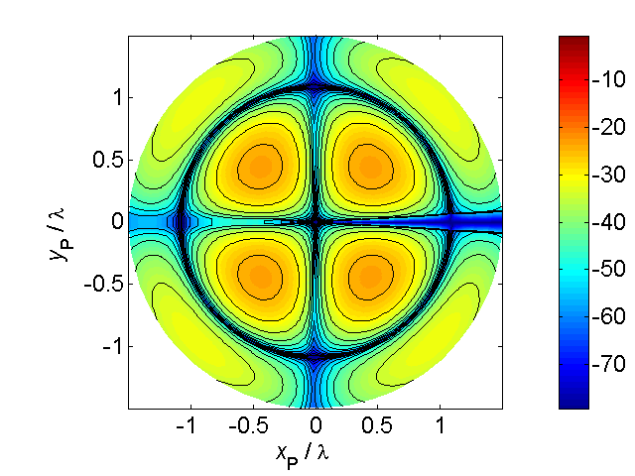

[**HSC PHYSICS ONLINE**](http://www.physics.usyd.edu.au/teach_res/hsp/sp/spHome.htm)

**THERMODYNAMICS**

**METHODS OF HEAT TRANSFER**

**CONVECTION**

Liquids and gases are **fluids**. The particles in fluids can move from