

[**VISUAL PHYSICS ONLINE**](http://www.physics.usyd.edu.au/teach_res/hsp/sp/spHome.htm)

**MODULE 4.1**

**ELECTRICITY**

**QUESTIONS AND PROBLEMS**

EX100

A uniform electric field has a magnitude of 4.60x104 N.C-1 and is directed in the +X direction. Find the force acting on particle A which has a charge of +2.80 μC and particle B which has a charge of -9.30 μC.

EX200

Two particles with charges and  have equal magnitudes are arranged as shown in the figure. The resultant electric field at the point S is in the + Y direction. What can you conclude about the signs of the two charged particles?

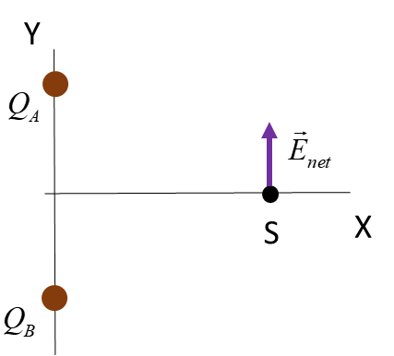

EX300

Can two electric field lines intersect each other? Explain.

EX400

Is it possible for equipotential lines to intersect? Explain.

EX450

The electric field between the plates of a parallel plate capacitor is uniform in the horizontal direction and has a magnitude *E*. A small charged ball with charge -6.10 μC and mass 0.125 kg is suspended by a light thread between the two plates. The charged ball is deflected in the electric field so that the thread is at an angle of 12.0o w.r.t. the vertical. Find the magnitude of the electric field *E*.

EX500

If the force on an electron at a particular point is 1.0x10-14 N in the direction of the positive Y axis, calculate the elecrtic field at that point and the force on an alpha particle at the same point (charge on alpha particle 4He2 nucleus is +2e).

EX600

A student in an examination wrote the statement “Charged particles **always** move along electric field lines.”

Explain why this statement by the student is **wrong**. Consider two examples for the motion of a negatively charged particle moving in a uniform electric field with initial velocities

(1) 

(2) 

Use the concept of **motion maps** (sequence of velocity vectors at uniform time intervals) to illustrate the motion of the two particles in the X and Y directions.

EX700

Decide whether each of the two statements is true or false.

1. The zero of potential energy is arbitrary.
2. The zero of the electric potential is arbitrary.

EX800

The maximum electric field that can be sustained in air without **breakdown** occurring is 3.0x106 N.C-1. What is the maximum electric potential difference that can be used between two points 10 mm apart?

**Electrical breakdown** or **dielectric breakdown** is when current flows through an electrical insulator when the voltage applied across it exceeds the breakdown potential (voltage). This results in the insulator becoming electrically conductive. Under sufficient electrical stress, electrical breakdown can occur within solids, liquids, gases or vacuum.

A dielectric is simply an insulator.

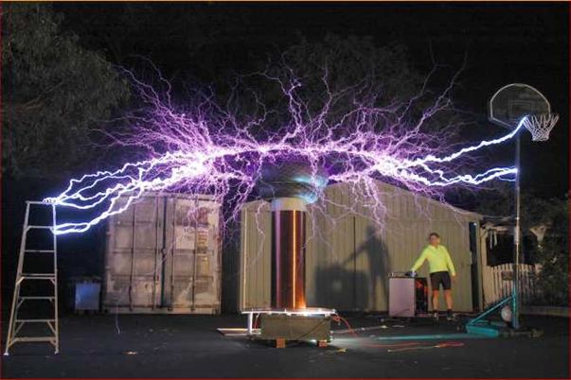

High voltages give rises to electrical discharges.

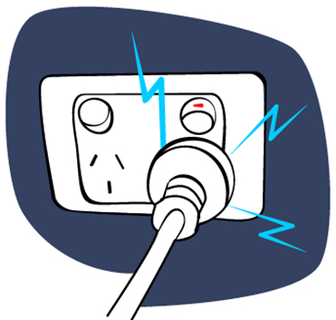EX900

Sometimes when a plug is removed from a power point socket and we see sparks. Why?

The maximum electric field that can be sustained in air without **breakdown** occurring is 3.0x106 V.m-1. The average potential difference (voltage) between the active terminal of the socket and the earth is 240 V. What is the separation distance between the conductors of the socket and plug that could result in an electrical discharge occurring when the plug is quickly pulled from the socket?

Answer 100



Answer 200

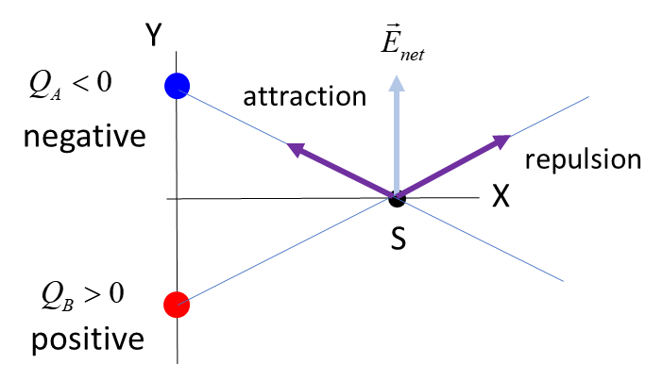

The direction of the electric field is in the same direction of the force that would act upon a positive charge at that point.

Answer 300

**Electric field lines cannot intersect.**

Electric field lines are always tangent to the electric field. Since the electric force and hence electric field, can only point in one direction at any location, it follows that the electric field lines cannot intersect.

Answer 400

**Electric potential lines cannot intersect.**

Consider the analogy of the contours on a topographical map. As we know, each contour corresponds to a different altitude. Because each point on the map has only a single value of altitude, it follows that it is impossible for contours to intersect.

Answer 450

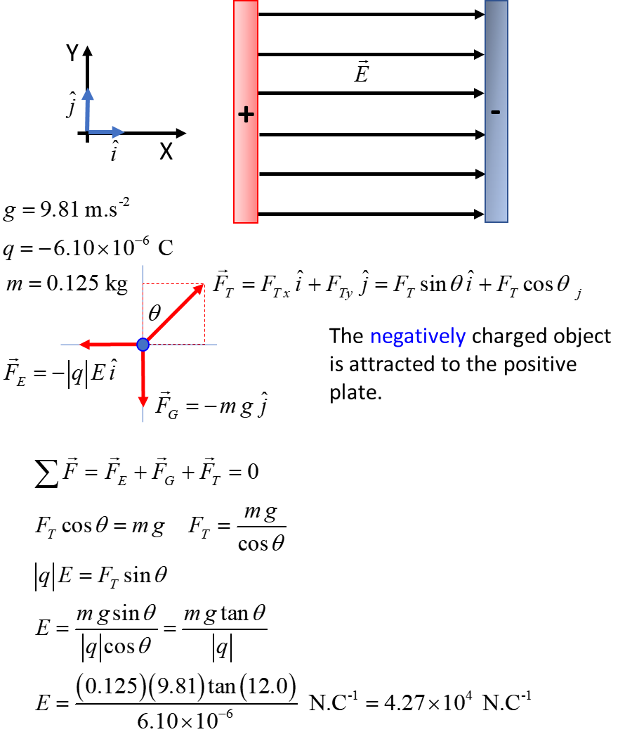

Answer 500

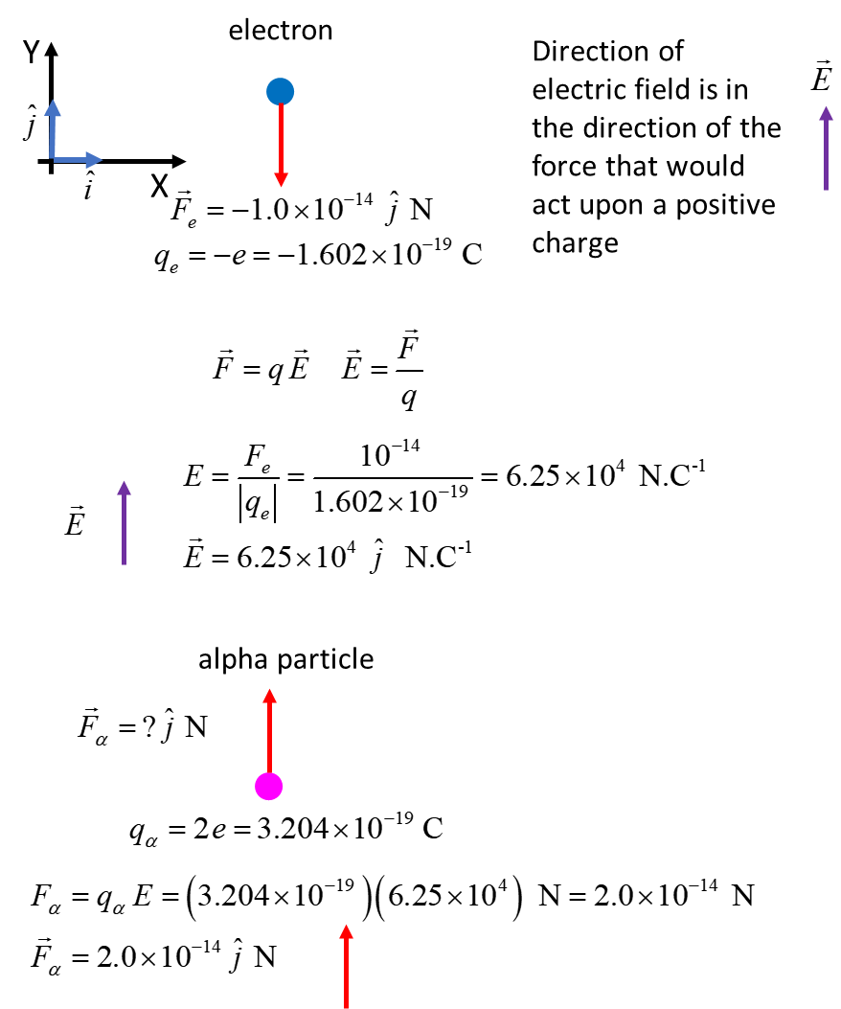

Answer 600

A charge particle does **not** necessarily follow the path of an electric field line. At any location, the direction of the electric field line indicates the direction in which a force would act on a positive charge located at that position.

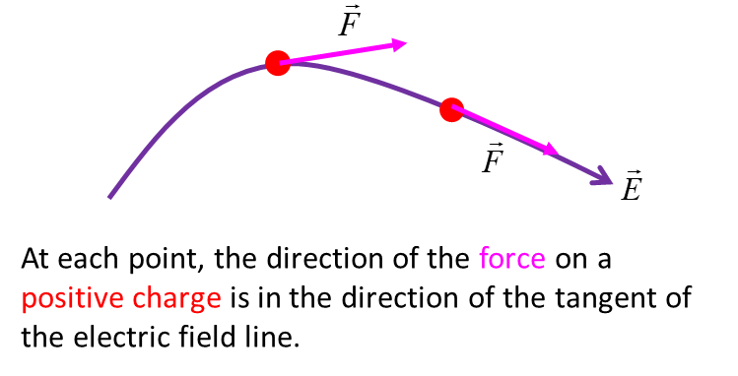

1. Initial velocity  of negative charge in uniform electric field in uniform .

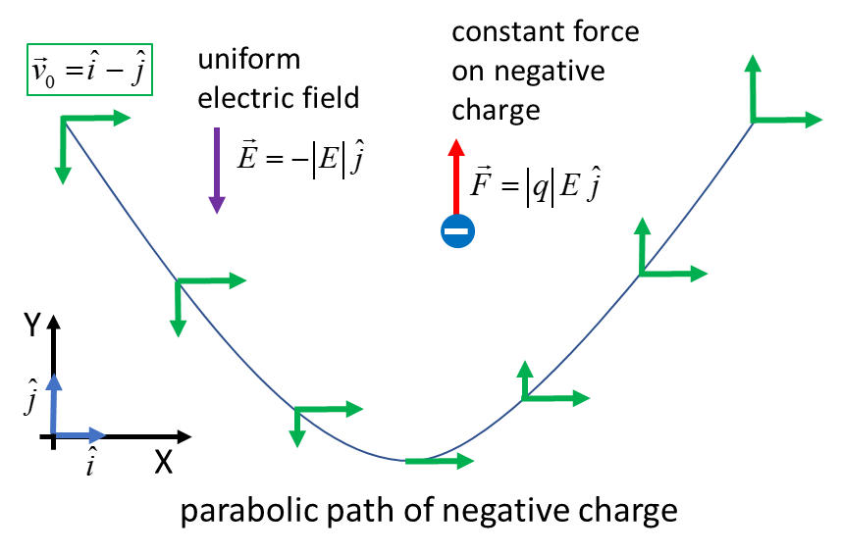

Motion of negative charge like the projectile motion of a ball.

1. Initial velocity  of negative charge in uniform electric field in uniform .

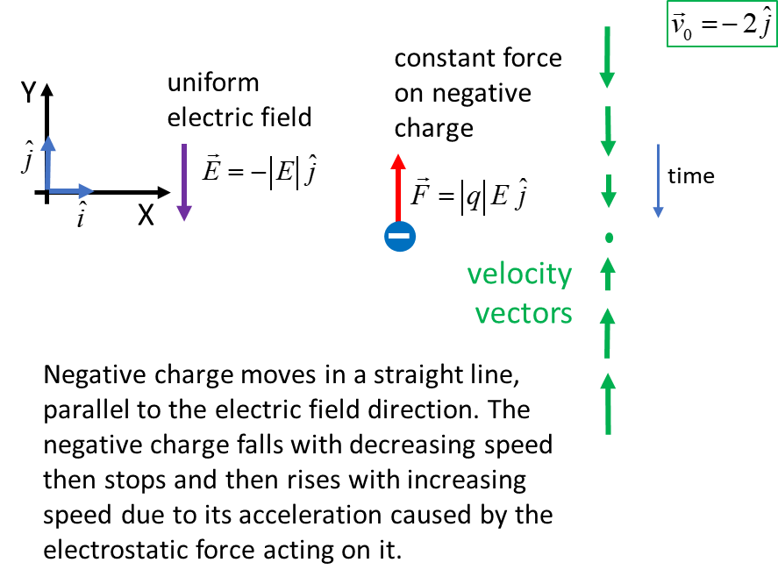

Answer 700

1. TRUE: only changes in potential energy are physically relevant.
2. TRUE: only the difference in potential between two points is physically relevant.

What is important is the potential difference between two points. It is by multiplying the potential difference between two points by the charge being moved that the change in potential energy (the quantity significant in defining motion) can be found.

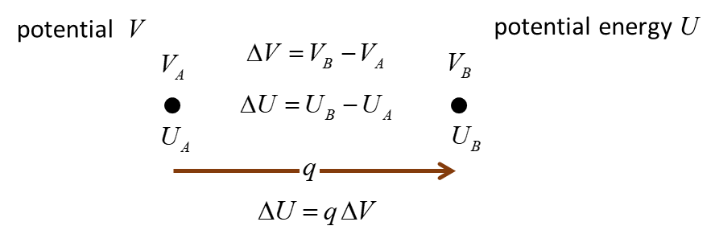

Answer 800

Breakdown electric field strength *E* = 30x106 N.C-1

Separation distance 

The connection between the electric field and potential for [1D] is



The maximum potential between two points without electrical breakdown is



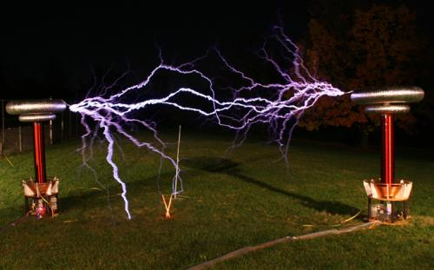



Answer 900

Breakdown electric field strength *E* = 30x106 N.C-1

Potential between socket and plug conductors 

Separation distance 

The connection between the electric field and potential for [1D] is



The separation distance  for electrical breakdown is



[VISUAL PHYSICS ONLINE](http://www.physics.usyd.edu.au/teach_res/hsp/sp/spHome.htm)

If you have any feedback, comments, suggestions or corrections please email Ian Cooper

ian.cooper@sydney.edu.au

Ian Cooper School of Physics University of Sydney