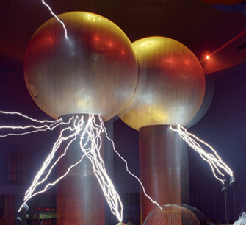

[**VISUAL PHYSICS ONLINE**](http://www.physics.usyd.edu.au/teach_res/hsp/sp/spHome.htm)

**MODULE 4.1**

**ELECTRICITY**

**QUESTIONS AND PROBLEMS**

EX100

What can you say about the relationship between the spacing of the equipotential surfaces and the magnitude of the electric field.

What can you say about the relative orientations of the equipotential surfaces and electric field lines.

EX200

A cathode ray tube (like in old television sets) consists of a heated filament known as a cathode (negative) and metal plates called the accelerating anodes (positive). Electrons are liberated from the heated cathode with negligible speed and are accelerated by the anodes before striking a phosphorescent screen. Assume the potential difference between the cathode and anode is 1600 V (accelerating potential). Calculate the kinetic energy (in J and eV), momentum and speed at which an electron strikes the phosphorescent screen.

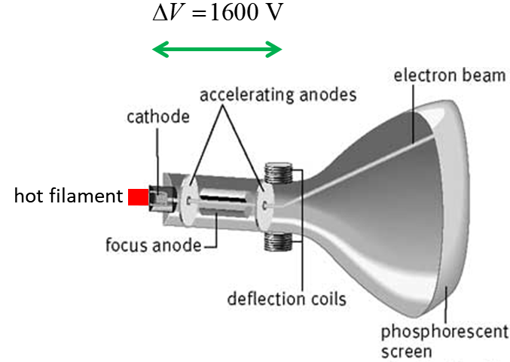



EX300

Two flat parallel plates which are 0.120 m apart are maintained at a potential difference of 30.0 V.

How does the electric potential change between the plates? What is the electric field between the two plates?

If a charge of -45.0 μC was placed between the plates, what force would act upon it?

EX400

A conductor is at +30 V with respect to the Earth.

What can you say about the charge on the conductor?

What is the electric field within the conductor?

In what direction, must the electric field lines leave the surface of the conductor?

EX450

In a certain region of space, the electrical potential is known to be constant. What conclusions can be made about the electric field?

EX500

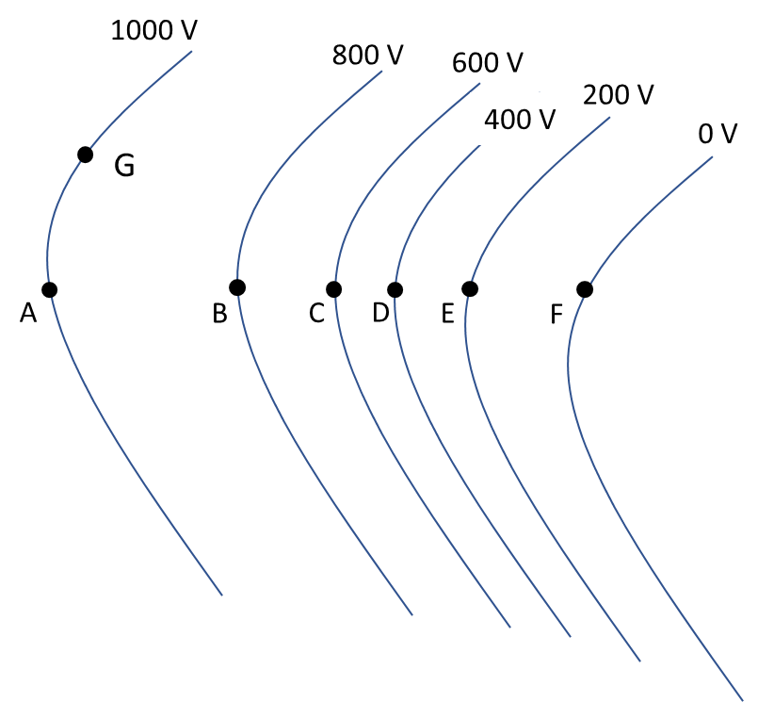

1. At which point A, B, C, D, E or F has the greatest magnitude for the electric field? Explain.
2. What is the direction of the electric field at the points A and F?
3. If a proton was released from rest at point D, would the proton move towards point A or point F? How does the kinetic energy, potential energy and potential of the proton change after it is released in the electric field?
4. A positive charge +2 C is moved from point E to point B by an external agent. What work is done by the external applied force if the charge particle starts at rest and at ends at rest. How much work is done by the electrostatic force. What is the net work done on the charge?
5. How much energy is need to move a -3 C charge from point A to point G?

EX600

An electron is initially moving in the +X direction along an electric field line whose direction is in the -X direction. Describe the changes in the parameters .

EX700

A proton and electron are both initially at rest in a uniform electric field.

1. When they are released describe the motion of both charges.
2. At time interval *t* after the charges have been released, what is the ratio of the distances travelled by the electron to the distance travelled by the proton?
3. When the electron and proton are accelerated through a potential difference of the same magnitude, what is the ratio of the change in their kinetic energies.

EX800

Few people survive being struck by lightning. What steps or precautions might you take if caught in the open as a thunder storm approaches?



EX900

Synchronous satellites used for communications must orbit the Earth in such a way that their position relative to the Earth’s surface is fixed. They travel in a circular orbit with a period of 1 day. A satellite in such an orbit is perturbed by the gravitational attraction of the Moon and so regular corrections to the orbit must be made. Synchronous satellites are equipped with **ion thrusters** which can exert small forces on the satellite to maintain the correct orbit.

The ion thruster ejects atoms with a certain amount of momentum in one direction, and imparts an equal and opposite momentum to the satellite (Newton’s 3rd Law / Law of Conservation of Momentum).

In an ion thruster, positive ions are emitted by a source and attracted to a negative electrode and are therefore can be accelerated to high speeds. The positive ion beam then passes through an electron source in the form of a ring. The electrons neutralize the high speed positive ions. So, a high-speed beam of neutral atoms is ejected from the ion thruster and so momentum can be transferred to the satellite. The resulting force on the satellite due to ejected gaseous atoms alters the trajectory of the satellite ever so slightly so that the correct orbit of the satellite is maintained. If the electron source ring was omitted, the satellite would acquire a negative charge and the positive ions would be drawn back to the satellite and would prevent any permanent transfer of momentum from the ions to the satellite.

Suppose that an ion thruster uses argon ions (Ar+) and that it fires 1019 ions per second through an electric potential difference of 1000 V. (mass Ag+ *m* = 6.6x10-26 kg). Calculate:

1. The kinetic energy given to each argon ion (J and eV).
2. Momentum given to the ions.
3. The force exerted on the satellite.
4. The electrical power consumed by the ion thruster.

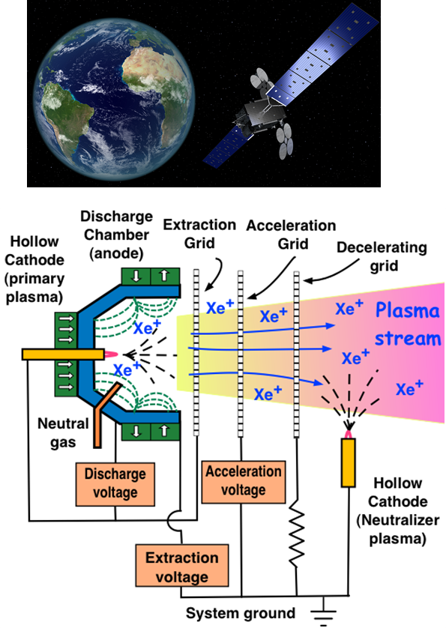

Answer 100

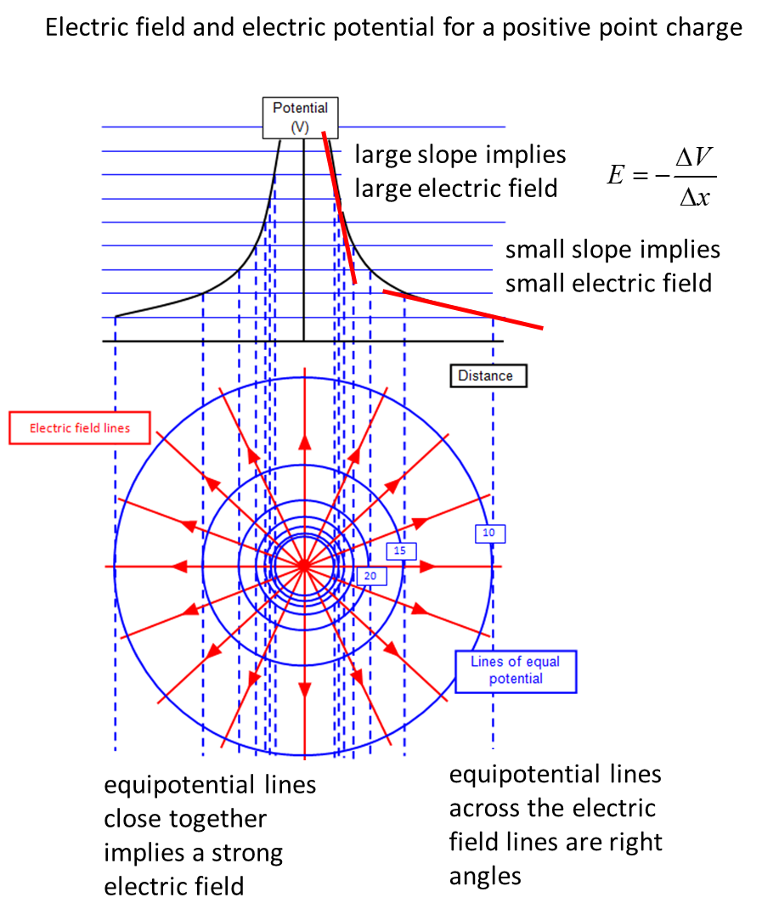

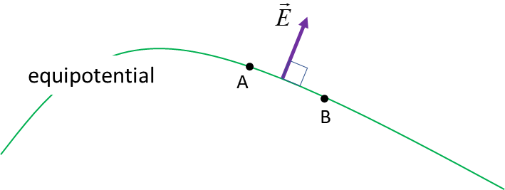

Since A and B are at the same potential, there can only be a zero force component along the line joining them. So, the electric field vector  must always cut the equipotential at **right angles**.

Answer 200



The electric field between the cathode and anode results in the electrical force acting on an electron to accelerate it from the low potential region to the high potential region.

The work done on the electron is



Work is only done on the electrons in their passing through the accelerating electric field. The electrons in travelling from the accelerating anode to the screen have no further acceleration (field free region) and hence travel at a uniform velocity. So, the values for the kinetic energy, momentum and speed of electrons hitting the screen as the same values as when the electrons reach the end of the accelerating anode.

The work done on an electron increases the kinetic energy of the electron and since the initial kinetic energy is zero, the final kinetic energy of an electron is



The connection between the kinetic energy and the momentum is



Hence, the final velocity of the electron is



Answer 300

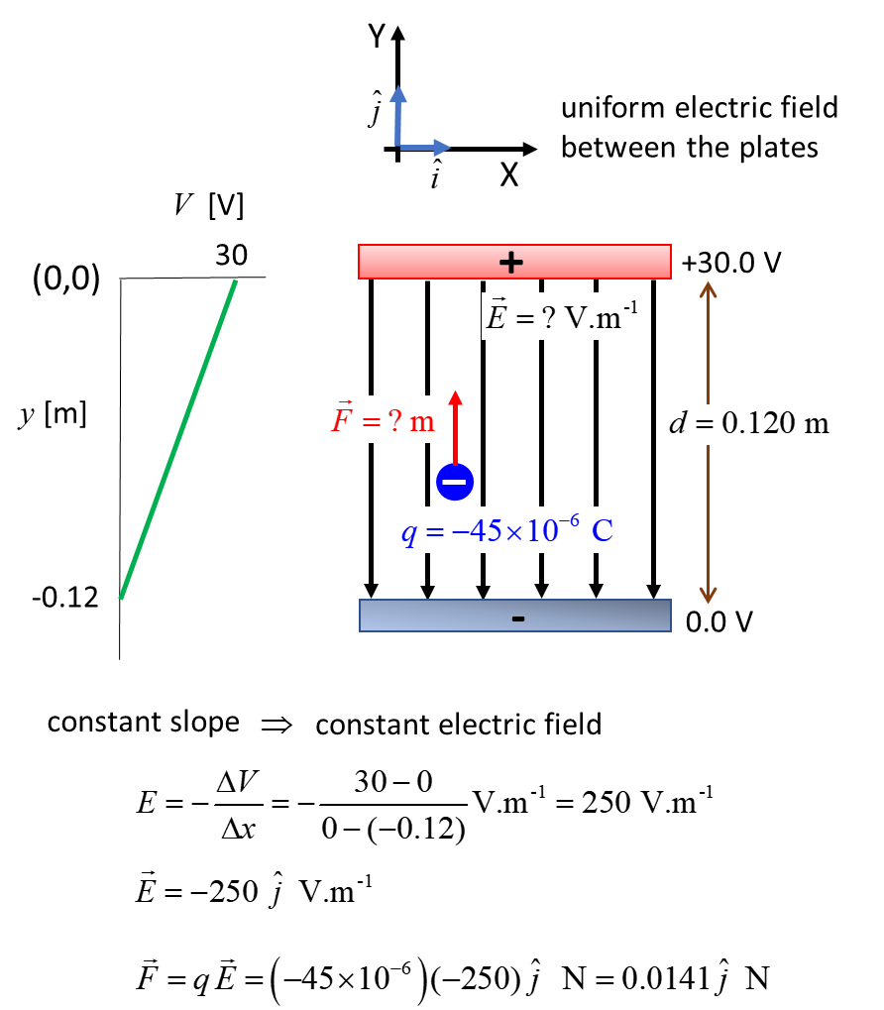

Answer 400

The conductor must be **positive** since it is at a higher potential than the Earth which is taken as neutral. Within the conductor, electrons are free: moving an electron involves zero force, zero change in potential energy and therefore, zero change in electrical potential. Since the potential within the conductor is the same everywhere, the electric field in any direction must be zero.

The surface of the conductor is an equipotential and so the electric field lines must leave at right angles.

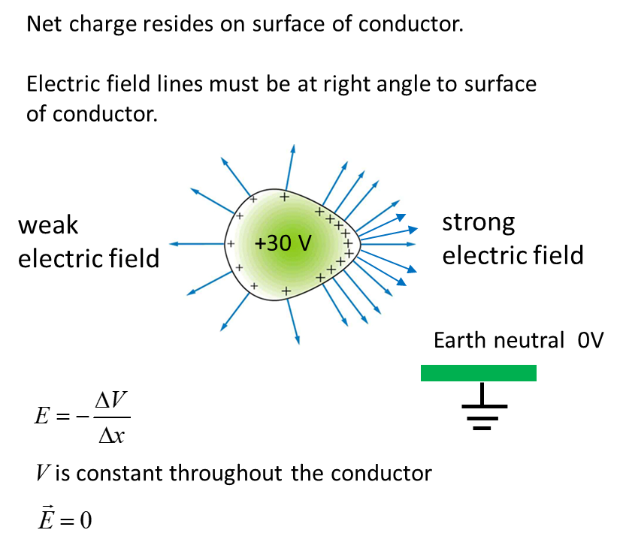

Answer 450

The electric field is zero.

The electric field is related to the rate of change of electric potential with position, not to the value of the potential. Since the rate of change of a constant potential, the change in potential is zero, hence the electric field vanishes.



Answer 500

(a) The electric field is greatest at point D. The density of the equipotential lines is greatest near the point D than at any other point, that is, the gradient of the potential is greatest near the point D. 

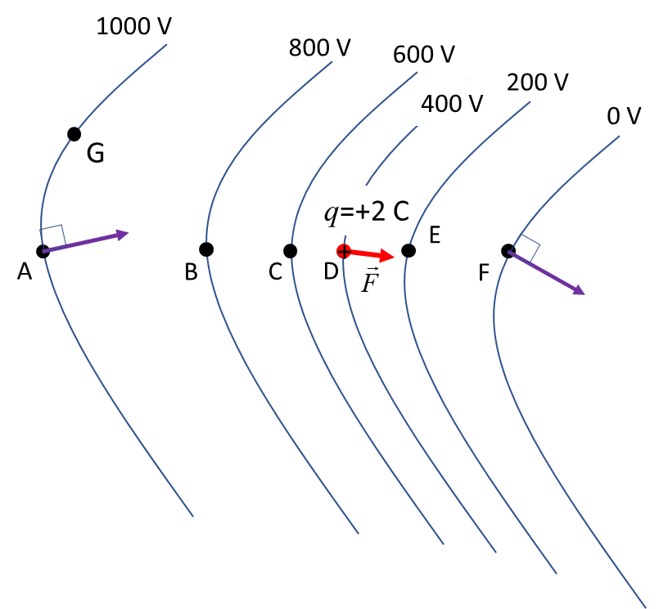

(b) The electric field lines are always at right angles to the equipotential lines.

(c) A positive charge placed at D would experience an accelerating force in the direction towards the point F as shown in the figure. The electrostatic force does work on the positive charge, so its kinetic energy will increase but its potential energy will decrease. The positive charge moves from the higher potential to the lower potential, so the potential decreases.

(d) The work done by the external force acts against the electrostatic force. The change in kinetic energy *K* is zero, since the charge starts and ends at rest. Zero net work is done on the charge as it moves from point E to point B. The work done by the external force increases the potential energy *U* of the charge in the electric field.



(e) The change in potential for the charge moving along an equipotential line is zero, so zero work is done on the charge.



Answer 600

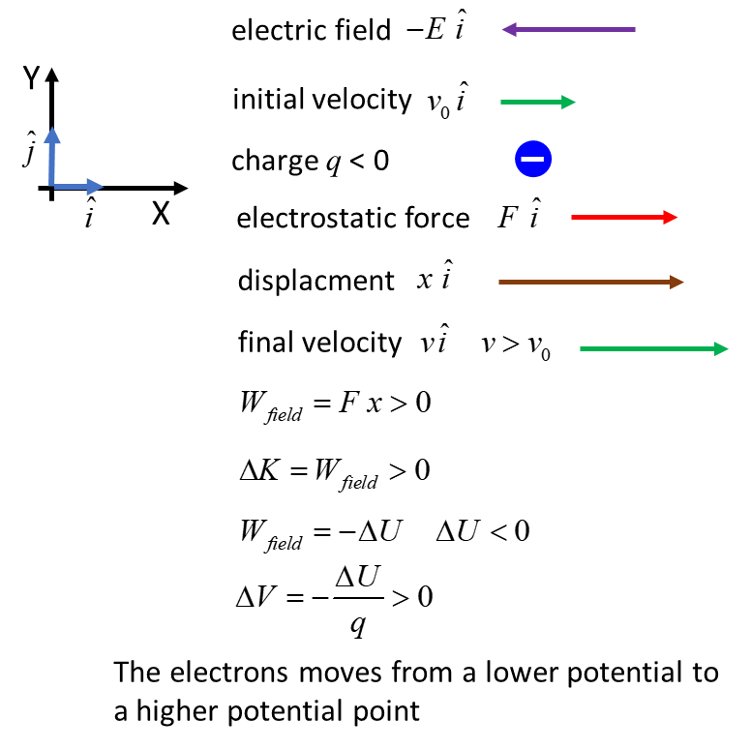

Answer 700

The electron and proton will move in opposite directions both with uniform accelerations. The magnitude of the force acting on the electron and proton in the uniform electric field is the same. But, from Newton’s Second Law, the acceleration is inversely proportional to mass of the particle for a constant force. So, the electron will have a much greater acceleration than the proton and in a given time interval, the displacement of the electron is much greater than that of the proton. However, when they are accelerated through a potential difference of the same magnitude, they will acquire the same increase in kinetic energy.

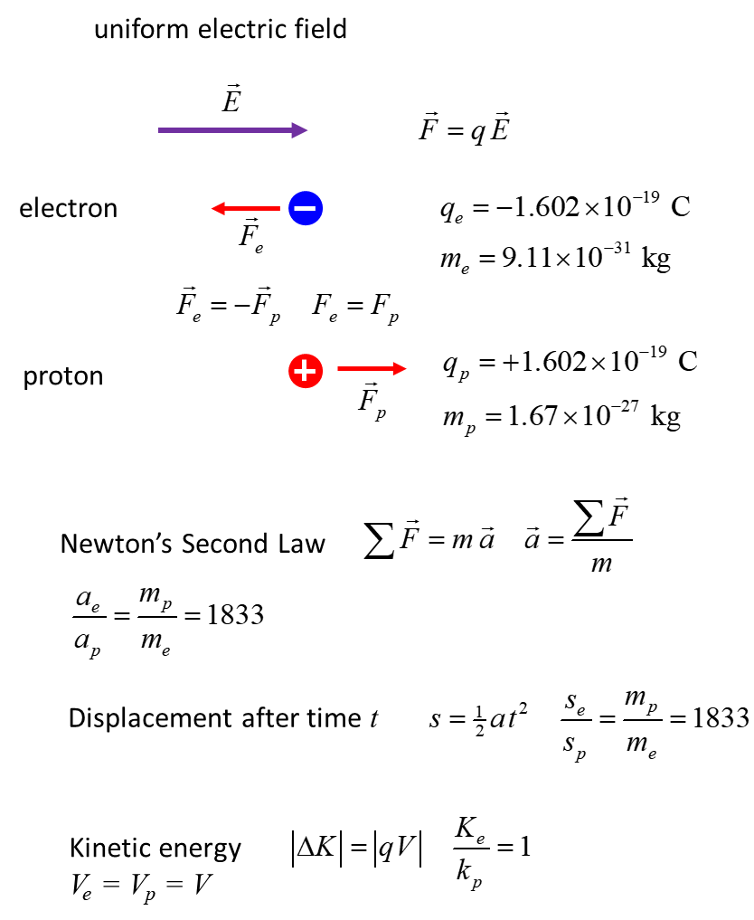

Answer 800

[view lightning safety](http://solutionsforyourlife.ufl.edu/hot_topics/families_and_consumers/lightning_safety.shtml)

The thunder storm produces an electric field *E* in the region you are standing and a potential difference  can be generated. To minimize the potential difference  across your body you should squat and make your body as small as possible to reduce your dimensions *d*.



The smaller the value of *d* the smaller the potential difference  between any two points.

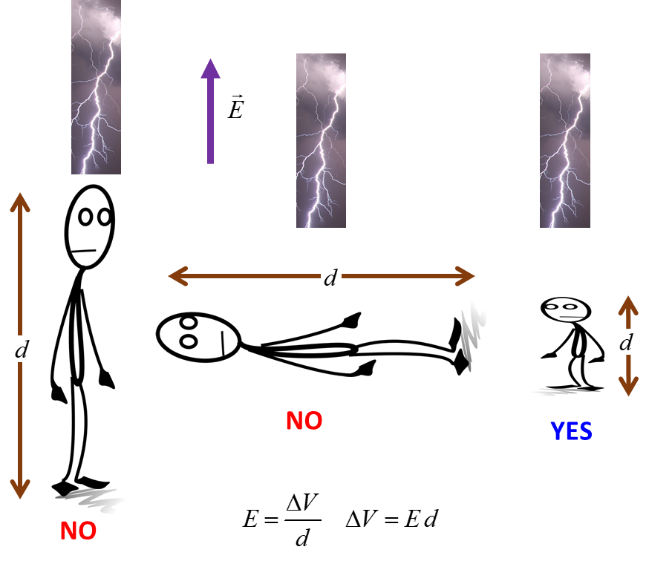

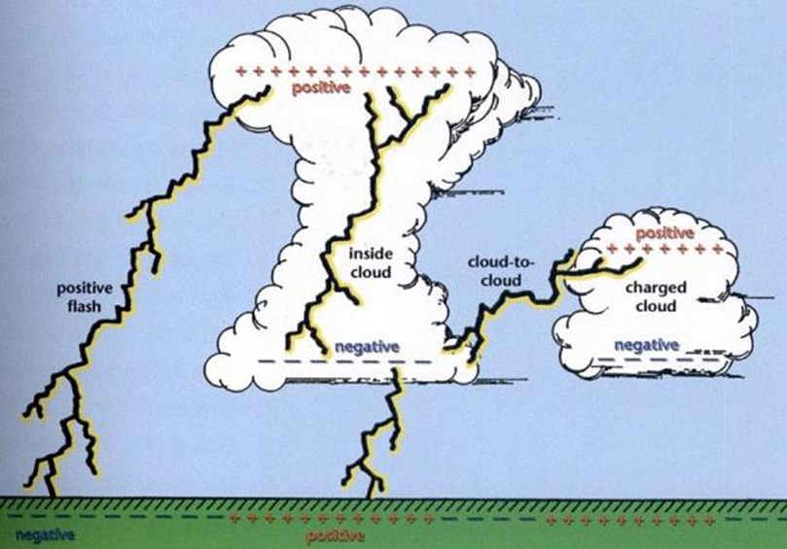

Answer 900

’

(a) kinetic energy *K*

The argon ion is singly charged and accelerated through a potential difference of 1000 V, therefore, the kinetic energy of the accelerated ions in eV is *K* = 1000 eV

The kinetic energy in joules is *K* = *q V* = 1.602x10-16 J

(b) momentum *p*

single ion



(c) force exerted on satellite *F*

Total rate of change of momentum and hence force *F* exerted on the satellite is



(d) power P

The power consumed is equal to the rate at which kinetic energy is given to the ions



This power can be supplied by batteries which are continuously recharged from solar cells.

[VISUAL PHYSICS ONLINE](http://www.physics.usyd.edu.au/teach_res/hsp/sp/spHome.htm)

If you have any feedback, comments, suggestions or corrections please email Ian Cooper

ian.cooper@sydney.edu.au

Ian Cooper School of Physics University of Sydney