

[**VISUAL PHYSICS ONLINE**](http://www.physics.usyd.edu.au/teach_res/hsp/sp/spHome.htm)

**MODULE 4.1**

**ELECTRICITY**

**QUESTIONS AND PROBLEMS**

**EX100**

Two brushes are charged by vigorously brushing a moulting dog. (a) Will the hairs that fall out attract or repel each other? (b) Will the hairs be attracted to the brush or repelled from it? (c) Will the two brushes attract or repel each other? Explain.

**EX200**

A glass rod is rubbed with silk. After the glass rod has become charged, has the mass of the glass rod changed? Explain.

**EX300**

A proton and electron are initially a fixed distance apart. When released simultaneously, they are free to move. When they collide, are they (a) at the mid-point of their initial separation, (b) closer to the electron’s initial position, or (c) closer to the proton’s initial position? Explain.

**EX400**

A charged objected -*q* can be placed at either point S or point T as shown in the figure. Assume that points S and T lie on the line midway between two positive charges +*Q*. Is the resultant force experienced by the by the charged object (-*q*) at point S (a) greater than, (b), equal to, or (c) less than the resultant force experience at point T?

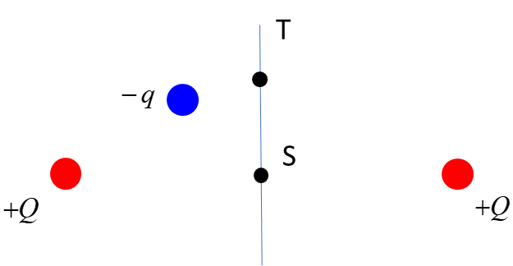

**EX450**

As two small spheres are brought close together, they are found to attract each other by an electrostatic force. What can you say about the charges on the two spheres?

**Ex500**

Image three point-like objects A, B and C each with a charge +*q* located at the corners of an equilateral triangle. Draw a diagram to show the physical situation. Show the forces acting on charge A due to the presence of charges B and C and the resultant (net) electrostatic force acting on A.

**EX600**

Three charges are arranged in a straight line. Assume that *q*1 and *q*3 are held in fixed positions. Calculate the value of the charge *q*3 that would be required to hold *q*2 in equilibrium.

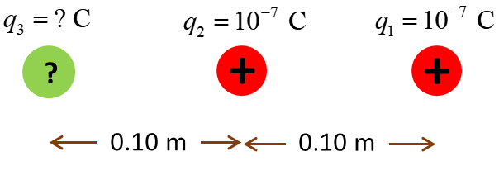

**Answer 100**

In the brushing process, charge (electrons) will be transferred between the brush and the hairs. This will leave the brush and the hairs to be oppositely charged, one negative and the other positive.

1. The hairs carry the same charge, so they will repel each other.
2. The hairs and brush have opposite signs for their charges, so they will attract each other.
3. The brushes carry like charges and so repel each other.

**Answer 200**

When glass is rubbed with silk, it becomes positively charged as electrons are transferred from the glass to the silk. Each electron has a small mass but non-zero mass. Therefore, the glass rod mass decreases ever so slightly as it is charged.

**Answer 300**

Newton’s 3rd law – the force exerted on the electron and the force exerted on the proton are equal in magnitude and opposite in direction. Since they are oppositely charged, they attract each other. Newton’s 2nd law, the acceleration of a particle is inversely proportional to the mass of the particle. The electron has a much greater acceleration then the proton and will travel a much greater distance than the proton. So, the collision will occur at a positon much closer to the initial location of the proton.

**Answer 400**

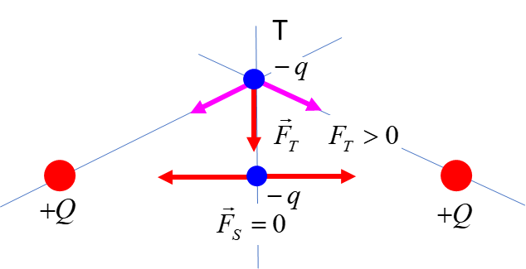

The net force at point S is less than the net force at point B.

**Answer 450**

If the two spheres attract each other, there are two possibilities.

1. The spheres carry opposite charges.
2. One sphere is charged and the other is uncharged (neutral). As the spheres get closer, the neutral sphere has its charge redistributed by induction. The initially uncharged sphere may be either a conductor or insulator.

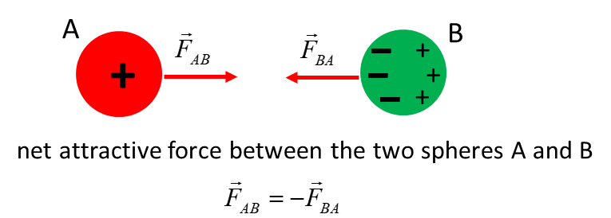

**Answer 500**

The force on A due to the charge B will act along the line joining A and B. Because A and B are like charges, the electrostatic force is repulsive. Similarly, the repulsive force on A due to charge C is along the line joining A and C. Because charges B and c are identical and equidistance from A, the two forces are equal in magnitude.

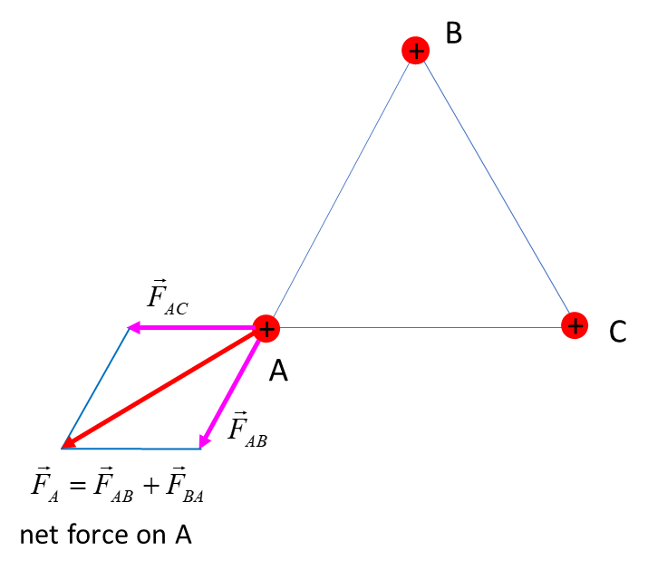

[VISUAL PHYSICS ONLINE](http://www.physics.usyd.edu.au/teach_res/hsp/sp/spHome.htm)

If you have any feedback, comments, suggestions or corrections please email Ian Cooper

ian.cooper@sydney.edu.au

Ian Cooper School of Physics University of Sydney