

[**VISUAL PHYSICS ONLINE**](http://www.physics.usyd.edu.au/teach_res/hsp/sp/spHome.htm)

**MODULE 4.1**

**ELECTRICITY**

**INTERACTION BETWEEN CHARGES**

“Electricity is the Soul of the Universe”

John Wesley (1703 – 1791)

**Questions and Problems** [ex41A](http://www.physics.usyd.edu.au/teach_res/hsp/sp/mod41/ex41A.pdf)

**Charge** is an intrinsic property of the fundamental particles – the **electron** and the **proton**.

* Electrons repel electrons
* Protons repel protons
* Electrons and protons attract each other.

This property, charge, gives rise to all electrical forces. By convention, the **electron** is said to be **negatively charged** and the **proton** **positively charged**.

|  |
| --- |
| **Charge**: *q* or *Q*  S.I. unit: coulomb [ C ]  elementary charge *e* = 1.6x10-19 C  1 C = 6.28x1018 electrons  charge on an **electron** **-** *e*  charge of a **proton** + *e* |

Since electrons repel electrons, protons repel protons and electrons and protons attract each other:

**Objects with the same charge repel each other**

**Objects with the opposite sign attract each other**

**Any charged object can attract a neutral object**

**Coulomb’s Force Law for point-like charges**

Between 1785 and 1787 Charles-Augustin de Coulomb (French physicist 1736 – 1806) performed a critical and difficult series of experiments using charged objects and a sensitive torsion balance that he invented for measuring small forces. He discovered that the mutual electrical force of attraction or repulsion on each of two small, point-like charged objects varied inversely as the distance of separation and was proportional to the magnitude of the product of the two charges.

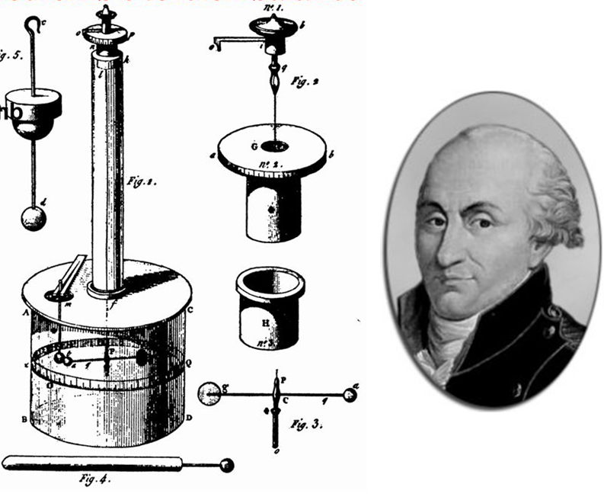

Consider two point-like charges  and  with a separation distance placed within a medium with its electrical properties specified by the its **electrical permittivity**  (  Greek letter epsilon).

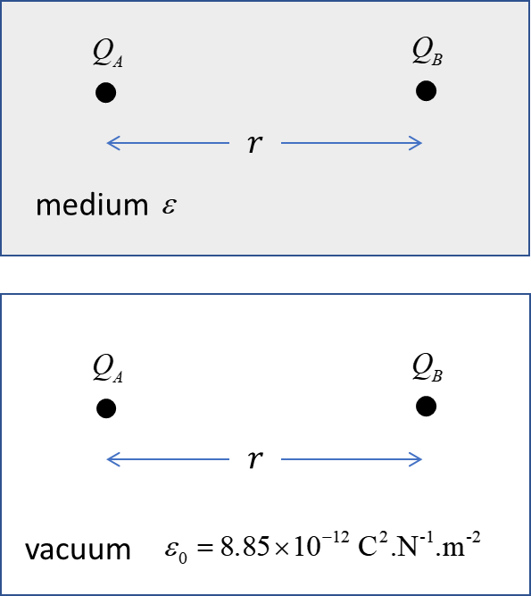

Fig. 1. The forces that any two point-like charges exert on each other are equal in magnitude but act in opposite directions – Newton’s 3rd Law.

The magnitude of the electric force  that the two point-like charges exert on each other is best written as

 **Coulomb’s Law**

This is equation is known as **Coulomb’s Law**.

Note: in this equation, the absolute vales of the charges are used. This is not usually done but it much better physics to ignore the sign of the two charges. The force is attractive if the charges are of opposite sign and if the charges are the same sign then the force is repulsive. Force is a vector quantity given by its magnitude (positive number) and its direction, so it is not appropriate to have a positive or negative force.

On most occasions, the charges are separated in a vacuum (for Coulomb’s Law, the air as the medium is a good approximation to a vacuum). The electrical properties of a vacuum are specified by the **permittivity of free space** 



For a vacuum (air), Coulomb’s Law can be written as





where the Coulomb constant  is



|  |
| --- |
| **Example 1**  A point-like charge -2.23 C is located 250 mm from another point-like charge + 4.45 C. What are the forces acting on each charge?  **Solution**  How to approach the problem?  Visualise the physical situation.  Indicate a frame of references.  Draw a scientific annotated diagram of the situation.  Working with vectors: magnitudes, directions, components, unit-vectors.  Physical principles, laws, equation, assumptions. |

|  |
| --- |
| **Example 2**  Three charges ,  and  are fixed at the corners of an equilateral triangle. The length of a side is 2.00x10-4 m. The magnitude of the charge is  = 6.68 nC. Find the net (resultant) force acting on the charge . For each charged object, how many electrons have been transferred to or from the object?    **Solution**  How to approach the problem?  Visualise the physical situation.  Indicate a frame of references.  Draw a scientific annotated diagram of the situation.  Working with vectors: magnitudes, directions, components, unit-vectors.  Physical principles, laws, equation, assumptions.  Label charges A, B and C        Coulomb’s Law  Force of A on C (attractive)    Force of B on C (repulsive)      The net force (resultant) acting on C is the superposition of the forces of A and B acting on C      Note: the vertical forces acting on C cancel each other.  Note: the use of unit vectors makes complicated calculations easier.  Charge is quantized    Object A  electrons transferred **to** A  Object B  electrons transferred **from** B  Object A  electrons transferred **from** C    **MATLAB EXTENSION**  A great way to improve your understanding and knowledge of physics and hence perform better in your HSC physics examination is through coding (programming). The best software tool for this purpose is MATLAB, but MS EXCEL is also OK.  MATLAB function to calculate the force  between two charged objects and the X and Y components of the force. Inputs: values for the two charges  and ; separation distance *r*; and orientation of charges with respect to the X axis . Outputs: electrostatic force, X component and Y component .  If use MATLAB then try the code, if not work through the code – by understanding the code, your physics will improve.  You can also use MS EXCEL for this calculation.  clear all  close all  clc  % INPUTS  r = 250e-3;  QA = 2.23e-6;  QB = 4.45e-6;  theta = 180;  % CALCULATIONS  [F, Fx, Fy] = coulomb(QA,QB,r,theta);  % DISPLAY RESULTS  disp('INPUTS:')  textD = [' r = ',num2str(r),' m'];  disp(textD);  textD = [' QA = ',num2str(QA),' C'];  disp(textD)  textD = [' QB = ',num2str(QB),' C'];  disp(textD)  textD = [' angle: theta = ',num2str(theta),' deg'];  disp(textD);  disp('OUTPUTS:')  textD = [' FE = ',num2str(F),' N'];  disp(textD);  textD = [' Fx = ',num2str(Fx),' N'];  disp(textD);  textD = [' Fy = ',num2str(Fy),' N'];  disp(textD);    % FUNCTION ===========================================  function [F, Fx, Fy] = coulomb(QA,QB,r, theta)  k = 9e9;  F = k * QA*QB / r^2;  Fx = F * cosd(theta);  Fy = F * sind(theta);  end  Results for Example 1 – force on  r = 0.25 m  QA = 2.23e-06 C  QB = 4.45e-06 C  angle: theta = 180 deg  OUTPUTS:  FE = 1.429 N  Fx = -1.429 N  Fy = 0 N  Why is the angle  ? |
| **Example 3**  Two identical charged uranium ions separated by 2.30 nm have a force between them of 1.09 nN. What is the charge on each ion and how many electron charges does this represent?  (nano n 1x10-9)  **Solution**  *Identify / Setup*    Coulomb’s Law    ions  repulsive force  = 1.09×10-9 N  separation distance *r* = 2.30×10-9 m  electron charge *e* = 1.602×10-19 m  number of elementary charges *n* = *q/e* ?  *Execute*  Using Coulomb’s Law    *Evaluate*  Number of elementary charges is an integer ok  **Predict Observe Explain**  Predict the shape of the graph for the repulsive force between the two uranium ions if the separation distance varied from 1nm to 10 nm. If one of the uranium ions had 25 electrons removed rather than 5, how would the graph change?  Predict the shape of the graphs for the repulsive force as a function of charge between two uranium ions at the separation distances of 2.0 nm and 6.0 nm when uranium ion A has only one electron removed while the uranium ion B has 0 to 25 electrons removed.  Only after you have made your predictions, view the plots of the force against separation distance and force against charge. |

|  |
| --- |
| Graphical view of Coulomb’s Law for the two uranium ions.  *n* represents the number of electrons removed. Coulomb’s Law is an example of an inverse square law .  Graphical view of Coulomb’s Law for the repulsive force between two uranium atoms as a function of charge for two separation distances.  What does each circle represent?  Note: a straight line can be draw through each plot. Why?  Note: The charge of the uranium ion B is quantized, therefore, the force between the ions also must also be quantized – the force is not a continuous function of charge. |

**Permittivity **

Why does table salt (NaCl) dissolve in dissolve in water but not air?

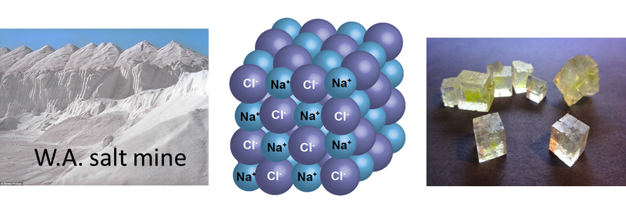



It is found that the maximum electrostatic force between point-like charges separated by a fixed distance occurs when the charged objects are placed in a vacuum. In all other material media, the force is reduced. The minimum possible value of the permittivity therefore corresponds to the case when .

**permittivity of free space** 

The permittivity of all material media is greater than the free space value. The ratio  is known as the dielectric constant . The permittivity of air at normal pressures is only 1.005 time the permittivity of free space  , so, it is usual to use the value  for the permittivity of air.

|  |  |
| --- | --- |
| **Dielectric constant** | |
| vacuum | 1.000 |
| air | 1.005 |
| wood | 2.1 |
| nylon | 3.7 |
| glass | 6.7 |
| water | 80 |

The reason the electrostatic force depends upon the medium is that the charges  and  distort the atoms (polarization) in the surrounding medium. The extent of the polarization modifies the electrostatic force and the degree of polarization depends upon the atoms that constitute the medium and the number of atoms per unit volume. Thus, gases with relatively few atoms per unit volume have dielectric constants only slightly greater than 1 , so the reduction in the electric force is only small. Table salt is made up of positive ions (Na+) and negative ions (Cl-). In air, the attractive force between ions of opposite sign is greater than the repulsive force between ions of the same charge, so, the ions are tightly bound to each other in a crystal structure.

However, water has a very large value for its dielectric constant  so, it very readily dissolves many substances. When table salt (NaCl) is added to water, the sodium chloride crystal composed of Na+ and Cl- ions disintegrates and the ions move freely about in the water as the polar water molecules come between the Na+ and Cl- ions reducing the attractive force between the ions by a factor of 80.

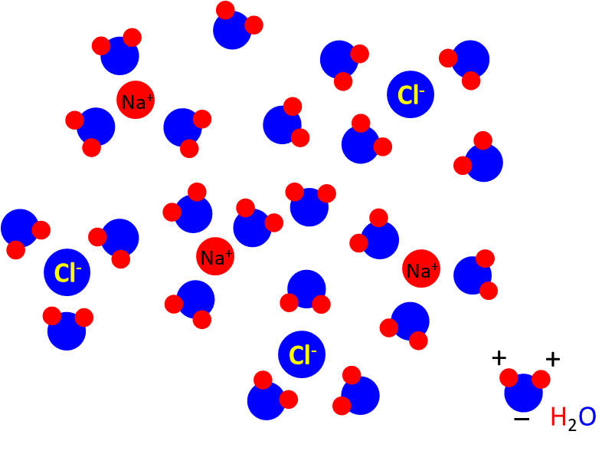

**Questions and Problems with answers**

[ex41A](http://www.physics.usyd.edu.au/teach_res/hsp/sp/mod41/ex41A.pdf)

[VISUAL PHYSICS ONLINE](http://www.physics.usyd.edu.au/teach_res/hsp/sp/spHome.htm)

If you have any feedback, comments, suggestions or corrections please email Ian Cooper

ian.cooper@sydney.edu.au

Ian Cooper School of Physics, University of Sydney

<http://www.physics.usyd.edu.au/teach_res/hsp/sp/spHome.htm>