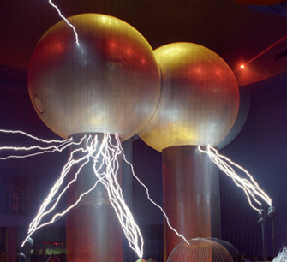

[**VISUAL PHYSICS ONLINE**](http://www.physics.usyd.edu.au/teach_res/hsp/sp/spHome.htm)

**MODULE 4.1**

**ELECTRICITY**

**ELECTRIC FIELD**

|  |
| --- |
| **Electric field**  Vector  Direction same as the force that would  be exerted on a positive charge  Magnitude  Components [2D]    S.I. units  N.C-1 (newton / coulomb)  V.m-1 (volt / metre) |

Before proceeding with the notes on electric fields, review the topic on scalar and vector fields and watch the video on electric fields

[Review scalar and vector fields](http://www.physics.usyd.edu.au/teach_res/hsp/sp/mod1/m1_A.pdf)

[Watch video](http://www.pbs.org/video/2365917598/)

As you watch the video, make a summary of the key point.

A **scalar field** is a region of space where some physical quantity has a definite value at every point.

A **vector field** is a region of space where the vector quantity is specified by its magnitude and direction at every point.

An electric field  is a region where an object of charge  will experience an electric force .

(1) 

At each point in the electric field space, the magnitude of the force is  and the direction of the electric force is in the same direction as the force that would be exerted on a positive charge placed at that point. Equation (1) is only **valid** if the charge  does not change the electric field.

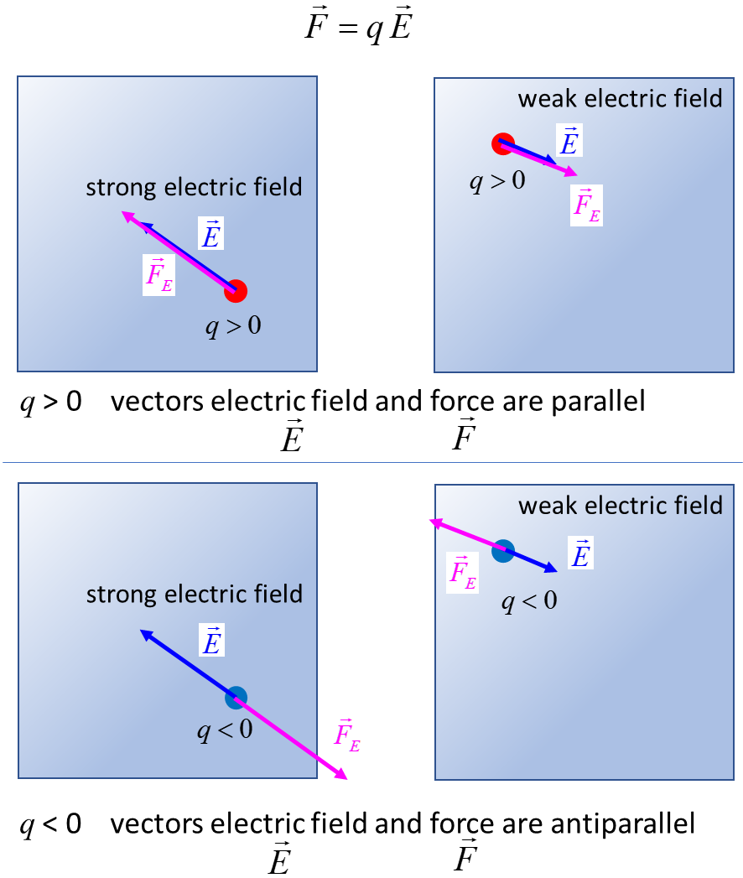

Fig. 1. The direction of the electric field is in the direction of the force that would act upon a positive charge.  is the electric force acting on the charge at the location where the electric field is .

**How are electric fields produced?**

We know that electric charges exert attractive or repulsive forces on other charges. So, any **charge distribution** gives rise to an electric field. Another way in which electric fields are generated is due to the fact that a **changing magnetic field induces a changing electric field**. The reverse is also true, a **changing electric field induces a changing magnetic field**. This is how electromagnetic waves propagate through space: a changing magnetic field induces a changing electric field which generates a changing magnetic field, and so on and on. An electromagnetic wave is self-propagating.

Watch video [jumping ring](https://www.youtube.com/watch?v=V690VphqTwg)

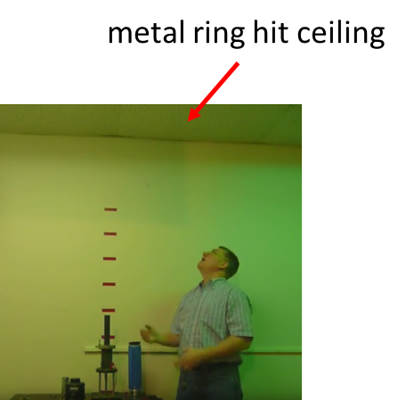

Fig. 2. An alternating magnetic field from the coil induces a changing electric field in the metal ring. The induced electric field in the ring generates a current in the ring. The current in the ring creates a magnetic field which opposes the original magnetic field from the coil – the metal ring is repelled from the coil and is projected so high that it hits the ceiling.

The magnitude of the electric field  around a **single point-like charge**  is given by

(2)  **inverse square law**

When an object of charge  is placed within this field , it will experience an electric force  described by Coulomb’s Law

(3)  **Coulomb’s Law**

The concept of electric field is much more powerful than the concept associated with electrical force. The physical quantity electric field is used extensively in describing electromagnetic phenomena, whereas force is barely used. The concept of electric field is useful in visualizing electrical interactions taking place via an electric field. Consider two charge objects A and B that are initially a fixed distance apart. Suddenly the charged object B is moved away from A so the separation distance increases. The charged object A does not feel a different force or different electric field instantaneously. Rather, at the location of the charged object A, the force on A and the electric field at this point does not change in the time required for light to travel from B to A. So, disturbances in the electric field arising from accelerated charges are propagated at the finite speed of light.

This is no mere accident. Light consists of electric and magnetic fields travelling through space. An electric field become detached from the electric charge generating it. Such electric and magnetic fields (electromagnetic waves) are physically real in the sense that one can attribute to them such “mechanical” properties as energy and momentum.

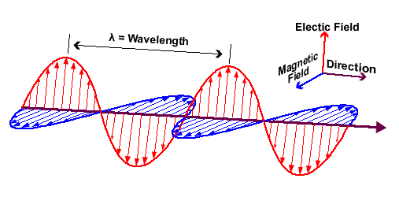

Fig. 3. Self-propagating electromagnetic wave.

**Electric field lines (electric lines of force)**

One may use a number of vectors to represent an electric field. The vectors all point radially outward for a positive point-like charge (radially inward for a negative charge) and their magnitude (length) is chosen to be inversely proportional to the square of the distance from the charge.

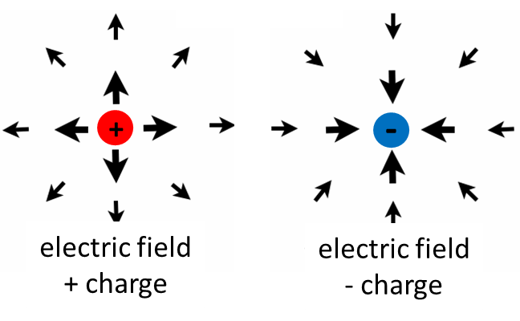

Fig. 4. The electric field of a point-charge represented by vectors.

However, this is not the best way to visually represent an electric field since the length of the arrows are generally too small to view when the electric field has a small value. We can map an electric field by using electric field lines. The direction of the lines gives the electric field direction and the number of field lines per unit area (density of electric field lines) gives the magnitude of the electric field. The tangent to an electric field line at any point gives the direction of the electric force on a positive charge. The electric field lines are a very useful means of visualizing the electric field. The electric field is a real physical quantity that can be measured, however, the lines which represent the field are a useful fiction.

Electric field lines originate from positive charges and terminate on negative charges.

When the field lines are crowded together the field is strong.

Where the lines are uniformly (equally) spaced and parallel, the field is uniform (constant).

Any object carrying a single charge (either positive or negative), when viewed from a great distance will have an electric field of a point-like charge where .

The field lines do not show the trajectories of a charged particle released in an electric field. However, knowing the electric field, one finds the force acting on the object from which one can compute the particle’s acceleration, then velocity, then displacement at all times given the initial velocity of the charged particle.

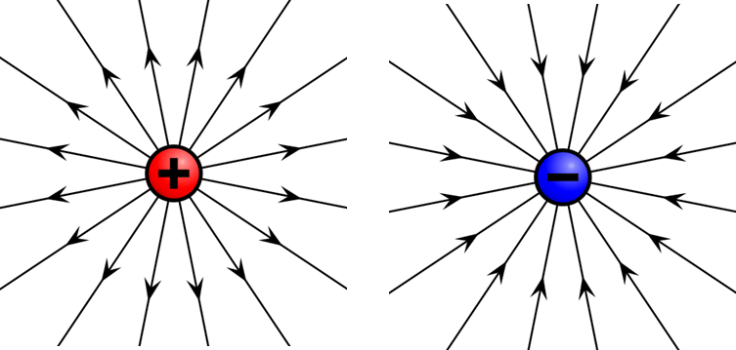

Fig. 5. Electric field surrounding point-like charged objects represented by electric field lines in one plane through the centre of the charged objects.

[2D] view only.

For the point-like charged object, the number  of electric field lines passing through any spherical shell is constant. The density of the electric field lines at a distance  from the centre of the charged object is given by the number of field lines divided by the surface area of shell



Figure 6 shows the [2D] electric field line representation surrounding a positive charge. Note: In [3D] the electric field lines point outwards in all direction. The density of the electric field lines increases as the distance from the charge decreases.

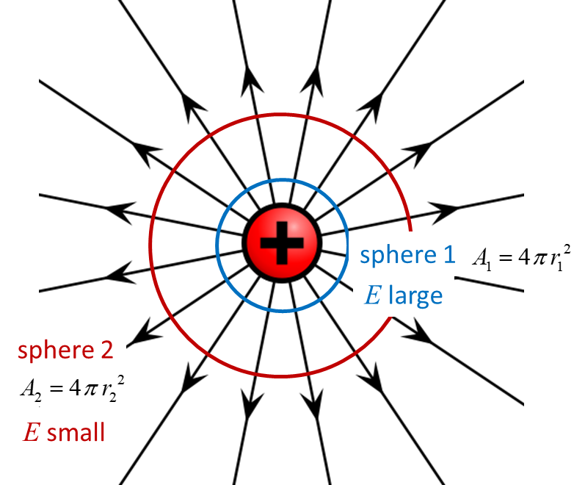

Fig. 6. The electric field is inversely proportional to the distance from the charged object as shown by the decrease in the density of the lines as the distance from the charged object increases. The electric field lines originate at the positive charge and terminate at infinity .

**The number of field lines drawn from a charged object is proportional to the magnitude of the charge**.

In figure 7, for a charge , 12 electric field lines are drawn and for the charge , 24 electric field lines are drawn.

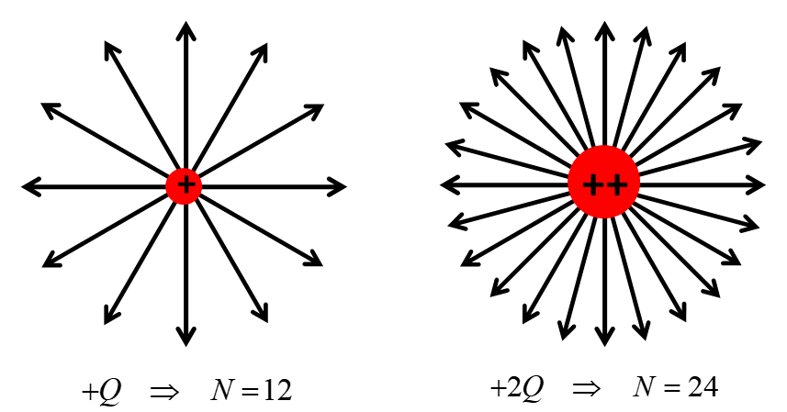

Fig. 7. The number of electric field lines drawn from a charged object is proportional to the magnitude of the charge.

The electric field of an **electric dipole** is shown in figure 8. An electric dipole is composed of the two charges of equal magnitude but opposite sign separated by a fixed distance. The electric field lines originate from the positive charge and terminate on the negative charge.

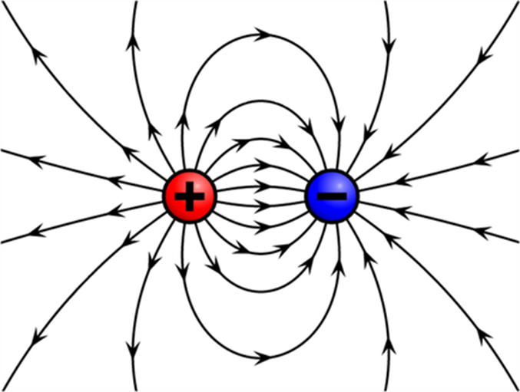

Fig.8. Electric field surrounding an electric dipole. The electric field lines originate from the positive charge and terminate at the negative charge.

|  |
| --- |
| **Exercise 1**  Explain why the electric field between two equal and opposite charges is shown by the pattern in figure 8.  Print a copy of figure 8 or place a piece of paper on the screen and trace the pattern for a few lines.  Select three points on the field lines. Measure the distance from each of these points to the centres of the two charges.  Draw to scale from your distance measurements, the vectors for the force on a small positive test charge placed at each point. At each point add the two force vectors.  You should find that the resultant vectors are tangential to the electric field at these points. |

Figure 9 shows the electric field pattern for the configuration of two equal positive charged objects separated by a fixed distance.

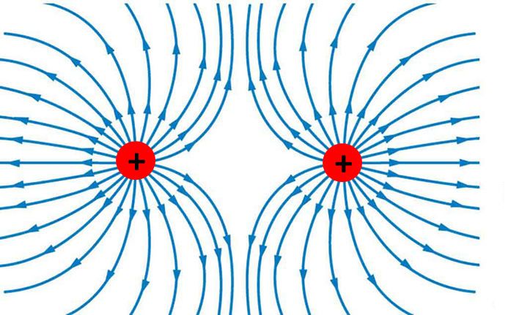

Fig. 9. Electric field pattern for two equal positively charged objects. Note: 24 electric field lines originate from each charge.

|  |
| --- |
| **Example 1**  What are the sign of two two charged objects?  What is the ratio of the two charges ?    **Solution**  The elctric field lines terminate on object 1, so, object 1 is negatively charged.    The elctric field lines orginate on object 2, so, object 2 is positively charged.  4 field lines originate from object 2  16 field lines terminate on object 1  The charge ratio is |

**Uniform electric field**

A good approximation to a **uniform** (constant) electric field is the electric field between two parallel oppositely charged conducting plates known as a **parallel plate** **capacitor** (figure 10). A **capacitor** is a passive two-terminal electrical component that stores electrical energy in an electric field. Capacitors are found in most electronic circuits. Your mobile phone only functions because of the capacitors used in the electronic circuits.

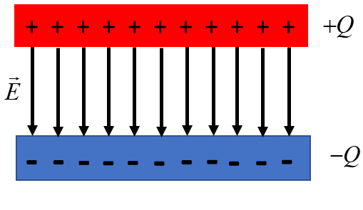

Fig. 10. Uniform electric field: two parallel, uniformly charged plates of opposite sign.

|  |
| --- |
| **Example 2**  A beam of electrons moving in the +X direction with an initial veloicty  enters a region of uniform elctric field  directed in the +Y direction generated by a pair of oppositely charged parallel plates (parallel plate capacitor) which has a length  in the X direction.  Determine the path of the electron when it is moving through the uniform electric field. What is the vertical distance  the electron will be deflected when passing through the uniform electric field.  Descibe the path of the elctron beam after leaving the uniform electric field. The electron beam hits a screen located at a distance  from the end of the parallel plate capacitor. What is the vertical deflection  of the electron beam from its original trajectory when it strikes the screen?  **Solution**  [Watch Video](https://www.youtube.com/watch?v=XSXKk_A3xUM) (concentrate on the motion of charged particles through a uniform electric field).  [Review motion with a uniform acceleration](http://www.physics.usyd.edu.au/teach_res/hsp/sp/mod1/m1_aconstant.pdf)  [Review [2D] motion in a plane](http://www.physics.usyd.edu.au/teach_res/hsp/sp/mod1/m1_plane.pdf)  Think about how to approach the problem by visulaizing the physical situation.  Draw an annoated scientifc diagram.  State the known and unknown physical quantities.  State the equations that you will need.  State the physical principles and concepts needed to solve the problem.  This is a long (difficult ???) problem, but if think about breaking the problem into four smaller problems, then you will find that it is not such a difficult problem.  The problem can be solved using the equations for uniform accelerated motion resolved into the X direction and the Y direction.  uniform accelerated motion    **X motion through capacitor (uniform electric field region)**  Initial conditions    Transit time    **Y motion through capacitor (uniform electric field region)**  Force acting on electron and its acceleration    Initial conditions    Time at which electron leaves electric field region    Vertical velocity of electron leaving electric field    Vertical displacement of electron leaving electric field    **X motion field free region**  Initial conditions    Time for electron to travel from capacitor to screen    **Y motion field free region**  Initial conditions    Vertical displacment for position of electron striking screen    The vertical deflection  of the electron on the screen is proportional to the electric field strength between the plates. In cathode ray tubes used in television sets of the past, the path of the electrons through the tube to the screen could be controlled by changing the electric field between the plates of the capacitors. |

**Electric fields and conductors**

For a conductor in electrostatic equilibrium:

* At every point inside the conductor, the electric field is zero . This is because the free electron in the conductor can move and redistribution until the net force acting upon them is zero, so the electric field at every point cancels. There is zero net charge in the interior of the conductor, only the surface of the conductor has a net charge.
* At the conductor’s surface, the electric field  is always perpendicular to the surface. The charges on the surface distribute themselves so that they will be at rest. So, the force acting on the electrons parallel to the surface must be zero.
* The are no electric field lines within the conductor. The electric field lines either originate or terminate from charges at the surface and the electric field lines are always perpendicular to the surface.
* Charges accumulate on the surface with greater density where the curvature of the surface is greater, at these locations the electric field is stronger.

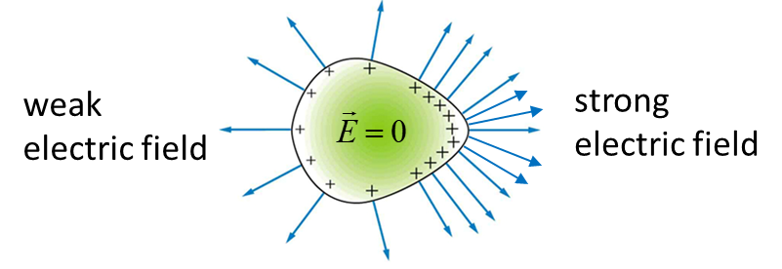

Fig. 11. Positvely charged conductor.

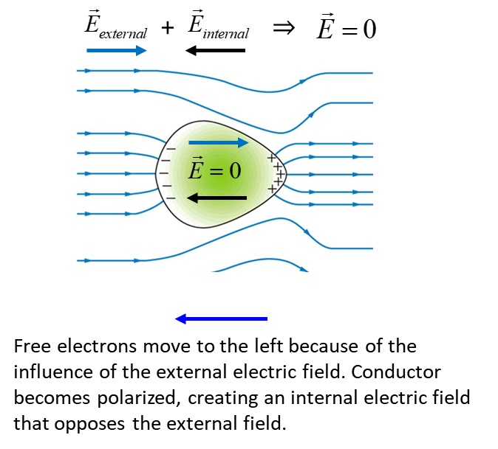

Fig. 12. A neutal conductor in an external electric field.

|  |
| --- |
| **Memory Mindmap Summary**  On one A4 sheet of paper, make a Mindmap of these notes on electric fields. You can condense these many pages to just one page containing the essential physics that you must commit to memory. |

[VISUAL PHYSICS ONLINE](http://www.physics.usyd.edu.au/teach_res/hsp/sp/spHome.htm)

If you have any feedback, comments, suggestions or corrections please email Ian Cooper

ian.cooper@sydney.edu.au

Ian Cooper School of Physics University of Sydney

<http://www.physics.usyd.edu.au/teach_res/hsp/sp/spHome.htm>