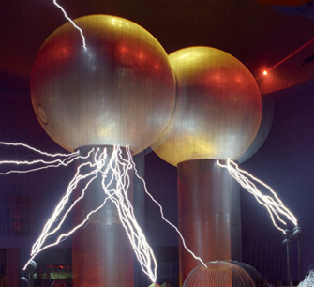

[**VISUAL PHYSICS ONLINE**](http://www.physics.usyd.edu.au/teach_res/hsp/sp/spHome.htm)

**MODULE 4.1**

**ELECTRICITY**

**ELECTRIC CURRENT**

|  |
| --- |
| **CURRENT**  Charges in motion.  Direction: same direction in which  positive charges would move.  S.I. unit  A (ampere, amps) |

[Watch video](http://www.pbs.org/video/2365917588/)

As you watch the video, make a summary of the key points including the equations. This video was not so good. **Explain why**.

**Electric** **charges in motion** constitute an electric **current**.

A current  is defined to be the amount of charge  passing through an area  in the time interval 

(1)  **current is the rate at which charge is transferred**

Any movement of charges gives an electric current, for example, the movement of protons, positive ions, electrons and negative ions. An **ion** is an atom or molecule with either an excess or deficiency of electrons.

**The direction of a current is taken to be in the same direction in which positive charges would move.**

Ionic conduction is very important. For example, the messages in nerve cells are due to the movement of mainly Na+, K+ and Cl- ions across nerve cell membranes.

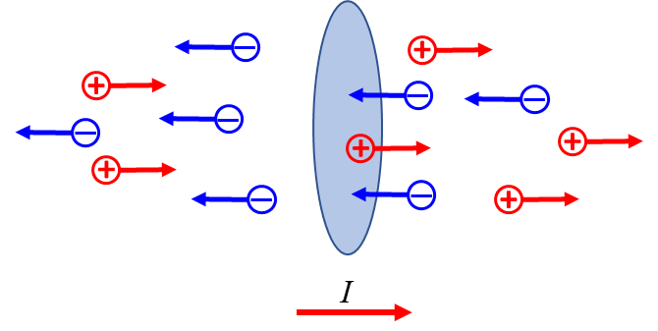

Fig. 1. Both positive charges moving to the right and negative charges moving to the left contribute to the current which is directed towards the right.

In metals, such as copper, the positive ions are relatively immobile since they are fixed in a regular array called a **lattice**. Metal ions are always positive, being formed from atoms that lose one or more electrons. These ***free electrons*** wander through the positive ion lattice, and it is these negative charges that gives metals there conducting properties.

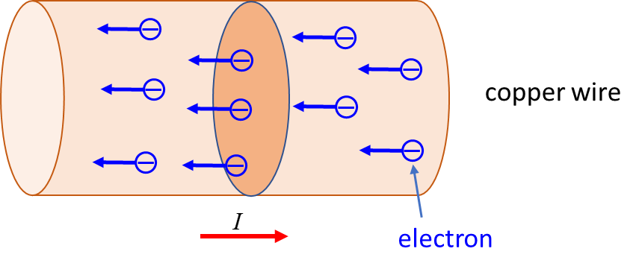

Fig. 2. In a metal, the current is due to the movement of free electrons through a lattice of positive metal ions.

**Common currents**

current in mobile phone antenna ~ 10 nA (1 nA = 10-9 A)

mobile phone ~100 mA (1 mA = 1x10-3 A)

incandescent light globe ~ 1 A

car battery ~ 10 A

electric radiator ~ 15 A

lightning ~ 1 MA (1 MA = 106 A)

1 A = 1 C.s-1 flow of 6.24x1018 electrons.s-1

The unit of current, the **ampere** takes its name from Andre-Marie Ampere, a French scientist of the early 19th century. In the S.I. System of units, the ampere is the fundamental (base) unit for electromagnetism. Other units such as coulomb are derived units. The most commonly used current-measuring devices are called **ammeters**. Their operation depends upon the torque produced by a magnet on a current-carrying conductor.

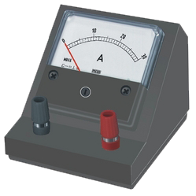

|  |
| --- |
| **Example**  The current in a mobile phone circuit is 2.00 mA. How many electrons moved through part of the circuit in a one minute interval?  **Solution**  Think about how to solve the problem.  What do you know?  Visualize the physical situation  Draw an annotated diagram showing the known and unknown physical quantities. |

Suppose that a current consists of *N* charge carriers (electrons) each with a charge of magnitude *q* drifting along at an average speed *v* within a cylinder of volume *V* with length *L = v dt* and cross-sectional area *A*.

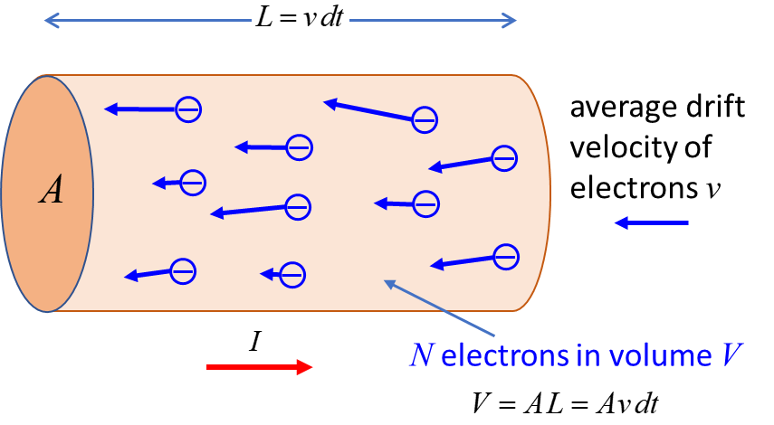

Fig. 3. Electrons drifting at speed *v* through a metal cylinder of cross-sectional area *A* in the time interval *dt*.

Then, in the time interval *dt*, all the charges contained within the cylinder of volume *V* will have passed through the area *A*. Therefore, the total charge that passes through the area *A* in the time interval *dt* is . Let the number density of the charge be *n* where



Consequently, the current is 

If several species of charge carriers differing in *q*, *n* and *v* contribute to the current *I*, we may generalize by expressing the current as

(2) 

Note: each charge does not move at a constant velocity. The charged particles may in fact move with a complicated motion, as do the free electrons in ordinary conductors. The velocity *v* in equation 2 represents the **average drift velocity** of the charged particles. For free electrons in conductors, the drift speed is less than 0.1 mm.s-1.

|  |
| --- |
| **Example 1**  A current of 1.00 A exists in a copper wire whose cross-sectional area is 1.0 mm2. What is the drift speed  of the conduction (free) electrons?  density of copper (rho) kg.m-3  molecular mass of copper  g.mol-1  Avogadro’s number  In copper, as in other typical metallic conductors, there is approximately one free electron per atom. We can find the number density  of charged carriers from Avogadro’s number , the density of copper  and its molecular mass    where  is the mass of a single copper atom and  is the number of copper atoms.  Mole:  Number density  free electrons.m-3        The free electrons average speed through the copper conductor is less than 0.1 mm.s-1, a remarkably low speed. However, it is important to note that even though the average drift speed of the free electrons is very small, the speed of propagation of the signal driven by an electric field along the conductor is very high. When you turn on a light, it lights up almost instantaneously.  WOW!!! Think about what you have just accomplished – we started with a simple model describing the conduction in a metal conductor. In doing a not so difficult calculation found that we can predict the speed at which electrons crawl through the conductor. See, simple physics can give powerful results. |

An electric current has three effects that reveals its existence.

1. **Heating** and **light**: when a current passes through a light globe, the filament gets hot (increase in internal energy) and visible light is emitted.
2. **Magnetic**: a magnetic compass will be deflected by a current passing near it.

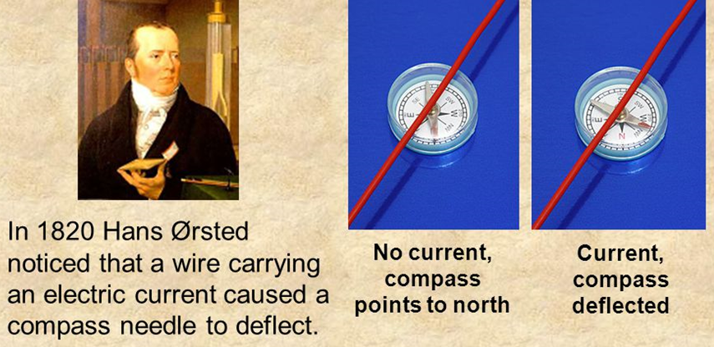

1. **Chemical**: bubbles of gas are given off when a current passes through an acid solution. Another example is in process known as **electrolysis**, a current through water causes the molecules of hydrogen and oxygen to dissociate. 

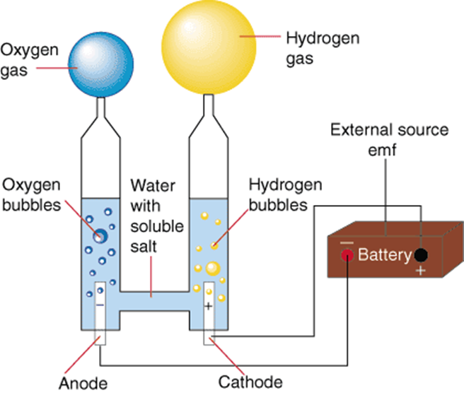

**Types of current**

A **direct current** (**DC**) implies that the direction of the current is always in one direction, but the magnitude of the current may not be constant. A battery provides a constant DC current.

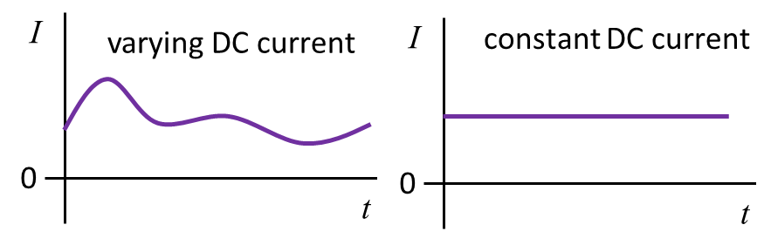

When the direction of the current changes with time, the current is referred to as **alternating current** (**ac**). Our household electric supply produces a sinusoidal ac current at 50 Hz.

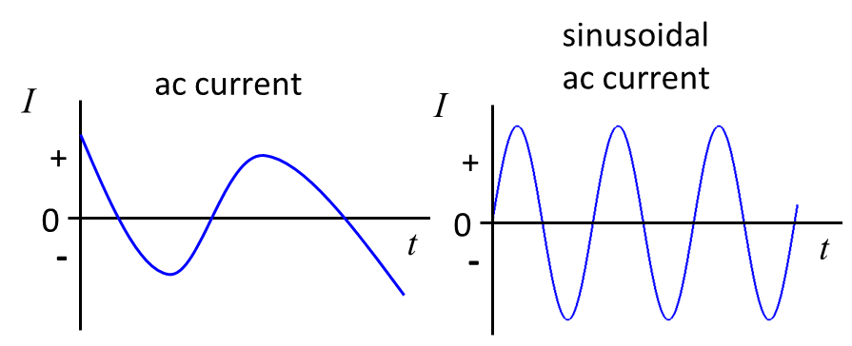

**Why is the website’s main title called** **Visual Physics**? Images can play a leading role in the memory and learning process. This is why many images are included in my web pages. It is much easier to recall images than words. I often watch Korean drama on the web. After a while, the stories can become blurred and it is often difficult to recall the stories that I have watched. I knew I watched a really good drama few months, but could not remember the story at all. Then I recalled an image of the leading actress, then I could recall other images then the story line and only then did I remember the title.



For current, I always associate a picture of the **devil** – the devil lives in a hot place, this helps me never to forget

**A current through a resistive material has a heating effect**

*You should make you own images of physics concepts to help you master and remember your physics.*

**Equations tell a story**

An equation contains lots of information that tells a story. However, initially when you start studying physics, when you see an equation, you only see a collection of symbols. You need to take definite actions to find the story attached to the equation. One of the best ways to do this is by:

* Attaching an image to each symbol in the equation
* Identifying the units of each physical quantity
* Identifying the constants and variables.
* How do things change when only one variable is changed while others are kept constant.
* Ask yourself, when is the equation applicable.
* Give a Graphical representation.

As an example, consider the equation



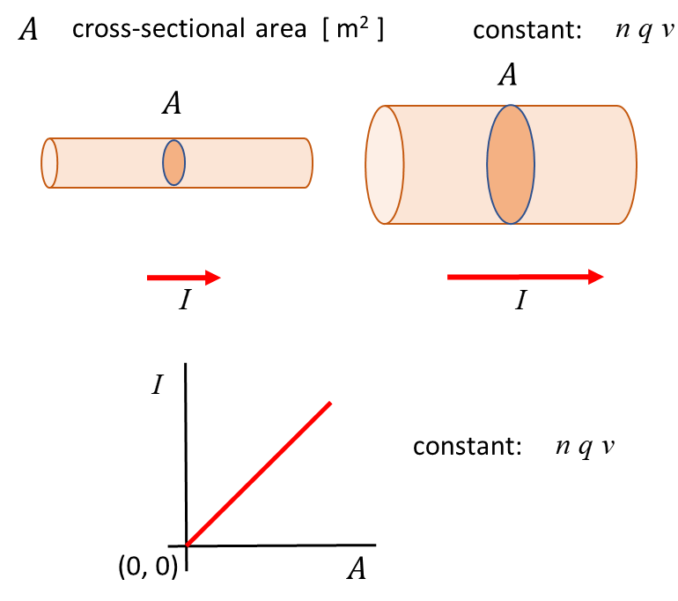

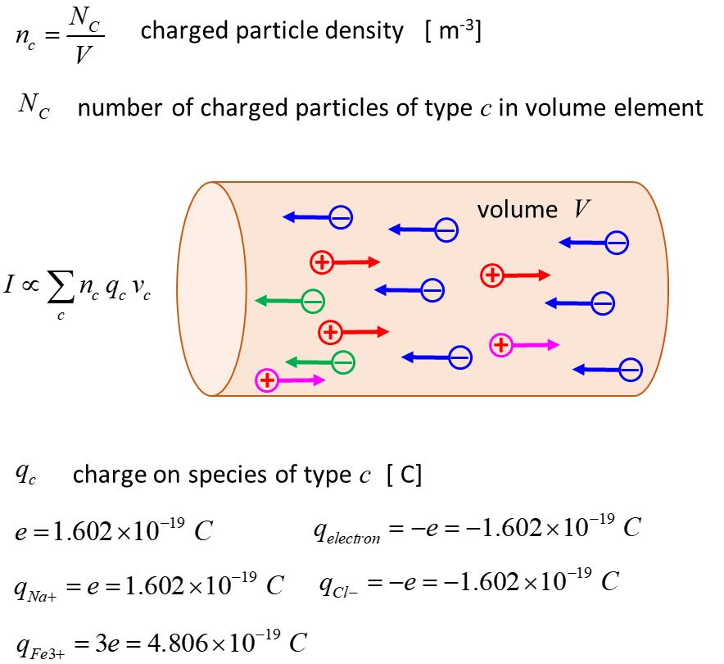

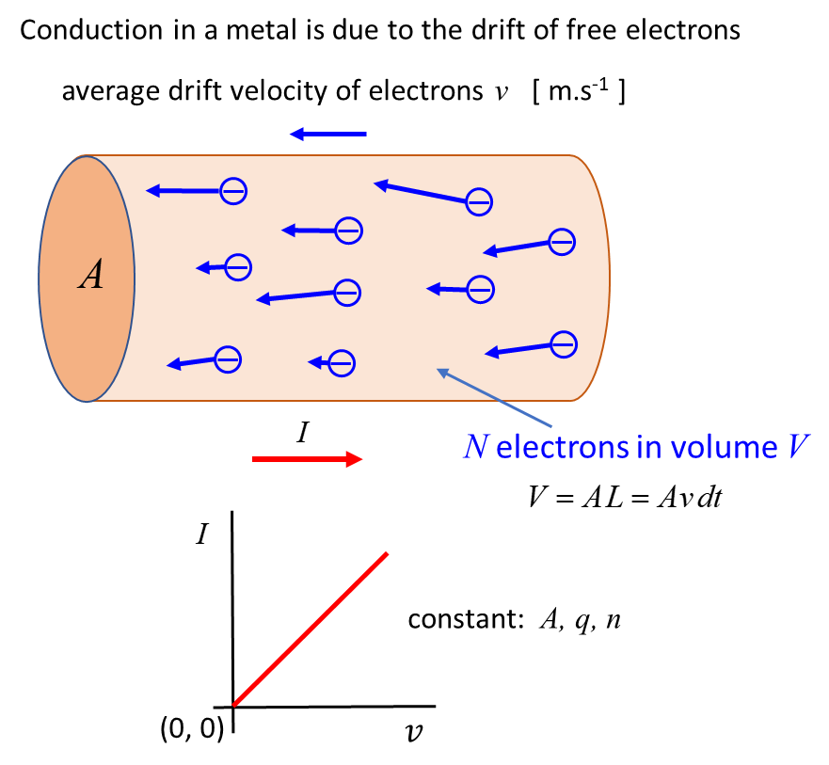

**Learning is a process of invention.** Your physics will not improve by simply reading the notes. You must make learning an active process by:

* Creating your own memory mindmap summaries.
* Using visualization techniques.
* Creating equation mindmap summaries as outlined above.

You can start now, go back to Module 1 and make our own images, memory mindmap summaries and equation mindmap summaries (one mindmap for each equation).

[VISUAL PHYSICS ONLINE](http://www.physics.usyd.edu.au/teach_res/hsp/sp/spHome.htm)

If you have any feedback, comments, suggestions or corrections please email Ian Cooper

ian.cooper@sydney.edu.au

Ian Cooper School of Physics University of Sydney

<http://www.physics.usyd.edu.au/teach_res/hsp/sp/spHome.htm>