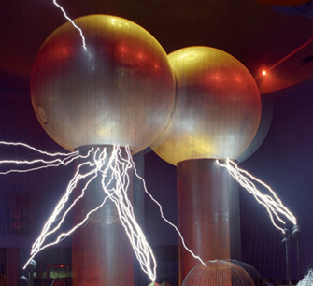

[**VISUAL PHYSICS ONLINE**](http://www.physics.usyd.edu.au/teach_res/hsp/sp/spHome.htm)

**MODULE 4.1**

**ELECTRICITY**

**DC CIRCUITS 2**

|  |
| --- |
| **Charge**  [ C coulomb ]  **Current**  [ A ampere ]  **time interval**  [ s second ]    **potential** / **potential difference** / **voltage** / **emf**  [ V volt ]  **resistance**  [ ohm ]    **energy**  [ J joule ]    **power**  [ W watt ]    **Ohm’s Law**  (constant resistance and constant temperature)    **Kirchhoff’s Junction Rule**  at any junction  **Kirchhoff’s Loop Rule**  around any loop  **Resistors in series**    **Resistors in parallel** |

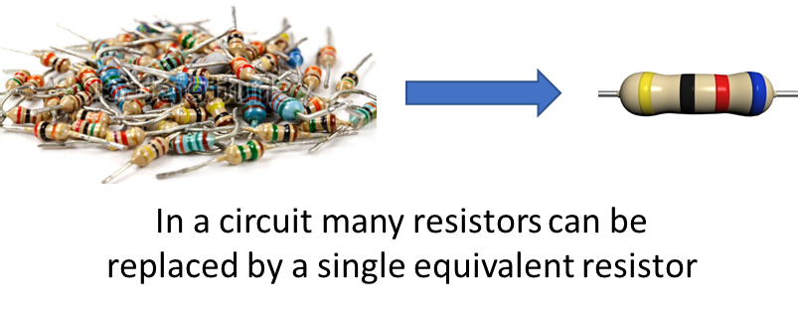

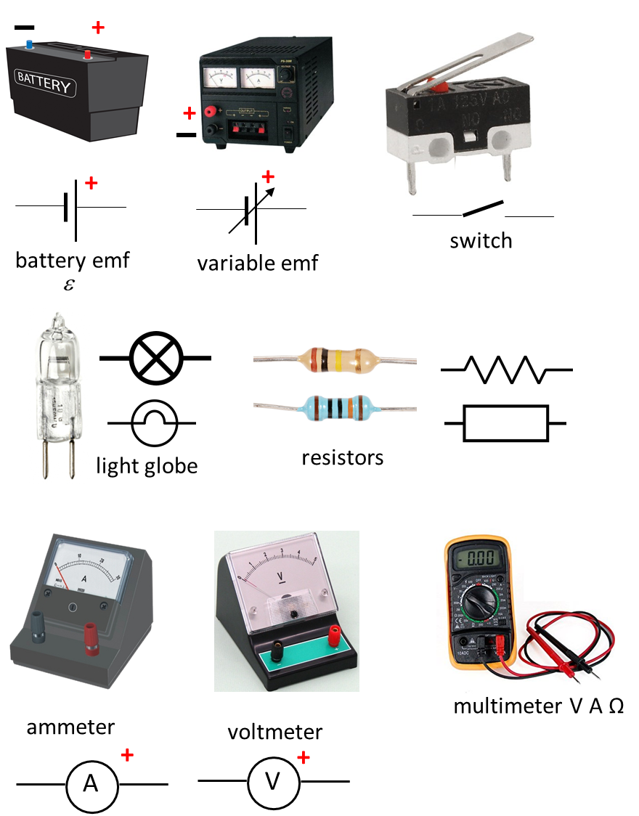

Circuit Symbols

[REVIEW: Electric Currents](http://www.physics.usyd.edu.au/teach_res/hsp/sp/mod41/m41Current.pdf)

[REVIEW: DC Circuits 1](http://www.physics.usyd.edu.au/teach_res/hsp/sp/mod41/m41DC1.pdf)

**Resistors in series**

**What is the equivalent resistance of any number of resistors in series?**

In a **series circuit**, the different components follow one after the other and there is just one loop for the current to follow and the current is the same at all points.

**Equivalent resistance** means that a number of resistors can be replaced by a **single resistor** such that it does not change the current drawn from the sources of electrical energy or the emf of the sources.

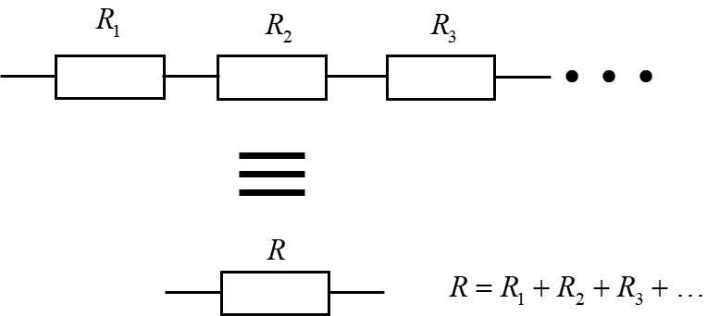

From Kirchhoff’s Junction (Current) rule, the same current must pass through each resistor and therefore, the potential drop across each resistor is



In the equivalent circuit, the potential drop across the equivalent resistor is



Applying Kirchhoff’s Loop (Voltage) Rule, we must have





Hence,

 **resistors in series**

The greater the number of resistors in series, then the larger the resistance value.

**Resistors in parallel**

**What is the resistance of a number of resistors in parallel?**

Consider a number of resistors connected in parallel and their equivalent resistance

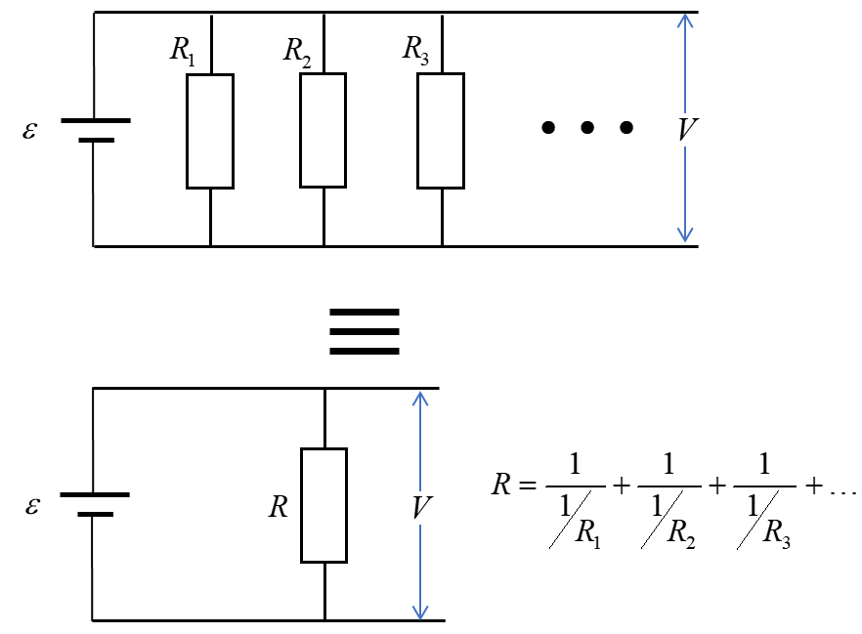

Kirchhoff’s Loop (voltage) Rule: the same potential difference *V* must exist across each resistor in parallel, so,



In the equivalent circuit, the potential drop is



Applying Kirchhoff’s Junction (current) Rule: we must have





Therefore,



 do **not** use this form of the equation

 **use this equation for resistors in parallel**

Adding more resistors in parallel reduced the total resistance value.

|  |
| --- |
| **Example**  For the circuit shown below, find the current through each resistor.    **Solution**  Draw the circuit and label each component.  Replace the parallel combination with its equivalent resistor and redraw the circuit.  Apply Ohm’s Law and Kirchhoff’s Rules.        Let the current be in a clockwise sense and traverse the circuit loop also in a clockwise sense.  Kirchhoff’s Junction (current) Rule      Kirchhoff’s Loop (voltage) Rule          Using Ohm’s Law, the potential differences across the parallel combination and resistor #1 are    The currents through resistors #2 and #3 are    Check    as expected |

[VISUAL PHYSICS ONLINE](http://www.physics.usyd.edu.au/teach_res/hsp/sp/spHome.htm)

If you have any feedback, comments, suggestions or corrections please email Ian Cooper

ian.cooper@sydney.edu.au

Ian Cooper School of Physics University of Sydney

<http://www.physics.usyd.edu.au/teach_res/hsp/sp/spHome.htm>