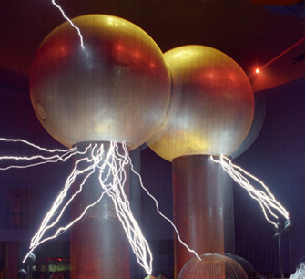

[**VISUAL PHYSICS ONLINE**](http://www.physics.usyd.edu.au/teach_res/hsp/sp/spHome.htm)

**MODULE 4.1**

**ELECTRICITY**

**ELECTRIC FIELD**

**ELECTRIC POTENTIAL**

**QUESTIONS and PROBLEMS (with ANSWRES)**

[ex41B](http://www.physics.usyd.edu.au/teach_res/hsp/sp/mod41/ex41B.pdf) [ex41C](http://www.physics.usyd.edu.au/teach_res/hsp/sp/mod41/ex41C.pdf)

|  |
| --- |
| **electric force**  [N]  charge of opposite signs attract / charges of the same sign repel  **electric field**  [N.C-1 or V.m-1]  region where charges experience an electrical force  **electric potential energy**  **work**  [J]    **electric potential** V [V]  electric potential energy / charge  **potential difference**  [V] |

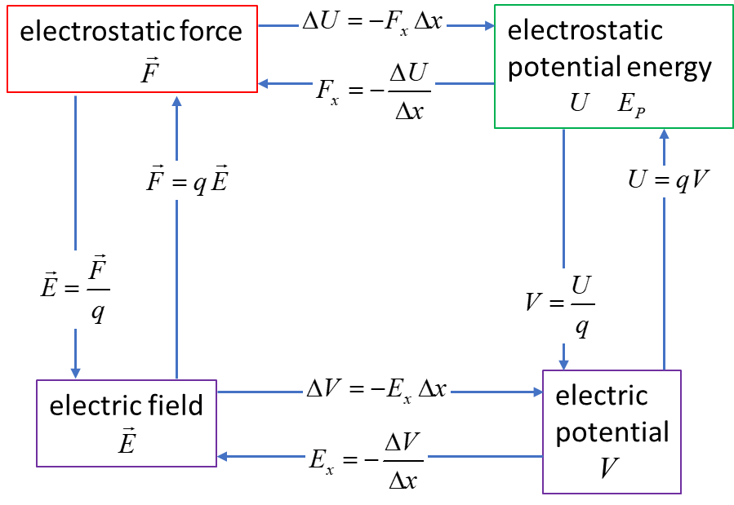

**Unit of energy: electron-volt or eV**

It is defined as the amount of energy an electron gains after being accelerated by potential difference 1 V (1 volt).

The S.I. unit for energy is the joule [J]. However, it is sometimes useful to use electron-volts for very small amounts of energy. The electron-volt is often used in atomic, nuclear and particle physics.



**ELECTRIC FIELD LINES**

**EQUIPOTENTIAL LINES**

The **electric field** can be represented graphically by a set of **electric field lines**. The density of the electric lines being proportional to the strength of the electric field.

The **electric potential** is represented graphically by drawing **equipotential lines** or in [3D], **equipotential surfaces**. An equipotential line or surface is one in which all points have the same electric potential. So, between any two point on a equipotential line (or surface) the potential difference must be zero, and no work is required to move a charge along the equipotential line. The equipotential line must be perpendicular to the electric field at all points.

The fact that the electric field lines and equipotential surfaces are mutually perpendicular helps us locate the equipotential lines when the electric field lines are known. In a [2D] drawing, the equipotential lines are the intersections of the equipotential surface and the plane of the drawing.

A useful analogy for equipotential lines is a **topographical map**: the contours of equal elevation are essentially gravitational equipotential lines.

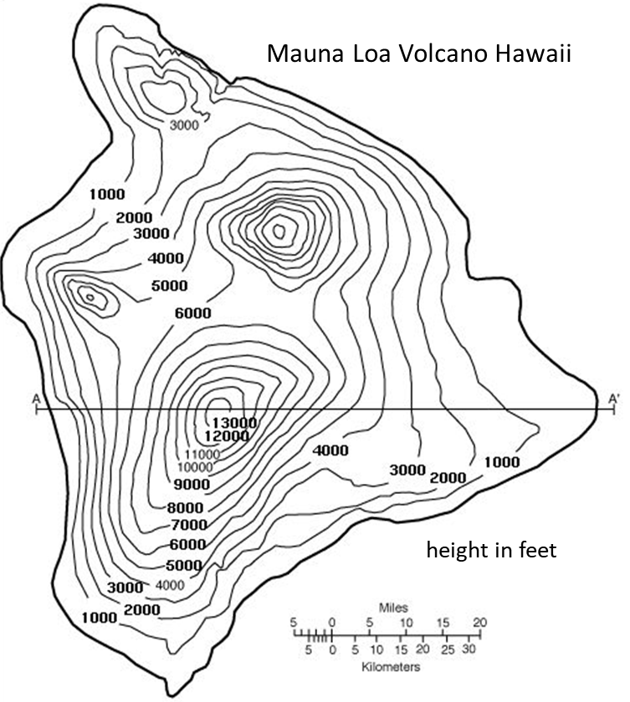

**Uniform electric field of a parallel plate capacitor**

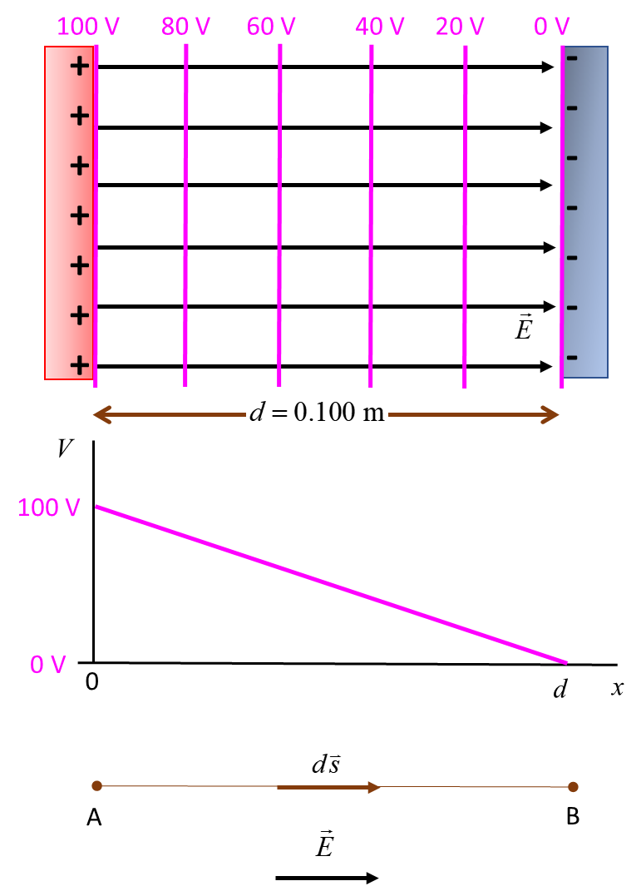In figure 1, a few **equipotential lines** are drawn for the **electric field** between two parallel plates at a potential difference of 100 V. The negative plate is arbitrary chosen as the reference point for the zero potential. Note: the equipotential lines have a uniform spacing of 20 V, the electric field lines point towards lower values of potential, and the field lines and equipotential lines are perpendicular to each other.

Fig. 1. **Equipotential lines** and **electric field lines** between two oppositely charged parallel plates.

The electric field can be calculated from the **gradient** of the electric potential



The potential only depends upon the x values and does not vary in the Y and Z directions, therefore, the electric field  is



and the magnitude of the electric field  for a uniform electric field is simply

 **slope of the potential vs distance graph**

From figure 1, the slope of the electric potential vs distance graph gives the electric field (constant slope, so electric field is constant in the region between the two charged plates)

The potential difference between the two plates is



and the separation distance of the plates is .

Then, the electric field  between the plates is



If we know the electric field, we can calculate the electric potential difference between two points.



From figure 1,



The point B is at a lower potential than the point A.

**Review**: For a **uniform electric field**, the connection between the electric field *E* and the electric potential or potential difference  is



It is now obvious that the S.I. Unit for electric field can be expressed as V.m-1.

**Electric field and electric potential for a point charge**

The electric field  at the distance *r* from a point charge *Q* is

 **single point charge**

The electric field is radially symmetric around a point charged particle and is directed away from a positive charge and directed towards a negative charge.

For the electric potential, the reference point for the zero in electric potential is taken at an infinite distance from the charge



Then, the electric potential *V* at a distance *r* from a single point charge is

** single point charge**

|  |
| --- |
| **Mathematical Extra: You don’t need to know the derivations given below for any exams.**  Consider a point charge +*Q* that is fixed at the Origin of a Cartesian coordinate system. A positive charge *q* is placed at position A at a distance *rA* from the Origin and then released. The charge *q* interacts with the electric field  and is repelled causing it to accelerate away from the Origin. The charge *q* will gain kinetic energy  due to the work done  by the electric repulsive force  acting on the charge *q*. Energy must be conserved so that the increase in kinetic energy results in a corresponding decrease in potential energy . So, the potential energy  at the point B is lower than the potential energy at A.  When the charged particle *q* reaches an arbitrary point B  Work done on charge    Change in potential energy      Potential difference between points A and B    Let the particle approach an infinite distance from the Origin and set the zero of potential energy to be at    So, we can conclude that the electric potential at any point a distance *r* from a point charge *Q* is  **electric potential for a point charge**  and the potential energy is  **potential energy for a point charge**  NOTE: We have used two symbols for potential energy *U* and *EP*. Better to use *U* rather than *EP* in most cases so as not to be confused with the electric field *E*. |

The following figures illustrate graphically the electric field and electric potentials surrounding a positive charge of + 20 C and a negative charge of -20 C. When  , so, to avoid this problem the maximum values for the electric field and electric potential are set to some arbitrary saturation value in all graphs.

**Single positive point charge +20 C**

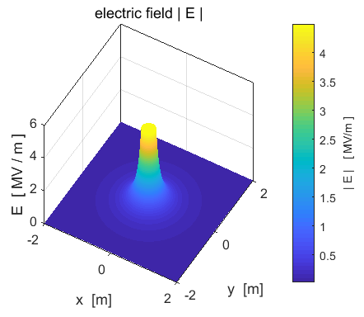

Electric field (magnitude): positive point charge +20 C.

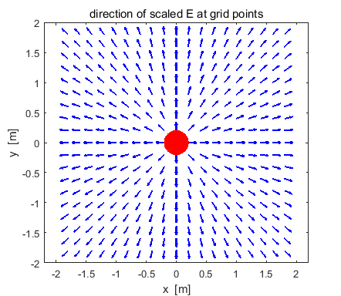

Electric field: positive point charge + 20 C. The vectors only show the direction of the electric field and not the magnitude.

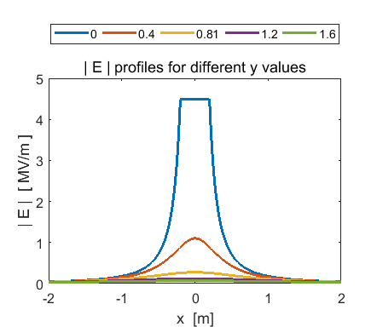

The magnitude of the electric field decrease rapidly with distance from the Origin . Values are saturated near the Origin.

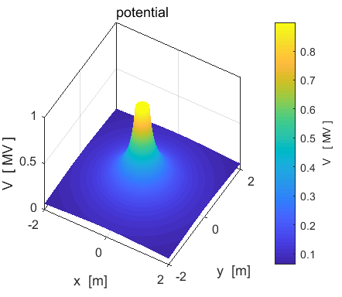

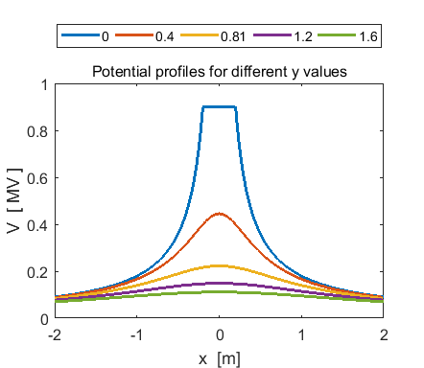

Electric potential for a positive point charge +20 C. Near the positive charge, the electric potential forms a “potential hill”. A positive charge near the Origin will be repelled like a ball rolling down a hill.

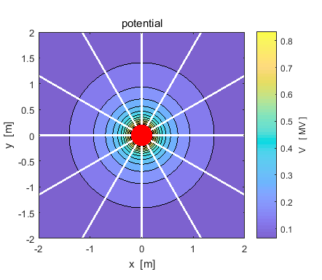

The white lines are the electric field lines. The density of lines increases towards the Origin as the electric field strength increases. The black concentric circles are the electric equipotential lines. The equipotential lines are crowded together near the Origin where the electric field strength is greatest - the electric potential changes more rapidly in fixed distance intervals nearer the Origin ().

**Single positive point charge - 20 C**



Electric field (magnitude): negative point charge -20 C.

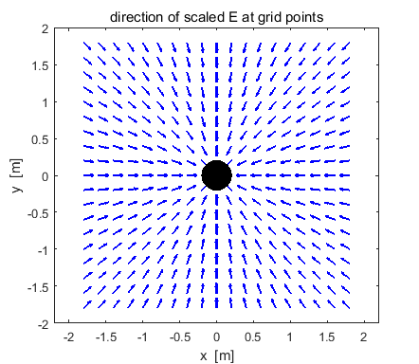

Electric field negative point charge - 20 C. The vectors only show the direction of the electric field and not the magnitude.



The magnitude of the electric field decrease rapidly with distance from the Origin . Values are saturated near the Origin.

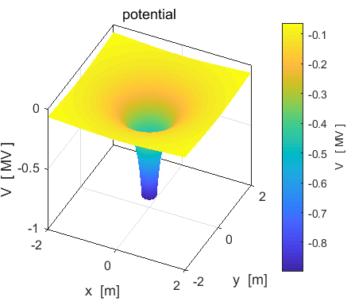

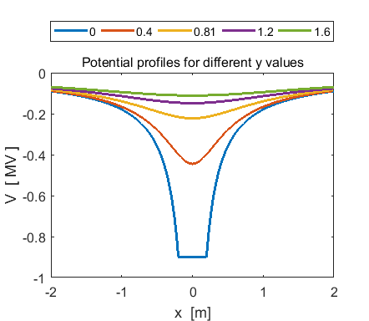

Electric potential for a negative point charge -20 C. Near the negative charge, the electric potential forms a “potential well”. A positive charge near the Origin will be attracted like a ball falling into a well.

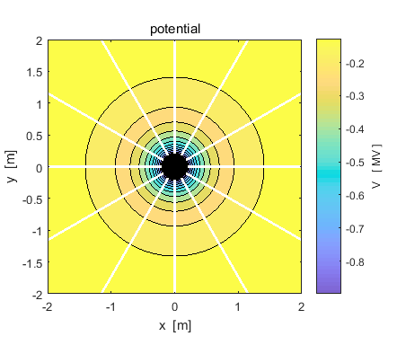

The white lines are the electric field lines. The density of lines increases towards the Origin as the electric field strength increases. The black concentric circles are the electric equipotential lines. The equipotential lines are crowded together near the Origin where the electric field strength is greatest - the electric potential changes more rapidly in fixed distance intervals nearer the Origin ().

**A positive charge +20 C and a negative charge -20 C at a fixed separation distance of 1.00 m**

Consider two charged point like particles A and B of opposite signs with a fixed separation distance.

Point particle A: 

Point particle B: 

Find the electric field  and electric potential  at the points S(0, 0.5) m and T(0.25, 0.5) m.

Coulomb constant 

The electric field  is given by

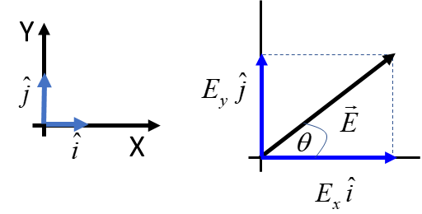



and the electric potential is given by



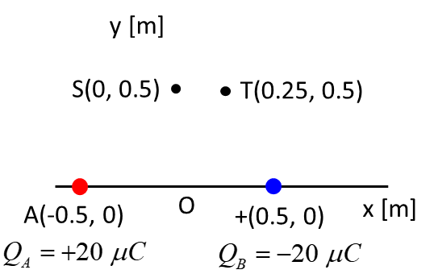

**The electric field  and electric potential  at the point S.**

**Charge A** 









**Charge B** 









**Electric field at S**

components 

magnitude 

 direction 

**Electric potential at point S**



**The electric field  and electric potential  at the point T.**

**Charge A** 









**Charge B** 









**Electric field at T**

components 

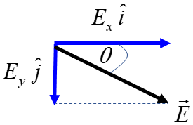 magnitude 

direction 

**Electric potential at point T**



Comments: Note the careful use of subscripts to identify the parameters. You can now see why it is much better working with electric potentials (scalar) then with electric fields (vector).

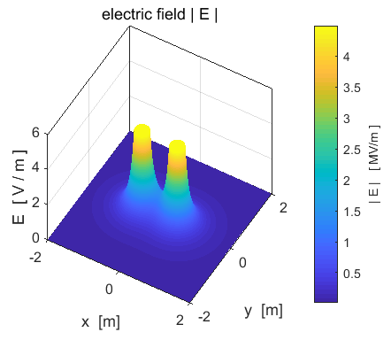

Magnitude of the electric field for the +20 C and -20C C distribution.

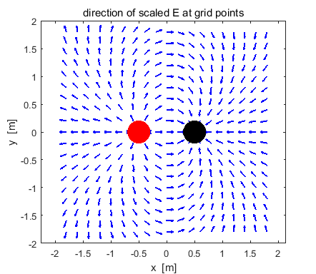

Electric field for the +20 C and -20C C distribution. The vectors only show the direction of the electric field and not the magnitude.

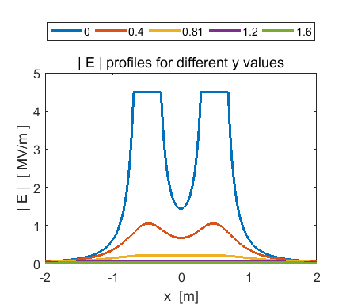

Electric field for the +20 C and -20C C distribution. The magnitude of the electric field decrease rapidly with distance near a point like charge . Values are saturated near the charges.

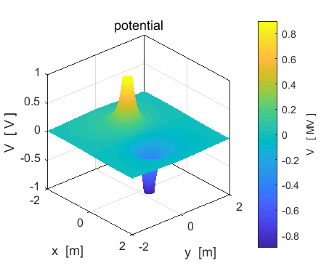

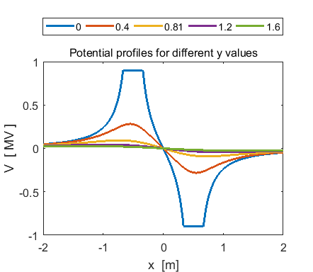

Electric potential for the +20 C and -20C C distribution.

Near the negative charge, the electric potential forms a “potential well” and near the positive charge a “potential hills occurs”. A positive charge will be repelled from the hill and attracted to the well.

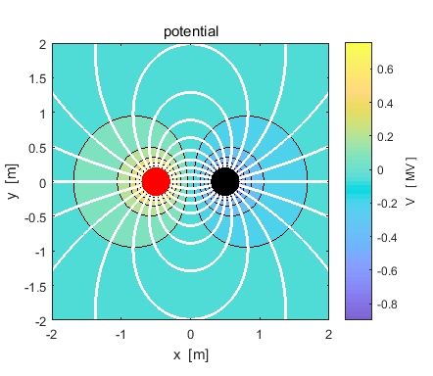

The white lines are the electric field lines. The field lines emerge from the positive charge (**red**) and terminate at the negative charge (**black**) or a infinity. The density of electric field lines increase towards a charge as the electric field strength increases. The black concentric circles are the electric equipotential lines. The equipotential lines are crowded together near a charge where the electric field strength is greatest - the electric potential changes more rapidly in fixed distance intervals () or where the equipotential lines are closely spaced, the potential varies rapidly with distance and the electric field is large. The electric field is strong between the charges, and the potential changes rapidly.

|  |
| --- |
| **PREDICT OBSERVE EXPLAIN EXERCISE**  For each of the charge configurations shown below, sketch the electric field patterns and equipotential line patterns. Where is the electric field strongest and where is the electric potential changing most rapidly with position?  Observe the figures below and compare your predictions with your observations – resolve any discrepancies. |

**View the figures only after you have made your predictions**

**Two charges of equal magnitude and same sign**

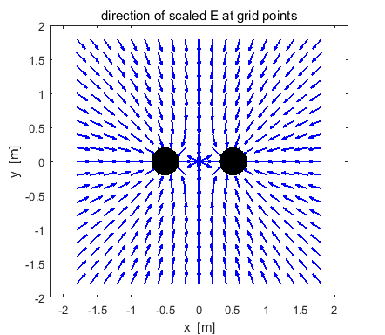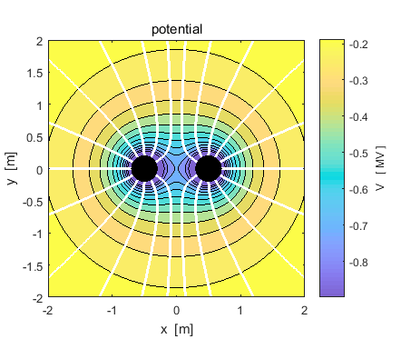

**Two charges of unequal magnitude and opposite signs**

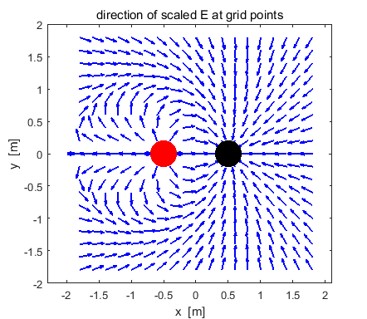

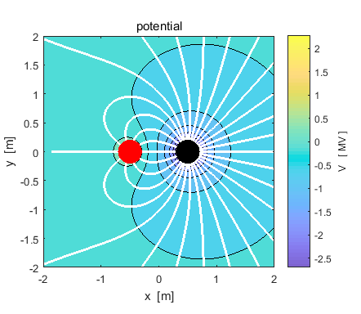

What is the ratio of the two charges? What location has the strongest electric field?

**Two charges of unequal magnitude and same sign**

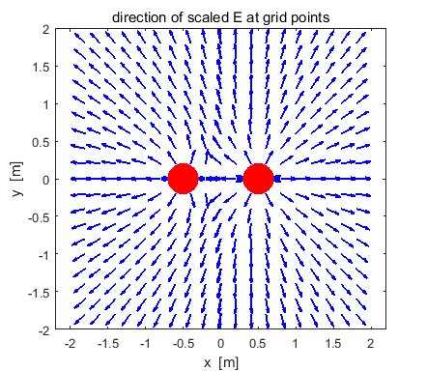

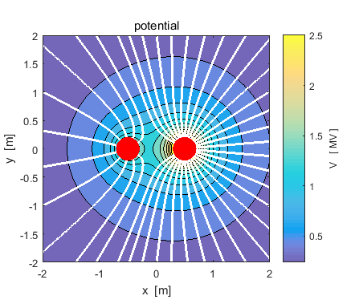

What is the ratio of the two charges? What location has the strongest electric field?

**[2D] quadrupole – four charges of equal magnitude and alternating sign lying on the corners of a square**

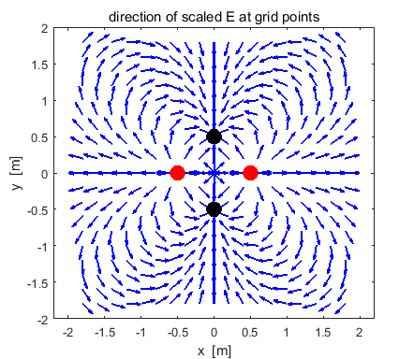

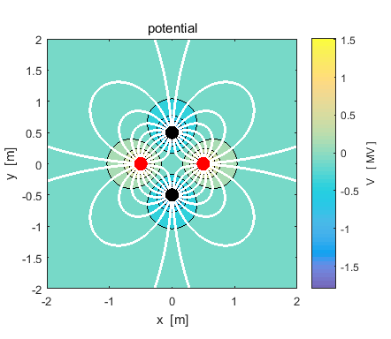

**[1D] quadrupole of 3 charges in a straight lines -*q* +2*q* -*q***

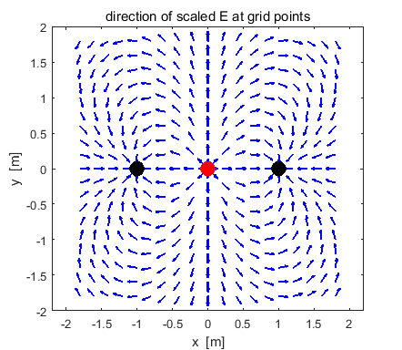

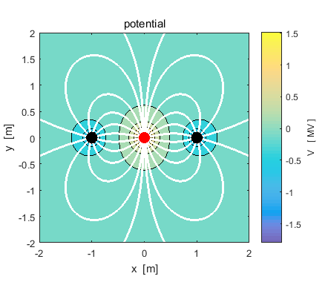

**Four equal charges at the corners of a square**

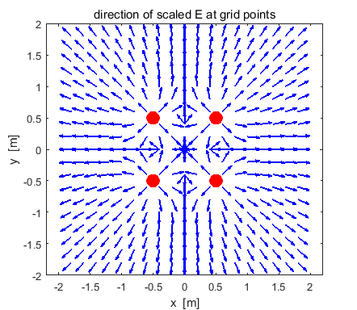

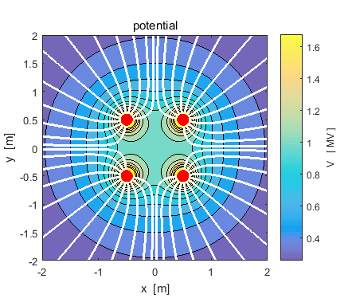

**A short capacitor model**

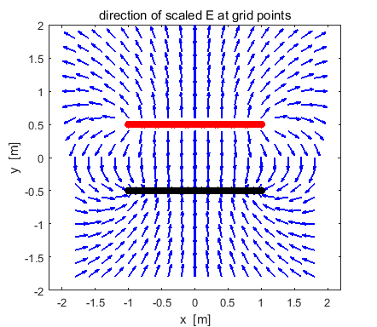

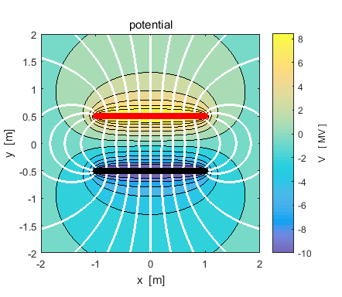

[VISUAL PHYSICS ONLINE](http://www.physics.usyd.edu.au/teach_res/hsp/sp/spHome.htm)

If you have any feedback, comments, suggestions or corrections please email Ian Cooper

ian.cooper@sydney.edu.au

Ian Cooper School of Physics University of Sydney

<http://www.physics.usyd.edu.au/teach_res/hsp/sp/spHome.htm>