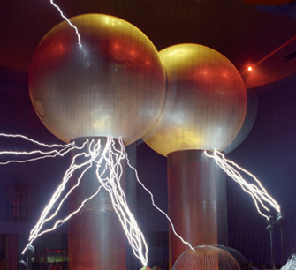

[**VISUAL PHYSICS ONLINE**](http://www.physics.usyd.edu.au/teach_res/hsp/sp/spHome.htm)

**MODULE 4.1**

**ELECTRICITY**

**ELECTRICAL POTENTIAL**

|  |
| --- |
| **voltage**  **electrical potential**  **potential difference**  **potential drop voltage drop**  **emf**  **electromotive force**  Scalar quantities  S.I. unit: V (volt) 1 V ≡ 1 kg.m2.s-3.A-1    Between any **two points**, an electric field will create a potential difference. |

The voltage of the car battery is 12 V.

There is an electrical potential of 100 kV.

The potential difference between two points A and B is 5.0 V.

The potential drop across the resistor is 15 V.

The voltage drop in the circuits was 50 mV.

The emf of the battery is 1.5 V.

The electromotive force produced by the generator is 37 V

**What do all these terms mean?**

The concept of potential is the most complex and complicated term that you will come across in your physics course. So, you need to tread carefully and think carefully about the concepts and implications of the terms associated with electrical potential.

Before continuing with this set of notes, **review** the concepts associated with force and work

[energy work power](http://www.physics.usyd.edu.au/teach_res/hsp/sp/mod2/m2_EWPC.pdf)

[conservation of energy](http://www.physics.usyd.edu.au/teach_res/hsp/sp/mod2/m2_CEC.pdf)

NOTE: We will use the system *U* for potential energy and *K* for kinetic energy and not *EK* and not *EP* or *EK* so there will be less confusion with the electric field E.

**Gravitational Field / Gravitational Potential Energy**

Before, we look at electric fields and potentials, we will step back and look at the concepts of gravitational potential energy and gravitational fields.

We will consider a basketball in the gravitational field near the Earth’s surface. We can assume that near the Earth’s surface, the gravitational field is uniform and the gravitational field strength is  (the acceleration due to gravity near the Earth’s surface is). An object of mass  placed in the gravitational field  will experience a gravitational force  as shown in figure 1. Note: an object with a positive charge placed in an electric field  whose direction is in the -Y direction will experience an electric force  in the -Y direction.

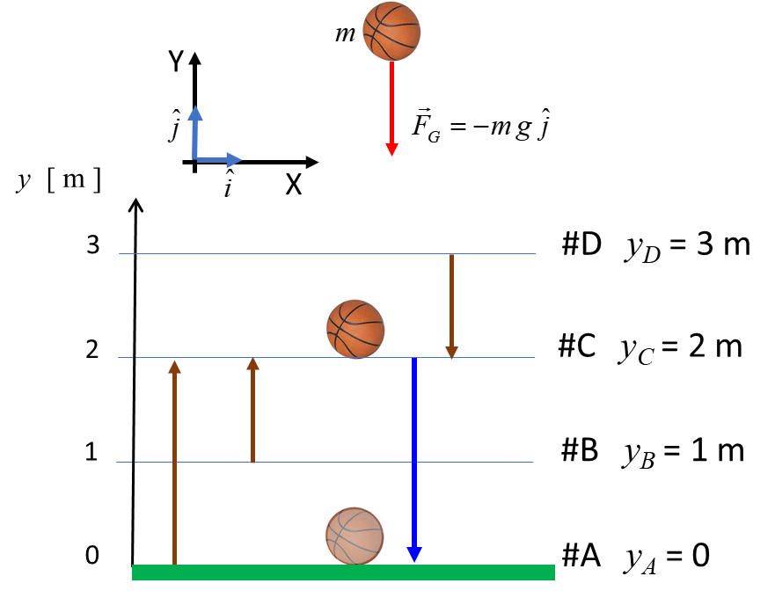

Fig. 1. Note the similarities of the gravitational field and electric field. The big difference though is that the gravitational field is also associated with attractive forces, whereas the electric field gives both attractive and negative forces.

The basketball has a mass *m*, and when dropped, it possesses momentum and kinetic energy, but, the basketball does not possess gravitational potential energy. Potential energy is not a property of an object. Potential energy is a property of the object and the gravitational field. Consider the basketball in the gravitational field near the Earth’s surface as shown in figure 2. A reference point must be given to specify for the potential energy . The initial position of the basketball is *yC* = 2 m. The ball is dropped from rest and its final position is *yA* = 0 m. Consider four frames of reference (A, B, C and D) in which the gravitational potential energy zero is defined at different vertical positions.

Initial vertical position of basketball *yC* = 2 m

Final position of basketball *yA* = 0 m

#A 

Initial PE 

Final PE 

Change in PE 

#B 

Initial PE 

Final PE 

Change in PE 

#C 

Initial PE 

Final PE 

Change in PE 

#D 

Initial PE 

Final PE 

Change in PE 

Notice that the gravitational potential energy is different in the four frames of reference, but the change in the gravitational potential energy is the **same** in the four cases. The potential energy is not important, it is only the **change** in the potential that occurs is important.

As the ball falls, mechanical energy is conserved and the increase in the kinetic energy of the ball just before it hits the ground is



The increase in kinetic energy of the ball can also be calculated from the work done *W* by the gravitational force on the ball. For a constant force



In lifting the ball from ground to the vertical position *yC* without any increase in kinetic energy of the ball, the work done against gravity in raising the ball is



The method of understanding the physics of a ball in a gravitational field can be applied to the motion of charged particles in electric field.

A charge distribution gives rise to an electric field where charged particles experience electrical forces. Therefore, energy must be supplied by some external agent (e.g., chemical reactions in a battery, electromagnetic induction effects, photovoltaic processes in solar cells, etc.) to move charges against the electric field, that is, work must be done to move charges from one position to another against the forces acting on the charges due to the electric field. This energy can be stored by these charges in the electric field. So, we can associate a potential energy with these charges and the field. This stored energy can be utilized when the potential energy of the system decreases as potential energy is transformed into kinetic energy of moving charges. The electrical forces acting on the charges due to the electric field does work on the charges. This movement of charges is known as an electric current. The kinetic energy of the charges in motion can be used to produce thermal energy when a current passes through a resistance, or be transformed into light energy, or used as mechanical energy in an electric motor.

We will consider a positive charge *q* (*q* > 0) placed in a uniform electric field  as shown in figure 2. The positive charge accelerates in the direction of the electric field since conservative forces act on the charged particle (the positive charge is repelled from the positive plate and attracted to the negative plate). The displacement of the charged particle is  in moving from the point A to a point B. The charged particle gains kinetic energy and the potential energy system (charge and field) decreases.

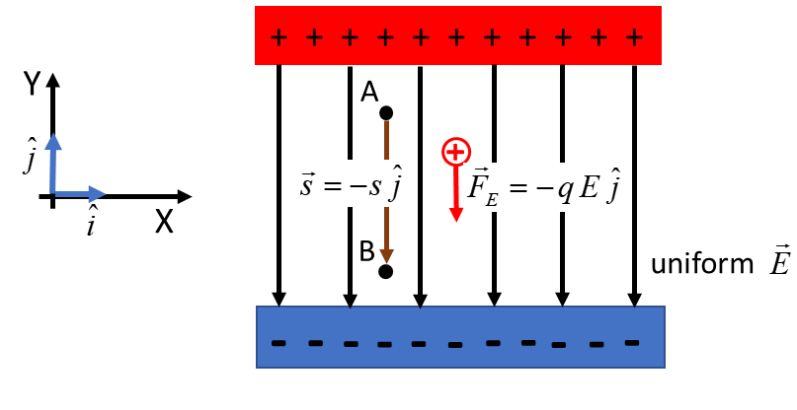

Fig. 2. Work is done on a positive charge in the electric field increasing the charged particle’s kinetic energy at the expense of the potential energy of the system.

The work done *WBA*  by the electric force  on the charge *q* for the displacement  from A to B is



(1)  constant force acting on charge

The work done by the conservative electric force is also equal to the negative of the change in potential energy of the charged particle in the electric field

(2) 

Equating equations 1 and 2

(3) 

We can now define the term, potential difference. The **potential difference**  is defined as the work done when a unit positive charge is moved from one point to another in an electric field

(4) 

and the potential  at a point as

(5) 

So, equation 3 can be expressed in terms of potentials

(6)  uniform electric field only

When the potential difference represents a source of electrical energy, it is referred to as an **emf** (or electromotive force ). For example, it is best to say that the emf = 12 V for a car battery). The term **voltage** is a general term for potential difference, potential or emf. It is best to avoid the term voltage in a scientific sense – it is better to use the terms potential, potential difference or emf. When work is done by the charges, electrical energy is transformed into some other forms and the potential difference between two points is often referred to as a potential drop or voltage drop.

If some point is chosen as a reference point, them all potentials can be measured with respect to the reference point. We then refer to the potential at a point. The Earth for all practical purposes can be regarded as neutral. It is used a standard of neutrality and is often represented by the signs



The Earth (ground) is often used as a reference point in defining potentials where the Earth or ground is taken a 0 V.

**Potential can also be thought of as a measure**

**of the imbalance of charges**

Beware: the symbol *V* is confusing – *V* represents both a potential at a point and a potential difference.

The greater the excess electrons an object possesses, the more negative it is with represent to the ground or the greater the deficiency of electrons, the positive it is with respect to the ground.

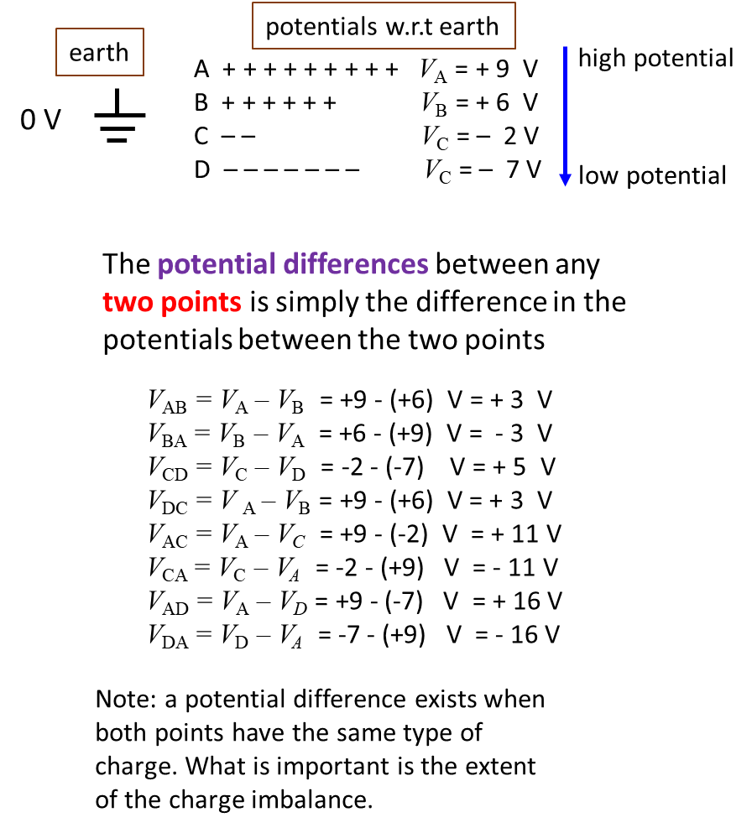

If two points in an electric field have a potential difference between them and are joined by an electrical resistance, a current will be established between the two points. The current is driven by the electric field caused by some charge imbalance. The direction of current is defined to be in the direction in which positive charges would move. This means that the direction of current is from a point of higher potential to a point of lower potential.

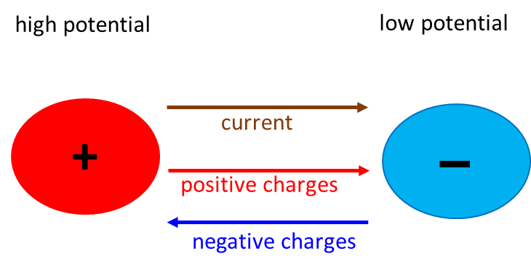

* Direction of current is from a region of higher potential to a region of lower potential.
* Positive charges move from a region of higher potential to a region of lower potential.
* Negative charges move from a region of lower potential to a region of higher potential.

**Potential and potential differences in an electric circuit**

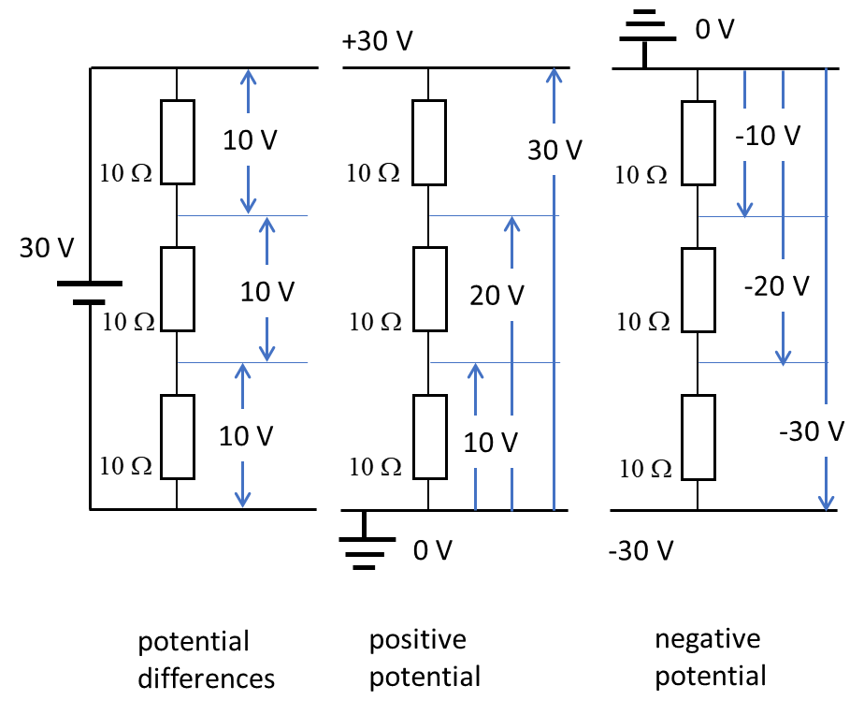

|  |
| --- |
| **Example 1**  A charge of 5.23 C at rest is released into a uniform electric field of 1.56 kV.m-1. Describe the motion of the positively charged particle. Calculate the following after the charged particle with a mass of 5.00 g has moved a distance of 100 mm from its starting position:   1. Force acting on charged particle. 2. Acceleration of the charge particle. 3. Final velocity of charged particle. 4. Final kinetic energy of charged particle and the change in its kinetic energy. 5. Work done on the charged particle by the electric force. 6. The change in potential energy of the charged particle. 7. The potential difference between the final position and initial position of the charged particle. |

|  |
| --- |
| **Solution**  Since the electric field is uniform, the force and hence acceleration of the charged particle are also uniform. As the charged particle is released from rest, the particle will move in a straight line with a constant acceleration. The positive charged particle will move from the higher potential point to the lower potential point (there exists a potential difference between the points A and B) due to the interaction between the positive charge and the electric field. Work is done on the charged particle by the electric force, thus, increasing its kinetic energy while the potential energy is decreased.    (a) Electric force is directed in the + X direction    (b) Acceleration is constant and directed in the + X direction  Newton’s 2nd Law    (c) Final velocity at point B  constant acceleration    (d) Kinetic energy      Change in KE  (e) Work done on charge by electric force    Note: same answer as part (d) as expected  (g) Change in potential energy    (f) Potential difference    The answer is negative, since the point B is at a lower potential than the point A. Note: only difference in potential energy or potential are important and not the values of potential energy or potential at a point. |

**Sources of electrical energy**

The source of electrical energy required to produce an electric current in a circuit is known as the **emf** (electromotive force: note – it is better just to use the term emf and not electromotive force since the quantity is not a force). For example, in a torch, the source of electrical energy is the chemical reactions taking place in the battery where electrons are transferred to maintain a constant potential difference between the positive and negative terminals.

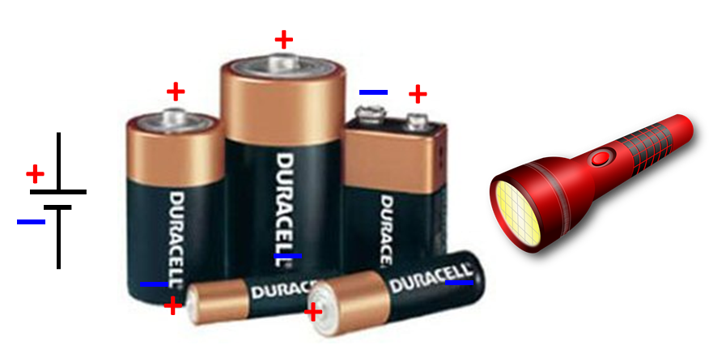

**Common emfs**

lightning ~ MV (mega volt 1 M = 1x106)

torch battery 1.5 V

car battery 12 V

mains electricity 240 V (rms value, peak value 339 V)

high tension wires 330 kV

|  |
| --- |
| **Mathematical Extra**: you do not need to know the following mathematical analysis for your examinations, but, by understanding the mathematics of electric fields and electric potentials, you can have a much better appreciation and understanding of these two difficult concepts.  Consider a positively charged particle  which moves from a point A to point B by the interaction of charge  and the electric field . The work done  on the charge  by the electric force  is    The electric force  is connected to the electric field  by    Hence,  The connection between the work done  and the change in potential energy  is    The **potential difference**  between the point A and point B is defined as        The reverse process of integration is differentiation. So, the electric field can be calculated from the **gradient** of the    The electric field is a vector function whereas the electric potential is a scalar function. It is much easier working with scalars compared with vectors, so the electric potentials are much better to work with rather than the electric fields.  When water runs down a mountain it will follow the path which has the steepest gradient (slope). This is the same with the gradient function for the potential. The electric field at any point will point in the direction in which the electric potential is decreasing most rapidly (greatest slope or greatest gradient).  Will examine the implications of these equation in the next set of notes on Electric Fields and Electrical Potentials. |

[VISUAL PHYSICS ONLINE](http://www.physics.usyd.edu.au/teach_res/hsp/sp/spHome.htm)

If you have any feedback, comments, suggestions or corrections please email Ian Cooper

ian.cooper@sydney.edu.au

Ian Cooper School of Physics University of Sydney

<http://www.physics.usyd.edu.au/teach_res/hsp/sp/spHome.htm>