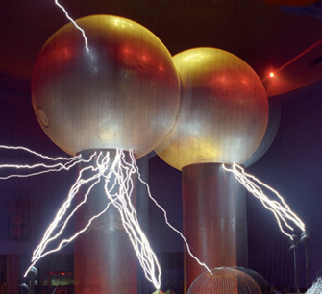

[**VISUAL PHYSICS ONLINE**](http://www.physics.usyd.edu.au/teach_res/hsp/sp/spHome.htm)

**MODULE 4.1**

**ELECTRICITY**

**SAFETY and HOUSEHOLD WIRING**

This topic is not necessarily covered in the syllabus, but it contains knowledge that all people should know about. Better knowledge about electrical safety in the home can save lives.

**ELECTRICAL SAFETY**

**The Fatal Current I = V / R**

Electric shock may cause burns, cessation of breathing, unconsciousness, ventricular fibrillation, cardiac arrest or death. When electric current is passed through the body, part of this current may pass through the heart and interfere with the normal functioning of it causing death. If a person receives a 240 V shock, it is **NOT** the voltage of this shock that is important, but rather the **current** through the body. Whether a person receives a weak or a fatal shock depends upon the circumstances. A voltage as low as 40 V can kill, whereas, people have received an 11 000 V shock and only received severe burns. If a person receives a 240 V shock standing in a dry environment, insulated by normal clothing, the shock may hardly be felt as the current may be below 1 mA. If, however, a person receives a 240 V shock while standing barefoot on wet ground, the person would receive a severe shock and probably be killed as the current may exceed 100 mA. We are most susceptible to currents with frequencies around 50 Hz. At 10 000 Hz and DC (direct current), the threshold of sensation is approximately five times greater than at 50 Hz.

|  |  |
| --- | --- |
| **Current** | **Response** |
| < ~1 mA | no sensation |
| ~ 1 mA | mild sensation |
| ~ 10 mA to ~ 100 mA | can’t let go – muscular paralysis  severe shock  laboured breathing  extreme breathing difficulties |
| **~100 mA to ~2 A** | ***ventricular fibrillation***  **probable death** |
| > 2 A | serve burns and shock  breathing stops  clamping of heart |

Figure 1: 50 Hz shock current (arm-to-arm)

Figure 1, shows the physiological effects of 50 Hz arm-to-arm current. If a current less than about 1 mA is passed through the body, there is generally no sensation and apparently, no significant physiological effect. As the current is increased to a few milliamperes, a tingling sensation is felt, becoming more and more uncomfortable as the current is increased. At about 10 mA muscles contract and are held contracted, in particular the fingers may clamp on to a conductor, and it is impossible to open the hand. The term let go current means the highest current at which one can still let go. It is important to note that a current just above the let go current value is usually harmless. When the current is broken, the victim is shaken but alive. As the current rises above 10 mA, breathing becomes laboured and may cease. The victim may still recover spontaneously if the current is promptly stopped.

A current of about 100 mA sustained for a second or so is all that is needed to switch the heart over from its normal pumping rhythm to a useless random twitching action known as ***ventricular fibrillation***. The heart action does not recover spontaneously when the current is broken. Ventricular fibrillation refers to the rapid irregular contractions of the heart muscle that interferes with the normal blood pumping action of the heart and eventually causes death. Ventricular fibrillation is started by currents passing directly through the heart during a specific portion of the cardiac cycle known as the vulnerable period. The vulnerable period for ventricular muscle occurs during the up stroke of the T-wave and a single shock impulse lasting for less than 0.1 seconds could cause ventricular fibrillation if received during this vulnerable period. If the oxygen supply to the brain is interrupted for more than a few minutes, permanent brain damage will occur. Once ventricular fibrillation has started it is often difficult to stop.

Electrical shocks are given by a defibrillator to clamp the heart with the hope that the heart will return to its normal rhythm.



Figure 2: Cardiac Cycle

Currents much greater than 100 mA can also cause internal and skin burns. Paradoxically, brief currents of > 2 A may be less dangerous than lower currents, as instead of putting the heart into ventricular fibrillation, they are sufficient to clamp the whole heart muscle simultaneously, and when the current is turned off, the normal heart beat may resume of its own accord. Indeed, currents of about 1 A are used clinically to defibrillate the heart.

**Micro-shocks**

Quite small frictional effects can produce large voltages between bodies, eg, combing hair with a plastic comb and walking on nylon carpet, but the amount of energy this represents is very small. The danger from such static electricity is not that it could not produce a large current through a human body but that it can cause fires or explosions by sparking.

In cardiac intensive care, patients may have catheters and electrodes inserted into or near the heart. Such patients are vulnerable to micro-shocks produced by current accidentally carried directly to the heart by these inserted lines. Research at the Prince Henry Hospital in Sydney during the 1970s established that the minimum current passed directly into the heart which would induce ventricular fibrillation was only about 60 μA. Since a typical resistance of the saline column in a cardiac catheter is about 500 Ω, it follows that a potential as low as 30 mV on the catheter could be fatal. Such small potentials are easily produced in any number of ways - contact potentials, earth leakage currents, induced EMF's, electrostatic effects, etc. Before the dangers were fully appreciated there is little doubt that many cardiac patients who died of heart failure were indeed victims of micro-shocks.

**Skin resistance**

The***resistance of the skin*** plays an important part in determining the extent of the shock. The body’s resistance is made of two components: the skin resistance and the internal resistance. The skin resistance is normally very high (105 Ω to 106 Ω hand-to- hand) and varies between different points on the body. However, if the skin becomes wet, its resistance can drop to less than 1000 Ω. The internal resistance of our bodies is very low since is basically the resistance of an electrolyte which is a good conductor of electricity.

**What to do for a victim?**

Cut the voltage and / or remove the victim from contact as quickly as possible – but without endangering your own safety. Use a length of dry wood, rope, blanket, etc to pry or pull the victim loose, because if you come into contact with the electricity you could suffer muscular paralysis and not be able to let go. Don't waste valuable time looking for the power switch. A fatal current may result if action is delayed because the body's resistance decreases with time. If a person, is knocked out by an electric shock then it is impossible to tell what current passed through the vital organs of the body. Artificial respiration and heart massage must be applied immediately if breathing has stopped.

***Do not stop resuscitation until medical authorities pronounce the victim beyond help.***

It may take as long as eight hours to revive the patient. There may be no pulse and a condition similar to rigor mortis may be present; however, these are the manifestation of electric shock and not an indication that the victim has succumbed.

**Mouth-to-Mouth Method of Artificial Respiration**

1. Kneel beside the victim's shoulder.
2. Tilt the victim's head well back. Place one hand on the lower jaw to open the mouth.
3. Take a deep breath through your mouth.
4. Pinch the victim's nostrils to form an air seal.
5. Press your lips around the victim's open mouth.
6. Breath out firmly into the victim's mouth. Check if the chest rises as in normal breathing.
7. Move your mouth well clear of the victim's mouth. Watch the chest deflate.
8. The first four or five inflations should be given as rapidly as possible.
9. The continued rate of inflations should be about 12 per minute.
10. Continue until breathing is restored or until medical help arrives.

**DOMESTIC ELECTRICITY**

Electric power stations produce alternating current (frequency 50 Hz) by means of large generators. The electric power is distributed from the power station to individual homes by a pair of power lines - the ***live*** or ***activ****e* wire and the ***neutral***wire. Each house is connected in parallel to these power lines. The average (root mean square - rms) voltage across these power lines is 240 V (340 V peak). The neutral power line is connected to the earth by means of wires buried in the ground, that keeps the line at zero potential. The potential of the live wire oscillates, positive, negative, positive, … with respect to the grounded neutral power line at a rate of 50 times a second and hence the frequency of our mains electricity supply is 50 Hz.

There is a third electrical wire found in the home. It is called the ***earth*** wire. It plays no part in delivering the electricity but is a safety wire in case certain electrical accidents occur. The three electrical wires are coloured coded so that it is easy to identify them. There is a new colour system and an old system.

|  |  |  |
| --- | --- | --- |
| **Wire** | **New Colour Code** | **Old Colour Code** |
| active or live | brown | red |
| neutral | blue | black |
| earth | green / yellow | green |

|  |
| --- |
|  |

Figure 3: Schematic diagram of the electrical wiring in a home.

The fuse (circuit breaker) and the meter are connected in series with the active wire entering the house, and all electrical equipment and appliances are connected in parallel, across the active and neutral wires. The full 240 V is maintained between the active and neutral, however there is zero current until a connection is made between the active and the neutral. When the switch is turned on, there is a connection between the active and neutral wires via the resistance of a light globe or an appliance and a current will flow in the circuit. Since the neutral wire is connected to the earth, all that is needed for a current to be established is a connection between the active wire and the earth. This fact is responsible for many electrocutions that occur each year, since a person can act as the resistive path between the active and the earth and hence the current will flow through that person.

The ***fuse*** is another electrical safety device. When a current passes through a wire a heating effect is produced. The greater the current, then the greater the heating effect. If an electrical fault occurs such as a low resistance path (***short circuit***) between the active and neutral wires, a large current will flow and this could start a fire. The purpose of the fuse is to prevent this occurring. The fuse is the ‘weakest’ part of the electrical wiring and if the current is large enough, the fuse will get hot and melt, breaking the connection to the active wire and hopefully prevent any major catastrophe. Many homes have ***circuit breakers*** instead of fuses. They work on the same principle. If there is too much current in the circuit, the circuit breaker is tripped and breaks the connection to the active wire.

As more appliances are connected, the total resistance between the active and neutral wires decreases and hence a larger current. For example, if too many appliances are connected to a power point for example, the fuse should blow or the circuit breaker tripped. It is most important when replacing the fuse that you use the correct fuse rating, if not, a serious accident could occur. If the fuse constantly blows, an electrician should be notified to check the wiring and your electrical appliances.

Because appliances require different amounts of current, the wiring in the home is divided up into a number of separate circuits and each circuit has is own fuse or circuit breaker. Typical ratings for these different circuits are shown in figure 3.

The lighting circuits supply filament or fluorescent lamps that are comparatively small loads and therefore require only small cables and fuses. Heating for cooking, water heating, and space heating are heavier loads and require larger cables and fuses. Cookers and some fixed heating appliances are connected to their own individual fuses or circuit breakers. Portable heating appliances up to about 3.6 kW can be connected to the supply using plugs and sockets

In a 100 W light bulb, the current and resistance are given by:

*I* = *P* / *V* = (100 / 240) A = 0.42 A

*R* = *V*2 / *P* = (2402 / 100) A = 573 Ω

In a 2400 W heater, the current and resistance are given by:

*I* = *P* / *V* = (2400 / 240) A = 10 A

*R* = *V*2 / *P* = (2402 / 2400) A = 24 Ω

Accidents are often caused by:

* frayed power cords leading to short circuits
* overloading a power point with too many appliances via an adaptor
* faulty appliances.

**Earth wire – earthing**

Since one side of an electric supply is grounded, a circuit is complete when the other (active or live) wire connects to ground. For example, if the active wire breaks and makes contact with the metal frame of an appliance, the frame would become live. If a person touched the live appliance, the current would flow through the person's body, since the human body offers a route to earth. The result could be severe electric shock or electrocution.

To prevent this type of accident, many appliances are fitted with a safety earth wire. This is a thick copper wire of low resistance covered with a green/yellow insulation, and forms the third component of a three-core flexible cable, the other two being the brown live and the blue neutral conductors. One end of the green/yellow earth wire is connected to the frame of the appliance, the other to the earth by way of a main cold water pipe or copper plate buried in the earth. If the appliance becomes live, the current path is the earth wire and this acts like a short circuit causing the fuse to blow or circuit breaker tripped and thus protects the person.

|  |
| --- |
|  |

Figure 4: Electric shock with faulty earth connection

The earthing of high voltage equipment can prevent high voltages building up on its case. For example, if an instrument has a leakage current of 5.0 mA and it is properly earthed through a resistance of 1.2 Ω then the voltage of the instrument case with respect to the earth will be

*V* = *I R* where *I* = 5.0 mA = 5.0×10-3 A, *R* = 1.2 Ω

*V* = (5×10-3)(1.2) V = 6.0×10-3 V = **6.0 mV**

If the instrument had a faulty earth connection with a resistance to earth of 104 Ω

then the voltage that could build up on the case

*V* = *I R* where *I* = 5×10-3 A, *R* =104 Ω

*V* = (5×10-3)(104) V = **50 V**

This voltage could give a person a serve shock if they touched the instrument.

**Three Pin Plugs and Sockets**

Figure 5: Power socket with DPST switch

Power sockets can be wired incorrectly. The switch should be wired so that the active wire connection is broken. However, the socket may be wired incorrectly so that the switch may only break the neutral conductor in a SPST (single pole single throw) switch. The switch will operate as 'normal' under most circumstances. Nonetheless, people who were unaware of a faulty switch have been killed. For example, Mr I A's drill was giving him trouble so he decided that he would try and fix it. He turned the drill off at the switch but he left the plug in. He touched the live wire with his hands and received a fatal shock because the switch had not broken the live wire and so when he touched it he completed the circuit to ground. It is safer to use a DPST (double pole single throw) switch in which both the active and neutral wires are disconnected simultaneously as shown in figure 5.

***Always remove the appliance from the power point before tampering with it.***

Incorrect connection of the green core in three core flex cables is a major cause of domestic electrical fatalities. For example, be careful borrowing an extension cord – people have been killed by using a faulty cord in which the active wire was connected to the earth socket.

# Double insulation

Many small power tools and domestic appliances are double insulated. This means that instead of having an earthed conducting case, they have a plastic case and all external metal parts are separated from the mains by two separate electrically insulating barriers or a single insulator of equivalent insulating properties. In electric hand drills for example, part of the internal drive shaft is plastic.

# Electric shocks

In normal use, current goes to electrical equipment (e.g. toaster) via the active wire and back to the transformer via the neutral. However, because the neutral is earthed, the current can return via the earth rather than the neutral. For example, an unwary person eating breakfast touching the live end of the toaster element with a knife can get a shock. In addition to the normal current *I*, through the toaster there is an additional shocking current *I*s through the active lead, through the knife, hand, arm, body, chair, floor and back to the neutral via the earth How dangerous such a shock is depends on the current, which in turn depends on the resistance in the path of the shocking current, i.e. the resistance provided by the person, floor, chair, etc.

In the example above with the toaster, the average (rms) potential between active and earth is 240 V. The resistance in the path of the current through the person is made up as follows:

*R*total = *R*mains supply + *R*knife + *R*hand-to-knife contact+ *R*body +

*R*body-to-floor + *R*earth return path

Of all of these, the resistance of the earth, the knife and the mains supply are less than a few ohms and can be neglected. The body resistance (arm, trunk, leg) is usually very large. The body contact resistances to the knife and to the floor will depend critically on the circumstances. Thus

*I*shock = *V* / (*R*body + *R*contact)

When a voltage is applied across two points on a human body, what happens depends not on the voltage, but on the current available from the energy source and hence on the power available. For example, a voltage of 100 V applied to two point with a resistance of 20 Ω between them indicates that 5 A (l00 V/ 20 Ω ) should pass through the body. But this cannot happen unless the power rating of the source of electrical energy is 500 W (*P* = *V I* = 100 × 5 W). A bank of cells in series could provide the voltage but would not produce the necessary current because the power is not available. A cell has a definite maximum rate at which it can convert chemical energy into electrical energy by removing charge from the negative to the positive plate. If too large a current is drawn from the cell, the charge cannot be returned to the positive plate fast enough, and the voltage between the plates drops rapidly.

**Examples of death by electrocution**

*1 Sex: Female Age: 38 y Occupation: Housewife*

The deceased received a fatal 240 V shock from the metal door handle of a refrigerator while standing bare-footed on a concrete floor. A defective taped joint

in figure 8 flexible cord to the interior light intermittently energised the equipment. The circuit fuse blow but it was still too late for the person.

*2 Sex: Male Age: 2 y Occupation: not known*

The fatal 240 V shock was received from the element and earthed metal frame of a radiator which had the three pin plug of the attached flexible cord inserted in a socket outlet in a bedroom. The controlling switch of the outlet was in the off position but it did not break the active conductor.

*3 Sex: Male Age: 45 y Occupation: not known*

While attempting to use a polisher scrubber on car mats in the yard of his home the deceased received a fatal 240 V shock from the frame of the appliance. The earthing conductor in the flexible cord was connected to a current carrying terminal in the three pin plug.

*4 Sex: Female Age: 24 y Occupation: Nurse*

While attempting to heat water in a washing machine by means of an immersion heater, the deceased received a fatal 240 V shock from the exposed metal of the heater. The earthing conductor in the flexible cord was connected to a current carrying terminal (active wire) in the attached three pin plug.

*5 Sex: Male Age: 78 y Occupation: Shopkeeper*

From burn marks on the deceased and on tools being used it is apparent that the deceased, while connecting additions to the electrical installation, received a 240 V shock which caused a fall from a tank stand 3m above a concrete path. The connection was being made to a circuit controlled by a single pole switch that did not break the active conductor.

*6 Sex: Male Age: 22 y Occupation: Theological Student*

Apparently, after inserting the bared ends of the red and green conductors of the sheathed flexible cord of a washing machine in a socket outlet, the deceased received a fatal 240 V shock from the frame of the machine. Previously the machine had fallen over and the black insulated conductor in the flexible cord had broken of within the sheathing giving the cord the appearance of having only two cores.

**ELECTRICAL POWER DISTRIBUTION**

In 2001 the total NSW electric energy production was about 80 000 GWh (gigawatt-hours). Much of this power was produced by seven coal-fired power stations. The largest of these is Bayswater with a capacity of 2640 MW from four 660 MW stream driven turbines. The Snowy Mountains hydroelectric scheme provides an additional capacity of 3740 MW. Several smaller hydro and gas turbine stations contribute a further 600 MW. These power stations are sited close to their source of energy - i.e. the coal fields or dams - because it is less costly (and more environmentally friendly) to transmit power than transport coal. Then the state power grid distributes the energy to the users.

Very high voltage AC (alternating current) transmission lines are required to efficiently transmit large amounts of power over long distances. AC voltages are always quoted as rms ("root mean square") values, which is the square root of the average of the square of the voltage as it varies with time - in fact it is *V*o/√2 where *V*o is the amplitude of the alternating potential. In Australia, normal household voltage is 240 V rms at a frequency of 50 Hz. The actual voltage signal therefore varies as a sine wave between ±340 V, with a period of 20 ms. In the US and Canada power is supplied at 110 V rms and 60 Hz.

|  |
| --- |
|  |

In NSW the power is produced at rms voltages between 17 and 23 kV at the power stations. It is transformed up to transmission line voltages which are typically 132 or 330 kV, with some others at 220 and 500 kV. Most of these transmission lines are aluminium conductors suspended overhead on steel lattice towers. The conductors are insulated from the towers by porcelain, glass or synthetic insulators. Transmission lines may also be laid underground, but at much higher cost than overhead lines.

However recent concerns with the possible effects of electromagnetic radiation from high voltage lines, plus the appearance of overhead lines, may make underground lines more attractive in the future, at least for short distances in urban areas.

Voltage levels must be reduced before the power can be used in the home or by industry. First, the power is delivered to substations where it is transformed to 66 or 132 kV to be sent, generally on wood or concrete poles, to zone substations where it transformed again to 11 or 22 kV. From this point, it is transmitted to various substations and local transformers where it is stepped down to 240 V for general use. You can see the local transformers on poles in the street or in cubicles at ground level. At the local transformer, one lead, known as the ***neutra***l (N) is connected to the earth via a thick cable with one end buried in the ground. The other wire from the transformer, the ***active*** lead (A) is thus at an rms potential of 240 V relative to the ground, i.e. to our surroundings. The active and neutral conductors are connected to the A and N points of the user's outlet sockets. The user's earth (E) point is connected as directly as possible to the ground close to the house. Since the neutral wires in the power lines carry large currents and since they have finite resistance (ideally the resistance would be zero) they cannot be at exactly the same potential at all places along the wire. The neutral is usually connected to the ground at several other points between the transformer and the houses in order to keep the neutral lead at a potential near earth potential (ie 0 V). This ensures that only the active lead is at a high potential which is less dangerous than having two high voltage wires.

**EARTH LEAKAGE CIRCUIT BREAKERS**

The 50 Hz domestic mains supply consists of three leads called the active, the neutral and the earth. The earth connects exposed metal parts of an appliance to the earth locally while the active and negative are responsible for delivering the power. The neutral should be close to earth potential while the active has an alternating potential difference with respect to the neutral of 240 V rms. Under normal conditions of operation the current in the active and neutral should be the same.

The most common cause of electrocution is when a person comes into contact with the active lead so that current flows to earth through the person. In such circumstances the current in the neutral lead will be less than the current in the active lead - a situation that is referred to as earth leakage. A device, called an ***earth leakage circuit breaker***, detects this imbalance and immediately cuts of the electrical supply. The active and neutral leads are wound in opposite senses on a ring of ferromagnetic material (usually referred to as a core). The function of the ferromagnetic core is to guide the magnetic flux from each winding through the third winding. When the currents in the active and neutral leads are equal the fluxes due to each cancel and there is no net flux through the third winding. If however there is leakage to earth from the active lead the fluxes will not cancel and there will be a net flux through the third coil. As the flux will be alternating (at a frequency of 50 Hz) it will induce an emf in the third coil. With the aid of further electronics this signal can be used to trigger a circuit breaker that disconnects the mains supply.

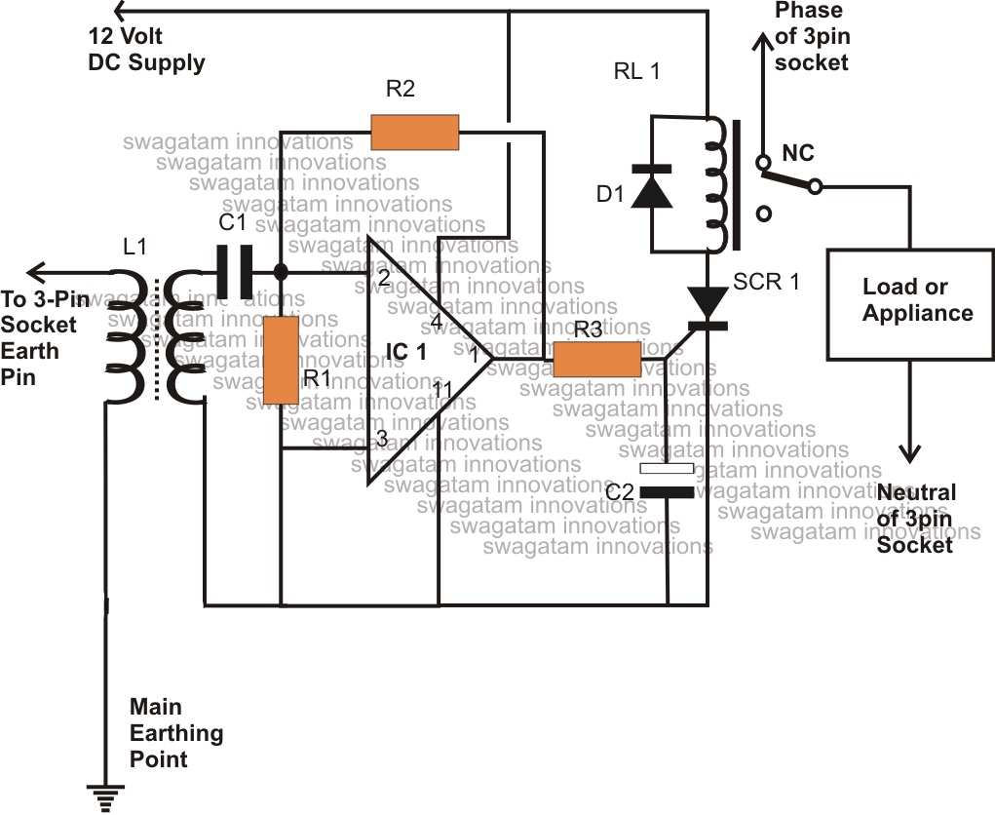

Figure 6: Earth leakage detector

Other terms for earth leakage circuit breakers include core balance relays and earth leakage protectors. They can be installed as a single unit in the meter box of a domestic dwelling to provide protection for all power and light outlets. It is also possible to obtain portable units for use with individual appliances and power sockets that incorporate such devices. A typical power point unit will trip when an imbalance of greater than 10 mA is detected; in such circumstances the power cuts off within about 40 ms of the imbalance being detected.

**ATMOSPHERIC ELECTRICITY**

# The Fine Weather Electric Field

In fine weather there is a weak electric field at the surface of the earth. It has a magnitude of about 100 V.m-1 and a direction vertically down. This field decreases with altitude until it eventually disappears at the altitude of the ionosphere (approximately 100 km). As the ionosphere is a highly ionised region of the atmosphere it is a good electrical conductor and is consequently an equipotential region. Thus we can consider the ionosphere and the earth to be a gigantic parallel plate capacitor where the ionosphere is one electrode and the earth is the other. Field lines will start from positive charge in the ionosphere and terminate on negative charge on the surface of the earth. Measurements of the field as a function of altitude lead to an estimate of the potential difference across this capacitor of 300 kV.

Even at altitudes well below the ionosphere the atmosphere is not a perfect insulator as there is a small amount of ionisation produced by radioactive decay from the earth, ultraviolet radiation from the sun and cosmic rays. Thus, one consequence of this atmospheric electric field is a steady current towards the surface of the earth of the order of pA.m-2. Over the whole surface of the Earth the total current is about 1 kA. The electric field can also drive currents in tall towers; if the tower is not securely earthed it can produce an electric shock when touched. When earthed, the potential difference between it and the atmosphere at the top may lead to an electrical discharge from the top. This is called a corona discharge and is the same as the phenomenon that causes a buzzing sound near high voltage power lines, particularly under conditions of high humidity. The earth's electric field contributed to the loss of the zeppelin Hindenburg in 1937.

As the flow of current calculated above is sufficient to discharge the 'atmospheric capacitor' in about an hour, what maintains the electric field? It is the flow of negative charge to the surface of the earth which occurs during thunderstorms. During a typical thunderstorm, there is an average of about 1 A of negative charge flowing to the surface of the earth. Thus, approximately 1000 thunderstorms continually in progress over the earth's surface maintain the charge on the 'atmospheric capacitor’.

# Storm Clouds

In storm clouds, strong convection and friction between air molecules and ice particles lead to charge separation with a positive charge at the top of the cloud and negative charge at the bottom. The electric field between the cloud and the ground is much greater than under fine weather conditions, being around 5 kV.m-1. Thus for a cloud base of 1 km the potential difference between the cloud and the surface of the earth will be about 5 MV.

Although most lightning flashes occur between charged regions within storm clouds approximately 10% occur between the cloud and ground. The latter are responsible for the transport of negative charge from the lower regions of the cloud to the surface of the Earth. In a typical lightning flash a current of about 20 kA flows for about 50 ps, in the process transporting about 1 C of charge. These values vary greatly from one lightning flash to another.

# Protection Against Lightning

Maximum protection is provided by a Faraday cage - a continuous metal enclosure. Currents can flow in the enclosure but the field inside will be zero. Cars and aircraft are good approximations to such a structure; they and their occupants rarely suffer harm due to lightning strikes.

Large buildings can be protected by lightning conductors. These are conductors extending above the highest points of buildings and connected by thick cable to a metal object buried in the ground. The elevated tips of lightning conductors are far more likely to be struck than other points on the building and as they are well earthed they provide a safe path for lightning discharge currents to earth. In the absence of a lightning conductor, the discharge current may take an erratic path through the structure causing injury and damage.

# THE EARTH'S MAGNETIC FIELD

The earth's magnetic field is due to currents that flow in the outer core of the earth. The outer core is a region of molten iron that extends from the surface of the solid inner core (radius 1200 km) out to a radius of about 3500 km. (The radius of the Earth is 6370 km.) The mechanism for the generation of these currents, called the geodynamo, is likely to involve gravitational, thermal and rotational effects; at present it is poorly understood.

The earth's magnetic field is similar to that of a magnetic dipole - the field produced by a bar magnet or short solenoid - with a magnetic moment of approximately 8 x 1022 A.m2. If this dipole moment were due to a single loop of current at a radius about half way across the outer core, the magnitude of the current would be about 5 GA. The magnetic field lines pass out through the surface of the earth in the southern hemisphere and re-enter in the northern hemisphere. Thus the direction of the magnetic at the surface of the Earth varies from horizontal near the equator to vertical near the poles. At any position on the Earth, the magnitude of the magnetic field decreases with altitude as the inverse cube of distance from the centre of the earth. At the surface of the earth, the magnitude is approximately 50 μT.

The axis of the earth’s magnetic dipole does not coincide closely with the rotation axis of the Earth and furthermore its direction varies over time. There is strong evidence from the magnetisation direction of the ocean crust formed from magma welling up along the mid-Atlantic ridge that the direction of the earth’s magnetic field has reversed many times over the last 160 million years. During the last 10 million years the earth’s field has reversed polarity every 500 000 years or so with the duration of polarity changes lasting tens of thousands of years, the last reversal occurred about 700 000 years ago.

[VISUAL PHYSICS ONLINE](http://www.physics.usyd.edu.au/teach_res/hsp/sp/spHome.htm)

If you have any feedback, comments, suggestions or corrections please email Ian Cooper

ian.cooper@sydney.edu.au

Ian Cooper School of Physics University of Sydney