[**VISUAL PHYSICS ONLINE**](http://www.physics.usyd.edu.au/teach_res/hsp/sp/spHome.htm)

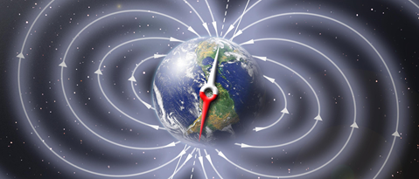

**MODULE 4.2**

**MAGNETISM**

**THE EARTH’S**

**MAGNETIC FIELD**

The Earth's magnetic field is due to currents that flow in the outer core of the earth. The outer core is a region of molten iron that extends from the surface of the solid inner core (radius 1200 km) out to a radius of about 3500 km. (The radius of the Earth is 6370 km.) The mechanism for the generation of these currents, called the geodynamo, is likely to involve gravitational, thermal and rotational effects, at present it is poorly understood.

The Earth's magnetic field is similar to that of a **magnetic dipole** - the field produced by a bar magnet or short solenoid. If this dipole moment were due to a single loop of current at a radius about half way across the outer core, the magnitude of the current would be about 5 GA (1 GA = 109 A). The magnetic field lines pass out through the surface of the Earth in the southern hemisphere and re-enter in the northern hemisphere. So, the direction of the magnetic at the surface of the Earth varies from horizontal near the equator to vertical near the poles. At any position on the Earth, the magnitude of the magnetic field decreases with altitude as the inverse cube of distance from the centre of the earth. At the surface of the Earth, the magnitude is approximately 50 μT.

Reference: <https://en.wikipedia.org/wiki/Earth%27s_magnetic_field>

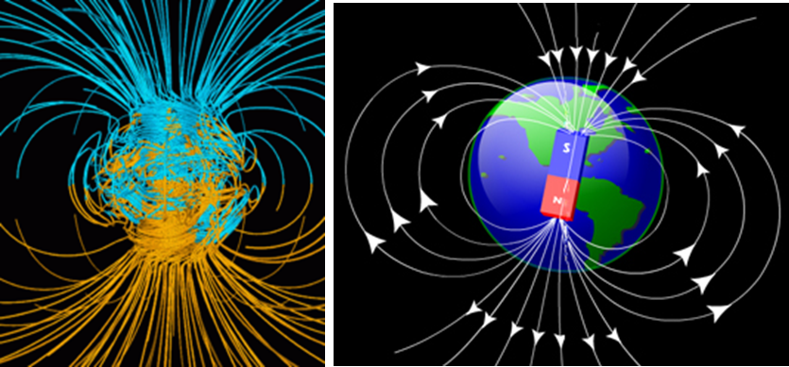

Computer simulation of the Earth's magnetic field. The lines represent magnetic field lines, blue when the field points towards the centre and yellow when away. The dense clusters of lines are within the Earth's core. The rotation axis of the Earth is centred and vertical and the axis of dipole magnetic field is currently tilted at an angle of about 11 degrees with respect to Earth's rotational axis The North geomagnetic pole, located near Greenland in the northern hemisphere, is actually the south pole of the Earth's magnetic field, and the South geomagnetic pole is the north pole.

The axis of the Earth’s magnetic dipole does not coincide closely with the rotation axis of the Earth and furthermore its direction varies over time. There is strong evidence from the magnetisation direction of the ocean crust formed from magma welling up along the mid-Atlantic ridge that the direction of the Earth’s magnetic field has reversed many times over the last 160 million years. During the last 10 million years, the Earth’s field has reversed polarity every 500 000 years or so with the duration of polarity changes lasting tens of thousands of years, the last reversal occurred about 700 000 years ago.

While the North and South magnetic poles are usually located near the geographic poles, they can wander widely over geological time scales, but sufficiently slowly for ordinary compasses to remain useful for navigation.

The magnetosphere is the region above the ionosphere that is defined by the extent of the Earth's magnetic field in space. It extends several tens of thousands of kilometres into space, protecting the Earth from the charged particles of the solar wind and cosmic rays that would otherwise strip away the upper atmosphere, including the ozone layer that protects the Earth from harmful ultraviolet radiation.

**Dancing Lights: Auroras**

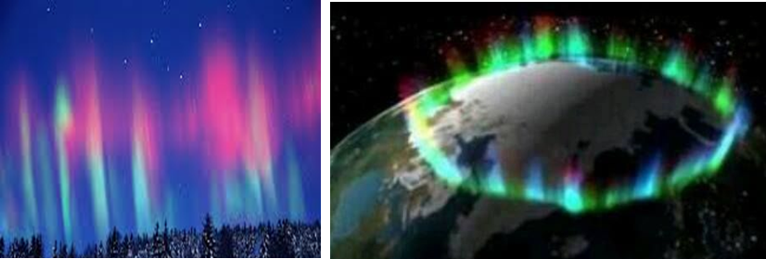

The bright dancing lights of the aurora are actually collisions between electrically charged particles from the Sun that enter the Earth's atmosphere. The lights are seen above the magnetic poles of the northern and southern hemispheres. They are known as 'Aurora borealis' in the north and 'Aurora australis' in the south. The lights are observed near the poles because the charged particles are accelerated to high energies by the **Earth’s magnetic field** which is strongest in the polar regions. The highly energic charged particles have sufficient energy to excite atmospheric molecules.

Aurora displays appear in many colours although pale green and pink are the most common. Shades of red, yellow, green, blue, and violet have been reported. The lights appear in many forms from patches or scattered clouds of light to streamers, arcs, rippling curtains or shooting rays that light up the sky with an eerie glow. Variations in colour are due to the type of gas particles that are colliding. The most common auroral colour, a pale yellowish-green, is produced by oxygen molecules located about 80 km above the earth. Rare, all-red auroras are produced by high-altitude oxygen, at heights of up to 300 km miles. Nitrogen produces blue or purplish-red aurora.

[View movies](https://en.wikipedia.org/wiki/Aurora)

[VISUAL PHYSICS ONLINE](http://www.physics.usyd.edu.au/teach_res/hsp/sp/spHome.htm)

If you have any feedback, comments, suggestions or corrections please email Ian Cooper

ian.cooper@sydney.edu.au

Ian Cooper School of Physics University of Sydney