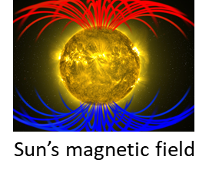[**VISUAL PHYSICS ONLINE**](http://www.physics.usyd.edu.au/teach_res/hsp/sp/spHome.htm)

**MODULE 4.2**

**MAGNETISM**

**MAGNETIC PROPERTIES OF MATERIALS**

If we try to magnetize samples of brass, iron, glass, etc, in a current-carrying solenoid, only some materials show any magnetic effect. Some substances such as liquid oxygen and some iron compounds are slightly magnetic but, most substances are non-magnetic. Non-magnetic substances cannot be magnetized, while a magnetic substance such as iron is called a magnet when magnetized. A few materials such as iron exhibit huge magnetic effects and can made into a permanent magnet.

The magnetic properties of materials are related to the behaviour of groups of atoms of the material called **domains**.

We know that a magnetic field exists when there is a current. A simple example is a current loop which has a magnetic field like a bar magnet.

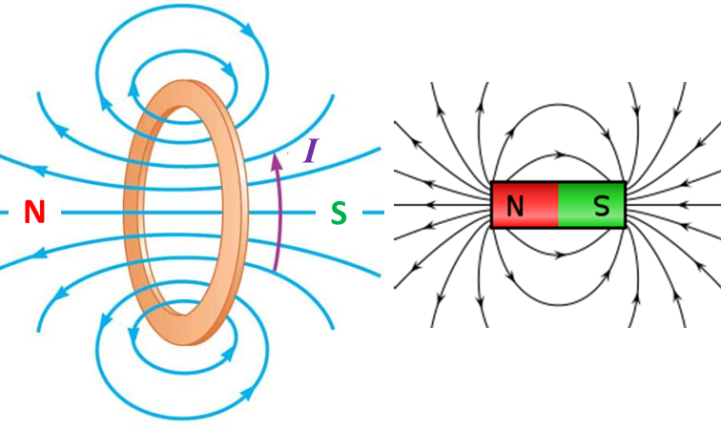

A model of an electron in an atom (not a “real-life” picture, but a mathematical picture) is that they have an orbital motion and a spin motion. Since the electron is charged, the electron has magnetic properties due to the orbital and spin motions.

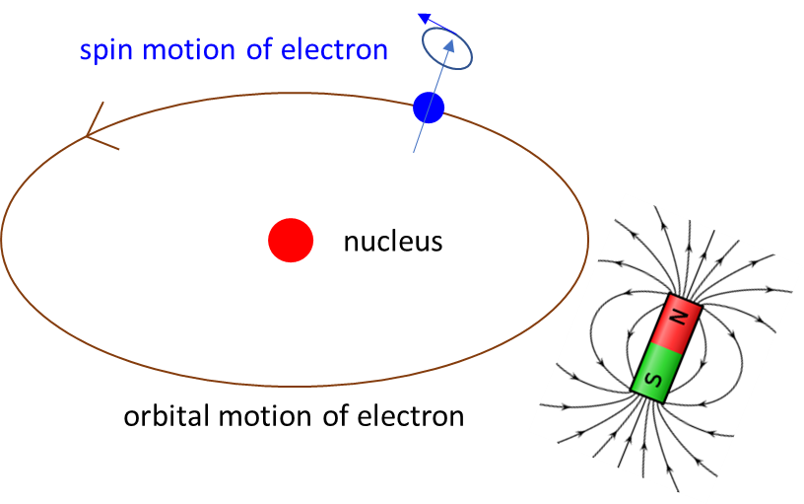

The magnetic properties of an atom depend upon how the magnetic effects of the individual electrons add. So, the magnetic properties of a material depend upon the magnetic properties of the electron and hence on the magnetic properties of the individual atoms of a material. For most materials, the magnetic effect of all the atoms cancel and the material is said to be non-magnetic.

Some materials which are called **ferromagnetic**, the magnetic effects of the atoms do not cancel but reinforce each other in regions called **domains**. Each domain behaves like a tiny bar magnet and the alignment of these “atomic magnets” for a domain is represented by an arrow pointing from the south-pole to the north-pole. The microscopic examination of a magnet shows these domains which are at most 1 mm in length or width.

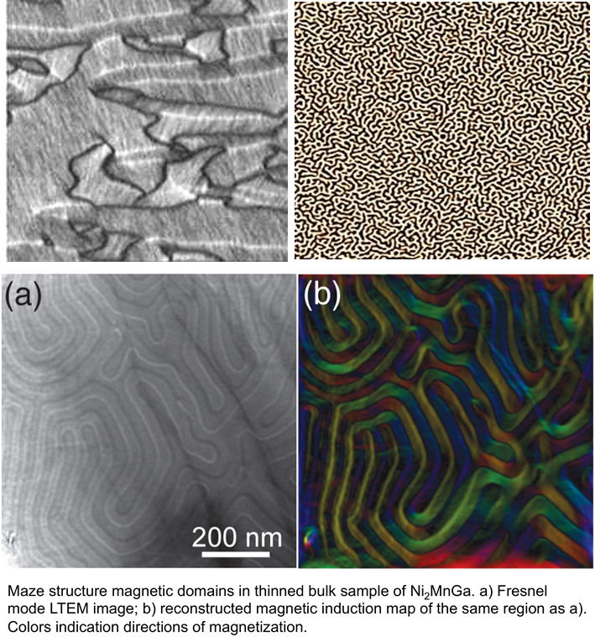

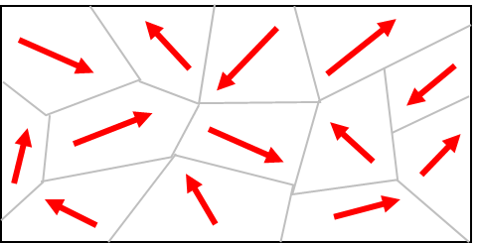In an unmagnetized piece of iron, these domains are arranged randomly and the magnetic effects of the domains cancel each other out.

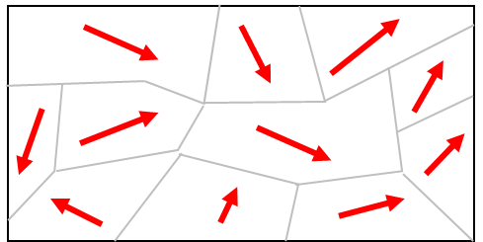

Greater alignment of the magnetic domains makes the material slightly magnetic with some increase in domain size.

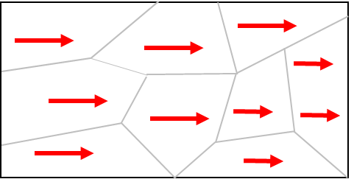**Saturation**: all the domains are aligned to give a magnet with the greatest strength. Further increase in the size of some domains.

The magnetic effect of the material is called the **magnetization**. As the magnetization increases, the greater the alignment of the domains and the domains grow in size.

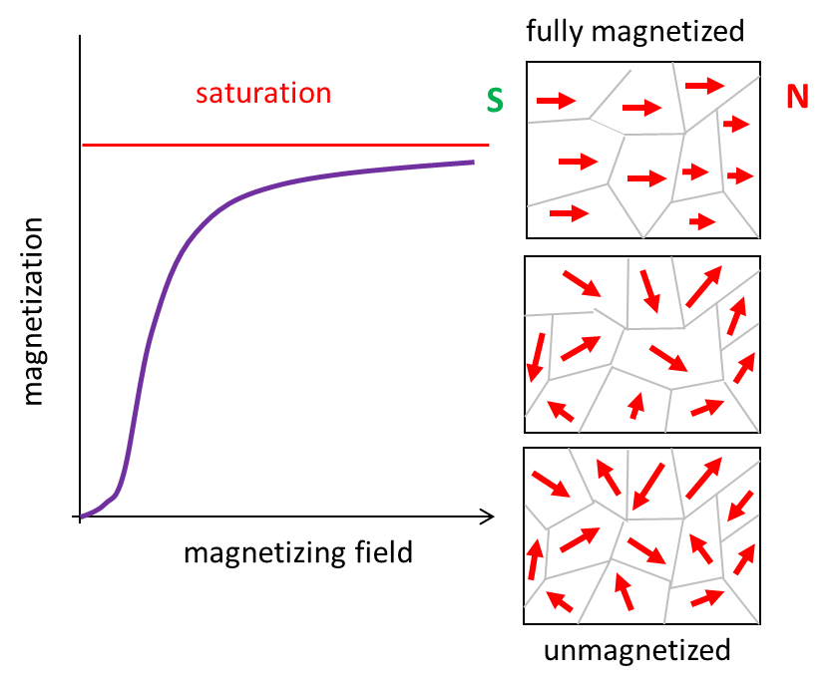

With this simple model of domains for ferromagnetic materials, we can explain many of the properties of magnets.

1. It explains the appearance of new poles when we break a magnet into smaller and smaller pieces.

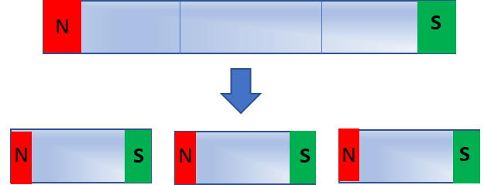

1. It explains why a non-magnetized piece of iron can become a magnet by stroking it with a magnet. The stroking bar results in a greater alignment of the domains.

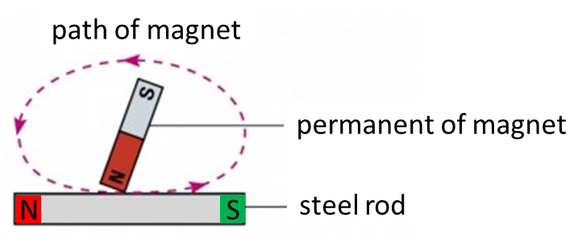

1. It explains why a no-magnetized piece of iron can become a magnet by placing it into a current carrying solenoid. The current through the solenoid produces a magnetic field directed along the axis of the solenoid. This magnetic field is responsible for increasing the magnetization of the iron as domains grow in size and align along the solenoid’s axis.

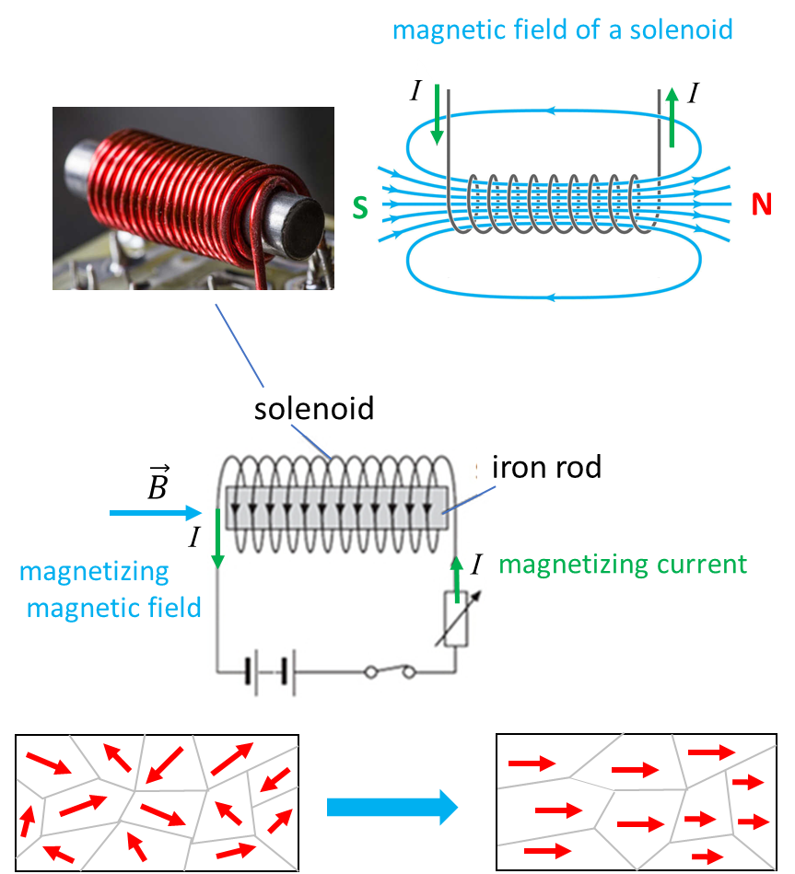

1. If the iron that was magnetized remains magnetized for a long time, it is called a permanent magnet. Due to thermal motion of the atoms within the iron, the domains will lose their alignment and the iron will become less magnetic. If you hit a magnet with a hammer or drop it on the floor, you may jar the domains into randomness and the magnet may lose some or all of its magnetism. Heating a magnet too can cause a loss of magnetization, for increasing the temperature, increases the random thermal motion of the atoms which tends to randomize the domains. Above a certain temperature, called the **Curie temperature** (1034 K for iron), the iron will be fully non-magnetic.

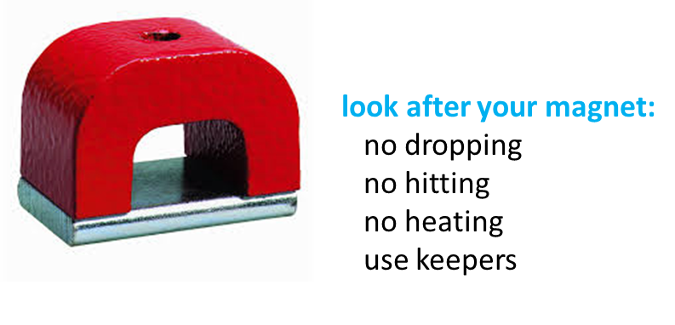

1. Preserving magnets – how to prevent them from losing their magnetization: Horseshoe magnets are often provided with keepers – a soft iron bar which bridges the poles. Bar magnets are often stored in pairs with soft iron keepers. The soft iron keepers become temporarily magnetized in such a way that there is a closed ring which helps keep the domains aligned.

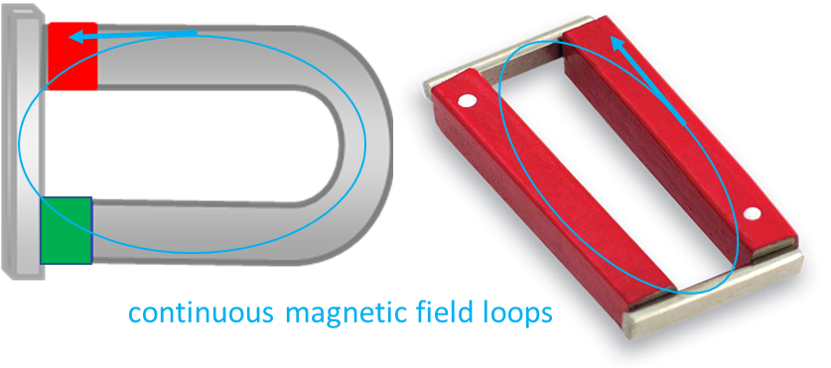

1. So, far we have said that a magnet has a north-pole and a south-pole. **Can we magnetize a ring of iron?** With no theory to support you, you may conclude that it is **not** possible to make a ring magnet because there would be no poles – no poles no magnet. However, using our domain theory, you can see that is possible to magnetize the ring – the “atomic magnets can be arranged heat-to-tail around the ring. **A theory enables us to understand what would otherwise be incomprehensible.**

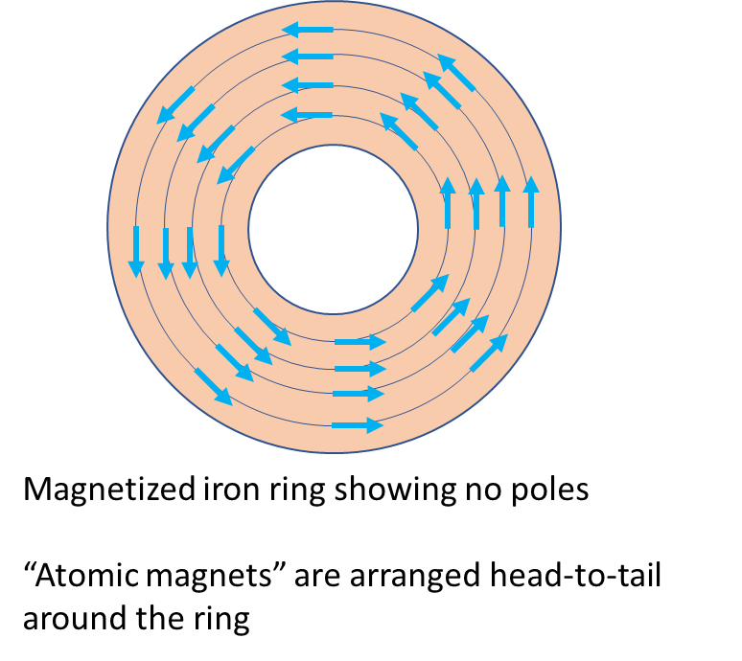

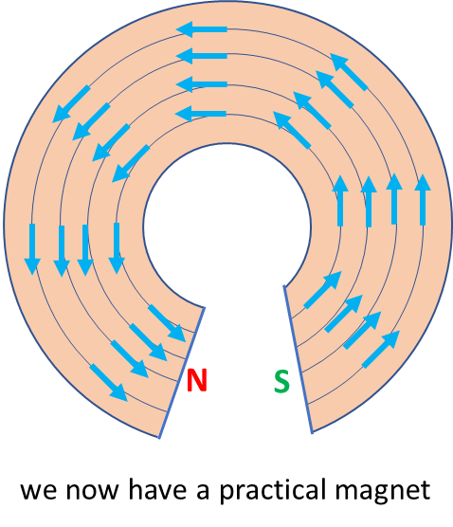

[VISUAL PHYSICS ONLINE](http://www.physics.usyd.edu.au/teach_res/hsp/sp/spHome.htm)

If you have any feedback, comments, suggestions or corrections please email Ian Cooper

ian.cooper@sydney.edu.au

Ian Cooper School of Physics University of Sydney