[VISUAL PHYSICS ONLINE](http://www.physics.usyd.edu.au/teach_res/hsp/sp/spHome.htm)

PRACTICAL ACTIVITY

**HOW DO THE PANETS MOVE?**

One of the most important questions historically in Physics was how the planets move. Many historians consider the field of Physics to date from the work of Newton, and the motion of the planets was the principle problem Newton set out to solve. In the process of doing this, he not only introduced his laws of motion and discovered the law of gravity, he also developed differential and integral calculus.

Today, the same law that governs the motion of planets, is used by scientists to put satellites into orbit around the Earth and to send spacecraft through the solar system.

How the planets move is determined by gravitational forces. The forces of gravity are the only forces applied to the planets. The gravitational forces between the planets are very small compared with the force due to the Sun since the mass of the planets are much less than the Sun's mass. Each planet moves almost the way the gravitational force of the Sun alone dictates, as though the other planets did not exist.

The motion of a planet is governed by the Law of Universal Gravitation

*F* = *G* *M*S *m* / *r*2

where *G* is the Universal Gravitational Constant, *M*S is the mass of the Sun, *m* is the mass of the planet and *r* is the distance from the Sun to the planet.

*G* = 6.67×10-11 N.m2.kg2

*M*S = 2.0×1030 kg

Historically, the laws of planetary motion were discovered by the outstanding German astronomer Johannes Kepler (1571-1630) on the basis of almost 20 years of processing astronomical data, before Newton and without the aid of the law of gravitation.

## Kepler's Laws of Planetary Motion

1 The path of each planet around the Sun is an ellipse with the Sun at one focus.

2 Each planet moves so that all imaginary lines drawn from the Sun to the planet sweeps out equal areas in equal periods of time.

3 The ratio of the squares of the periods of revolution of planets is equal to the ratio of the cubes of their orbital radii (mean distance from the Sun or length of semimajor axis, *a*)



## Kepler’s First Law

A planet describes an ellipse with the Sun at one focus. But what kind of an ellipse do planets describe? It turns out they are very close to circles. The path of the planet nearest the Sun, Mercury, differs most from a circle, but even in this case, the longest diameter is only 2% greater than the shortest one. Bodies other than the planets, for example, comets move around the Sun in greatly flattened ellipses.

Since the Sun is located at one of the foci and not the centre, the distance from the planet to the Sun changes more noticeably. The point nearest the Sun is called the perihelion and the farthest point from the Sun is the aphelion. Half the distance from the perihelion to the aphelion is known as the semimajor radius, *a*. The other radius of the ellipse is the semiminor radius, *b*.

### **The Path of a Planet Around the Sun is an Ellipse**

*x*2 / *a*2 + *y*2 / *b*2 = 1

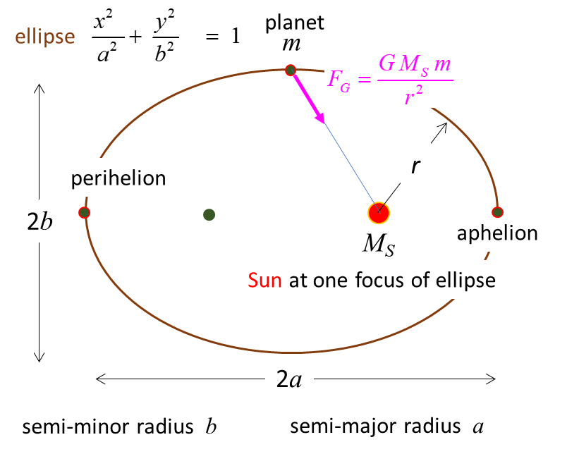

## Kepler's Second Law

Each planet moves so that an imaginary line drawn from the Sun to the planet sweeps out equal areas in equal periods of time. This law results from the Law of Conservation of Angular Momentum

Angular momentum = *L* = *m v r* = constant

where *m* is the mass of the planet, *r* is the distance from the Sun and *v* is the tangential velocity of the planet.

Angular momentum is conserved because the force acting on the orbital body is always directed towards the centre of the coordinate system (0,0), i.e., the Sun. Thus, this force cannot exert a torque (twist) on the orbiting body. Since there is zero torque acting, the orbital angular momentum must remain constant.

Since a planet moves in an elliptical orbit, the distance *r* is continually changing. As it approaches nearer the Sun the planet must speed up and as it gets further away from the Sun it must slow down such that the product

*v r* = constant.

The area of each triangle (for a small time interval d*t*) can be expressed as

*A*l = ½ (*v*l d*t*) *r*l *A*2 = ½ (*v*2 d*t*) *r*2 *A*1 / *A*2 = *v*l *r*l / *v*2 *r*2

Since angular momentum must be conserved, *L* = *m* *v*1 *r*l = *m* *v*2 *r*2

*A*1 / *A*2 = 1

Therefore, in equal time intervals, equal areas are swept out.

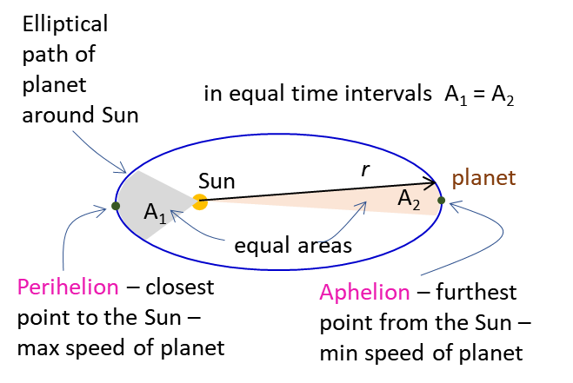

## Kepler's Third Law

For an orbiting planet, the centripetal force results from the gravitational attraction between the planet and the Sun

Centripetal force = Gravitational force

*m v*2 / *a* = *G M*S *m* / *a*2

*v*2 = *G M*S / *a*

*v* = *a* ω, ω = 2 π *f* = 2 π / *T*

*v*2 = (4 π2 / *T*2 ) *a*2 = *G M*S / *a*



**Activity Testing Kepler's Third Law**

What is the relationship between a planet's period and its mean distance from the Sun? (A planet's mean distance from the Sun is equal to its semimajor radius).

Kepler had been searching for a relationship between a planet's period and its mean distance from the Sun since his youth. Without such a relationship, the universe would make no sense to him. If the Sun had the "power" to govern a planet's motions, then that motion must somehow depend on the distance between the planet and Sun, BUT HOW?

By analysing the planetary data for the period and mean distance from the

Sun, can you find the relationship?

**Planet Mean Distance from Period**

**Sun *a* (m) *T* (s)**

Mercury 5.79×l010 7.60×106

Venus 1.08×1011 1.94×107

Earth 1.496×1011 3.156×107

Mars 2.28×1011 5.94×107

Jupiter 7.78×1011 3.74×108

Saturn 1.43×1012 9.35×l08

Uranus 2.86×1012 2.64×109

Neptune 4.52×1012 5.22×109

Pluto 5.90×1012 7.82×109

From laboratory experiments it is possible to find a value for the Universal Gravitational Constant. Its value is

*G* = 6.67×10-11 N.m2.kg2

Draw the following graphs:

X axis Y axis

 

 

 

 

Hence, determine the mass of the Sun *M*S.

You can draw the graphs by hand or better, enter and plot the graphs in MS EXCEL.

**Answers**

MS EXCEL used for the data analysis

Kepler’s Third law may be written in the form *T* = *k an* where the constants *k* and *n* can be determined by analysing the data.

The data of the mean distance from the Sun and the corresponding period for each planet is plotted as a linear graph and the trendline (power) is fitted to the data. The equation of the fitted curve is

*T* = 5.1×10-10 *a*1.50 (correlation coefficient = 1)

*n* = 1.5 = 3/2

*k* = 5.51×10-10 s

From the *k* value the mass of the Sun is

*M*S = 1.95×1030 kg

|  |
| --- |
|  |

A straight-line graph can be obtained by plotting log(*T*) against log(*a*). A trendline (straight line) can be fitted to the graph and the linest command in MS EXCEL can be used to determine the slope and intercept of the fitted line plus the uncertainties in the slope and intercept. The values are

*n* = (1.4996 ± 0.0004)

*k* = (5.51 ± 0.06) ×10-10 s

*M*S = (1.95 ± 0.04) ×1030 kg

The accepted value for the mass of the Sun is 1.987×1010 kg. So we get excellent agreement between the accepted value for the mass of the Sun and the value from processing the measurements on the movement of the planets.

|  |  |  |  |  |  |  |  |
| --- | --- | --- | --- | --- | --- | --- | --- |
|  | | | | | | | |
|  |  |  |  |  |  |  |  |
| **Testing Kepler's Third Law** | | | ***T* =  *k a*n** |  |  |  |  |
|  |  |  |  |  |  |  |  |
| **Planet** | **Mean distance from Sun *a* (m)** | **Period *T* (s)** |  | **log(a)** | **log(*T*)** |  |  |
| Mercury | 5.79E+10 | 7.60E+06 |  | 10.76 | 6.88 |  |  |
| Venus | 1.08E+11 | 1.94E+07 |  | 11.03 | 7.29 |  |  |
| Earth | 1.50E+11 | 3.16E+07 |  | 11.17 | 7.50 |  |  |
| Mars | 2.28E+11 | 5.94E+07 |  | 11.36 | 7.77 |  |  |
| Jupiter | 7.78E+11 | 3.74E+08 |  | 11.89 | 8.57 |  |  |
| Saturn | 1.43E+12 | 9.35E+08 |  | 12.16 | 8.97 |  |  |
| Uranus | 2.86E+12 | 2.64E+09 |  | 12.46 | 9.42 |  |  |
| Nepture | 4.52E+12 | 5.22E+09 |  | 12.66 | 9.72 |  |  |
| Pluto | 5.90E+12 | 7.82E+09 |  | 12.77 | 9.89 |  |  |

|  |  |  |  |  |  |  |  |
| --- | --- | --- | --- | --- | --- | --- | --- |
|  |  |  |  |  |  |  |  |
| Trendline - power | |  |  | Linest - curve fitting | |  |  |
| n = | 1.500 |  | n = | 1.4996 | -9.25894 | = log(k) |  |
| *k* = | 5.51E-10 | s | Δn = | 0.0004 | 0.004627 | = Δ log(k) |  |
|  |  |  |  | 1 | 0.000829 |  |  |
| Mass of Sun | |  | Δn / n % = | 0.03 |  |  |  |
| *G* = | 6.67E-11 | N.m2.kg-2 |  |  |  |  |  |
| *M*S  = | 4 π2(/*k*2 *G*) |  | k = | 5.51E-10 | kmax = | 5.57E-10 | s |
| *M*S  = | 1.95E+30 | kg |  |  | kmin = | 5.45E-10 | s |
|  |  |  |  |  |  |  |  |
|  |  |  | *M*S  = | 4π2(/*k*2 *G*) | |  |  |
|  |  |  | *M*S  = | 1.95E+30 | kg |  |  |
|  |  |  | min *M*S  = | 1.99E+30 | kg |  |  |
|  |  |  | max *M*S  = | 1.91E+30 | kg |  |  |

The following plots were done in Matlab. From any of the straight line plots you can calculate the slope and then the mass of the Sun.

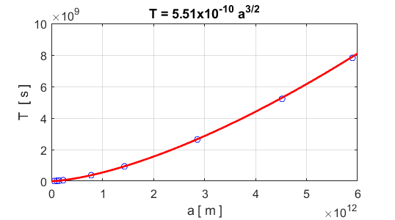

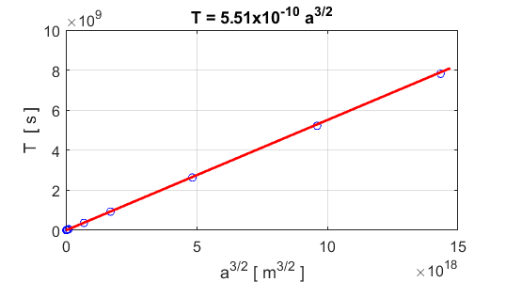

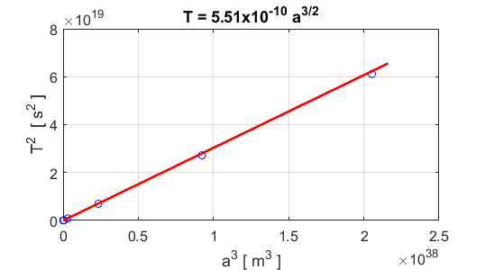

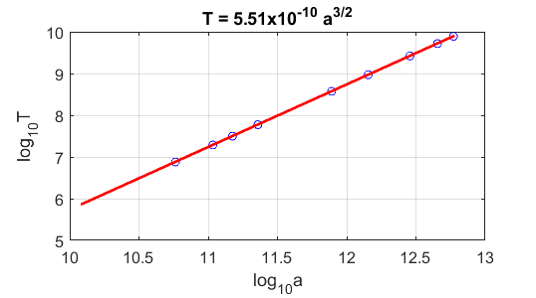

**From each of the graphs you see the excellent agreement of the motion of the planets as described by Kepler’s Third Law.**

**VISUAL PHYSICS ONLINE**

<http://www.physics.usyd.edu.au/teach_res/hsp/sp/spHome.htm>

If you have any feedback, comments, suggestions or corrections please email:

ian.cooper@sydney.edu.au

Ian Cooper School of Physics University of Sydney