[VISUAL PHYSICS ONLINE](http://www.physics.usyd.edu.au/teach_res/hsp/sp/spHome.htm)

EXCEL SIMULATION

**MOTION OF SATELLITES**

DOWNLOAD the MS EXCEL program [**PA50satellite.xls**](http://www.physics.usyd.edu.au/teach_res/hsp/sp/mod5/)**x**

and view the worksheet **Display** as shown in the figure below.

One of the most important questions historically in Physics was how the planets move. Many historians consider the field of Physics to date from the work of Newton, and the motion of the planets was the principle problem Newton set out to solve. In the process of doing this, he not only introduced his laws of motion and discovered the law of gravity, he also developed differential and integral calculus.

Today, the same law that governs the motion of planets, is used by scientists to put satellites into orbit around the Earth and to send spacecraft through the solar system.

How the planets or satellites move is determined by gravitational forces. The forces of gravity are the only forces applied to the planets. The gravitational forces between the planets are very small compared with the force due to the Sun since the mass of the planets are much less than the Sun's mass. Each planet moves almost the way the gravitational force of the Sun alone dictates, as though the other planets did not exist.

The motion of a planet is governed by the Law of Universal Gravitation

*F* = *G* *M*S *m* / *r*2

where *G* is the Universal Gravitational Constant, *M*S is the mass of the Sun, *m* is the mass of the planet and *r* is the distance from the Sun to the planet.

*G* = 6.67×10-11 N.m2.kg2

*M*S = 2.0×1030 kg

Historically, the laws of planetary motion were discovered by the outstanding German astronomer Johannes Kepler (1571-1630) on the basis of almost 20 years of processing astronomical data, before Newton and without the aid of the law of gravitation.

## Kepler's Laws of Planetary Motion

1 The path of each planet around the Sun is an ellipse with the Sun at one focus.

2 Each planet moves so that all imaginary lines drawn from the Sun to the planet sweeps out equal areas in equal periods of time.

3 The ratio of the squares of the periods of revolution of planets is equal to the ratio of the cubes of their orbital radii (mean distance from the Sun or length of semimajor axis, *a*)



## Kepler’s First Law

A planet describes an ellipse with the Sun at one focus. But what kind of an ellipse do planets describe? It turns out they are very close to circles. The path of the planet nearest the Sun, Mercury, differs most from a circle, but even in this case, the longest diameter is only 2% greater than the shortest one. Bodies other than the planets, for example, comets move around the Sun in greatly flattened ellipses.

Since the Sun is located at one of the foci and not the centre, the distance from the planet to the Sun changes more noticeably. The point nearest the Sun is called the perihelion and the farthest point from the Sun is the aphelion. Half the distance from the perihelion to the aphelion is known as the semimajor radius, *a*. The other radius of the ellipse is the semiminor radius, *b*.

### **The Path of a Planet Around the Sun is an Ellipse**

*x*2 / *a*2 + *y*2 / *b*2 = 1

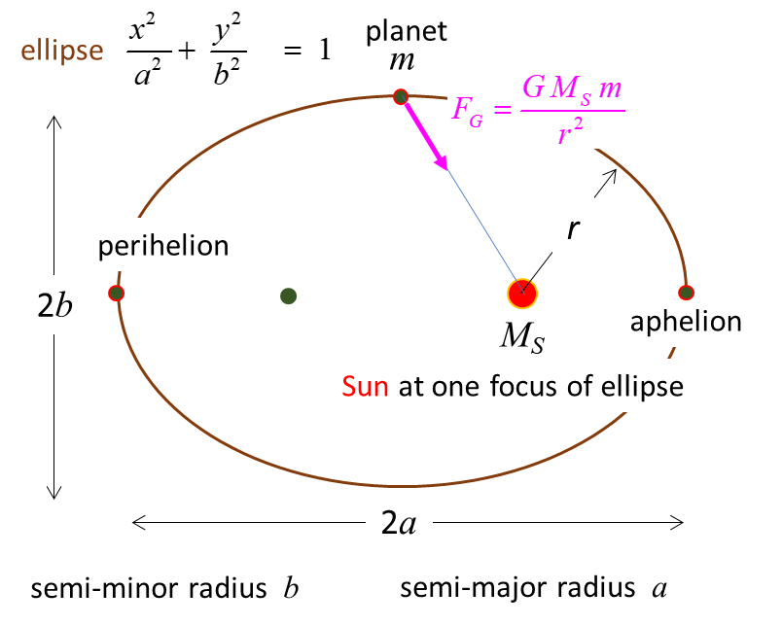

## Kepler's Second Law

Each planet moves so that an imaginary line drawn from the Sun to the planet sweeps out equal areas in equal periods of time. This law results from the Law of Conservation of Angular Momentum

Angular momentum = *L* = *m v r* = constant

where *m* is the mass of the planet, *r* is the distance from the Sun and *v* is the tangential velocity of the planet.

Angular momentum is conserved because the force acting on the orbital body is always directed towards the centre of the coordinate system (0,0), i.e., the Sun. Thus, this force cannot exert a torque (twist) on the orbiting body. Since there is zero torque acting, the orbital angular momentum must remain constant.

Since a planet moves in an elliptical orbit, the distance *r* is continually changing. As it approaches nearer the Sun the planet must speed up and as it gets further away from the Sun it must slow down such that the product

*v r* = constant.

The area of each triangle (for a small time interval d*t*) can be expressed as

*A*l = ½ (*v*l d*t*) *r*l *A*2 = ½ (*v*2 d*t*) *r*2 *A*1 / *A*2 = *v*l *r*l / *v*2 *r*2

Since angular momentum must be conserved, *L* = *m* *v*1 *r*l = *m* *v*2 *r*2

*A*1 / *A*2 = 1

Therefore, in equal time intervals, equal areas are swept out.

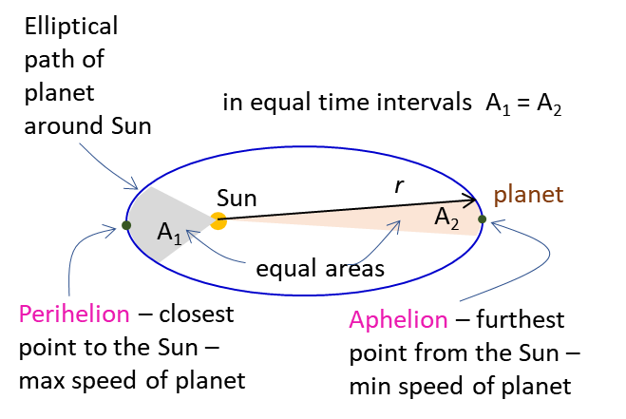

## Kepler's Third Law

For an orbiting planet, the centripetal force results from the gravitational attraction between the planet and the Sun

Centripetal force = Gravitational force

*m v*2 / *a* = *G M*S *m* / *a*2

*v*2 = *G M*S / *a*

*v* = *a* ω, ω = 2 π *f* = 2 π / *T*

*v*2 = (4 π2 / *T*2 ) *a*2 = *G M*S / *a*



We can also apply these laws to the motion of satellites around the Earth if we can ignore any frictional forces acting on the satellite.

In our EXCEL simulation, we are going to model the motion of a satellite given an initial velocity by firing a rocket for a very small time interval and calculating its resulting trajectory.

**SIMULATION MOTION OF A SATELLITE**

DOWNLOAD the MS EXCEL program [**PA50satellite.xls**](http://www.physics.usyd.edu.au/teach_res/hsp/sp/mod5/)**x**

and view the worksheet **Display** as shown in the figure below.

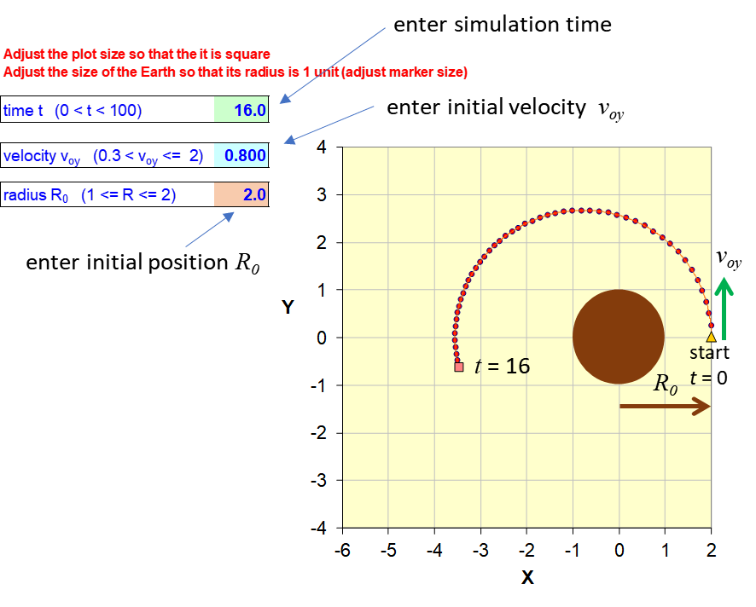

The EXCEL Worksheet is used for a simulation of the motion of a satellite around the Earth. To simplify the calculations, the product *GM*E and the radius of the Earth *RE* are set to one . The location of the Earth is at the Origin (0,0) and corresponds to a focus point of the ellipse.

You can change three parameters in our model by entering their values into one of three cells.

* The simulation time *t*. Always start the simulation with a low value for *t* and slowly increment its value. Often, you need to find *t* so that the simulation time is equal to the period *T* of the orbit.
* The initial velocity of the satellite *v0y*. The satellite is always launched with an initial velocity which only has a Y component .
* The initial position of the satellite *R0*:

initial x position, *x*o = *R0* 

initial y position, *y*o = 0

**EXPLORATIONS**

**1**

Basically, there are three types of trajectories for the motion of the satellite. **Predict** what are the three trajectories.

Vary the input parameters and observe the graphical output so that you become familiar with using the Worksheet. **Observe**: can you identify the three trajectories**. Explain** any discrepancies between your predictions and observations.

**2**

Given that  show that

(1) Orbital velocity for a circular orbit 

(2) Escape velocity 

(3) Kepler’s 3rd Law 

Enter these formula into the indicated Cells in the Worksheet.

**3** **Circular orbits**

**3.1** Select three values of *R0* from 1 to 2 and vary the initial velocity  to obtain circular orbits. Do the numerical results you obtain for  agree with the predictions of equation 1? In each case vary the time interval for the simulation to show one orbit. Do your time intervals agree with the predictions of equation 3?

**3.2** From the spacing of the dots marking the trajectory, what can you conclude about the velocity of the satellite?

(The dots are plotted at equal time intervals).

**3.3** Calculate the circumference of the orbit. Hence, calculate the orbital velocity from your measurements of the circumference and period. Does your value agree with the other predictions for the orbital velocity?

**4** **Elliptical orbits**

**4.1** Start with  and set  so that you get a circular orbit. **Predict** the shape of the orbit as you increase the value of  and then decrease its value. **Observe** the resulting plots of the trajectory and **explain** any discrepancies between your observations and predictions.

Set the input parameters so that you get one orbital for a non-circular elliptical trajectory.

**4.2** From the plot of the trajectory. Test that the orbit is actually an ellipse. An ellipse satisfies the condition that the sum of the distances from any point on it to the two foci is a constant. Trace the trajectory onto a piece of paper to make the distance measurements from two points on the trajectory.

Is Kepler's First Law obeyed for each of the above initial conditions? Explain your answer.

**4.3** What is the significance of the spacing of the dots showing the trajectory of the planet? Comment on the velocity of a planet for an elliptical orbit.

From the numerical results, what are the maximum and minimum velocities? where is the planet moving most rapidly? What is this point called? Where is the planet moving most slowly? What is this point called? (View calculations Worksheet).

Is Kepler's Second Law satisfied? (View calculations Worksheet).

**4.4** Measure the semimajor radius *a* of the ellipse. Hence, calculate the period. Does the value agree with the simulation value of the period?

Is Kepler’s Third Law satisfied?

**4.5** What is the direction of the force on the satellite at each point in its trajectory?

**5 Satellite crashes to Earth**

Input 

Predict what will happen if you enter . Observe and explain your predications and observations.

Find the smallest value of  so that the satellite will just orbit the Earth and not crash.

**6 Satellite escape Earth’s gravitational field**

For  calculate the escape velocities. Confirm your calculations with the trajectories of the satellite. When the satellite is far from the Earth, what can you conclude about the satellite’s velocity?

**Answers**

**1**

The satellite can

1. Crash into the Earth.
2. Orbit the Earth in an elliptical path (a circle is a special case of an ellipse).
3. Escape from the Earth’s gravitational field.

**3.2**



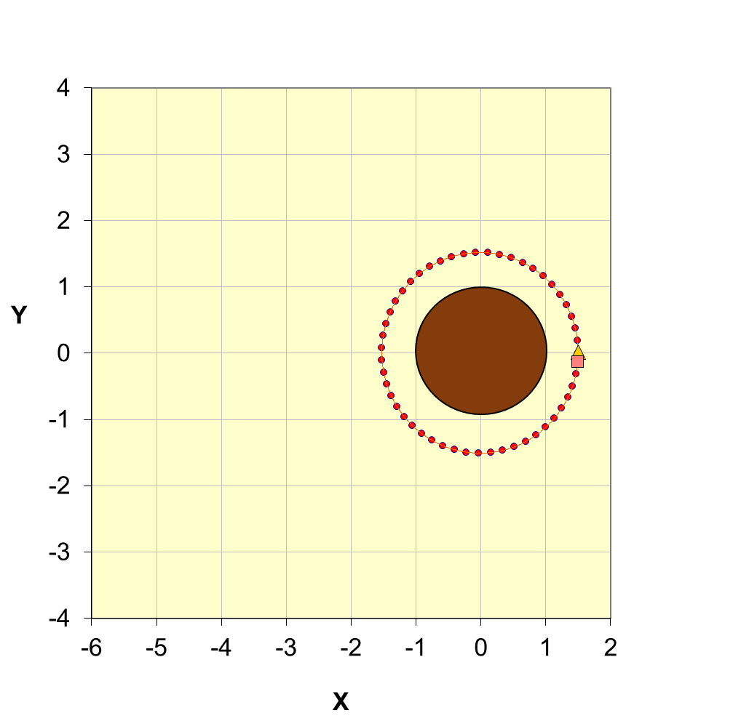

**3.3** The spacing of the dots is uniform, hence, we can conclude that the magnitude of the velocity is constant, but it is accelerating since it is always changing direction.

Circumference *C* = 9.42  

Excellent agreement between numerical results from graph and the theoretical predictions from the equations.

**4**

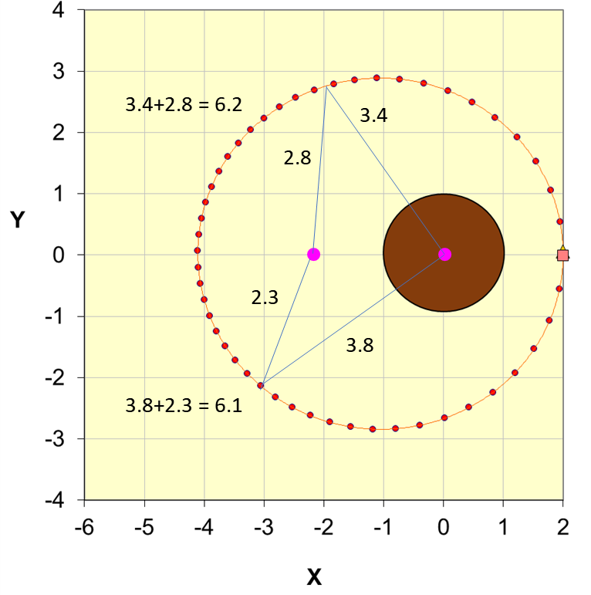



**4.2** An ellipse satisfies the condition that the sum of the distances, *d* from any point on it to the two foci is a constant. We can conclude that with the inputs used, Kepler’s 1st Law is satisfied – the trajectory of the satellite is an ellipse. Kepler's First Law is not obeyed for all initial conditions. If the satellite is moving just at the right speed, the orbit is circular. If the satellite initially is moving slightly more rapidly, then the orbit will be elliptical with the trajectory outside that of the circular orbit. If the satellite initially is moving slightly more slowly, then the orbit will be elliptical with the trajectory inside that of the circular orbit. If the satellite is initially moving too rapidly, it escapes from the Earth and if too slowly it crashes into the Earth’s surface.

**4.3**

The spacing of the dot is a measure of the average speed of the satellite at that location. The dots are equally spaced for the circular orbit. For a non-circular elliptical orbit, the spacing of the dots is not regular. As the satellite approaches the perihelion (closest point of the satellite to the Earth) the dots are widely spaced. This indicates a large speed compared to when the planet approaches the aphelion (furthest point of the satellite from the Earth) where the dots are closely spaced and the speed is smaller.

From the numerical, the product  is essentially constant, indicating conservation of angular momentum and hence equal areas swept out in equal time intervals. So, Kepler’s 2nd Law is satisfied.

( Worksheet calculations, column K **L(t) = v(t)*r(t)** )

**4.4**



Kepler’s 3rd Law is satisfied



**4.5**

The direction of the force on the satellite is always directed to the centre of the coordinate system (0,0) i.e., to the Earth that is located at one of the foci of the ellipse.

**5 Satellite crashes**

If  the satellite falls in a straight line and crashes into the Earth’s surface. If  the satellite moves in a parabolic path before crashing into the surface of the Earth.

**6 Satellite escapes**

The initial speed of the satellite is so large the gravitational force cannot bend the trajectory into a bound orbit. The satellite escapes on a path approaching a straight line and with a speed that approaches a constant value as it gets further from the Earth. This happens because the force acting between the two bodies decreases rapidly as their separation increases, so that before long the moving body has effectively escaped the influence of that force.

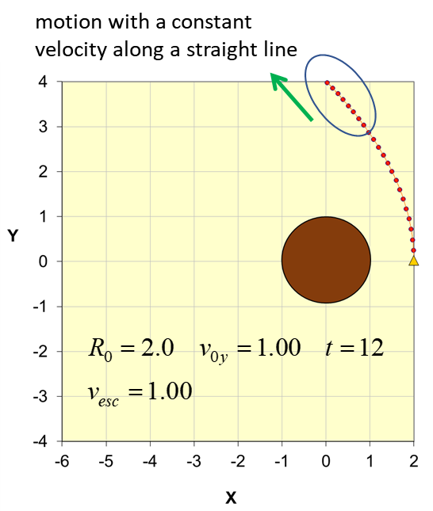

**Appendix**

**Numerical Method for calculating the trajectory**

Newton’s Second Law *F*(*t*) = *m* d2*x*(*t*)/d*t*2 (A1)

can be solved numerically to find the position of the particle as a function of time. In this numerical method, approximations to the first and second derivatives are made. Consider a single-valued continued function ψ(*t*) that is evaluated at *N* equally spaced points *x*1, *x*2, …, *x*N. The first and second derivatives of the function ψ(*t*) at the time tc where c is an index integer, c = 1, 2, 3, …, N are given by Eqs. (A2) and (A3) respectively. The time interval is Δ*t* = *t*c+1 – *t*c.

 (A2)

. (A3)

To start the calculation one needs to input the initial conditions for the first two time steps.

The force acting on the planet is given by the Law of Universal Gravitation and therefore, the equation of motion of the planet is

*m a* = - *G M*S *m* / *r*2

Thus, the acceleration in vector form is

**a** = - (*G M*S / *r*3) **r**

Squaring both sides ⇒ *a*2 = (*GM*S / *r*3)2 *r*2 = (*GM*S / *r*3)2 (*x*2 + *y*2)

Therefore, the x and y components of the acceleration are

*a*x = - (*GMS* / *r*3) *x* *a*y = - (*GM*S / *r*3) *y*

Using eq (A3) we can approximation the position of the planet by

*x*(*t* + Δ*t*) = -2Δ*t* *GM*S *x*(*t*) / {*x*(*t*)2 + *y*(*t*)2}3/2 + 2*x*(*t*) – *x*(*t* - Δ*t*)

*y*(*t* + Δ*t*) = -2Δ*t* *GM*S *y*(*t*) / {*x*(*t*)2 + *y*(*t*)2}3/2 + 2*y*(*t*) – *y*(*t* - Δ*t*)

Once, the position is known then the velocity can be calculated from eq (A2)

*v*x(*t*) = {*x*(*t* + Δ*t*) – *x*(*t* - Δ*t*)} / 2Δ*t v*y(*t*) = {*y*(*t* + Δ*t*) – *y*(*t* - Δ*t*)} / 2Δ*t*

The acceleration is calculated from

*a*x(*t*) = - (*GM*S / *r*(*t*)3) *x*(*t*) *a*y(*t*) = - (*GM*S / *r*(*t*)3) *y*(*t*) *r*(*t*)2 = *x*(*t*)2 + *y*(*t*)2

**VISUAL PHYSICS ONLINE**

<http://www.physics.usyd.edu.au/teach_res/hsp/sp/spHome.htm>

If you have any feedback, comments, suggestions or corrections please email:

ian.cooper@sydney.edu.au

Ian Cooper School of Physics University of Sydney