[**VISUAL PHYSICS ONLINE**](http://www.physics.usyd.edu.au/teach_res/hsp/sp/spHome.htm)

**MODULE 5**

**ADVANCED MECHANICS**

**EXPERIMENT 533**

**PROJECTILE MOTION**

A video was recorded of a golf ball launched from a table. The video was then played back frame-by-frame and the positions of the golf ball displayed at each successive frame as shown in figure 1. A meter rule is attached to the table which can be used to calibrate distance measurements.

Your main goals are to test the hypothesis that the motion of the ball is described by a constant acceleration in the vertical direction and zero acceleration in the horizontal direction and to find the frame rate for the video recording.

Secondary goals are to find the numerical values for:

* The initial velocity.
* The time to reach the maximum height and the components of the displacement and velocity at this instant.
* The time when the golf ball would hit the table and the components of the displacement and velocity at this instant.

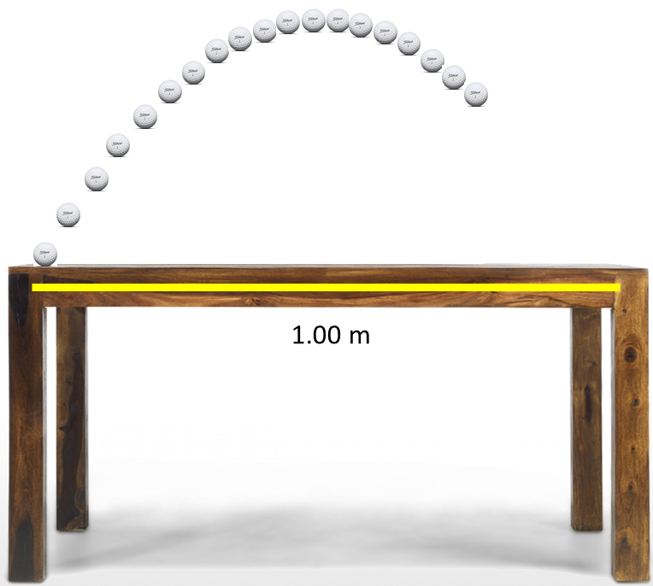

Fig. 1. Video recording of the flight of a golf ball. Multiple frames are displayed for the trajectory of the ball.

**Getting Started**

Before you start, think about a strategy that you can implement to perform the analysis for this experiment.

* Print figure 1 or make a tracing of the multiple positions of the ball from the screen.
* Construct a Table with 8 columns and 22 rows as shown below. Alternatively, entering your measurements into a spreadsheet will save you lots of time and effort.
* Add to your plot the XY coordinate axes with the Origin at the location of the ball for frame 1.

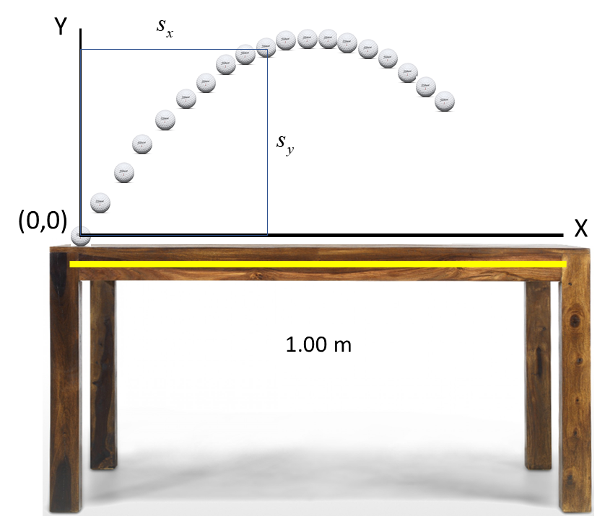

* Measure the X and Y displacements in arbitrary units (a.u.) w.r.t. to the Origin for the ball’s position shown at each frame. Record your measurements in columns 3 and 4 of the Table.
* Measure the length of the 1.00 m rule in arbitrary units. Calculate the scale factor to convert a.u. into metres. Enter the X and Y displacements of the ball into columns 5 and 6 measured in metres using the scale factor.
* Draw a graph of the trajectory of the golf ball



* The vertical displacement of the ball is described by the equation . We can transform this equation into a linear equation by dividing by *t*



* Enter the values for  into column 7.
* Draw the graph  where the time is measured in units called steps. The plot should be a straight line with a slope equal to .
* Converts steps into seconds 
* Enter into column 2, the time in seconds for each time step.
* Draw a graph of . The intercept of this line is equal to the initial velocity of the ball. Estimate the initial velocity of the ball and record its value.
* For the equation  the term  is the average velocity . Hence, we can derive an equation for the instantaneous vertical velocity



* Calculate the values for the vertical velocity  and enter the values into column 8.
* Draw a graph of the vertical displacement as a function of time . What is the height reached?
* Draw a graph for the vertical velocity as a function of time

. Measure the slope of the line. The slope of the line should be equal to -9.81 m.s-2. Why?

* Draw a graph of the horizontal displacement as a function of time . Estimate the initial velocity of the golf ball in the horizontal direction.
* Calculate the initial velocity of the ball (magnitude and direction).
* Estimate the maximum height of the ball and the time at which the ball reaches its maximum height.
* Calculate the range of the golf ball and its time of flight.
* Test the hypothesis.
* Determine the frame rate of the video recording.

|  |  |  |  |  |  |  |  |
| --- | --- | --- | --- | --- | --- | --- | --- |
| 1 | 2 | 3 | 4 | 5 | 6 | 7 | 8 |
| Frames | (s) | (a.u.) | (a.u.) | (m) | (m) | (m/s) | (m/s) |
| 1 | 0 | 0 | 0 | 0 | 0 | --- | --- |
| 2 |  |  |  |  |  |  |  |
| 3 |  |  |  |  |  |  |  |
| 4 |  |  |  |  |  |  |  |
| 5 |  |  |  |  |  |  |  |
| 6 |  |  |  |  |  |  |  |
| 7 |  |  |  |  |  |  |  |
| 8 |  |  |  |  |  |  |  |
| 9 |  |  |  |  |  |  |  |
| 10 |  |  |  |  |  |  |  |
| 11 |  |  |  |  |  |  |  |
| 12 |  |  |  |  |  |  |  |
| 13 |  |  |  |  |  |  |  |
| 14 |  |  |  |  |  |  |  |
| 15 |  |  |  |  |  |  |  |
| 16 |  |  |  |  |  |  |  |
| 17 |  |  |  |  |  |  |  |
| 18 |  |  |  |  |  |  |  |
| 19 |  |  |  |  |  |  |  |
| 20 |  |  |  |  |  |  |  |

***ONLY AFTER YOU HAVE COMPLETED YOUR ANAYSIS SHOULD YOU LOOK AT MY ANAYLSIS TO COMPARE THE RESULTS OR IF YOU HAVE DIFFICULTIES GETTING STARTTED, WORK THROUGH MY ANAYLSIS STEP BY STEP***

**SAMPLE RESULTS: VIDEO ANALYSIS OF THE FLIGHT OF THE GOLF BALL**

Scale factor 1.00 m = 11.65 a.u.

1 a.u. = (1/11.65) m

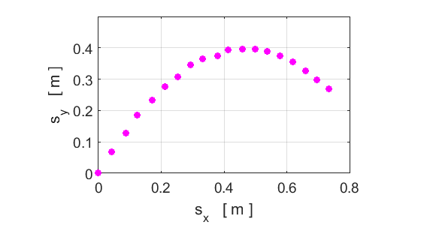

Trajectory of the golf ball. the maximum vertical height is 0.40 m. The shape of the curve appears to be a parabola. The horizontal distance travelled by the ball when it reaches its maximum height is 0.45 m.

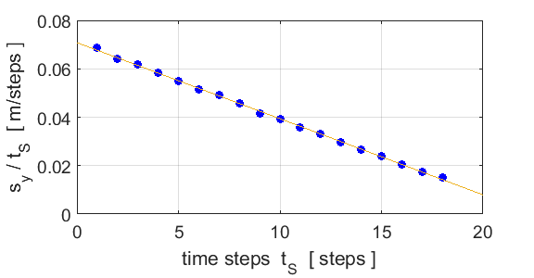





The frame rate of the video is



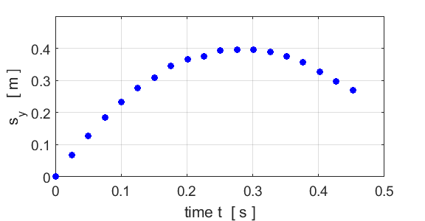

The maximum height reached by the golf ball is 4.0 m at time 0.28 s.

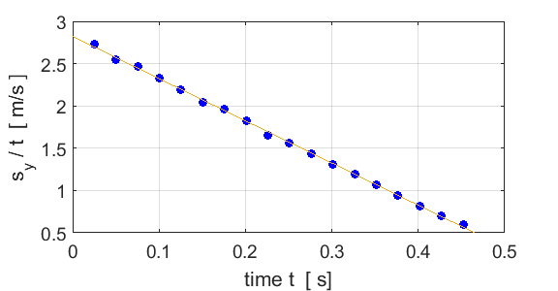

The initial vertical velocity is .

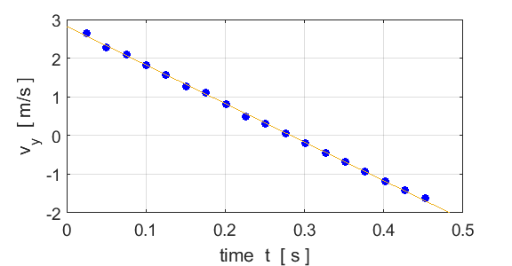

The straight line supports the hypothesis that the vertical motion can be described by a constant acceleration in the vertical direction .

The initial velocity given by the intercept is 

The negative value of the slope gives the acceleration due to gravity . Reasonable agreement with value of 9.81 m.s-2.

When the ball reaches the point at which its height is a maximum, the vertical velocity of the golf ball is **zero**. From the graph, the ball reaches its maximum height after a time .

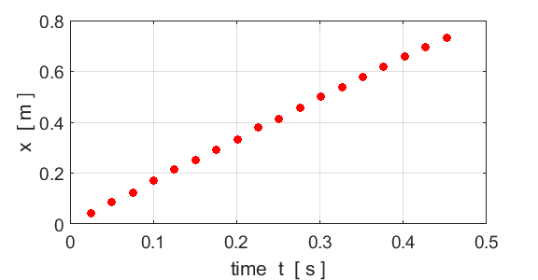

The straight line supports the hypothesis that the horizontal motion can be described by a zero acceleration in the horizontal direction . The slope of the line gives the horizontal velocity (constant) .

**Initial velocity**









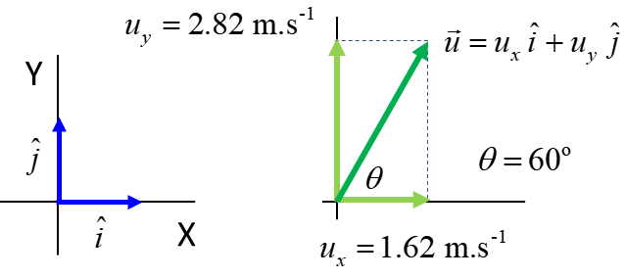

**Range of golf ball**

The time it takes for the ball to reach its maximum height is . So, the time it takes to return to its launch height is twice this time.  
 flight time 

Therefore, the range of the golf ball is



The horizontal distance travelled by the ball when it reaches its maximum height is 0.45 m. The range is twice this distance



[VISUAL PHYSICS ONLINE](http://www.physics.usyd.edu.au/teach_res/hsp/sp/spHome.htm)

If you have any feedback, comments, suggestions or corrections please email Ian Cooper

ian.cooper@sydney.edu.au

Ian Cooper School of Physics University of Sydney