

[**VISUAL PHYSICS ONLINE**](http://www.physics.usyd.edu.au/teach_res/hsp/sp/spHome.htm)

**MODULE 5**

**ADVANCED MECHANICS**

**NON-UNIFORM CIRCULAR MOTION**

|  |
| --- |
| Equation of a circle  Angular displacement  [rad]  Angular speed  [rad.s-1]  Tangential velocity  [m.s-1]  (direction: tangent to circle)  Centripetal acceleration  [m.s-2]  (direction: towards centre of circle / perpendicular to circle)  A force must be applied to an object to give it circular motion. This net force is called the centripetal force.    (direction: towards centre of circle / perpendicular to circle)  Vector product  Torque  [N.m] |

[Review: Language of Physics](http://www.physics.usyd.edu.au/teach_res/hsp/sp/mod1/m1_A.pdf)

**VECTOR (CROSS) PRODUCT**

The **vector product** or **cross product** of two vectors  and  is defined as



The magnitude of the vector  is .

The vector  is a unit vector which is perpendicular to both the vectors  and .

The angle between the two vectors is always less than or equal to 180o. The sine over this range of angles is never negative, hence the magnitude of the vector product is always positive or zero .

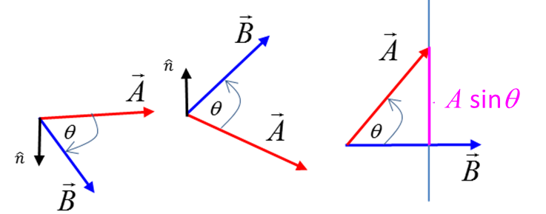

The direction of the vector product is perpendicular to both the vectors  and . The direction is given by the **right-hand screw rule**. The thumb of the right hand gives the direction of the vector product as the fingers of the right hand rotate from along the direction of the vector  towards the direction of the vector.

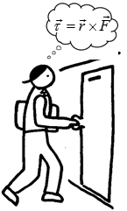**TORQUE and the VECTOR PRODUCT**

**What is the physics of opening a door?**

It is the torque applied to the door that is important and not the force.

A force can cause an object to move and a torque can cause an object to rotate. A torque is often thought of as a force multiplied by a distance. However, using the idea of the vector (cross) product we can precisely define what we mean by the concept of **torque**.

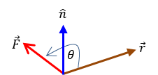



The vector  is the torque applied, the vector is the lever arm distance from the pivot point to the point of application of the force . The angle  is the angle between the vectors  and . The direction of the torque  is found by applying the righ-hand screw rule: the thumb points in the direction of the torque as you rotate the fingers of the right hand from along the line of the vector to the vector . The torque is perpendicular to both the position vector and the force .

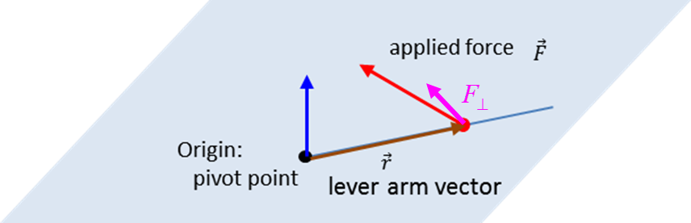

The magnitude of the torque can be expressed as



where  is the component of the applied force which acts at right angles to the radius vector .



A non-zero net force acting on an object causes it to accelerate in the direction of the force (Newton’s 2nd Law of motion). However, a net toque acting on an object is necessary to cause an angular acceleration of an object.

In uniform circular motion, the tangential speed of the object is constant. To change the tangential speed,a **non-zero torque**  must act on it, producing a tangential component of the acceleration. The acceleration  of the object has two components – the centripetal acceleration  (directed towards the centre) and a tangential component  (directed along the tangent to the circle).

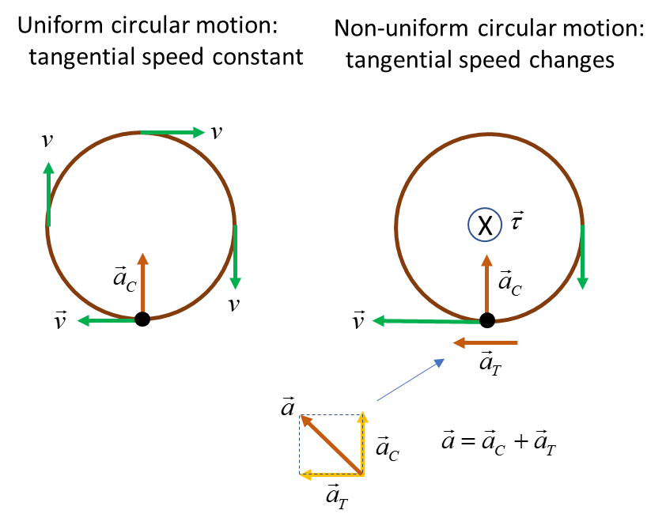

|  |
| --- |
| **Example**  A ball of mass 0.250 kg at the end of a long string of length 2.23 m (negligible mass) is swung in a vertical circle. Determine the minimum speed the ball must have at the top of its arc. Calculate the string tension at the bottom of the swing if the ball is moving at twice the speed of the ball had at the top of the swing.  **Solution**  Visualize the problem / how to approach the problem / scientific annotated diagram    The string tension  and the gravitational force  provide the centripetal force required for the ball to move in the circular path.    Note: in this example the speed of the ball changes, however, it is still true that a force equal to the centripetal force is needed to hold the ball in its circular orbit.  When the ball is at point A, the centripetal force is the sum of the string tension and the gravitational force (weight of ball).    The minimum speed  of the ball to keep moving in a circular path is when the string just goes limp .      At the bottom of the swing at point B      Since the ball’s speed changes as it moves around the circle, a net torque must act on the ball due to the string tension and the gravitational force. |

Note: The equation given in the Physics Stage 6 Syllabus for the torque is **incorrect**

 you simply cannot multiple two vectors together

[VISUAL PHYSICS ONLINE](http://www.physics.usyd.edu.au/teach_res/hsp/sp/spHome.htm)

If you have any feedback, comments, suggestions or corrections please email Ian Cooper

ian.cooper@sydney.edu.au

Ian Cooper School of Physics University of Sydney