**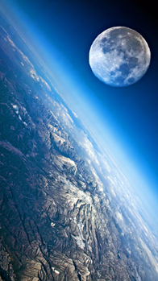**[**VISUAL PHYSICS ONLINE**](http://www.physics.usyd.edu.au/teach_res/hsp/sp/spHome.htm)

**MODULE 5**

**ADVANCED MECHANICS**

**DEPTH STUDY**

**ROCKETS and SATELLITES**

A suitable topic for a Depth Study is to investigate the **motion of projectiles, satellites and rockets**. You should review the topics on projectile motion, and the motion of satellites and rockets.

The following notes on exploring space using satellites and rockets is to help you get started on your Depth Study activities.

**ELECTROMAGNETIC COMMUNICATIONS**

Rockets and satellites are essential devices for our modern world based upon the internet, GPS and mobile phones. Communications around the globe between mobile phones, computers, etc use radio waves and microwaves for the transfer of information. Satellites are used for: radio and television transmissions; weather; military applications; GPS; phones and more. Just about all parts of the globe can transmit or receive electromagnetic wave communications via orbiting satellites and Earth bound transmitters and receivers (figure 1).

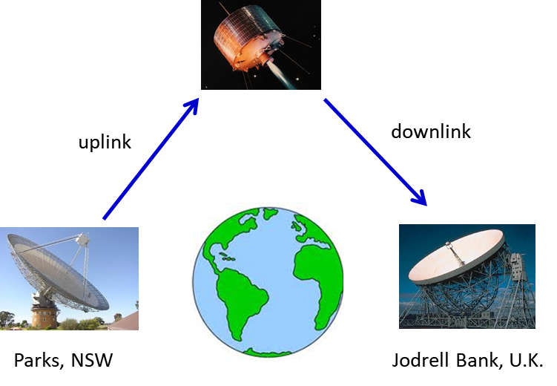

Fig. 1. Radio telescopes and satellites make it possible for information to flow freely around the globe.

There are 24 satellites that make up the GPS space segment. They orbit the Earth about 20 000 km above us. These satellites are travelling at speeds of approximately 11 000 km.h-1 and make two complete orbits in less than 24 hours. GPS satellites are powered by solar energy. They have backup batteries on-board to keep them running in the event of no solar power. Small rocket boosters on each satellite keep them flying in the correct path. GPS satellites transmit two low power radio signals, designated L1 and L2. Civilian GPS use the L1 frequency of **1575.42 MHz** in the UHF band. The signals travel by line of sight, meaning they will pass through clouds, glass and plastic but will not go through most solid objects such as buildings and mountains.

Magnetic storms set off by the Sun can be a threat to the transfer of information transmitted back and forth between the radio telescopes and satellites close to Earth. These disruptions may have devastating economic impacts, for example, international banking could be halted. Solar radiation especially during active Sun spot and solar flare periods (figure 2) can energize a belt of high-energy particles that surrounds Earth, resulting in particularly strong magnetic storms in the Van Allen radiation belts (figure 3). The Van Allen radiation belts consist of two rings of high-energy particles that surround the Earth. The outer belt, which is made up of electrons, reaches from about 25 000 to 50 000 km above the surface, while the inner belt, which consists of a mix of electrons and protons, reaches from about 6 400 to 12 800 km above the Earth’s surface. Strong solar and electromagnetic activity in the Van Allen belts can interfere with satellite – Earth communications and the delicate instrumentation on satellites can be permanently damaged.

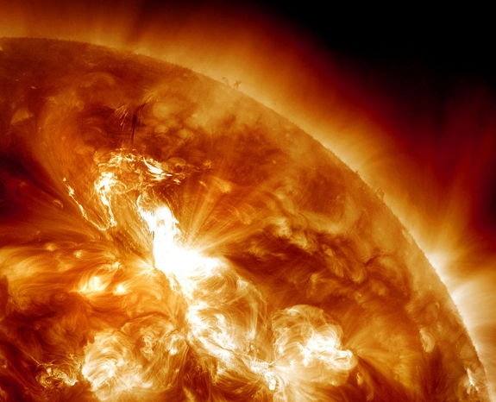

Fig. 2, Solar Flare, January 23, 2012 which was proceed by auroras around the world on the 22nd.

<http://www.space.com/13095-solar-storms-satellites-risk-geomagnetic-superstorms.html>



Fig.3. Van Allen Radiation Belts and the associated auroras.

Table 1 gives a brief summary of a division for part of the electromagnetic spectrum into bands for radio and microwaves radiation.

|  |  |  |
| --- | --- | --- |
| **Radio Band** | **Frequency** | **Wavelength (m)** |
| ELF – extremely low frequency | 3 – 30 Hz | 107 – 108 |
| SLF – super low frequency | 30 – 300 Hz | 106 – 107 |
| ULF – ultra low frequency | 300 – 3000 Hz | 105 – 106 |
| VLF – very low frequency | 3 – 30 kHz | 104 – 105 |
| LF – low frequency | 30 – 300 kHz | 103  – 104 |
| MF – medium frequency | 300 kHz – 3 MHz | 102 – 103 |
| HF – high frequency | 3 MHz – 30 MHz | 101 – 102 |
| VHF – very high frequency | 30 MHz – 300 MHz | 100 – 101 |
| UHF – ultra high frequency | 300 MHZ – 3 GHz | 10-1  – 100 |
| SHF – super high frequency | 3 GHZ – 30 GHz | 10-2  – 10-1 |
| EHF – extremely high frequency | 30 GHZ – 300 GHz | 10-3 – 10-2 |
| THF – tremendously high frequency | 300 GHz – 3000 GHz | 10-4 – 10-3 |

Table 1. Radio wave spectrum. The SHF – super high frequency range is used for most radar transmitters, microwave ovens, wireless LANs, cell phones, satellite communication, microwave radio relay links, and numerous short range terrestrial data links.

The atmosphere plays a major role in the transmission of radio through it. At certain wavelengths, the atmosphere absorbs ~100% of the electromagnetic energy while at other wavelengths there is ~100% transmission. For communications, only those wavelengths at which minimum absorption occurs can be used. There bands are often referred to as transmission windows.

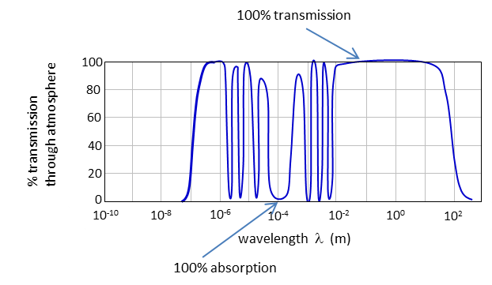

**Web search:** radio telescopes, satellites, solar flares, Sun spot activity, Van Allen radiation belts and auroras.

There are many dangers in space flight.

* Debris, particles, and even microscopic particle can impact the spacecraft and penetrate its surface. This can cause leakage of fuel and/or a loss in pressure within the spacecraft. Even at a low altitude of 20 km, the air pressure is so low that gas bubbles will form in the blood and water vapour would fill the lungs of unprotected astronauts.
* Rapid changes in temperature of the spacecraft as it moves from sunlight (temperatures ~ 100 oC) to shadow regions (~ - 100 oC).
* Radiation exposure at doses much greater than received on earth. This exposure to radiation can have biological effects on the cells of astronauts. The radiation danger is particularly server during periods of solar flares and when the Sun is active. This can disrupt the communications by radio links.
* Charged particles in the Van Allen Radiation belts and solar wind may damage sensitive electronic equipment. Normally spacecraft try to avoid the two radiation belts.
* The time it takes for a radio signal to travel between a spacecraft and the Earth.
* The transmitting power of a spacecraft is limited by the amount of energy that can be delivered by its solar cells or nuclear generator. Also, as the signal from the spacecraft spreads out as it travels to Earth with the intensity of the signal decreasing by the factor 1/*r*2 where *r* is the distance from the spacecraft. Earth-based communications antennae must be capable of receiving minute signals and to do this they must have large diameters (Parks radio telescope: diameter ~ 64 m).

**FORCES EXPERINECED BY ASTRONAUTS DURING TAKE-OFF**

As the acceleration of the rocket increases, so does the net force experienced by the astronauts inside the rocket. The magnitude of this force experience by the astronauts is related to the **g-force**, which is the ratio of the **normal force** (**apparent weight**) acting on them to their weight



Thus, the g-force can be expressed as



Saturn V rockets were used to launch the Apollo spacecraft. Some parameters for the Saturn V rockets are:

Length = 110 m

Initial mass = 2.7x106 kg

Thrust at lift off ~ 34x106 N

g-forces = 10 (often stated as 10g)

Parameters for the space shuttle:

Initial mass = 2x106 kg

Thrust at lift off ~ 31x106 N

The design of the shuttle engines enables much lower accelerations during the final stages of launch than the previous generations of rockets. The problem with high acceleration launches is that astronauts and payload suffer from the high g-forces produced. If an astronaut was sitting upright to the direction of motion, mental confusion and unconsciousness can result from the large g-forces. Internal organs are pulled down into the body cavity and blood pressure falls because blood gravitates to the feet.

During launch an astronaut is seated horizontally in a specially contoured chair - the astronaut has their back and legs below the knees in the horizontal plane. In this way most of the acceleration the astronaut experiences during launch is directed vertically upwards through their well-supported, horizontal back. This makes the g-forces more tolerable, although breathing can become a problem and an astronaut may need extra oxygen to make up for the decline in blood oxygen at these concentrations. Such transverse accelerations cause much less stress to the body than accelerations applied along the long axis of the body. Humans can tolerate up to 12g of transverse acceleration without undue discomfort or visual disorders. Accelerations acting along the long axis of the body can cause serious stress for fairly low g-forces (figure 5).



Fig. 5. Astronauts can withstand greater g-forces lying in a crouching position rather than in an upright position during lift off and re-entry because there is less pooling of the blood in the extremities of the body.

Because of the loss of mass of the rocket, reduction in air resistance and the reduction in acceleration due to gravity as altitude increases, the acceleration of a rocket will increase logarithmically. This means that astronauts will experience g-forces many times higher than 1. In fact, the g-forces will increase up to a maximum of about g-force = 3. As each stage of the rocket falls away, the astronauts experience momentary weightlessness. The g-forces rise again after each stage drops away but not to the same maximum. Eventually when the rocket is free of the Earth's gravity, astronauts will experience weightlessness (apparent weight *FN* = 0 “free fall”).

A pilot experiences a large acceleration applied in the direction from the feet to the head when the plane pulls out of a steep dive (figure 6). The pilot feels heavier and is therefore said to be experiencing positive *g*-forces. In this case, the blood is left behind in the feet so to speak. At 3g to 4g this loss of blood from the head may cause “grey outs” (blurring of vision caused by lack of blood flow in the eyes) or “black outs” (loss of vision) and from 3*g* to 5*g* loss of consciousness. A pilot can also experience acceleration applied in the direction from the head to the feet.

This results when the pilot executes an outside loop or pushover at the start of a dive. The pilot feels lighter or weightless and is therefore said to be experiencing negative g-forces. In this case, the blood is left behind in the upper body. At 3*g* to 4.5*g* this accumulation of blood in the upper body can cause red outs (all objects appear red) or loss of vision or unconsciousness. The average endurable times for tolerating negative *g*-forces are 15 seconds at 4.5*g* and 30 seconds at 3*g*.

Fig. 6. Pilots experience large g-forces when entering and pulling out of a steep dive.

You do not need to be an astronaut or pilot to have experienced positive and negative g-forces. Any person who has ridden a roller coaster has experienced these effects. As you pull out of a steep drop or negotiate an inside loop, you experience positive g-forces and feel heavier. This is a similar feeling to that experienced by astronauts at launch. As you fall from a height, you experience negative g-forces and feel somewhat weightless (figure 7).

[View an animation of blood pooling in the feet or head](http://www.physics.usyd.edu.au/teach_res/hsp/u5/ag_blood.htm)

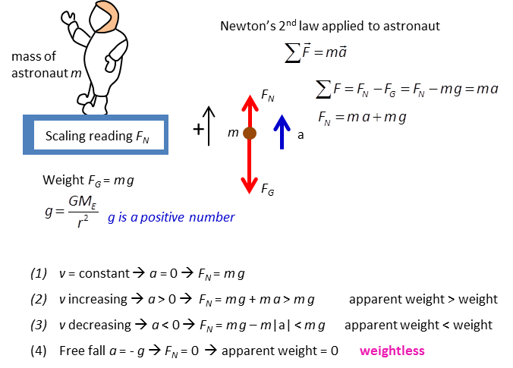

Fig. 7. Force experienced by an astronaut during a space flight.

**SAFE RE-ENTRY AND LANDING OF ROCKETS OR SPACECRAFT**

The safe return of a spacecraft into the Earth’s atmosphere and subsequent descent to Earth requires consideration of two main issues:

* How to handle the intense heat generated as the spacecraft enters the Earth’s atmosphere
* How to keep the g-forces of deceleration within safe limits.

On re-entry, friction between the spacecraft and the Earth’s atmosphere generates a great deal of thermal energy. Early spacecraft such as NASA’s Mercury, Gemini & Apollo capsules, used heat shields made from what was called an ablative material that would burn up on re-entry and protect the crew from the high temperatures. The Space Shuttle uses an assortment of materials to protect its crew from the intense thermal energy. Reinforced carbon-carbon composite, low and high temperature ceramic tiles and flexible surface insulation material all play important protective roles in appropriate positions on the Shuttle.

It would be wonderful if a spacecraft could re-enter the atmosphere vertically. Unfortunately, the thick, bottom section of our atmosphere that is used to effectively slow the spacecraft to safe landing speed is not sufficiently thick (about 100 km) to allow for vertical re-entry. So, the spacecraft is forced to re-enter at an angle to the horizontal of between 5.2o and 7.2o. This small angular corridor is called the re-entry window. If the astronauts re-enter at too shallow an angle, the spacecraft will bounce off the atmosphere back into space. If the astronauts re-enter at too steep an angle, both the g-forces and the heat generated will be too great for the crew to survive.



Fig. 11. For a safe landing of a spacecraft it must enter the atmosphere in the correct range of angles for a safe landing.

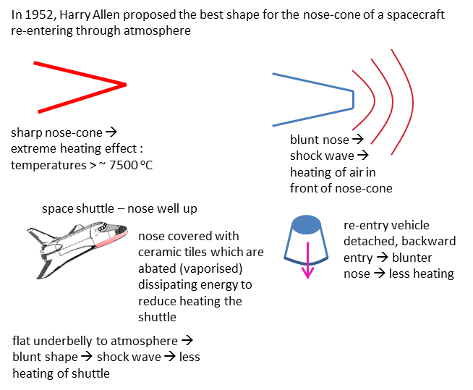

Fig. 12. Spacecraft re-entry and the heating effect in passing through the atmosphere.

**What Can Go Wrong?**

The following points represent the main reasons why a safe re-entry must be so carefully controlled:

* As described above, if the angle of re-entry is too shallow, the spacecraft may skip off the atmosphere. The commonly cited analogy is a rock skipping across a pond. If the angle of entry is too steep, the spacecraft will burn up due to the heat of re-entry.
* Because of collisions with air particles and the huge deceleration, a huge amount of thermal energy is produced from friction. The space shuttle must be able to withstand these temperatures. It uses a covering of insulating tiles which are made of glass fibres but are about 90% air. This gives them excellent thermal insulating properties and also conserves mass. The tile construction is denser near the surface to make the tiles more resistant to impact damage, but the surface is also porous. Damage to the space shuttle Columbia's heat shield is thought to have caused its disintegration and the loss of seven astronauts on 1st February 2003. Investigators believed that the scorching air of re-entry penetrated a cracked panel on the left wing and melted the metal support structures inside.
* Large g-forces are experienced by astronauts as the space shuttle decelerates and re-enters the Earth's atmosphere. Astronauts are positioned in a transverse position with their backs towards the Earth's surface as g-forces are easier for humans to tolerate in these positions. Supporting the body in as many places as possible also helps to increase tolerance.
* There is an ionisation blackout for the space shuttle of about 16 minutes where no communication is possible. This is because as thermal energy builds up, air becomes ionised forming a layer around the spacecraft. Radio signals cannot penetrate this layer of ionised particles.

**Web investigation**: rockets, rocket launch, g-force, sling slot effect, escape velocity, re-entry

**Web investigation**: Find out what were the major contribution to rocket science made by the following pioneers in rocket research – Tsiolkovsky; Oberth; Goddard; Esnault-Pelterie; O’Neill; von Braun

**VELOCITY BOOST**

The Earth rotates on its own axis in an easterly direction. At the latitude of NASA’s Cape Canaveral launch site, the speed of rotation is about 400 m.s-1. So, it makes good sense to launch a rocket in the easterly direction – hence, it already has a speed of 400 m.s-1 in the direction it wishes to go.

To penetrate the dense lower portion of the atmosphere by the shortest possible route, rockets are initially launched vertically from the launch pad. As the rocket climbs, its trajectory is tilted in the easterly direction by the guidance system to take advantage of the Earth’s rotational motion. Eventually, the rocket is travelling parallel to the Earth’s surface immediately below and can then be manoeuvred into an orbit around the Earth.



Fig. 8. Rockets are launched in an easterly direction to get a velocity booster because of the Earth spinning about its axis of rotation.

**SLING SHOT EFFECT**

The **slingshot effect** is also known as a planetary swing-by or a gravity-assist manoeuvre. It is performed to achieve an increase in speed and/or a change of direction of a spacecraft as it passes close to a planet. As it approaches, the spacecraft is caught by the gravitational field of the planet, and swings around it. The speed acquired is then sufficient to throw the spacecraft back out again, away from the planet. By controlling the approach, the outcome of the manoeuvre can be manipulated and the spacecraft can acquire some of the planet’s velocity, relative to the Sun.

The manoeuvre can be analysed as an elastic mechanical interaction, in which both momentum and kinetic energy are conserved. As a result of the interaction, the spacecraft will have sped up relative to the Sun, acquiring kinetic energy. The planet will have slowed very marginally, losing an equivalent amount of kinetic energy. Remember that *EK* = ½*mv*2 and the mass of a planet is very large so that the change in velocity of the planet is insignificant.

The slingshot effect uses the motion of a planet to alter the path and speed of a spacecraft to manoeuvre it to travel to the outer planets of our solar system, which would otherwise be prohibitively expensive, if not impossible, to reach with current technologies.

Consider a spacecraft on a trajectory that will take it close to a planet, say Jupiter. As the spacecraft approaches Jupiter which must be moving toward towards the spacecraft relative to the Sun for the slingshot effect to work - Jupiter's gravity pulls on the spacecraft, speeding it up. After passing the planet, the gravity will continue pulling on the spacecraft, slowing it down, but since Jupiter is moving, momentum and kinetic energy are transferred to the spacecraft. While the speed of the spacecraft has remained the same as measured with reference to Jupiter, the initial and final speeds may be quite different as measured in the Sun's frame of reference. Depending on the direction of the outbound leg of the trajectory, the spacecraft can gain a significant fraction of the orbital speed of the planet. In the case of Jupiter, this is over 13 km.s-1.

**Web investigation**: sling shot effect, gravity-assist trajectories

**PREDICT / OBSERVE / EXPLAIN**

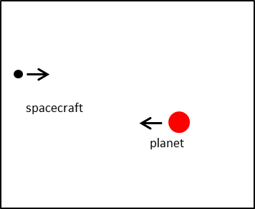

Consider the **slingshot effect** with a spacecraft moving toward a planet. Predict the following when spacecraft moves towards a (1) stationary planet and (2) planet moving towards spacecraft:

* The trajectories of the spacecraft and planet shown as lines and as a series of dots indicating positions at equal time intervals.
* Graph of kinetic energy of spacecraft, gravitational potential energy of system (spacecraft and planet) and total energy of system as a function of time as the spacecraft sweeps around the planet.
* Graph of the velocity of the spacecraft as a function of time as the spacecraft sweeps around the planet.
* Graph of the separation distance of the spacecraft from the planet as a function of time as the spacecraft sweeps around the planet.

Only after you have given careful thought and documented your prediction go to the link and **observe** the animations and graphs for the slingshot effect.

[http://www.physics.usyd.edu.au/teach\_res/hsp/u5/t5\_slingshot.htm](http://www.physics.usyd.edu.au/teach_res/hsp/u5/t5_slingshot.htm" \t "_blank)

Compare your predictions with your observation and **explain** any discrepancies.

[VISUAL PHYSICS ONLINE](http://www.physics.usyd.edu.au/teach_res/hsp/sp/spHome.htm)

If you have any feedback, comments, suggestions or corrections please email Ian Cooper

ian.cooper@sydney.edu.au

Ian Cooper School of Physics University of Sydney