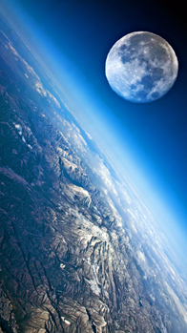[**VISUAL PHYSICS ONLINE**](http://www.physics.usyd.edu.au/teach_res/hsp/sp/spHome.htm)

**MODULE 5**

**ADVANCED MECHANICS**

**GRAVITATIONAL FIELD:**

**MOTION OF PLANETS AND SATELLITES**

|  |
| --- |
| **SATELLITES**: **Orbital motion** of object of mass *m* about a massive object of mass *M* (*m* << *M* assume *M* stationary w.r.t *m*) with an orbital radius *r*, orbital speed  and period *T*  Gravitational force (magnitude)  Centripetal force (magnitude)  **Orbital speed**  Angular momentum  Gravitational potential energy  Kinetic energy  Total energy  **Escape speed** |

|  |
| --- |
| **Example 1 Gravitational Force – attraction between people**  Chris has a mass of 75 kg and Pat has a mass of 50 kg are standing near each other a distance 0.52 m apart. Are they attracted to each other and how strong is the attraction?  **Solution 1**  THINK: how to approach the problem / type of problem / visualize the physical situation / annotated scientific diagram / what do I know!  The two people are attracted by the gravitational force. We can calculate the magnitude of the force using Newton’s Law of Universal Gravitation    The answer is that the gravitational attraction is very small . What other attraction there maybe, physics cannot answer. |

|  |
| --- |
| **Example 2 Gravitational Force on the Moon**  The Moon, the Sun and the Earth are aligned so that both the Sun and the Earth are at right angles to each other. Find the net force acting on the Moon.    **Solution 2**  THINK: how to approach the problem (ISEE) / type of problem / visualize the physical situation / annotated scientific diagram / what do I know!  Need to calculate the forces between the Moon and Earth and between Moon and Sun and then add the two forces vectorially. |

|  |
| --- |
| **Example 3 Acceleration due to gravity (gravitational field strength)**  Compare the acceleration due to gravity (gravitational field strength) at sea level and at the top of Mt Everest.  radius of the earth  height of Mt Everest      **Solution 3**  THINK: how to approach the problem (ISEE) / type of problem / visualize the physical situation / annotated scientific diagram / what do I know!  Image result for image mt everest  Newton’s Law of gravity between the Earth and an object of mass m is    The gravitational force can be expressed in terms of the gravitational field strength g    Hence, the gravitational field strength (acceleration due to gravity) is    At sea level,    At top of Mt Everest,    Ratio of the two accelerations due to gravity    A very small difference, however, we have ignored the extra mass that sits under the top of Mt Everest. |

**PUTTING SATELLITES INTO ORBIT**

The greater the launch velocity of an object, the greater the vertical height reached and the greater the horizontal range. If the launch velocity is greater enough then the acceleration due to gravity is no longer constant and we must use its dependence on the distance of the object from the centre of the Earth. Also, if the launch velocity is large enough, the object can be placed into orbit around the Earth or escape from the influence of the Earth’s gravitation field.

Rockets and satellites are essential devices for our modern world based upon the internet, GPS and mobile phones. Communications around the globe between mobile phones, computers, etc use radio waves and microwaves for the transfer of information. Satellites are used for: radio and television transmissions; weather; military applications; GPS; phones and more. Just about all parts of the globe can transmit or receive electromagnetic wave communications via orbiting satellites and Earth bound transmitters and receivers (figure 1).

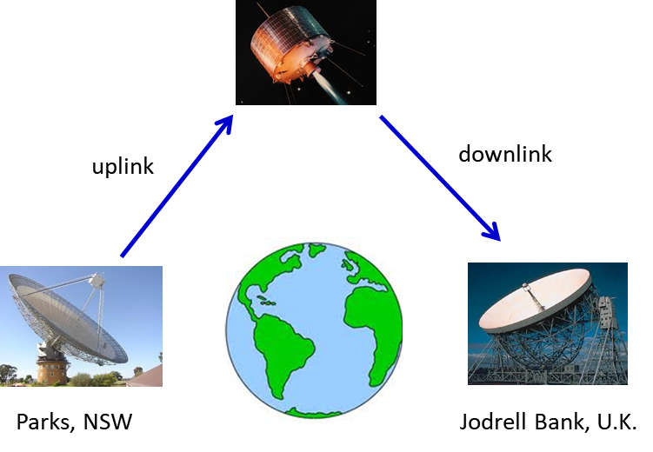

Fig. 1. Radio telescopes and satellites make it possible for information to flow freely around the globe.

There are 24 satellites that make up the GPS space segment. They orbit the Earth about 20 000 km above us. These satellites are travelling at speeds of approximately 11 000 km.h-1 and make two complete orbits in less than 24 hours. GPS satellites are powered by solar energy. They have backup batteries on-board to keep them running in the event of no solar power. Small rocket boosters on each satellite keep them flying in the correct path. GPS satellites transmit two low power radio signals, designated L1 and L2. Civilian GPS use the L1 frequency of **1575.42 MHz** in the UHF band. The signals travel by line of sight, meaning they will pass through clouds, glass and plastic but will not go through most solid objects such as buildings and mountains.

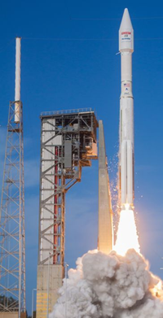**LAUNCHING A ROCKET**

A rocket is propelled through space by a continuous explosion produced by burning fuel and expelling the resulting hot gases out one end, i.e, chemical reactions, takes place inside the rocket and the gaseous products of combustion are propelled out of the rocket with tremendous a force acting on the gas. The hot gases have a momentum in one direction, and since the total momentum of the rocket-fuel system is zero, the rocket itself has an equal momentum in the opposite direction. Thus, the rocket moves off in the opposite direction to the expelled gases, in accordance with the Law of Conservation of Momentum.

This means that the backward momentum of the gases is exactly equal in magnitude to the forward momentum of the rocket. This is what gives the rocket its forward velocity. This is a consequence of Newton's Third Law which says that for every reaction there is an equal and opposite reaction; the rocket exerts a force on the gases and the gases exert a force on the rocket propelling it forward.

Note that there is no need for any air to push against'' for the rocket to work. Newton's Third Law assures us that ejection of an object from the system MUST propel the system in the opposite direction. This propulsive force is referred to as the **thrust** of the rocket.

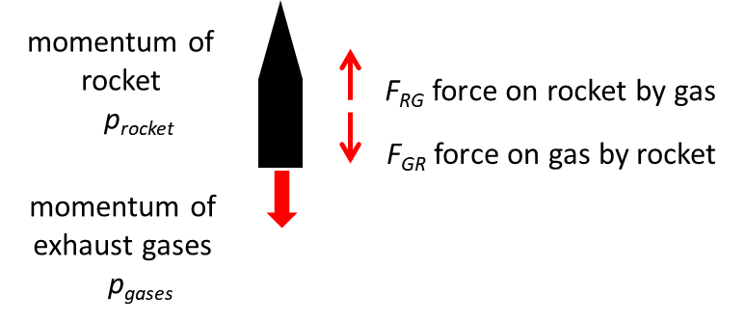

Fig. 2. Rocket propulsion.

Newton’s third law: 

Forces act for time interval  →

impulse: 

Impulse = Change in momentum: 



Momentum is conserved: 

You should note that because at any time instant the mass of the gases is much less than the mass of the rocket, we can see that the velocity of the gases will, therefore, be much higher in magnitude than the velocity of the rocket. Although the mass of the gas emitted per second is comparatively small, it has a very large momentum because its high velocity. An equal momentum is imparted to the rocket in the opposite direction. This means that the rocket, despite its large mass, builds up a high velocity.

As the launch proceeds, fuel is burnt, gases expelled and the mass of the rocket decreases. This produces an increase in acceleration, since acceleration is proportional to the applied force (the thrust) and inversely proportional to the mass. The initial acceleration is small, around 1 m.s-2 but continues to build as the mass of the rocket decreases.

*Rocket’s acceleration* – not constant: initially 90% mass of rocket is its fuel – fuel used up – mass of rocket decreases – thrust remains approximately constant ⇒ acceleration increases as mass reduces



An additional positive effect on the rocket is the decreases in aero dynamic drag with increasing altitude. The combination of these two factors accounts for the increase in acceleration during the launch of the rocket and helps the spacecraft reach the high velocity that is needed for space flight.

**ESCAPE VELOCITY**

For a spacecraft to go on a mission to another planet, it is first necessary for the spacecraft to achieve escape velocity from the Earth and to go into its own elliptical orbit around the Sun. The Earth orbits the Sun at about 30 km.s-1. Again, it makes good sense to use this speed to help a spacecraft achieve escape velocity for trips to other planets. So, if the spacecraft is to go on a mission to planets beyond the Earth’s orbit, it is launched in the direction of Earth’s orbital motion around the Sun and achieves a velocity around the Sun greater than the Earth’s 30 km.s-1. Thus, the spacecraft’s orbit is larger than that of the Earth and is arranged to intersect with the orbit of the planet to which it is heading at a time when the planet will be at that point. Similarly, if the target is Mercury or Venus, the spacecraft is launched in the opposite direction to the Earth’s motion through space. Then, the spacecraft achieves an escape velocity less than 30 km.s-1, where it enters an elliptical orbit around the Sun that is smaller than the Earth’s and can thus intercept either planet.

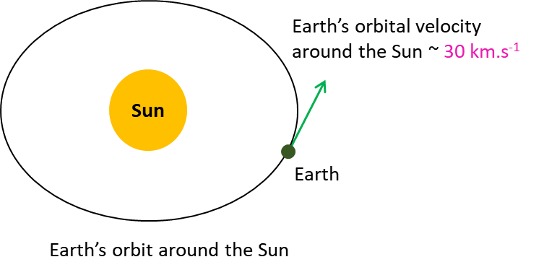

Fig. 3. Earth’s orbital motion around the Sun can be helpful in launching rockets to planets in our Solar System.

Newton showed that if you climb to the top of a mountain and throw a ball, it will travel a certain distance and then hit the ground (A). If you could throw the ball twice as fast it would travel even further (B) and if you threw it three times as fast it would travel further still. If you kept increasing the speed by firing it from a super powerful canon, and there was no air friction, a point would come when the ball would be travelling part-way around the world. If the ball could be fired at just the right speed, it would travel completely around the Earth and hit you in the back of the head (C). In this case, it would fall at exactly the same rate as the Earth curves. Faster still, the ball would go into elliptical orbit (D). If it was fired much faster than that, the canon ball would travel off into space and never return (F) as shown in figure 4.

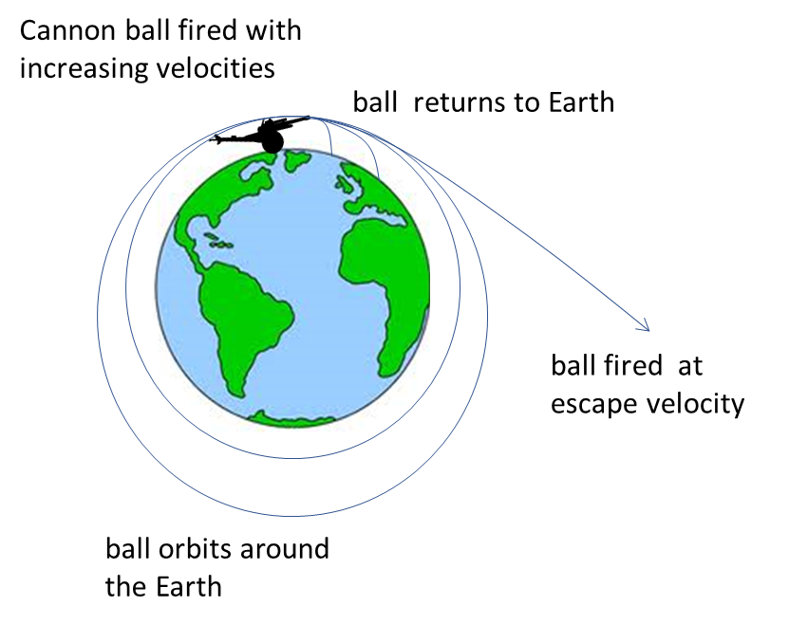

Fig. 4 Cannon ball launched from top of a mountain with increasing velocity.

**Escape velocity**  is defined as the smallest speed that we need to give an object in order to allow it to completely escape from the gravitational pull of the planet on which it is sitting. To calculate it we need only to realize that as an object moves away from the centre of a planet, its kinetic energy gets converted into gravitational potential energy. Thus, we need only figure out how much gravitational potential energy an object gains as it moves from the surface of the planet off to infinity.

For a rocket of mass *m* fired from the surface of the Earth, the total energy of the rocket-Earth system is assumed to be constant.

At the Earth’s surface, the total energy when the rocket is fired is



When the rocket has escaped the Earth’s gravitational pull, we assume the rocket is an infinite distance from the Earth  and ,  and 



Total energy is conserved





Therefore, the escape velocity is

(1) 

The escape velocity for a rocket fired from a planet or moon (mass *M*, radius *R*) is

(2) 

Note that the mass *m* of the object has cancelled, so that the escape velocity of any object is independent of its mass. This means that if you want to throw a grain of rice or an elephant into outer space, you need to give them both the same initial velocity which for the Earth works out to be about 104 m.s-1.

We can think of the gravitational field as a “gravitational well” surrounding the Earth just like a depressed dimple in a rubber membrane. Objects of mass are trapped in the well because of the attractive force pulling them in towards the centre of the Earth. To escape from the well work must be done on the object.

**SATELLITES and WEIGHTLESSNESS**

Artificial satellites circling the Earth are common. A satellite is placed into orbit by accelerating it to sufficiently high tangential speed with the use of rockets. If the speed is too low, it will return to the Earth. If the speed is too high, the spacecraft will not be confined by the Earth’s gravity and will escape, never to return. Satellites are usually placed into circular (or nearly circular) orbits because this requires the least take-off speed (figure 5).

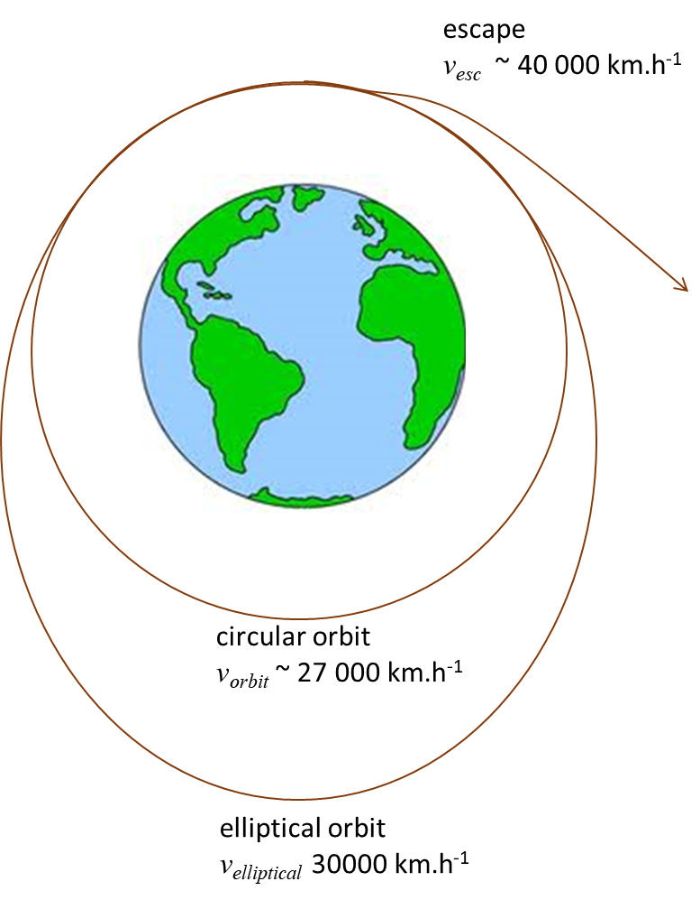

Fig. 5. Artificial satellites launched with different speeds.

**What keeps the satellite up?**

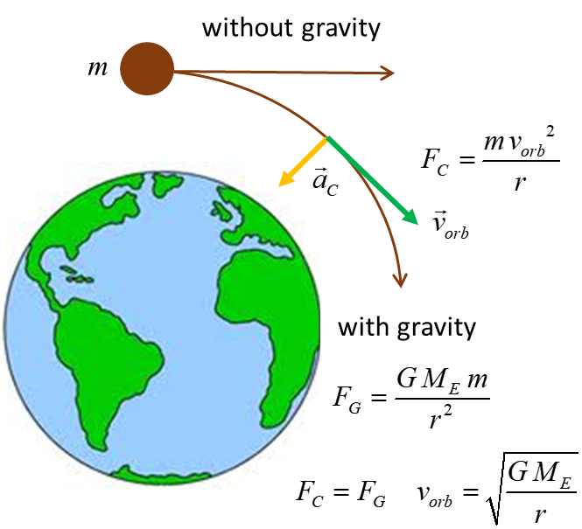

Fig. 6. A moving satellite is always falling towards the centre of the Earth.

A satellite is always falling towards the Earth, i.e., accelerating towards the Earth by the pull of the gravitational force. The high tangential speed keeps the satellite from hitting the Earth as the curvature of the satellite’s orbit as it falls matches the curvature of the Earth.

The **weightlessness** experience by astronauts in a satellite orbit is because they are falling freely since the satellite is falling freely towards the Earth. The acceleration of the satellite and astronauts matches the acceleration due to gravity at that point since the only force acting is the gravitational force of the Earth



Figure 7 shows examples of people in free-fall and experience the sensation of weightlessness.

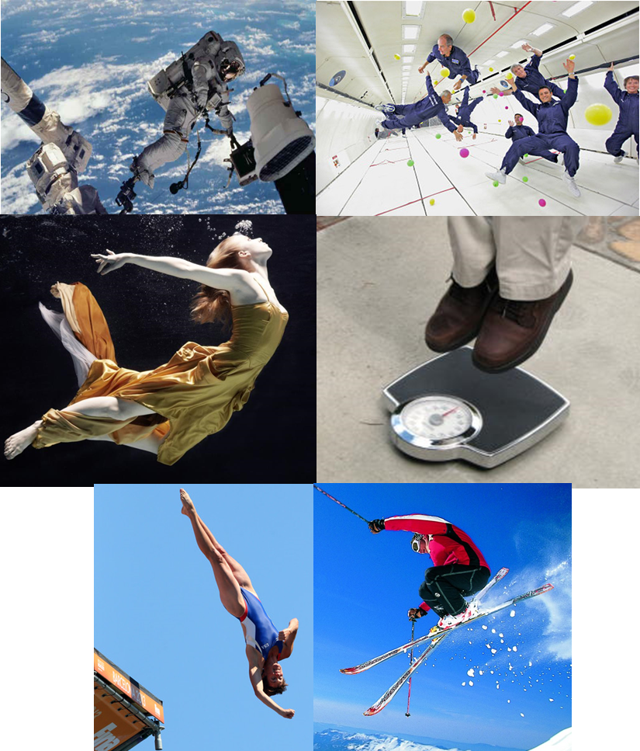

Fig. 7. Weightlessness on Earth.

Weightlessness does not mean your weight is zero. Your weight is still given by the gravitational force

weight 

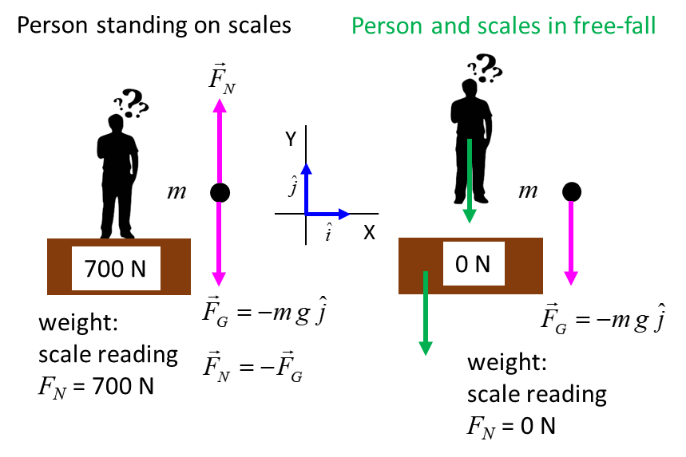

Fig. 8. The weight of the person is both cases in equal to . When the person is standing on the scales (left), the normal force is equal to the weight of the person. When the person and scales are in free fall (right), the normal force is **zero** and the person is said to be **weightless** enough though their weight is .

|  |
| --- |
| **Example 4**  A 60 kg person stands on a bathroom scale while riding an elevator. What is the reading on the scale in the following cases:   1. The elevator is at rest. 2. The elevator is going up at 2.0 m.s-1. 3. The elevator is going up at 4.0 m.s-1. 4. The elevator is going down at 2.0 m.s-1. 5. The elevator starts from rest and goes up reaching a speed of 2.0 m.s-1 in 1.8 s. 6. The elevator is moving up and accelerates from 2.0 m.s-1 to 4.0 m.s-1 in 1.8 s. 7. The elevator starts from rest and goes down reaching a speed of 2.0 m.s-1 in 1.8 s. 8. The elevator is moving down and accelerates from 2.0 m.s-1 to 4.0 m.s-1 in 1.8 s. 9. The elevator is moving up and slows from 4.0 m.s-1 to 2.0 m.s-1 in 1.8 s. 10. The elevator is moving down and slows from 4.0 m.s-1 to 2.0 m.s-1 in 1.8 s.   **Solution 4**  *THINK*: how to approach the problem / type of problem / visualize the physical situation / annotated scientific diagram / what do I know!  Visualize the situation – write down all the given and unknown information. Draw a diagram of the physical situation showing the inertial frame of reference.   * Type of problem – forces and Newton’s laws. * Draw a free-body diagram showing all the forces acting on the person. * Use Newton’s 2nd law to give the relationship between the forces acting on the person and the acceleration of the person. * Determine the acceleration of the person in each case. * Solve for the unknown quantities.     The person exerts a force on the bathroom scales and the bathroom scales exerts a force on the person. This is an action / reaction pair. But, we are only interested in the forces acting on the person which are the weight and the normal force due to the scale on the person.  The scale reading *FN* is found from Newton’s 2nd law:    acceleration due to gravity *g* = 9.8 m.s-2 (scalar quantity in this example)  acceleration of person *a* > 0 if direction up and *a* < 0 if acceleration down  The weight of the person is *FG* = *mg* = (60)(9.81) N =588.6 N  We can assume when the velocity changes the acceleration *a* is constant and equal to the average acceleration    In cases (1), (2), (3) and (4) there is no change in the velocity, hence    Therefore, the scale reading is *F*N = 588.6 N or 60 kg.  For cases (5), (6) and (10)  case (5)  case (6)  case (10)  The acceleration is    The scale reading is  or 67 kg  This scale reading is often called the person’s **apparent weight**.  The person feels the floor pushing up harder than when the elevator is stationary or moving with a constant velocity.  For cases (7), (8) and (9)  case (7)  case (8)  case (9)  The acceleration is    The scale reading is  or 53 kg  The person feels their weight has decreased.  In the extreme case when the cable breaks and the elevator and the person are in free-fall and the downward acceleration is *a* = -*g*. In this case the normal force of the scales on the person is *FN* = *m*(*g* - *g*) = 0 N. The person seems to be weightless. This is the same as an astronaut orbiting the Earth in a spacecraft where they experience **apparent weightlessness**. The astronaut and spacecraft are in free-fall and there are zero normal forces acting on the person. The astronaut still has weight because of the gravitational force acting on them.  The acceleration does not depend upon the direction of the velocity. What is important is the change in the velocity.  A good way to understand this concept is to draw the appropriate motion maps |

**Geosynchronous (geostationary) satellite**

A geosynchronous satellite is one that stays above the same point on the Earth, which is possible only if it is above a point on the equator. Such satellites are used for weather forecasting, TV transmissions, and communication relays.

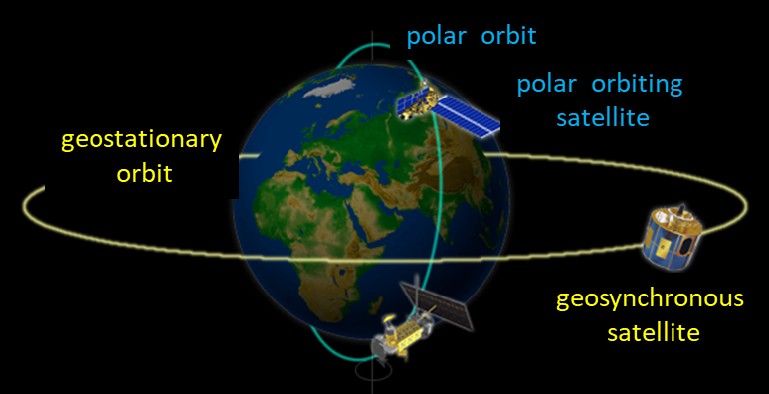

The only force acting on the satellite is the gravitational force. So, for the orbiting satellite, the gravitational force must be equal to the centripetal force assuming that the satellite moves in a circle



This equation has two unknowns  and . However, we know that our geosynchronous satellite revolves around the Earth with the same period  that the Earth rotates on its axis, namely once in 24 hours.

Thus, the speed of the satellite must be



where 

We can now solve for r and v



The radius of the Earth is 

So, a **geosynchronous satellite** must orbit at a distance of about **36000 km** above the surface of the Earth.

The **orbital speed**  of the satellite is



|  |
| --- |
| **Example 5**  For the radius for the orbit of a geosynchronous satellite given that the distance between the Earth and the Moon is 384 400 km.  **Solution 5**  *THINK*: how to approach the problem / type of problem / visualize the physical situation / annotated scientific diagram / what do I know!    How nice that the moon’s approximate period turns out to be a perfect cube! A geosynchronous satellite must be 1/9 the distance to the Moon (42 000 km from the centre of the Earth or 36 000 km above the Earth’s surface which equals about 6 Earth radii high). |

[VISUAL PHYSICS ONLINE](http://www.physics.usyd.edu.au/teach_res/hsp/sp/spHome.htm)

http://www.physics.usyd.edu.au/teach_res/hsp/sp/spHome.htm

If you have any feedback, comments, suggestions or corrections please email Ian Cooper

ian.cooper@sydney.edu.au

Ian Cooper School of Physics University of Sydney