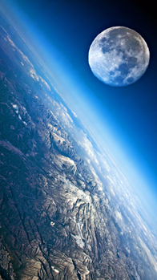[**VISUAL PHYSICS ONLINE**](http://www.physics.usyd.edu.au/teach_res/hsp/sp/spHome.htm)

**MODULE 5**

**ADVANCED MECHANICS**

**GRAVITATIONAL FIELD:**

**FORCES**

|  |
| --- |
| Newton’s Law of Universal Gravitation (attraction between two masses)  Gravitational field strength  Gravitation field strength surrounding the Earth  Gravitation field strength at the Earth’s surface    Weight |

**NEWTON’S LAW OF UNIVERSAL GRAVITATION**

Newton's Universal Law of Gravitation states that any two objects exert a gravitational force of attraction on each other. The direction of the force is along the line joining the two objects. The magnitude of the force is proportional to the product of the masses of the two objects, and inversely proportional to the square of the distance between them (figure 1, equation 1).

1.  **Newton’s Law of Universal Gravitation**

force *F* [N]

mass of the two objects *m*1 and *m*2 [kg]

distance between the centres of the two objects *r* [m]

Universal Gravitation Constant *G* = 6.673x10‐11 N.m2.kg‐2

This equation should **not** be expressed in terms of vectors. is the magnitude of the force acting on mass  and mass . The force acting on  is opposite in direction to the force acting on mass .

Figure 1 shows why it better not to use vector notation for the gravitational force.

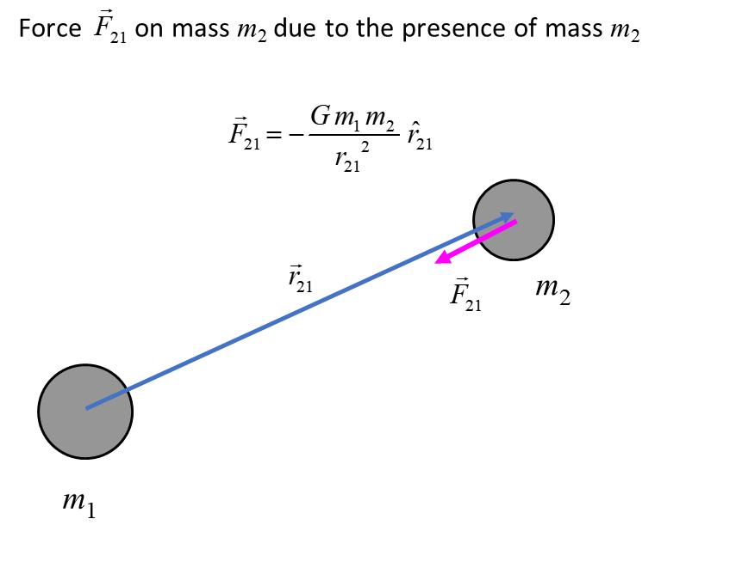

Fig. 1. Gravitational force  on mass on  due to presence of mass  in vector notation.

By 1687, Newton had formulated his ideas and unified centuries of astronomical observations into a coherent theory of gravity in his famous book *Philosophiae Naturalis Principia Mathematica*. A quote from Newton

*Every particle in the universe attracts every other particle with a force that is directly proportional to the product of their masses and inversely proportional to the square of the distance between them.*

For any calculations, we can take the mass of an object being concentrated at a point known as the **centre of mass**. For example, we take the geometric centres to determine the separation distance between two planets.

The variation of the magnitude of the gravitational force with separation distance between two objects is shown in figure (2).

Fig.2. Gravitation force as a function of separation distance. The graph shows the inversely proportional relationship between force and separation distance.

Figure 3 shows how the force is dependent upon the masses of the two objects and their separation distance.



Fig. 3. Gravitational force dependence on mass and distance.

Newton’s Law of Universal Gravitation plays a major role in calculations for the motion of rockets, satellites and the motion of planets around the Sun and the Moon around the Earth.

**GRAVIATIONAL FIELD**

A gravitational field surrounds every object that has mass, and this field permeates all of space. A second object of mass *m* experiences a gravitational force *F* in this field. A field is a region of space where an object experiences a force. For example, a charged particle will experience a force in an electric field and a moving charged particle will experience a force in a magnetic field.

The strength of the gravitational field is given by the **gravitational field strength** *g* (also called the acceleration due to gravity) where

(2)  **gravitational field strength**

The S.I. unit for the gravitational field strength *g* is N.kg-1 or m.s-2.

The gravitational field strength *gplanet* at the surface a planet can be determined from Newton’s Law of Universal Gravitation (equations 1 and 2). Consider an object of mass *m* at the surface of a planet where *Rplanet* is its radius and *Mplanet* is the mass of the planet.



(3) 

The gravitational force can be visualised by a pattern of **gravitational field lines**. The arrow shows the direction of a force on a mass placed at that point in the field and the density of the field lines is proportional to the gravitational field strength. Figure (4) shows the gravitational field surrounding a planet and in a region close to the surface of the planet.

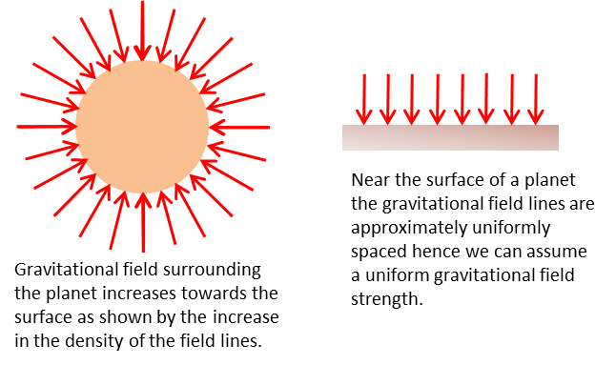

Fig. 4. Gravitational field surrounding a planet.

The gravitational field strength (or the acceleration due to gravity) for the Earth (mass *ME* and radius *RE*) is determined by considering the gravitational force acting of an object of mass *m* and distance *r* from the centre of the Earth and Newton’s Second Law





At the Earth’s surface, we take the gravitational field to be constant where *r* = *RE* and the value for the acceleration due to gravity or gravitational field strength is

(4) 

Earth’s mass *ME* = 5.97×1024 kg

Earth’s radius *RE* = 6.38×106 m

* *g* = 9.7871 m.s-2

The value of *g* for calculations is often taken as 10 m.s-2, 9.8 m.s-2 or 9.81 m.s-2.

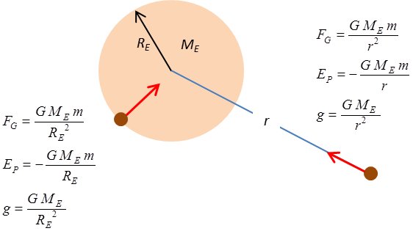

Fig. 5. Gravitational field surrounding the Earth. The magnitudes of the gravitational force, gravitational potential energy and the gravitational field strength (acceleration due to gravity) all depend upon the distance between the centre of the Earth and object within the gravitational field.

***Experiment*** – **Determination of the acceleration due to gravity**

The period of oscillation of a simple pendulum which vibrates with a small amplitude only depends upon the length of the pendulum and the acceleration due to gravity (equation 5)

(5)  small angles only

Perform you own experiment to measure *g* by varying the length *L* of the pendulum and measuring its period *T*.

Hint: Plot a graph of *T*2 vs *L*.

**Web activity and spreadsheet activity**

Use the web to find the mass and radius of all the planets, the Sun and Moon. Enter the data into a spreadsheet and calculate the acceleration due to gravity at their surfaces and compare their value with g at the surface of the Earth.

**What affects the value of *g* – variations of *g* from 9.8 m.s-2 ? W*hy ?***

* Changes in height of the Earth’s surface – mountains & valleys
* Distribution of mass near the Earth’s surface - dense mineral deposits
* Rotation of the Earth

(Earth ‘fatter’ at the equator *g*pole > *g*equator)

* Earth not a perfect sphere
* 9.782 m.s-2 (equator) ≤ *g*  ≤ 9.832 m.s-2 (pole)
* altitude *h* 

|  |  |  |  |
| --- | --- | --- | --- |
| **Location** | **g (m.s-2)** | **Altitiude (km)** | **g (m.s-2)** |
| Equator | 9.780 | 0 | 9.81 |
| Sydney | 9.797 | 1 000 | 7.33 |
| Melbourne | 9.800 | 5 000 | 3.08 |
| South Pole | 9.832 | 10 000 | 1.49 |

**WEIGHT**

In physics, weight is a measurement of the gravitational force acting on an object. Near the surface of the Earth, the acceleration due to gravity is approximately constant; this means that an object's weight is roughly proportional to its mass.

The weight of an object of mass *m* is

(6)  **weight**

* The weight of an object is the same as the gravitational force between the object and its central mass.
* The weight of an object varies according to the gravitational field strength (acceleration) that is affected by distance from the centre of a planet.
* Mass is not affected by gravitational acceleration while weight is.

The weight of an object can be found by measuring the extension or compression of a spring since its extension and compression are proportional to the mass of the object.

It some textbooks weight is defined as the force exerted on a support as shown in figure (5).



Fig. 5. Weight of an object can be found by measuring the extension or compression of a spring.

Note: The equations given in the Physics Stage 6 Syllabus are **incorrect**



you simply cannot divide by a vector

[VISUAL PHYSICS ONLINE](http://www.physics.usyd.edu.au/teach_res/hsp/sp/spHome.htm)

http://www.physics.usyd.edu.au/teach_res/hsp/sp/spHome.htm

If you have any feedback, comments, suggestions or corrections please email Ian Cooper

ian.cooper@sydney.edu.au

Ian Cooper School of Physics University of Sydney