****[**VISUAL PHYSICS ONLINE**](http://www.physics.usyd.edu.au/teach_res/hsp/sp/spHome.htm)

**MODULE 5**

**ADVANCED MECHANICS**

**GRAVITATIONAL FIELD:**

**POTENTIAL ENERGY**

|  |
| --- |
| Work  Gravitational force of the Earth    Gravitational field strength (acceleration due to gravity)    Gravitational potential energy near the Earth’s surface    The Earth’s gravitational potential energy    Conservation of energy |

**Work** *W* [ J ]



When a force acts on an object over a distance work is done on the object to change its kinetic energy or potential energy.

**Gravitational Potential Energy** *EP* *U UG* [ J ]

Consider lifting an object of mass *m* with your hand so that its kinetic energy does not change (object rises at a constant velocity, *a* = 0). Work *W* is done on the object increasing the gravitational potential energy Δ*EP*.

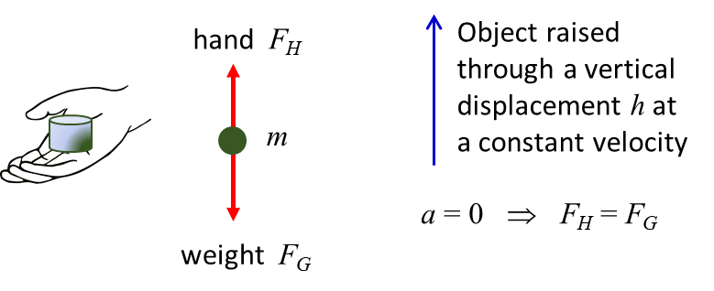

Fig. 1. Lifting the object vertically produces an increase in the gravitational potential energy of the System comprising the object and the Earth.

Work done by hand

= Increase in gravitational potential energy

(2) 

Near the Earth’s surface: *g* = constant (positive number)

g = 9.81 m.s-2

The gravitational potential energy represents an energy **stored** by the object in the gravitational field surrounding the Earth. For example, if the object is released by the hand, it falls a vertical distance *h*. The loss in potential energy is equal to the gain in the object’s kinetic energy.

Loss in potential energy = Gain in kinetic energy

(3) 

Hence, one can predict the velocity *v* of the object when it has fallen a distance *h* starting with an initial velocity *u*.

Equation 2 and 3 are only applicable **near the Earth’s surface** where the value of the gravitational field strength (acceleration due to gravity) *g* is a constant.

To find a more general expression for the gravitational potential energy, you must consider how the gravitational force varies with distance from the centre of the Earth.

Consider the application of a force *F* which moves an object of mass *m* at a constant velocity from its initial position a distance *r* from the centre of the Earth to an infinite distance away from the Earth. The work done on the object by the force *F* increases the gravitational potential energy Δ*EP* of the system of the Earth and the object. The object does **not** possess potential energy, the potential energy is a property of the object and the gravitational field of the Earth. The zero for the potential energy is defined to be at an infinite distance from the Earth



Since the object moves away from the Earth at a constant speed (*a* = 0), the magnitudes of the applied force *F* and the gravitational force *FG* are equal (| *F* | = | *FG* |)



Therefore, we can define the **gravitational potential energy** at a point which is a distance *r* from the centre of the Earth as

(4) 

Figure 2 shows the variation in the gravitational force as a function of distance (Newton’s Law of Universal Gravitation). This is an **inverse square law**. When *r* = 1.0 a.u., what is the value of *F* ? When *r* is doubled, *r* = 2.0 a.u., what is the value of *F* ? Explain why your values agree with the predictions of the inverse square law.

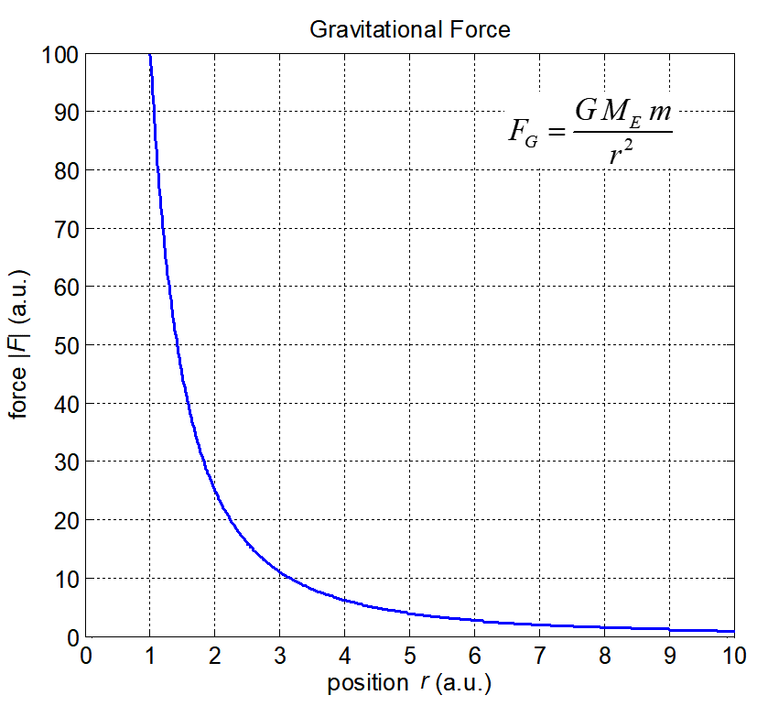

Fig. 2. The gravitational force as a function of distance from the centre of the Earth in arbitrary units.

Figure 3 shows the variation in gravitational potential energy as a function of distance from the centre of the Earth. When *r* → ∞, *FG* → 0 and *EP* → 0. The gravitational potential energy is negative and increases to zero as *r* increases and is a maximum at  where . The potential energy is **inversely proportional** to the distance. When *r* = 1.0 a.u., what is the value of *EP* ? When *r* is doubled, *r* = 2.0 a.u., what is the value of *EP* ? Explain why your values agree with the predictions of the inverse proportionality relationship.

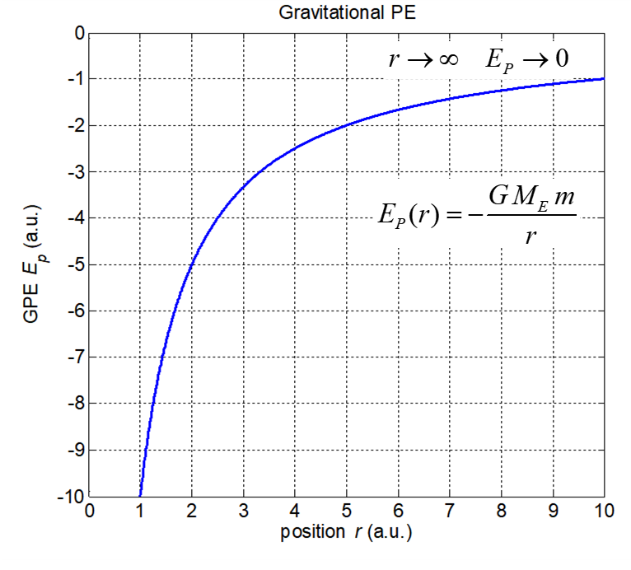

Fig. 3. The gravitational potential energy as a function of distance from the centre of the Earth in arbitrary units.

It is not meaningful to talk about the gravitational potential energy possessed by an object. It is best to refer to the potential energy of a system and define a reference point where the potential energy is taken as zero. The change in potential energy is a more important quantity than the actual value of the potential energy.

|  |
| --- |
| **Exercise using Figure 3**  How much energy (work) is required by an applied force to move an object of mass *m* from  *r* = 1.0 a.u. to *r* = 5.0 a.u.  *r* = 1.0 a.u. to *r* =  a.u.  An object is released from rest at a point where *r* = 5.0 a.u. Describe the subsequent motion of the object. When *r*= 1.0 a.u., what will be the value of its kinetic energy?  How would the values change if the mass of the object was 2*m*? |

**Conservation of energy**

Consider an object in motion that is acted upon only by the gravitational force. Then in the system of the Earth and the object, the total energy of the system is conserved. Hence, as the object moves, the change in total energy is zero.

Kinetic energy of the object, *EK*

Gravitational potential energy of system (GPE), *EP*

Total energy of system, *E* = *EK* + *EP*

Δ*E* = Δ*EK* + Δ*EP* = 0 ⇒ Δ*EK = -* Δ*EP*

⇒ gain in KE = loss in GPE or ⇒ loss in KE = gain in GPE

|  |
| --- |
| **Example**  Consider the flight of a cricket ball in the air. In flight the ball is only acted upon by the gravitational force. The ball initially has its maximum value for its KE and a minimum value for GPE. As the ball rises its potential energy increases at the same rate as its kinetic energy decreases. When the ball reaches its maximum height, its potential energy is a maximum and its kinetic energy a minimum (KE = 0). As the fall falls its potential energy decreases at the same rate as its kinetic energy increases.  When the ball is in flight (assuming only the gravitational force acts on the ball)    gain in KE = loss in GPE or loss in KE = gain in GPE |

|  |
| --- |
| **Example (near the Earth’s surface)**  A cricket ball is dropped from a tower. The ball falls vertically a distance of 134 m from rest before hitting the ground. What is the velocity of the ball immediately before hitting the ground?  **Solution**  How to approach the problem (Identify Setup Execute Evaluate)  Draw an annotated diagram  Type of problem: conservation of energy  Knowledge: total energy *E* = *EK* + *EP* = constant  gain in KE = loss in GPE or loss in KE = gain in GPE    Total energy *E* = *E*1 = *E*2  *EK*1 + *EP*1 = *EK*2 + *EP*2  0 + *mgh*1 = ½*mv*22 + 0  v2 = + √(2*gh*1) = + √[(2)(9.8)(134)]  v2 = + 51 m.s-1  plus sign indicates ball falling towards the ground |

Energy is stored in the gravitational field of the Earth and an object of mass *m*. For example, when a cricket ball is held above the ground and then dropped the stored energy of the ball is transferred into the kinetic energy of the falling ball.

To visualise how energy is stored, you can [view an animation of an oscillating spring](http://www.physics.usyd.edu.au/teach_res/hsp/u5/u5_ag_spring.htm) which shows how the total energy of the system remains constant but the there is a continual transfer between the stored energy of the spring (elastic potential energy) and the kinetic energy of the oscillating object.

[VISUAL PHYSICS ONLINE](http://www.physics.usyd.edu.au/teach_res/hsp/sp/spHome.htm)

http://www.physics.usyd.edu.au/teach_res/hsp/sp/spHome.htm

If you have any feedback, comments, suggestions or corrections please email Ian Cooper

ian.cooper@sydney.edu.au

Ian Cooper School of Physics University of Sydney